Project: Test Plan – Zac Baker | Peer Tester: Kyle Klausen
Course: CSD380: DevOps | CSD380 / DevOps
Description: Test plan draft for Todo Business | Description: Functional testing of Todo application based on defined business requirements
Date: 2026/02/04 | 2026/02/07

TABLE OF CONTENTS
Visit URL 2
Create Task Item 3
View List 4
Delete Task Item 5
Edit Task Item 6

Test 1 | Visit URL
 | Test Objective: Website should be visited through https://buwebdev.github.io/todo/ | Developer: Zac Baker  Date tested: 2026/02/04 | Peer tester: Kyle Klausen  Date tested: 2026/02/07
Step | Action | Expected results: | Developer  pass/fail | Tester pass/fail  + Screenshot
1 | Enter https://buwebdev.github.io/todo/ into search bar. | URL is exactly as shown and navigates to the correct website. | Yes | Yes  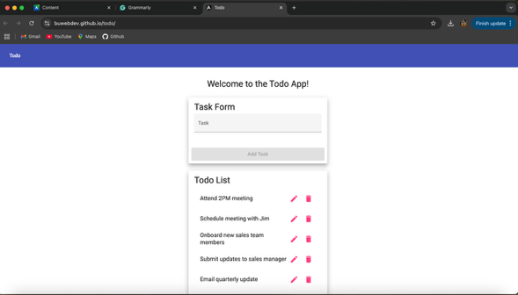
2 | Confirm the page loads correctly without any errors. | Todo main page loads without any errors. | Yes | Yes
3 | Refresh the browser page. | Todo page refreshes and navigates back to the main page. | Yes | Yes
4 | Confirm the page loads correctly without any errors. | Main page loads with the default values for the Todo list. | Yes | Yes
Comments | All steps executed successfully and matched the expected results. The application loaded consistently with no visible errors during navigation or refresh. The landing page displayed the todo interface correctly and met the business requirement.

Test 2 | Create Task Item
 | Test Objective: Users can create task items for the Todo list. | Developer: Zac Baker  Date tested: 2026/02/04 | Peer tester: Kyle Klausen  Date tested: 2026/02/07
Step | Action | Expected results: | Developer  pass/fail | Tester pass/fail  + Screenshot
1 | Type out task item. | A combination of numbers, letters, and symbols can be used in the input bar. | Yes | Yes  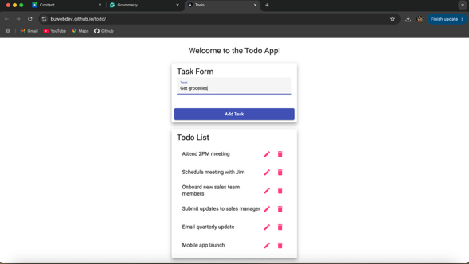
2 | Click “Add Task”. | Clicking the “Add Task” button will add the entered task item to the list. | Yes | Yes  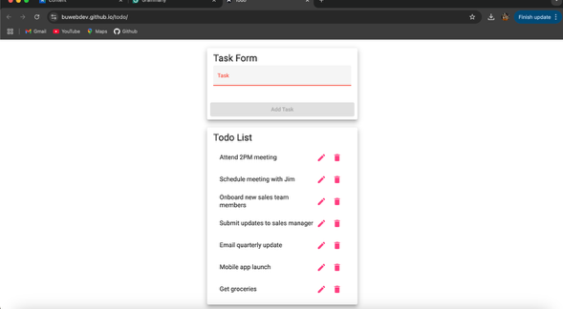
3 | Confirm the added task item is correct. | The added task item will be appended to the bottom of the list. | Yes | Yes
4 | Add another task item. | The Todo app will support multiple entries. | Yes | Yes  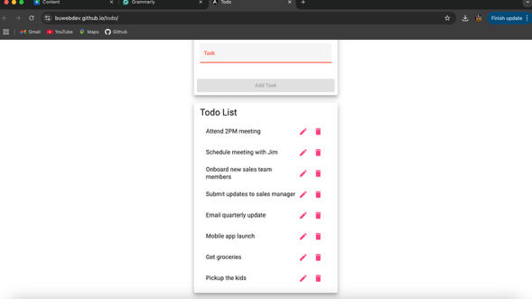
5 | Confirm the added task item is correct. | The added task item will be appended to the bottom of the list. | Yes | Yes
Comments | The todo item was created successfully and immediately appeared in the task list. No errors or unexpected behavior occurred during task creation. The application remained stable throughout the test.

Test 3 | View List
 | Test Objective: The list is visible and dynamically supports adding, deleting, and editing features. | Developer: Zac Baker  Date tested: 2026/02/04 | Peer tester: Kyle Klausen  Date tested: 2026/02/07
Step | Action | Expected results: | Developer  pass/fail | Tester pass/fail  + Screenshot
1 | Confirm the default list is visible. | The page will show the list in a clearly marked and visible area. | Yes | Yes
2 | Confirm the list shows added task items. | Added tasks will be visible in the dedicated list area. | Yes | Yes
3 | Confirm the list shows deleted task items. | Deleted tasks affect the order and size of the list. | Yes | Yes  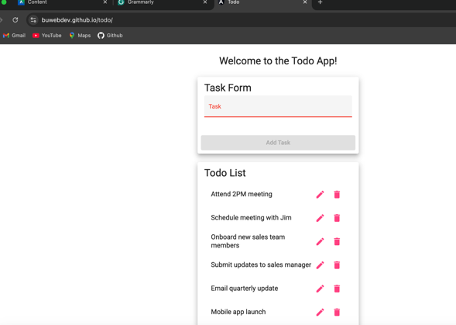
4 | Refresh the browser page. | Refreshing the page will change the entered task items. | Yes | Yes  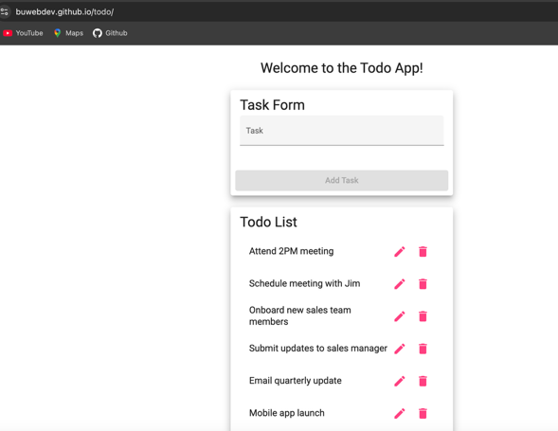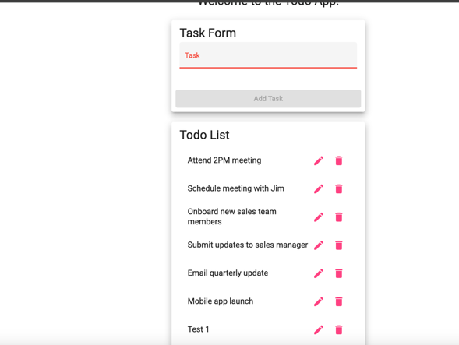
5 | Confirm the default list is visible. | The default list task items will be displayed on refresh. | Yes | Yes
Comments | The task list displayed correctly and dynamically updated when tasks were added or removed. Refreshing the page reset the list as expected based on application behavior. The list view remained clear, responsive, and easy to interact with.

Test 4 | Delete Task Item
 | Test Objective: Users can delete task items. | Developer: Zac Baker  Date tested: 2026/02/04 | Peer tester: Kyle Klausen  Date tested: 2026/02/07
Step | Action | Expected results: | Developer  pass/fail | Tester pass/fail  + Screenshot
1 | Click the trash icon to the right of a task item. | The delete button icon is functional and readily available. | Yes | Yes  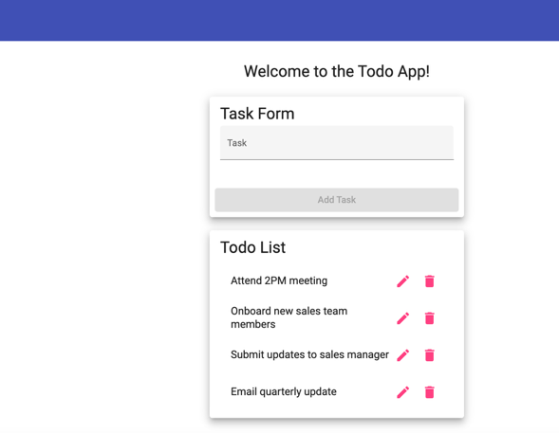
2 | Confirm the task has been deleted. | The delete button deletes the associated task item. | Yes | Yes
3 | Click the trash icon to the right of ALL task item. | All task items can be deleted. | Yes | Yes  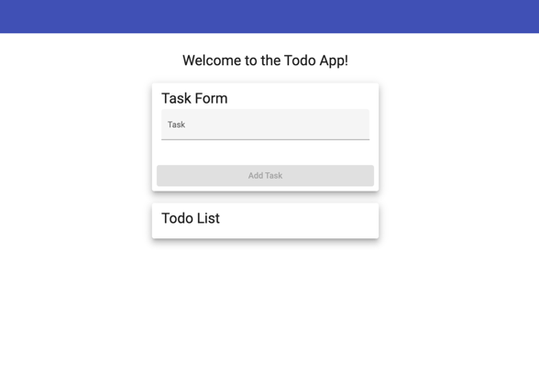
4 | Confirm ALL task items have been deleted. | All task items are deleted showing a blank list. | Yes | Yes
Comments | Task deletion functioned correctly for both individual and multiple task items. Deleted items were immediately removed from the list without errors. The application remained stable and responsive throughout the test.

Test 5 | Edit Task Item
 | Test Objective: Users can edit existing task items. | Developer: Zac Baker  Date tested: 2026/02/04 | Peer tester: Kyle Klausen  Date tested: 2026/02/07
Step | Action | Expected results: | Developer  pass/fail | Tester pass/fail  + Screenshot
1 | Click the pencil icon to the right of task item. | The edit button icon is functional and readily available. | Yes | Yes  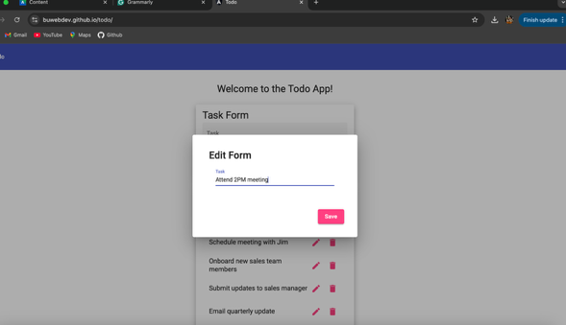
2 | Enter updated task name. | There will be a dedicated input field that users may utilize to enter and update task item name. | Yes | Yes  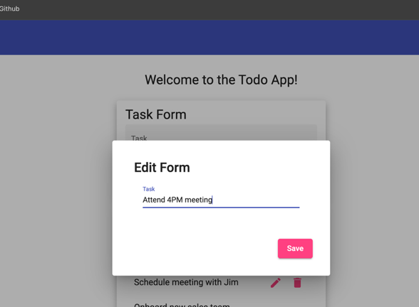
3 | Click “Save”. | There will be a save button or feature that allows the edit to be saved. | Yes | Yes  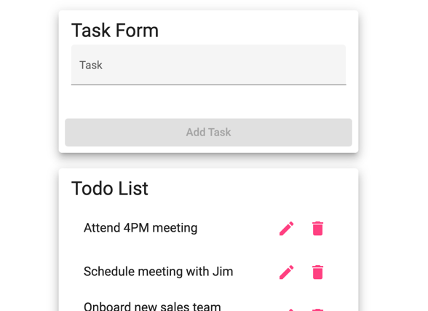
4 | Confirm task item has been edited successfully. | The list will show the updated task item name in the list area. | Yes | Yes
Comments | The edit functionality worked as expected and allowed task items to be updated successfully. Changes were saved immediately and reflected correctly in the task list. No errors or UI issues were observed during the edit process.

