**- config.json explanation:**

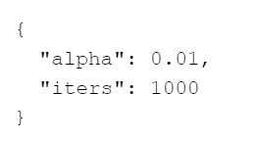

+ Given the contents of config.json, this code will use an alpha (learning rate) of 0.01 and perform 1000 iterations for training the linear regression model of house price predicting.

**- Model.json explanation:**



+ Theta[0] (Intercept term) = 340397.96353531966

This is the intercept term. It represents the base price of a house when both the size and number of bedrooms are zero. In practical terms, it serves as a starting point for the prediction.

+ Theta[1] (Coefficient for size in square feet) = 108742.6562723772

This coefficient represents the change in the predicted house price for each additional square foot of house size, assuming the number of bedrooms is held constant. A positive value indicates that larger houses are predicted to be more expensive.

+ Theta[2] (Coefficient for number of bedrooms) = -5873.229933827042

This coefficient represents the change in the predicted house price for each additional bedroom, assuming the house size (in square feet) is held constant. A negative value here suggests that, holding size constant, adding more bedrooms actually decreases the predicted price slightly.

+ Linear Regression Model Equation

Price = θ0 + θ1×size + θ2×bedrooms

**- Price.json explanation:**



+ This result is to predict the price house with 3 bedrooms have size =1650 square feet, can have a price = 293222.

+ This prediction based on calculating of datasets given