**Modeling the Elbow Forces During a Simplified Tennis Swing**

BIOE404 Section 0103 Final Project

Kyle King, Kristina Dziki, and Shiri Brodsky

# Abstract

The purpose of this model was to determine the effects of the lower arm extension involved in an amateur tennis swing. It was predicted that when the arm is fully extended the arm would experience the greatest force and be most prone to tennis elbow or other harmful events. By collecting data using Tracker software and analyzing the data with polynomial fit equations, the velocity, acceleration, and physiological parameters of a typical tennis swing were used to create a dynamic model. The graphed forces of the joint reaction and the tricep force show a peak at theta equal to 0, when the arm was horizontal. Likewise, the velocity and acceleration were greatest at this moment supporting the hypothesis. Through this model we hope to make better understand the risk of injury from continuous serving. The model may also function as a teaching aid to inspire the next generation of bioengineers.

Table of Contents

Abstract 1

Introduction 3

Methods 3

Results 5

Discussion/Conclusion 8

References 8

Appendix 1: Script File, trial.m 9

# Introduction

Amateur tennis players are most susceptible to an overuse injury called tennis elbow. The pain originates from miniscule tears or abrasions on the tendons and ligaments around the elbow (Elliot, 2006). This pain can potentially develop into a chronic condition called tennis elbow. Otherwise called lateral epicondylitis, the condition is predominantly attributed to excessive wrist tightness or an improper racket (Knudson, 2014). As tennis elbow is very common with tennis player sand prevents many from enjoying the sport, we hope to shed new light on the biomechanics behind the injury. By limiting internal strain of ligaments in the elbow, we hope to determine a feasible angle at which tennis players can successfully serve the ball while minimizing the stress and overuse of the muscles around the elbow.

To better understand the relationship between the angle at which a tennis ball is hit in an overhand serve and the various forces and moments within the elbow joint, we will be examining the joint reaction force at the elbow and the force exerted by the tricep muscle. To estimate the motion of the arm, we will use a human model to estimate typical swing rate parameters. From these forces, we will then try to determine at what angle the greatest tricep force is exerted to estimate the cause of tennis elbow. This ideal angle will then limit the strain on the tendons and ligaments of the player’s elbow.

# Methods

1. Assumptions

In this project, we simplified our model of the serving arm by making it consist of two straight segments from the shoulder to the elbow (vector SE), and from the elbow to the hand (vector EH). These two segments of the arm were kept at a constant angular relationship with each other, at 90 degrees. We assumed that the upper arm is positioned laterally (directly away from the body) at a constant 45˚ angle above the horizontal axis. The lower arm, EH then underwent a medial rotation and experienced a varus moment. Using a model human and using the open source, Tracker software, we calculated the position of three markers, as the arm went through a typical rotation. The markers were placed on the upper arm, the elbow, and the lower arm respectively, each two inches from the elbow marker. The serve, which lasted for 0.83 seconds, was split up in to 21 frames for a frequency of 25.3 s^-1 (or 25.3 Hz). To reduce the system of equations to those that could be calculated, the analysis was simplified to only consider the joint reaction force and the tricep force at the elbow as unknowns. The weight of the racket, the weight of the arm and the center of mass of the arm and racket were calculated based on estimations and research.

j

i

H

O

COM,arm

E

COM,racquet

F,is

F,arm

F,rac

H

O

COM,arm

E

COM,racquet

F,arm

F,rac

F,jrf

F,tricep

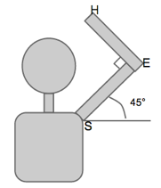

2. Data Analysis

The data collected from the tracker software was first imported into MATLAB into a set of arrays denoted data. This original data was clipped to remove erroneous data at the beginning and end of the swing to match the assumption of a continually accelerating swing and to account for tracking error. The data was then graphed for visual analysis (Figure 1.1 and Figure 1.2). To determine the angle with respect to horizontal of the arm, the arc tangent of segment EB was calculated then smoothed using the polyfit term. This fit was plotted in Figure 2. From this smoothed data, the changed angle over the given time point was used to programmatically calculate the velocity. The change in velocity over the given time was likewise calculated. Using these estimates, an average acceleration was calculated. This data was then plot in Figure 3 for further visual analysis.

3. Physiological Parameters

The estimation for arm weight and moment of inertia were calculated as:

*Mass of Forearm (mass_EH):*

2.07% of team member’s body weight:

120lb * (0.0207) = 2.48lb (4.448N/lb) = 11.05 N

11.05N/(9.8m/s^2) = 1.127 kg = mass_EH

*Mass Moment of inertia (I) of the forearm and racket, simplified to a rod-like structure:*

I = (1/12)*m*L^2

I = (1/12)*(1.127kg)*(0.2286m)^2

I = 0.00491 kg*m^2

4. Dynamic Analysis

Incrementing over time, the current angle was found using an analysis based on the average acceleration and the stepwise velocity. The acceleration was then used to find the moments within the arm at each new angle:

*Moment Balance:*

∑𝑀 = 𝐼𝛼 = **M**Ftriceps +**M**Fracquet +**M**Farm

**M**Fracquet = **r** x **F**racquet, , etc.

**M**Ftriceps= **r**EOx **F**triceps, , where **r**EO is physiologically known and **F**triceps is in a known direction

**r**EO **=-**2.5 cm i -3 cm j, based on BIOE404 F14 HW2 assumptions (Hsieh)

Armed with the moment analysis and the force exerted by the tricep to maintain the rotation, the total forces were calculated using this equation:

*Force Balance:*

∑𝐹 = 𝑚𝑎 = m(**at**ang + **a**norm) = **F**arm + **F**racquet + **F**IS,E

**at**ang = -r x 𝛼 and **a**norm =-r (*𝜔*)^2

∑𝐹=𝑚𝑎= m(**at**ang + **a**norm)=**F**arm+**F**racquet +**F**JRF,E + **F**triceps

Calculated **F**JRF,E for a range of alphas based on theta

Additional comments and programmatic notes can be found in Appendix A of the attached MATLAB script file. The norm of the joint reaction and tricep force were each graphed in Figure 4.1 alongside the velocity at each point of the rotation in Figure 4.2.

# Results

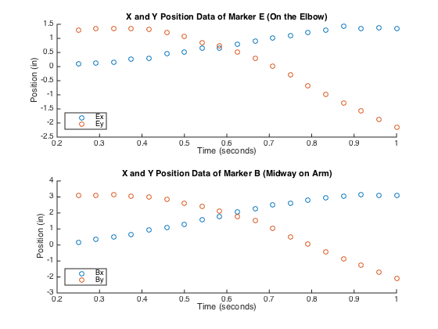This paper attempted to model the simplified rotation of an arm through a typical amateur tennis swing. The position vectors were graphed over time along with the smoothed and calculated velocity and acceleration. The forces present in this model were analyzed and likewise graphed to show the peak stress.

Figure 1.1 and 1.2 the relationship of x and y coordinates over time for marker E and B respectively

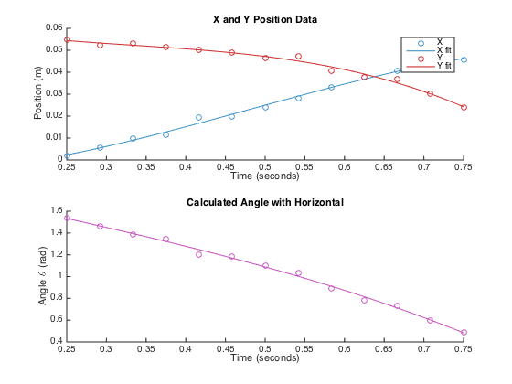The markers moved through a sweeping motion. Most notably, the marker E, at the elbow followed the sweeping rotation of the marker B. We initially expected this value to stay constant and have the arm rotate around that position, but this clearly shows that the elbow moves during a swing. The marker B moves a full 6” from the top of the stroke to the bottom and the marker shifts forward 3 inches at its max.

Figure 2.1 and 2.2 show the relationship of the calculated x and y components of the lower arm and the related angle with horizontal.

The angle and position data were fit with a polynomial of order 3, while the angle was best fit by a polynomial of order 1.The angle starts at 1.5 radians, which converts to 85.94 degree and ends at 22.92 degrees or about 0.4 radians. This data was used to extrapolate what a swing of a full 90 degrees would look like.

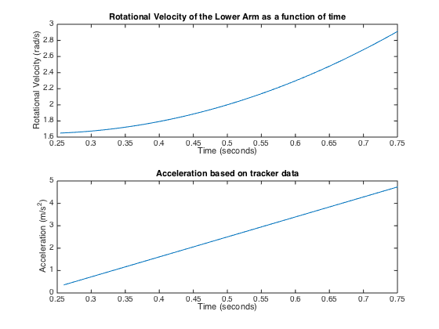

Figure 3.1 and 3.2 show the change in velocity and acceleration respectively over the time frame presented in the last figure

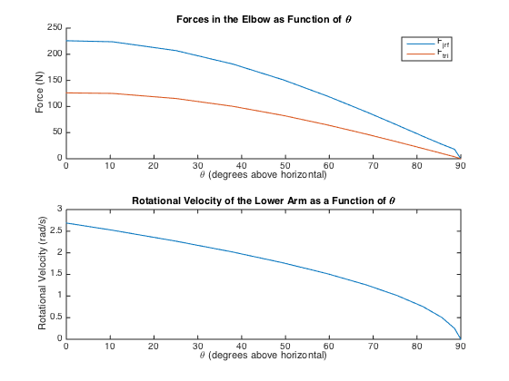The velocity of arm was increasing exponentially as the arm continued to accelerate down. The acceleration had a positive slope indicating the arm was continually accelerating and that the acceleration increased over time. This dynamic relationship applied additional force on the arm and creates the non-linear representation in force seen below:

Figure 4.1 and 4.2 show the force and velocity as a function of theta

The arm continued to experience an increasingly greater force the closer it approached to horizontal. Using the acceleration and position data collected, the force shows a non-linear relationship characteristic of the way the angle of theta and thus r vector to the center of mass changes more rapidly as time progresses.

# Discussion/Conclusion

The data collected in this paper is enough to show a simplified and rudimentary behavior of an arm while swinging. Using the before mentioned collected data, the acceleration and velocity of the arm make physiological sense. The player’s arm continually accelerates as the tricep force extends the lower arm forward. The greatest force is thus seen in the fully extended arm as both the joint reaction force and the tricep force peak at 0˚ of horizontal. As hypothesized, the ideal tennis swing will peak at a vertical position where contact with the ball is made. The player should then relax the triceps muscle and follow through the swing allowing the increasing weight-related moment forces to swing the arm through its arc and stopped by the stronger biceps muscle. However, the greatest acceleration and velocity is seen as the arm approaches horizontal, so the player wishing to maximize their swing would wish to extend as far forward as possible (Elliot, 2006). Ultimately, the data collected is too specific and not sufficient enough to pinpoint a range of maximum contact angles to reduce tennis elbow occurrence.

To draw a meaningful physiological understanding of the condition of tennis elbow, there must be additional studies to generalize and support the findings of this paper. To improve the collected data, the model should wear a tracking suit with multiple trackers that follow the arm in 3D space. Additionally, a higher frequency of images and automatic image analysis software is needed to generate specific and smooth data sets for additional analysis. A greater physiological understanding can be reached by analyzing tissue samples for the resilience to different types of stress to learn the physiological limit that will cause miniscule tears or with more advanced computational models, such as Dr. Riek’s “A simulation of muscle force and internal kinematics of extensor carpi radialis brevis during backhand tennis stroke: implications for injury” computational study. Additionally, the model should include multiple subjects of different heights, sizes, and weights should be studied to draw greater estimations for the population of amateur tennis players as a whole. While this model may not make a significant physiological impact, this model may serve as an effective teaching tool to inspire students to pursue engineering and explain the causation of tennis elbow.

# References

Elliott, B. “Biomechanics and tennis.” Br J Sports Med 40. di (2006):392–396. Web. 16 Oct.

2014.<http://www.ncbi.nlm.nih.gov/pmc/articles/PMC2577481/>

Knudson, Duane. “Recent Research Update: Factors Related to Tennis Elbow.” Tennis Pro

Jan-Feb 2014. Web. 16 Oct. 2014.

Riek, Stephan, AE Chapman, and Ted Milner. “A Simulation of Muscle Force and Internal

Kinematics of Extensor Carpi Radialis Brevis during Backhand Tennis Stroke:

Implications for Injury.” Clinical Biomechanics 14. di (1999): 477-483. Web. 16 Oct. 2014.

# Appendix 1: Script File, trial.m

% BIOE404 Project

% Kyle King, Shiri Brodsky, Kristina Dziki

% 12-20-2014

clc, clear all, close all % Boilerplate

%% Import data

Name = 'ShiriData.xlsx';

currentFolder = pwd;

filename = strcat(currentFolder, '/', Name);

Shiri_Data = xlsread (filename); % Takes data from excel sheet

% Parse data

start_analysis = 7;

times = Shiri_Data(start_analysis:end, 1);

data(:,1) = Shiri_Data(start_analysis:end, 4); data(:,2) = Shiri_Data(start_analysis:end, 5);

data(:,3) = Shiri_Data(start_analysis:end, 6); data(:,4) = Shiri_Data(start_analysis:end, 7);

%% Plot Captured Data

figure

subplot(2, 1, 1), hold all, plot(times, data(:,1), 'o'), plot(times, data(:,2), 'o')

legend('Ex', 'Ey', 'Location', 'SouthWest'), title('X and Y Position Data of Marker E (On the Elbow)')

xlabel('Time (seconds)'), ylabel('Position (in)')

subplot(2, 1, 2), hold all, plot(times, data(:,3), 'o'), plot(times, data(:,4), 'o')

legend('Bx', 'By', 'Location', 'SouthWest'), title('X and Y Position Data of Marker B (Midway on Arm)')

xlabel('Time (seconds)'), ylabel('Position (in)')

% Remove excess data points when Shiri's arm is de-accelerating

% end_analysis = length(times)-5;

end_analysis = length(times)-0;

t = Shiri_Data(start_analysis:end_analysis, 1);

Ex = Shiri_Data(start_analysis:end_analysis, 4).*0.03; Ey = Shiri_Data(start_analysis:end_analysis, 5).*0.03;

Bx = Shiri_Data(start_analysis:end_analysis, 6).*0.03; By = Shiri_Data(start_analysis:end_analysis, 7).*0.03;

% Find vector components of radius_BC (EB from tracker)

x = Bx - Ex;

y = By - Ey;

thetas = atan(y./x); % Find angle of lower arm from horizontal

t1 = linspace(t(1), t(end)); % higher resolution time points for fit

% Fit theta position data to a smooth curve

ptheta = polyfit(t, thetas, 3);

thetas1 = polyval(ptheta, t1); % fit

% Fit x position data to a smooth curve

px = polyfit(t, x, 3);

x1 = polyval(px, t1); % fit

% Fit y position data to a smooth curve

py = polyfit(t, y, 3);

y1 = polyval(py, t1); % fit

% Colors:

base = 256; % rgb is based on 256, but Matlab wants it on a 0 to 1 scale

blue = [69/base, 151/base, 204/base];

red = [255/base, 112/base, 112/base];

purple = [199/base, 87/base, 193/base];

% yellow = [255/base, 254/base, 169/base]; % too bright

red = [205/base, 51/base, 51/base];

% Plot to see what position data is calculated

figure, subplot(2, 1, 1), hold all

plot(t, x, 'o', 'Color', blue), plot(t1, x1, 'Color', blue)

plot(t, y, 'o', 'Color', red), plot(t1, y1, 'Color', red)

legend('X','X fit', 'Y', 'Y fit')

title('X and Y Position Data')

xlabel('Time (seconds)'), ylabel('Position (m)')

subplot(2, 1, 2), hold all

plot(t, thetas, 'o', 'Color', purple), plot(t1, thetas1, 'Color', purple)

title('Calculated Angle with Horizontal')

xlabel('Time (seconds)'), ylabel('Angle \theta (rad)')

% % 3D plot, because why not

% figure, plot3(t(7:end), x, y), axis tight

% title('X and Y Position Data and Calculated Angle with Horizontal')

% xlabel('Time (seconds)'), ylabel('Position (m)')

%% Find the angular velocity and acceleration

% Initialize variables

sum_acc = 0; vel(1) = 1.6503;

dt1 = t1(2) - t1(1); % Find change in time

for i = 2:length(t1)

% Find the change in angle (position)

dthetas1(i) = thetas1(i-1) - thetas1(i);

% Find the angular velocity

vel(i) = dthetas1(i)/dt1;

% Find the angular acceleration

acc(i) = (vel(i) - vel(i-1))/dt1;

% take summation of both values for average later

if i >= 3

sum_acc = sum_acc + acc(i);

end

end

% Take Averages

avg_acc = sum_acc/(i-1); % rad/s^2

% Plot speed and acceleration

figure, subplot(2, 1, 1), plot(t1(2:end), vel(2:end))

title('Rotational Velocity of the Lower Arm as a function of time')

xlabel('Time (seconds)'), ylabel('Rotational Velocity (rad/s)')

subplot(2, 1, 2), plot(t1(3:end), acc(3:end))

title('Acceleration based on tracker data')

xlabel('Time (seconds)'), ylabel('Acceleration (m/s^2)')

%% Initialize initial conditions

% Arm info

length_arm = 0.22; % in m

COM_arm = (1/2)*length_arm; % in m

mass_EH = (0.0207*120*4.448)/9.8; % in kg based on percent of body weight

% Racket based on average racket size and weight

mass_racket = 0.275; % kilograms

length_racket = 0.69; % meters

COM_racket = (2/3)*length_racket; % Estimate

% Total mass of arm with racket

mass_net = mass_EH + mass_racket;

Fw = [0, -mass_net*9.81, 0]; % N

% Net COM for racket and arm

com_net = ( COM_arm*mass_EH + (length_arm+COM_racket)*mass_racket ) / mass_net;

I = (1/12)*(mass_net)*(com_net)^2; % in kg*m^2

% Location of tricep muscle

r_tricep = [-0.025, -0.03, 0]; % end of tricep muscle

l_tricep = [-2/100, 14/100, 0]; % m

u_tricep = (l_tricep - r_tricep)./norm(l_tricep - r_tricep); % unit less

% For Loop variables

t_step = 0.1; count = 1;

angle_theta(1) = 90; % Start at vertical (90')

speed_vel(1) = 0; % with omega = 0

%% Test impact of end angle in swing on internal elbow forces

for t = 1:t_step:2.8

count = count+1; % Counter variable

time(count) = t; % store time value (s)

% Calculate the current velocity and angle of theta based on average acceleration

vel_step = t_step*avg_acc;

speed_vel(count) = speed_vel(count-1) + vel_step;

theta_step(count) = speed_vel(count) * t_step * (180/pi);

angle_theta(count) = angle_theta(count-1) - theta_step(count);

% Calculate new Center of Mass

com_loc = [cosd(angle_theta(count)), sind(angle_theta(count)), 0].*com_net;

% Calculate components of acceleration

atang(count, :) = cross(-com_loc, [0, 0, avg_acc]);

anorm(count, :) = -com_loc.*norm([0, 0, speed_vel(count)].^2);

atotal(count, :) = atang(count, :) + anorm(count, :);

% Solve for the force of the tricep muscle

M_net = [0, 0, I*avg_acc];

M_arm_racket_w = cross(com_loc, Fw);

F_tricep(count, :) = (M_net-M_arm_racket_w)/cross(r_tricep, u_tricep);

% Solve for inter segmental force at the elbow

F_jrf(count, :) = (mass_net*atotal(count, :)) - Fw - F_tricep(count, :); %N

% Store data in arrays for graphing

force_elbow_reactions(count) = norm(F_jrf(count, :));

F_tricep_graph(count) = norm(F_tricep(count, :));

anorm_graph(count) = norm(anorm(count, :));

atang_graph(count) = norm(atang(count, :));

end

%% Plot results

figure

subplot(2,1,1), hold all

plot(angle_theta, force_elbow_reactions), plot(angle_theta, F_tricep_graph)

legend('F jrf', 'F tri')

xlim([0 90])

title('Forces in the Elbow as Function of \theta')

xlabel('\theta (degrees above horizontal)'), ylabel('Force (N)')

subplot(2,1,2), plot(angle_theta, speed_vel)

xlim([0 90])

title('Rotational Velocity of the Lower Arm as a Function of \theta')

xlabel('\theta (degrees above horizontal)'), ylabel('Rotational Velocity (rad/s)')