**Question1**

P.1

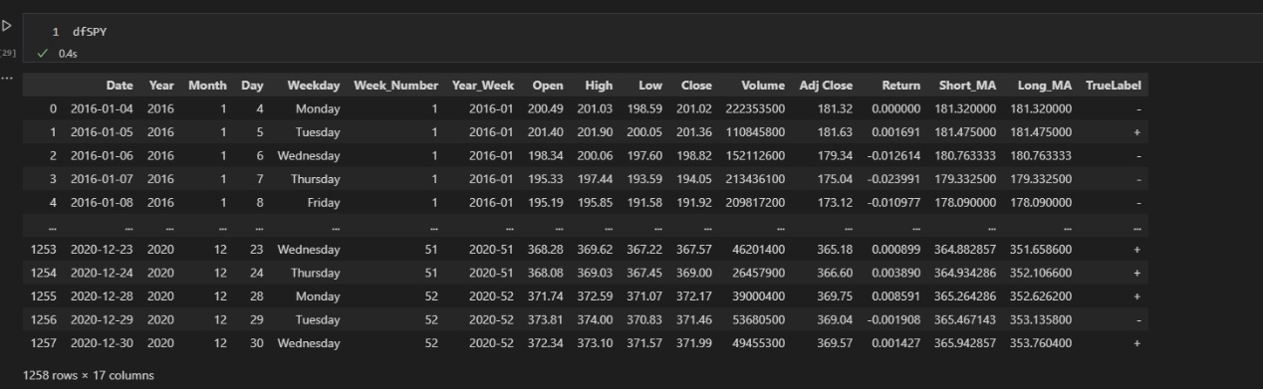

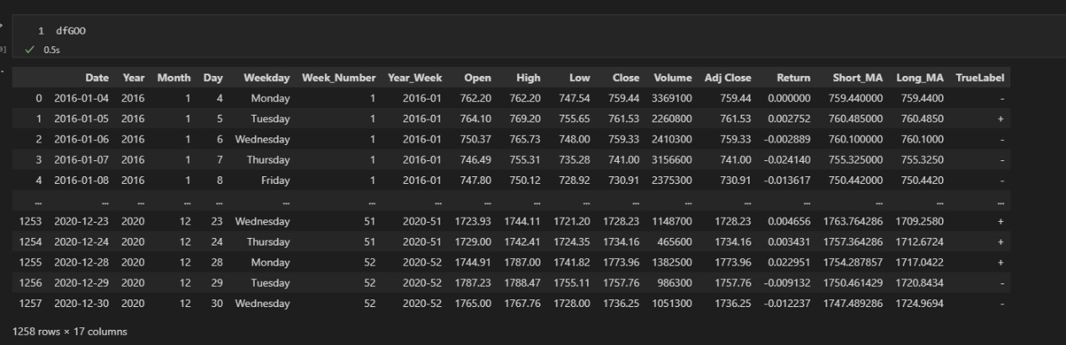

P.2 The default probability p* = 54.8%

P.3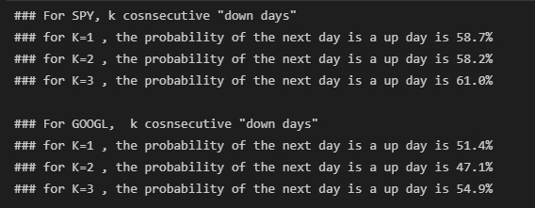

P.4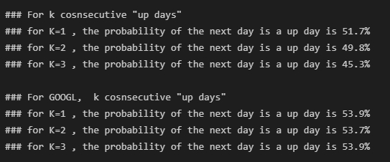

**Question2**

P.1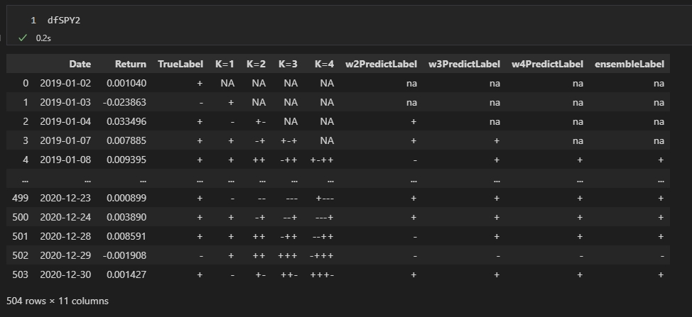

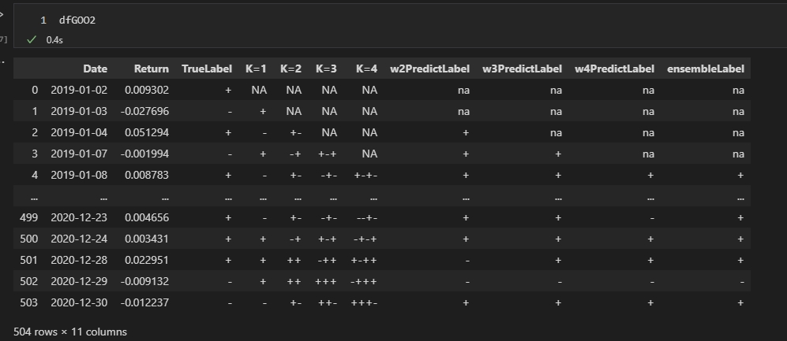

P.2 – P.3

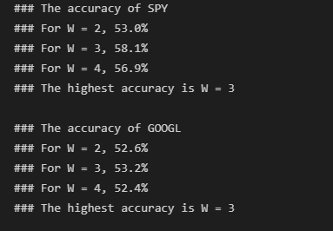

**Qeustion3**

P.1





P.2

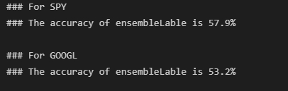

P.3

Did not improve the accuracy on predicting “-“

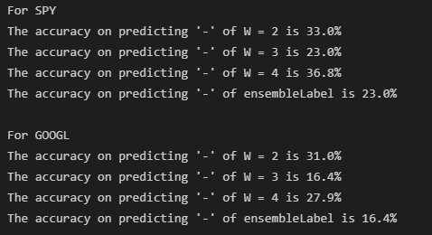

P.4

Did not improve the accuracy on predicting “+”

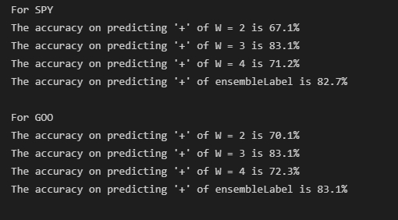

**Question4**

|  |  |  |  |  |  |  |  |  |
| --- | --- | --- | --- | --- | --- | --- | --- | --- |
| W | Ticker | TP | FP | TN | FN | Accuracy | TPR | TNR |
| 2 | SPY | 198 | 139 | 69 | 96 | 53.0% | 67.3% | 33.2% |
| 3 | SPY | 245 | 160 | 48 | 48 | 58.1% | 83.6% | 23.1% |
| 4 | SPY | 210 | 131 | 77 | 82 | 56.9% | 71.9% | 37.0% |
| Ensemble | SPY | 244 | 160 | 48 | 48 | 57.9% | 83.6% | 23.1% |
| 2 | GOO | 195 | 155 | 70 | 82 | 52.6% | 70.4% | 31.1% |
| 3 | GOO | 245 | 188 | 37 | 45 | 53.2% | 83.7% | 16.4% |
| 4 | GOO | 210 | 161 | 63 | 75 | 52.4% | 72.8% | 28.1% |
| Ensemble | GOO | 244 | 187 | 37 | 45 | 53.2% | 83.7% | 16.5% |

**Discussion:**

First, we can observe that W = 3 has the highest TPR but the lowest TNR, which means it is a good model for predicting bull market of the stock market but not suitable to predict the bear market. Moreover, all of the models are good in bear market prediction. In my opinion, stock market has a upward trend in a long time range, so the stock price is continuously rising. However, the drop of the stock price is usually caused by the urgent situation. The drop of the price is just the fluctuation of a upward trend market in long term time period.

Next, when predicting the drop of the price in the future, w = 4 is the best model for SPY and w = 2 is the best model for GOOGL. However, the True Negative Rate isn’t over that 50%, even tossing a coin could probably be more accurate. Again, within all models, none is suitable for predicting the future drop of the stock price.

Finally, there is a interesting fact that ensemble prediction is almost the same with the W = 3 prediction. I think the situation is based on two reasons, upward trend chrematistics of stock market, highest accuracy on TRP of W = 3. Usually, we can predict ‘+’ from most prediction pool (e.g. ‘++’, ‘--+’, ‘+-+-‘, etc.). And W = 3 are important when making the ensemble label prediction. Therefore, ensemble prediction might be almost the same with W = 3.