**Question 1**

1. 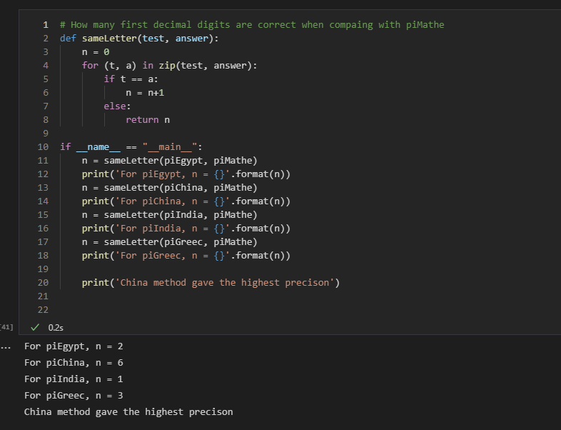

2. China method gave me the highest “precision” based on the correctness of how many first decimal.

3.

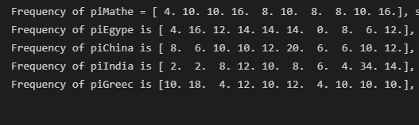

4.

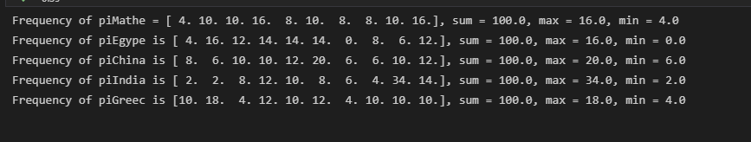

5.

|  |  |  |  |  |
| --- | --- | --- | --- | --- |
| Method | N | V | Min | Max |
| Exact | NA | (4 ,10,10,16,8 ,10,8 ,8 ,10,16) | 4 | 16 |
| Egypt | 2 | (4 ,16,12,14,14,14,0 ,8 ,6 ,12) | 0 | 16 |
| China | 6 | (8 ,6 ,10,10,12,20,6 ,6 ,10,12) | 6 | 20 |
| India | 1 | (2 ,2 ,8 ,12,10,8 ,6 ,4 ,34,14) | 2 | 34 |
| Greece | 3 | (10,18,4 ,12,10,12,4 ,10,10,10) | 4 | 18 |

6.

Based on the N data, we could know that China method is has the highest precision to the exact pi. In my opinion, the only meaningful data in this table is N. For example, I have no idea about what information can the distribution of digits provide, I can only know the digits distribution of each method; that’s it. And for the Min and Max, they can only provide which digit number appears the most time and the less time; however, in this situation, correctness should be the main point rather than the distribution of the digits.

**Question 2**

1.

|  |  |  |  |  |
| --- | --- | --- | --- | --- |
| Method | Max Absolute | Median Absolute | Mean Absolute | RMSE |
| Egypt | 8 | 4 | 3.6 | 4.4 |
| China | 10 | 4 | 3.6 | 4.6 |
| India | 24 | 2 | 5.2 | 8.3 |
| Greece | 8 | 4 | 4 | 4.6 |

2.

|  |  |
| --- | --- |
| Egypt | 0.89% |
| China | 0.0001% |
| India | 1.9% |
| Greece | 0.18% |

Like I said, I think it is meaningless to compare the error between distribution of digits. The distribution of digits could not perfectly show the permutation of these digits, we can only know the frequency of these digits which can not provide the information of accuracy of each method. For example, Max Absolute of the digit distribution could provide which digit’s distance is the most. Let’s see the Max Absolute of India, we could know there is a big distance of one digit between India method and exact pi, which can only provide the information that there must be a digit used heavily differently.

Therefore, I provide the data which I think is important, the absolute error of each method. We could find that China method is the closest to the exact pi. In contract, India method has the highest error percent. Moreover, within these four methods, the accuracy of China method is way more higher in a huge magnitude.