**Question**

1.

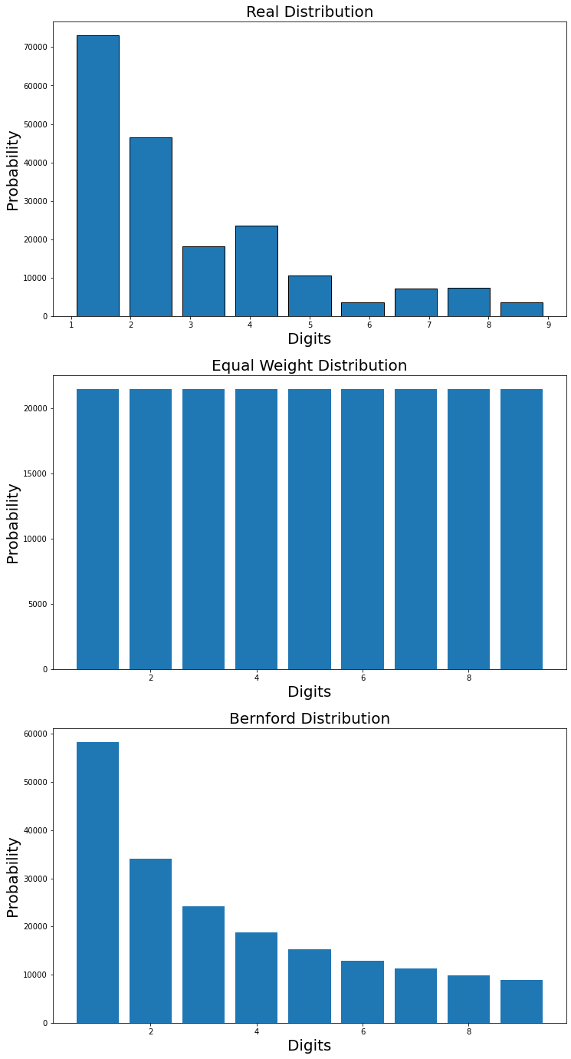

2.

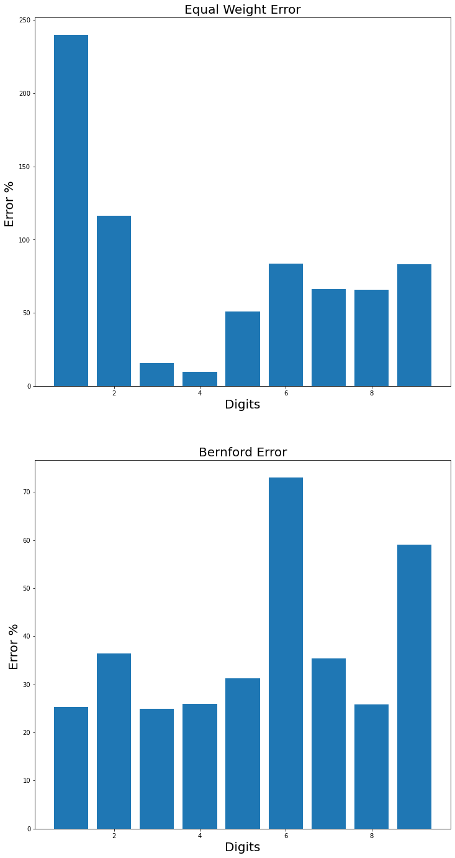

3.

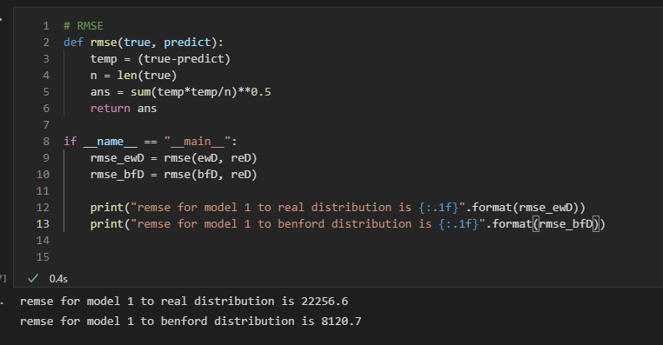

4.



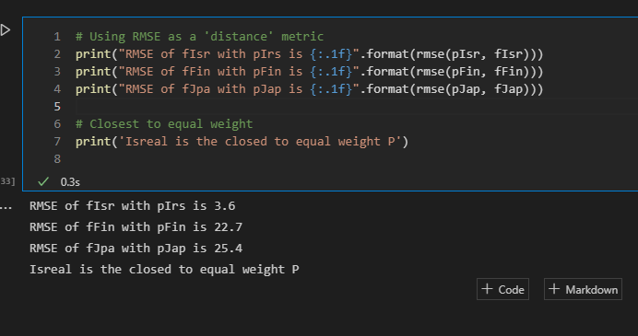

5.

I will discuss about the assignment in two parts, one for the entire real data, and the other of the selected country I choose.

Firstly, as we can see the figure in 1, we could realize the fact that the distribution of the entire data must be closer to the Bernford’s law rather than the equal-weight model. And then we could find the proof in figure 2, which provides the information of the error within two models. We could find that the error for each digit under Bernford’s law is way less than that under equal-weight model, giving us a strong proof to support the correctness of the Bernford’s law. Under the Bernford’s law, we could see digit 6 and digit 9 are two digits which the error is the highest with 9 digits; still, the error is still under 80%, which is a surprised finding.

Next, in this question, I choose Israel, Finland and Japan to analysis. We could obviously find that Israel is the closet to equal-weight distribution due to the error shown in figure4. And there is a possible explanation, which is the numbers of the data. As you can see that Israel has the less data amount. There are only 34 data of Israel while Finland and Japan have more than 150 data. Therefore, I bet the numbers of the data is the key reason why Israel is closer to the equal-weight distribution.

