**Question (Label the 2 year google data)**

I choose GOOGL as my stock, and I labeled 2019 and 2020 for the stock.

|  |  |
| --- | --- |
| Buy-And-Hold | 121.2 |
| Based on labels | 200.0 |

Strategy based on my labels results in a larger amount at the end of the year2020.

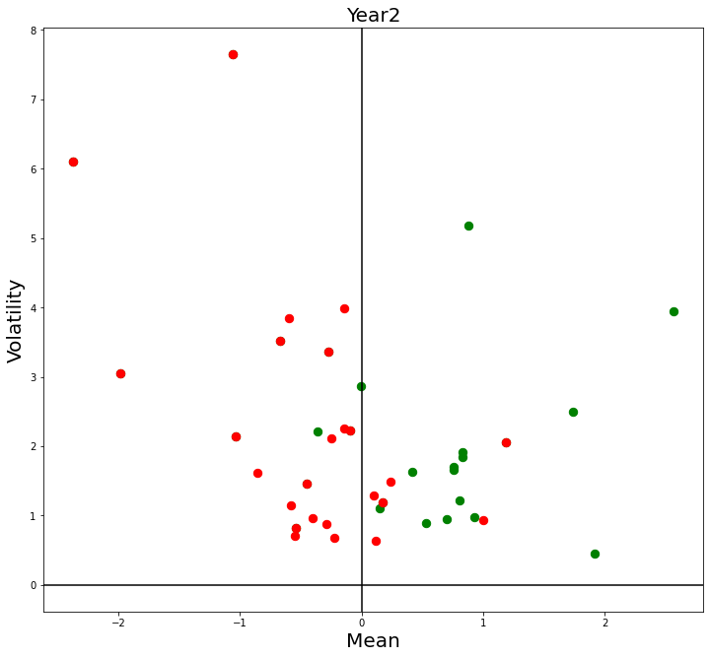**Question (Plot the feature)**

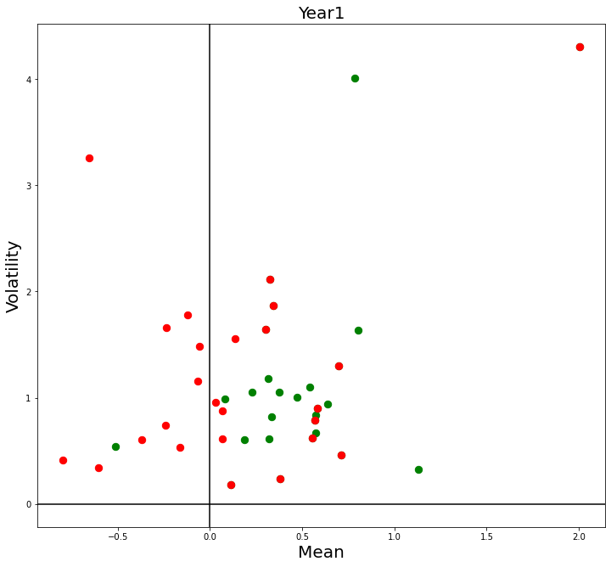

1. Green dots tends to distribute on the right side of the y-axis, which means Mean > 0.

For red dot, it distributes equally on both sides in year 1, but it distributes mostly on left side in year 2.

1. 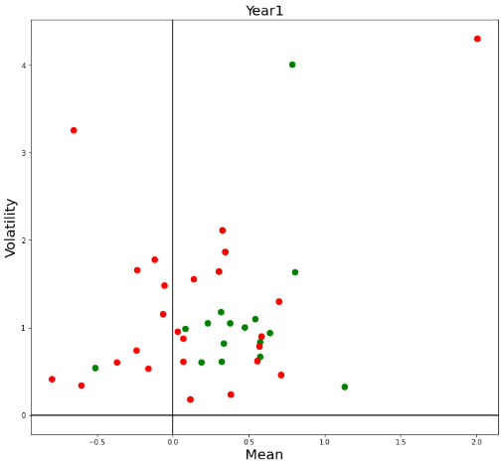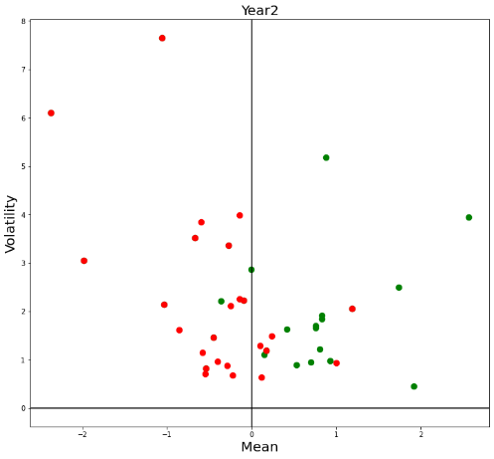

We could see the dots in year 2 tend to locate close to each other no matter it’s green or red.

However, in year 1, green dots are located close enough to be a small cluster, while red dots distribute dispersedly which means red dots don’t have a obvious cluster.

1. For the green dots, the pattern is the same from year 1 to year 2, tending to locate on the right side.

But for the red dots, the pattern is not as obvious as the green dots. We could find the red dots locate mostly on left side in year 2, but they locate dispersedly on both side in year 1.

1. I don’t think NN classifier would do well in year 1 as year 2. I personally think year 2 is more suitable for implementing NN classifier.