**Question1**

My stock is GOOGL

2016

|  |  |  |  |  |  |  |  |  |
| --- | --- | --- | --- | --- | --- | --- | --- | --- |
| Day | Mu(R)% | Sig(R)% | |R-| | Mu(R-)% | Sig(R-)% | |R+| | Mu(R+)% | Sig(R+)% |
| M | 0.20 | 1.1 | 20 | -0.76 | 0.7 | 26 | 0.95 | 0.7 |
| T | 0.31 | 1.1 | 18 | -0.81 | 0.5 | 34 | 0.89 | 0.9 |
| W | -0.04 | 1.1 | 26 | -0.82 | 1.0 | 26 | 0.73 | 0.5 |
| R | -0.17 | 1.2 | 32 | -0.84 | 0.8 | 19 | 0.97 | 0.9 |
| F | -0.16 | 1.6 | 26 | -1.24 | 1.4 | 25 | 0.95 | 0.8 |

2017

|  |  |  |  |  |  |  |  |  |
| --- | --- | --- | --- | --- | --- | --- | --- | --- |
| Day | Mu(R)% | Sig(R)% | |R-| | Mu(R-)% | Sig(R-)% | |R+| | Mu(R+)% | Sig(R+)% |
| M | 0.10 | 1.0 | 22 | -0.71 | 0.6 | 24 | 0.85 | 0.6 |
| T | 0.07 | 0.9 | 22 | -0.68 | 0.7 | 29 | 0.65 | 0.5 |
| W | 0.28 | 0.8 | 16 | -0.65 | 0.7 | 36 | 0.70 | 0.6 |
| R | -0.07 | 0.8 | 26 | -0.67 | 0.6 | 25 | 0.56 | 0.5 |
| F | 0.19 | 1.1 | 23 | -0.61 | 0.7 | 28 | 0.85 | 1.0 |

2018

|  |  |  |  |  |  |  |  |  |
| --- | --- | --- | --- | --- | --- | --- | --- | --- |
| Day | Mu(R)% | Sig(R)% | |R-| | Mu(R-)% | Sig(R-)% | |R+| | Mu(R+)% | Sig(R+)% |
| M | -0.20 | 1.7 | 22 | -1.70 | 1.4 | 26 | 1.06 | 0.6 |
| T | 0.02 | 1.8 | 26 | -1.24 | 1.4 | 25 | 1.35 | 0.9 |
| W | 0.29 | 1.9 | 21 | -1.22 | 1.4 | 29 | 1.38 | 1.4 |
| R | 0.19 | 1.6 | 22 | -1.22 | 1.3 | 29 | 1.26 | 0.9 |
| F | -0.25 | 1.7 | 33 | -1.21 | 1.1 | 18 | 1.51 | 1.1 |

2019

|  |  |  |  |  |  |  |  |  |
| --- | --- | --- | --- | --- | --- | --- | --- | --- |
| Day | Mu(R)% | Sig(R)% | |R-| | Mu(R-)% | Sig(R-)% | |R+| | Mu(R+)% | Sig(R+)% |
| M | -0.08 | 1.5 | 25 | -1.12 | 1.3 | 23 | 1.05 | 0.7 |
| T | -0.03 | 1.6 | 25 | -1.18 | 1.5 | 27 | 1.02 | 0.7 |
| W | -0.09 | 1.2 | 23 | -0.88 | 0.8 | 28 | 0.90 | 1.0 |
| R | 0.29 | 1.0 | 18 | -0.65 | 0.7 | 32 | 0.82 | 0.7 |
| F | 0.27 | 1.8 | 27 | -0.85 | 0.7 | 24 | 1.54 | 2.0 |

2020

|  |  |  |  |  |  |  |  |  |
| --- | --- | --- | --- | --- | --- | --- | --- | --- |
| Day | Mu(R)% | Sig(R)% | |R-| | Mu(R-)% | Sig(R-)% | |R+| | Mu(R+)% | Sig(R+)% |
| M | 0.18 | 2.8 | 19 | -2.20 | 2.7 | 29 | 1.75 | 1.7 |
| T | 0.32 | 2.1 | 22 | -1.52 | 1.2 | 30 | 1.68 | 1.6 |
| W | 0.27 | 2.4 | 21 | -1.74 | 1.7 | 31 | 1.64 | 2.0 |
| R | -0.06 | 2.3 | 23 | -1.82 | 2.2 | 28 | 1.37 | 1.0 |
| F | -0.07 | 2.3 | 23 | -1.80 | 1.4 | 26 | 1.45 | 1.8 |

3. In general, through 5 years, there are more ‘up’ days than ‘down’ days

4. Lost on ‘down’ day is pretty similar to lost on ‘up’ days

5. The results are not the same across the years, they will vary randomly.

**Question2**

1. If we focus on the ‘down’ day, it usually lost the most on Monday.

If we focus on the ‘up’ day, the highest return is never happened on Tuesday across the years.

If we focus on the total return, we could find that the highest return never happening on Monday and Friday.

1. Patterns will change slightly across the years.

|  |  |  |
| --- | --- | --- |
| Day | Best | Worst |
| 2016 | T | R |
| 2017 | W | R |
| 2018 | W | F |
| 2019 | R | W |
| 2020 | W | F |

1. Yes, these days change from year to year. However, it didn’t change a lot. For best day, it happens mostly on Wednesday, and never happens on Monday and Friday. For the worst day, it usually happens on Thursday and Friday, and never happens on Monday and Tuesday.

**Question3**

GOOGL

|  |  |  |
| --- | --- | --- |
| Day | Mean% | Sig% |
| M | 0.05 | 1.4 |
| T | 0.12 | 1.1 |
| W | 0.10 | 1.1 |
| R | 0.00 | 1.1 |
| F | 0.05 | 1.1 |

SPY

|  |  |  |
| --- | --- | --- |
| Day | Mean% | Sig% |
| M | 0.04 | 1.8 |
| T | 0.14 | 1.5 |
| W | 0.18 | 1.6 |
| R | 0.03 | 1.5 |
| F | 0.00 | 1.8 |

1. For google, best day is Tuesday, while worst day is Thursday.

For SPY, best day is Wednesday, while the worst day is Friday.

2. No, there are different

3. Yes, it is consistent

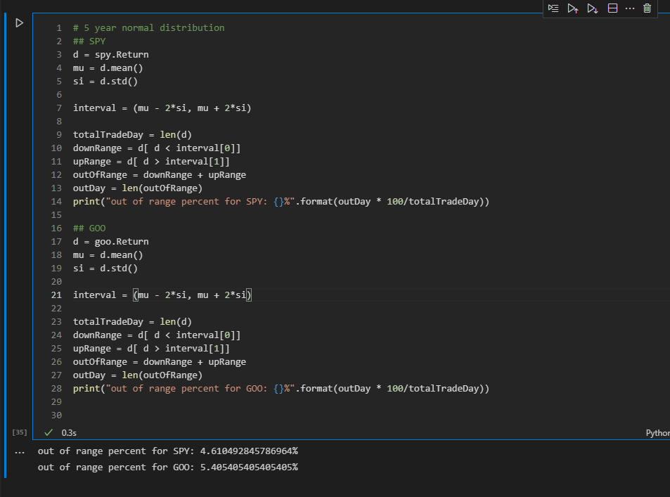

**Quesiton4**

1. 172704$ for GOOGL
2. 11985$ for SPY
3. 69 days for GOOGL, 113 days for SPY

**Question5**

1. 228$ for GOOGL, 203 for SPY
2. Buy-and-hold strategy perform worse than the way if you know the future!

|  |  |  |
| --- | --- | --- |
| Strategy | GOO | SPY |
| Buy and hold | 228 | 203 |
| Buy and hold with summer vacation | 163 | 143 |

Taking a summer vacation is not a good strategy, and we could know by the final profit.

|  |  |  |
| --- | --- | --- |
| Strategy | GOO | SPY |
| BH | 228 | 203 |
| BH Jan | 170 | 182 |
| BH Feb | 270 | 214 |
| BH Mar | 251 | 220 ( best month) |
| BH Apr | 194 | 170 |
| BH May | 190 | 196 |
| BH Jun | 260 (best month) | 184 |
| BH Jul | 155 (worst month) | 172 |
| BH Aug | 211 | 186 |
| BH Sep | 243 | 202 |
| BH Oct | 208 | 218 |
| BH Dec | 207 | 162 ( worst month) |
| BH Nov | 230 | 203 |

For the best month in both securities, we could find that the profit is growing even higher than buy-and-hold strategy. The possible reason might be that there are more ‘down’ days on these months; therefore, taking a month vacation could successfully hedge the risk.

**Question6**

|  |  |  |
| --- | --- | --- |
| Strategy | GOO$ | SPY$ |
| BH | 228 | 203 |
| P = 0.0 | 0.13 | 1.70 |
| P = 0.1 | 0.63 | 4.41 |
| P = 0.2 | 2.51 | 10.9 |
| P = 0.3 | 9.97 | 23.5 |
| P = 0.4 | 42.5 | 54.8 |
| P = 0.5 | 162 | 139 |
| P = 0.6 | 621 | 317 |
| P = 0.7 | 2619 | 952 |
| P = 0.8 | 10608 | 2349 |
| P = 0.9 | 46564 | 5519 |
| P = 1.0 | 172704 | 11985 |

For both securities, the results are comparable to BH strategy when P = 0.6.

When observing the table, the distribution range of GOO (0.13, 172704) is larger than SPY (1.70, 11985). We could tell that SPY is more stable on daily price movement and less risk to invest, especially when P = 0.

**Question7**

1.

|  |  |  |
| --- | --- | --- |
| Strategy | GOO | SPY |
| BH | 228 | 203 |
| P = 1 | 172704 | 11985 |
| Missed 10 best | 86829 | 6849 |
| Invested 10 worst | 86397 | 6333 |
| 5 best, 5 worst | 75409 | 5648 |

2. For both securities, it will lose more when investing 10 worst days.

3.

|  |  |  |
| --- | --- | --- |
| Strategy | GOO | SPY |
| 10 best | P = 0.94 | P = 0.91 |
| 10 worst | P = 0.94 | P = 0.91 |
| 5 best 5 worst | P = 0.92 | P = 0.90 |