Jisun Lee (U37416487) & Yi Lee (U64501194)

CS 699: Data Mining

Project Report

Due Date: April 6, 2022

Table of Contents
- Data Mining Goal
- Description of The Dataset
- Data Mining Tools
- Data Preprocessing
- Classification Algorithms
- Attributes Selection Algorithms
- Description of Data Mining Procedure
  - Step 1 Preprocess
  - Step 2 Train Test Split
  - Step 3 Attributes Selection
  - Step 4 Modeling
- Data Mining Result and Evaluation
- Conclusion

Data Mining Goal
Through the project, we want to predict whether NBA rookie players can survive in NBA for five years or not.

Description of The Dataset
We choose our data from data.world. Our dataset predicts NBA rookies' possibility to continue their careers for five years in the NBA. The information about the data is following:
- Data Dictionary:
  - Name: Name
  - GP: Games Played
  - MIN: Minutes Played
  - PTS: Points Per Game
  - FGM: Field Goals Made
  - FGA: Field Goal Attempts
  - FG%: Field Goals Percentage
  - 3PM: 3 Point Made
  - 3PA: 3 Point Attempts
  - 3P%: 3 Point Percentage
  - FTM: Free Throw Made
  - FTA: Free Throw Attempts
  - FT%: Free Throw Percentage
  - OREB: Offensive Rebounds
  - DREB: Defensive Rebounds
  - REB: Rebounds
  - AST: Assists
  - STL: Steals
  - BLK: Blocks
  - TOV: Turn overs
  - TARGET_5Yrs: outcome: 1 if career length >= 5 years, 0 if career length < 5 years.
This data has 21 attributes and 1340 tuples. The class attribute of this data is TARGET_5Yrs.

Data Mining Tools
R programming and Weka are tools we used in this project. First, we used R programming for data preprocessing and splitting data sets. Second, we used Weka for attribute selecting and model assessment.

Data Preprocessing
We will process 20 attributes with different criteria in our preprocessing and create six new columns for future analysis.

Existing Columns
Column Name | Before Preprocess | Action | After Process
Name | NA | Delete column | NA
GP | 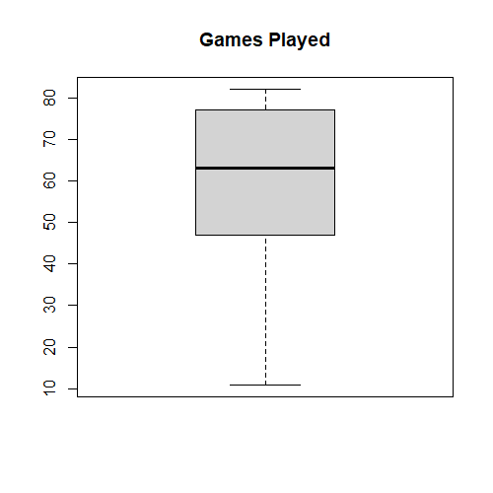 |  | 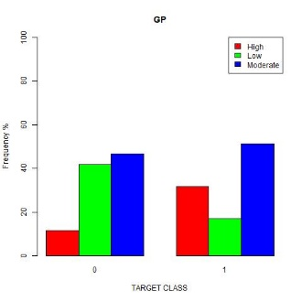
  Assign | condition
  High | > Q3
  Moderate | other
  Low | <= Q1
MIN | 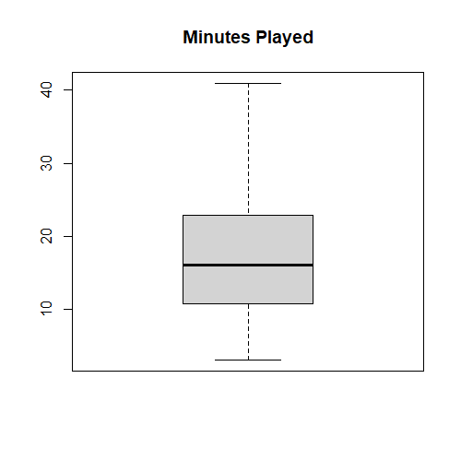 |  | 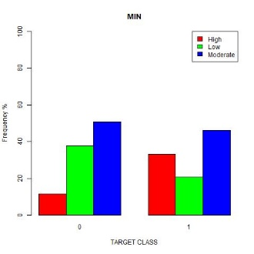
  Assign | condition
  High | > Q3
  Moderate | other
  Low | <= Q1
PTS | 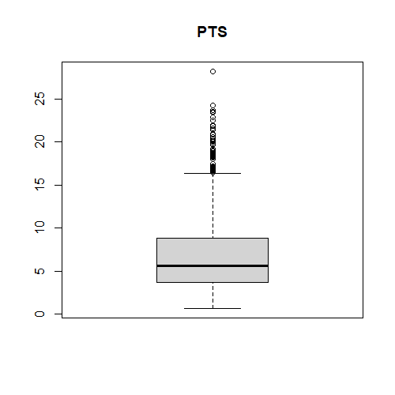 | Do nothing | 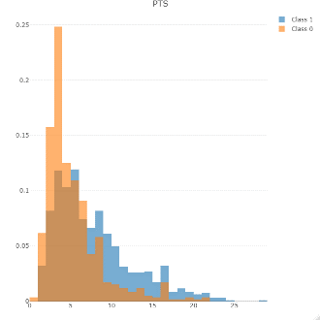
FGM | 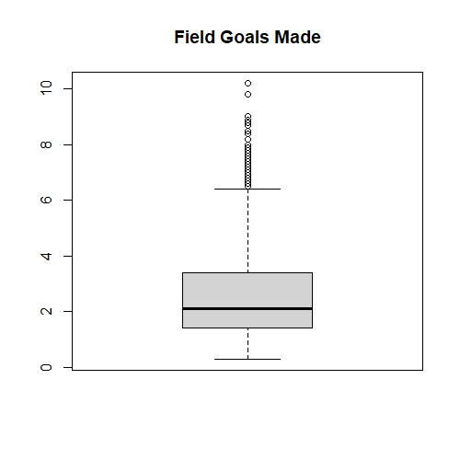 |  | 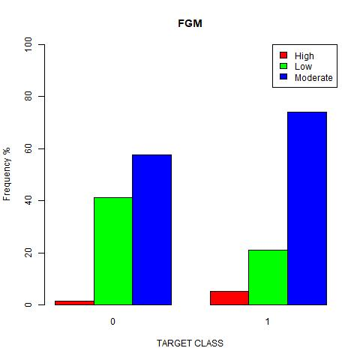
  Assign | condition
  High | > up limit
  Moderate | Other
  Low | <= Q1
FGA | 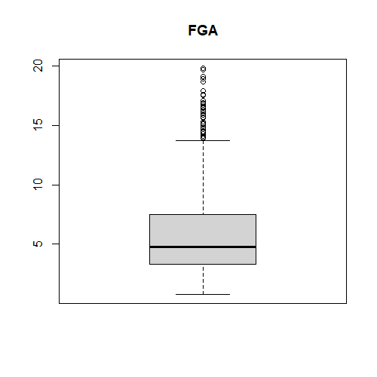 | Do nothing | 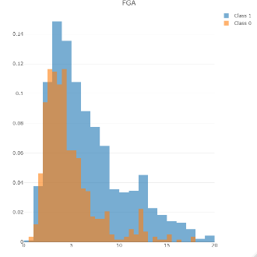
FG. | 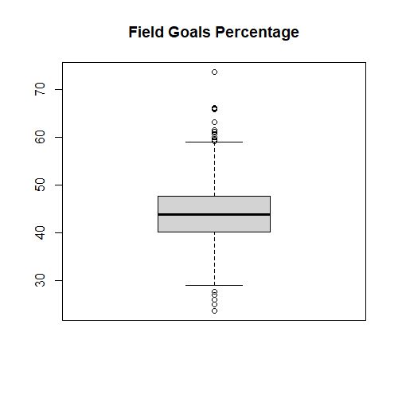 |  | 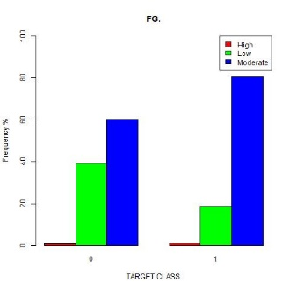
  Assign | condition
  High | > up limit
  Moderate | Other
  Low | <= Q1
X3P.Made | 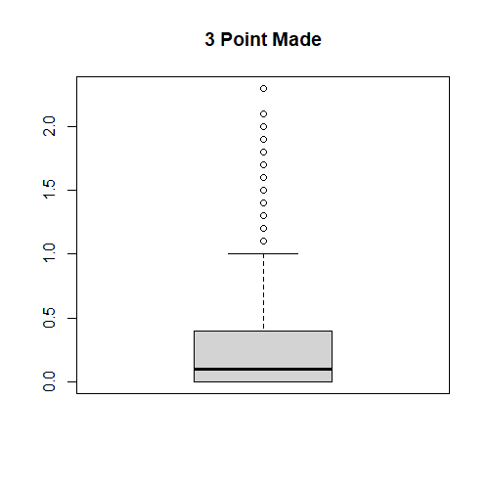 |  | 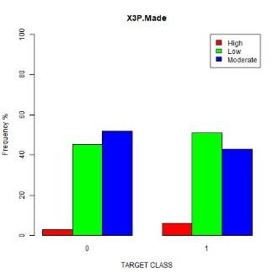
  Assign | condition
  High | > up limit
  Moderate | Other
  Low | <= Q1
X3PA | 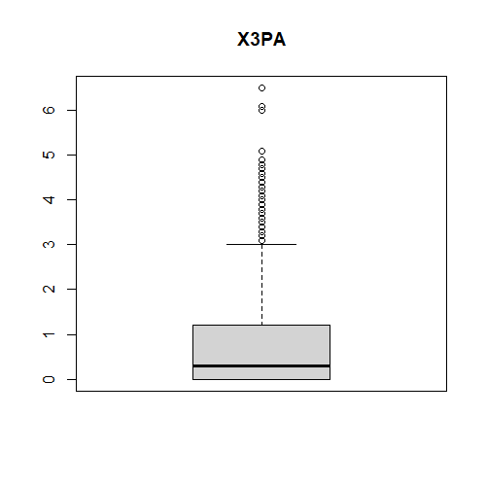 | Do nothing | 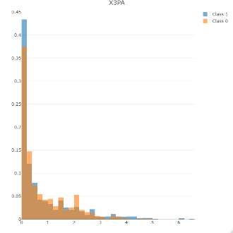
X3P. | 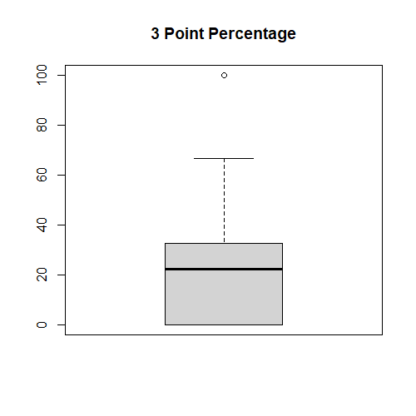 |  | 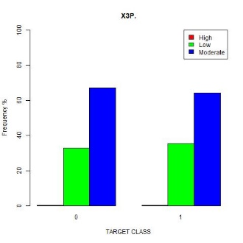
  Assign | condition
  High | > up limit
  Moderate | Other
  Low | <= Q1
FTM | 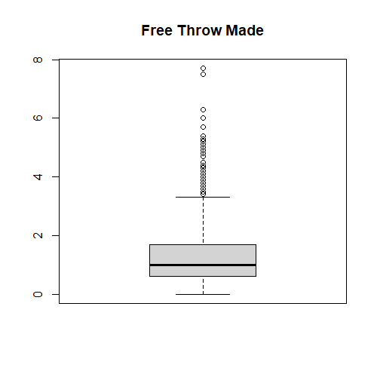 |  | 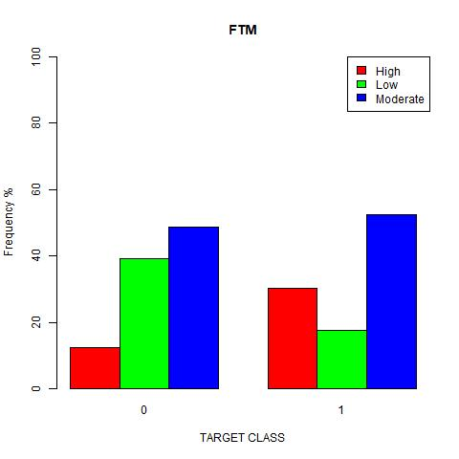
  Assign | condition
  High | > Q3
  Moderate | other
  Low | <= Q1
FTA | 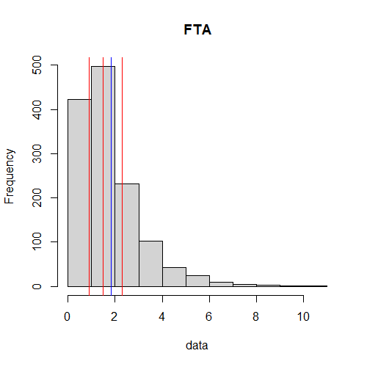 | Do nothing | 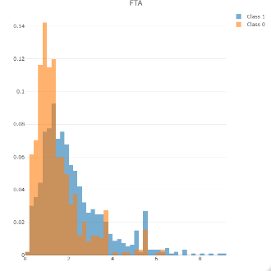
FT. | 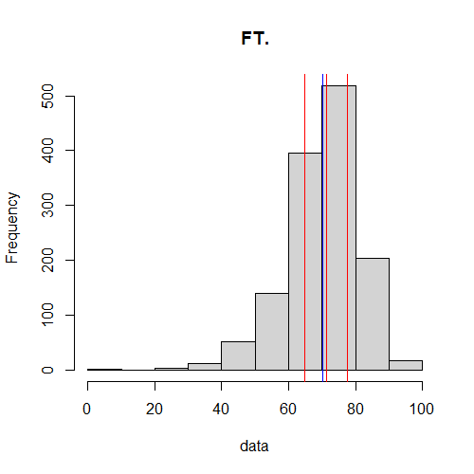 |  | 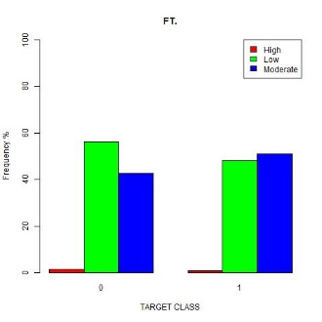
  Assign | condition
  High | > 90%
  Moderate | Other
  Low | <= median
OREB | 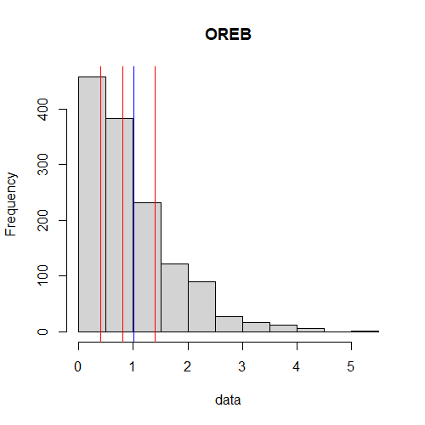 |  | 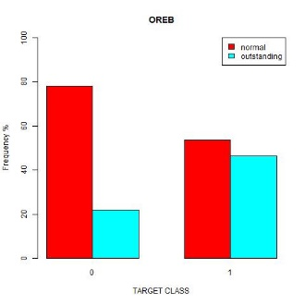
  Assign | condition
  Outstanding | > mean
  Normal | Other
DREB | 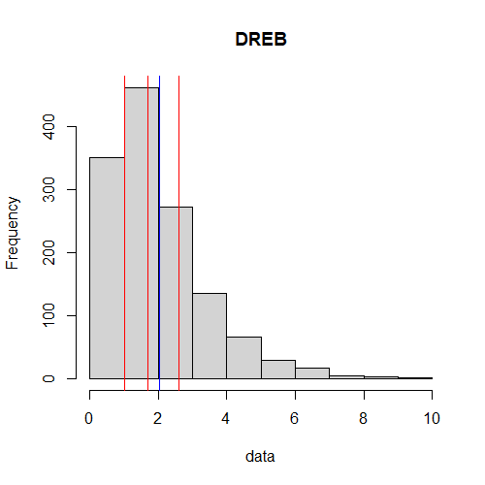 |  | 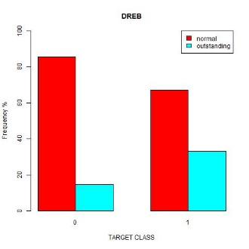
  Assign | condition
  Outstanding | > Q3
  Normal | Other
REB | 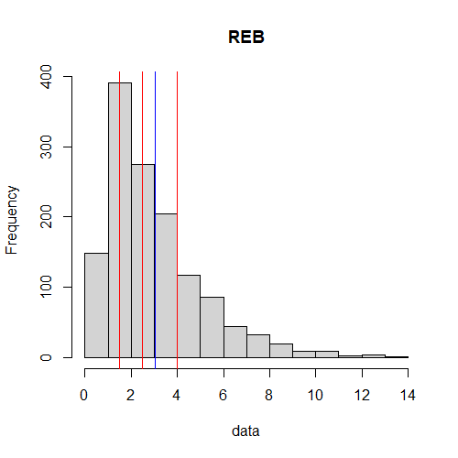 | Do nothing | 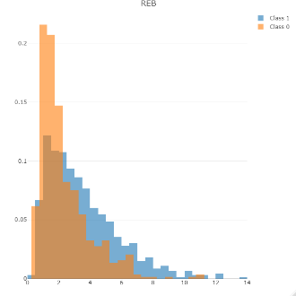
AST | 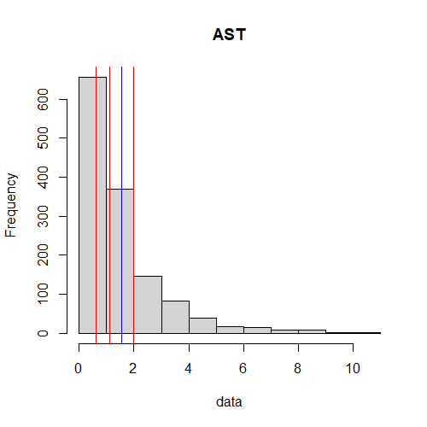 |  | 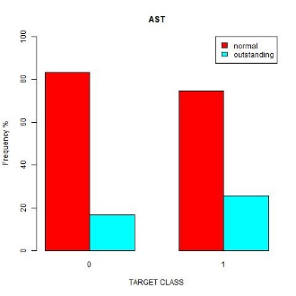
  Assign | condition
  Outstanding | > Q3
  Normal | Other
STL | 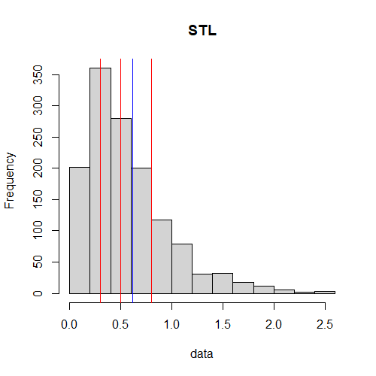 |  | 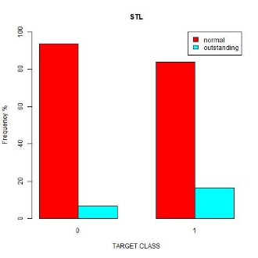
  Assign | condition
  Outstanding | > 1
  Normal | Other
BLK | 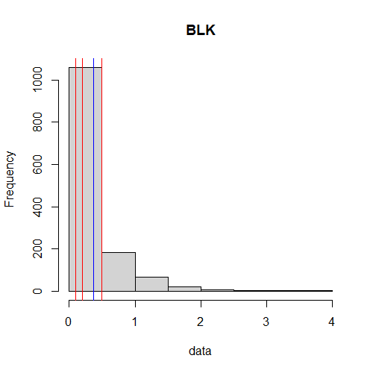 |  | 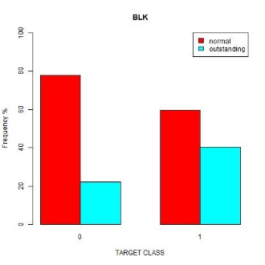
  Assign | condition
  Outstanding | > mean
  Normal | Other
TOV | 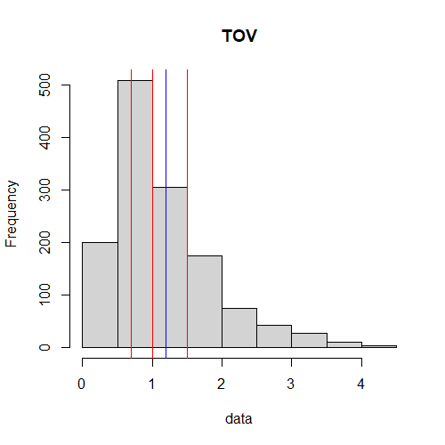 |  | 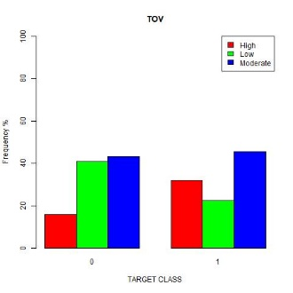
  Assign | condition
  High | > Q3
  Moderate | Other
  Low | <= Q1

New Column
Name | Elaboration | Plot
rule_180 | Sum of the percentage of two-point shot rate, three-point shot rate, and free throw rate.  It is a common metric to evaluate the NBA player. One player is usually defined as a great player if the value is over 180.  For example, if one player has FG. = 50%, X3P. = 30%, and FT. = 90%, then his rule_180 value = 170 | 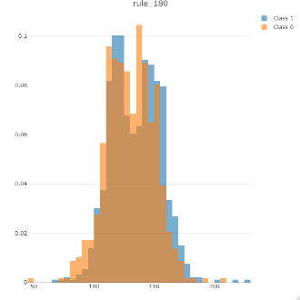
STL_TOV_ratio | Steal to Turnover ratio | 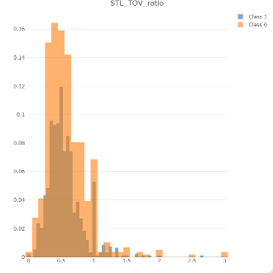
Double_time | To check how many times double does a play achieve.  For example, if one player has PTS = 10.2, REB = 8, BLK = 2, AST = 10.2, STL = 3, then his Double_time is 2 | 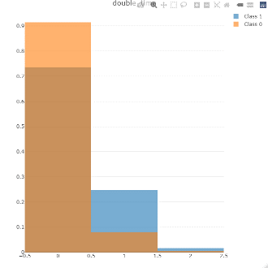
EEF | The efficiency of a player.  EEF = PTS + REB + AST + STL + BLK - Missed FG - Missed FT - TOV | 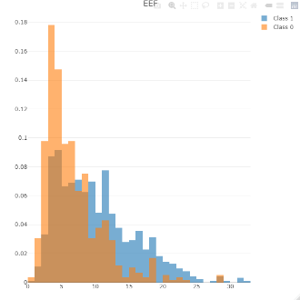
EEF_GP | Efficiency per game  EEF_GP = EEF / GP | 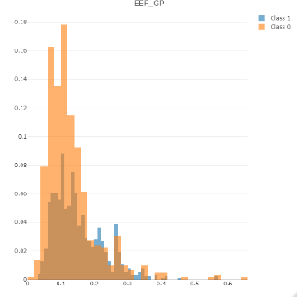
EEF_MIN | Efficiency played per minutes  EEF_MIN = EEF / MIN | 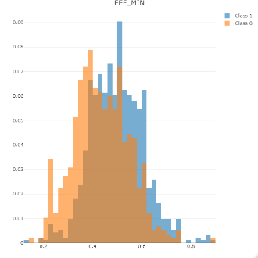

Therefore, we have 11 numerical attributes, five two-order attributes, and nine three-order attributes, which total 25 attributes.

Classification Algorithms
Naïve Bayes
Naïve Bayes is a classification that is easy to build and useful for large datasets. It is also known to surpass sophisticated classification methods. Naïve Bayes classifier assumes that the value of the feature is independent of another feature.
The pros of Naïve Bayes:
- It is easy and fast to predict the class of the dataset's test so that it can perform multiclass prediction.
- Although it has less training data, Naïve Bayes classifier performs better than other classifications.
The cons of Naïve Bayes:
- The assumption of Naïve Bayes is independent of the features; however, in our real lives, it is hard to have a complete set of independent.
- If the variable was not observed in the training set, the model would assign a zero (0). Since there is a zero (0), it makes it hard to make a prediction.

Logistic
Logistics is used to estimate the parameters of a logistic model. It is the classification used to find the probability of success and failure. In this classification, the dependent variable is binary. Logistic regression is also known as Binomial logistics regression.
The pros of Logistic:
- It is easier to implement and interpret and is very efficient for the training set.
- It makes no assumptions about distributions of classes in feature.
The cons of Logistic:
- The assumption of linearity between the dependent and independent variables is the primary restriction of Logistic Regression.
- Because logistic regression has a linear decision surface, nonlinear problems cannot be solved with logistic regression.

AdaBoost M1
AdaBoost M1 is used to boost the performance of decision trees on binary classification problems. AdaBoost M1 is used to combine weak base learners, but it can also combine strong base learners and provide a more accurate model.
The pros of AdaBoost M1:
- AdaBoost M1 is less prone to overfitting since the input parameters are not jointly tuned.
- It increases the accuracy of the weak classifiers.
The cons of AdaBoost M1:
- Before implementing an AdaBoost M1, it is necessary to prevent noisy data and outliers.

Multilayer Perceptron
It consists of at least three layers of nodes: an input layer, a hidden layer, and an output layer. Multilayer Perceptron utilizes a supervised learning technique. It can distinguish data that is not linearly separable.
The pros of Multilayer Perceptron:
- It can learn nonlinear models
The cons of Multilayer Perceptron:
- It is sensitive to feature scaling.
- It requires tuning several hyperparameters, such as hidden layers.
- The hidden layers of Multilayer Perceptron have a non-convex loss function that exists at more than one local minimum exist.

Random Forest
It is the most used supervised learning algorithm. It can quickly identify significant information from massive datasets.
The pros of Random Forest:
- It has a lower risk of overfitting.
- It has better accuracy than other classification algorithms.
- It can be used with categorical and numerical data
The cons of Random Forest:
- Since it has a slow pace, it is not suitable for predictions.
- It is time-consuming because when the Random Forest classifier makes a prediction, every tree in the forest has to predict simultaneously.

Attributes Selection Algorithms
We have three kinds of data format in the dataset: 3-order, 2-order, and numeric. The figures below are examples of the three types of data format.
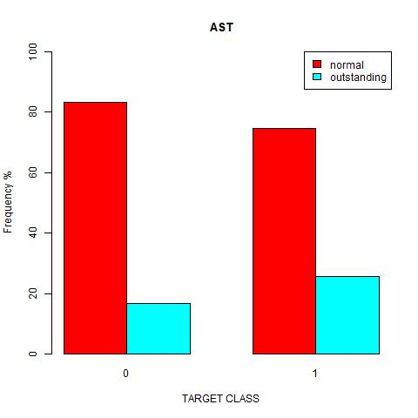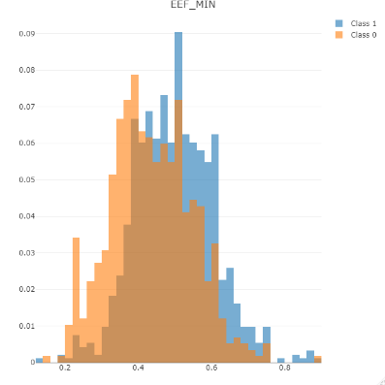

Therefore, we firstly built five groups of three kinds. Numeric Only, 3-order Only, 2-order Only, 3-order + 2-order, and All attributes. Then, we applied the InfoGainAttributeEval algorithm from Weka to pick the top 5 attributes for each group. The higher InfoGain means a high rank, in other words, a better choice of attributes.

Groups | Weka
Numeric Only | 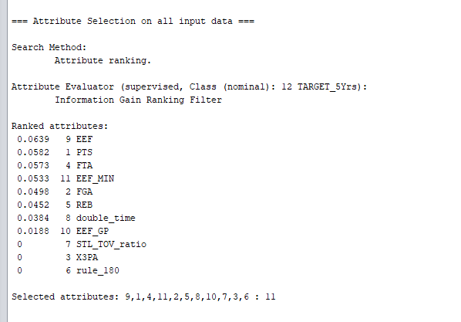
Three-order Only | 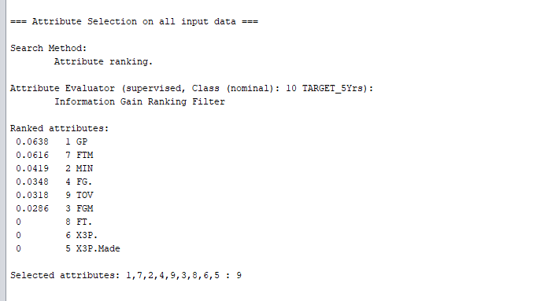
Two-order Only | We have only 5 2-order attributes, so we need to pick all 5
Three-order +  Two-order Only | 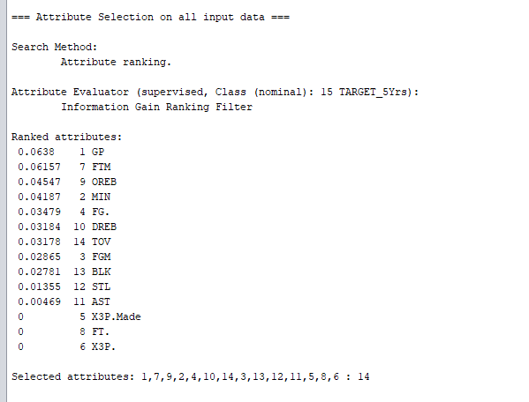
All Attributes | 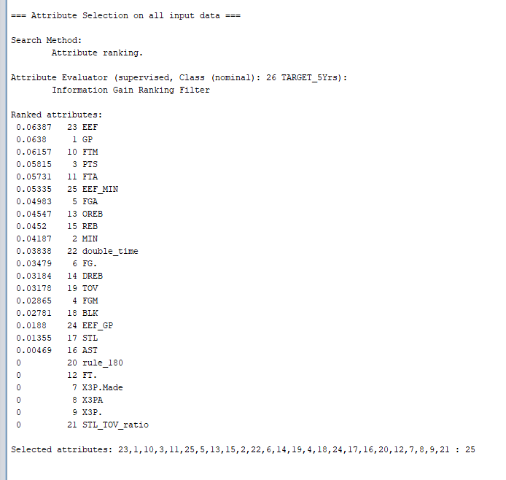

Conclusion
Group | 1 | 2 | 3 | 4 | 5
A1 | EEF | PTS | FTM | EEF_MIN | FGA
A2 | GP | FTM | MIN | FG. | TOV
A3 | AST | BLK | DREB | OREB | STL
A4 | GP | FTM | OREB | MIN | FG.
A5 | EEF | GP | FTM | PTS | FTA

Description of Data Mining Procedure
Step 1 Preprocess
Preprocess the raw data by using R programming.

Step 2 Train Test Split
Apply R programming to randomly split 66% of data into a training set and 34% of data into a testing set. The table below shows the balance between testing and training sets based on the class composition ratio view.
 | No | Yes
Testing | 192 (37.3%) | 322 (62.6%)
Training | 392 (39.2%) | 607 (60.7%)

Step 3 Attribute Selection
Selected five groups of attributes by using InfoGainAttributeEval algorithm in Weka.
Group | 1 | 2 | 3 | 4 | 5
A1 | EEF | PTS | FTM | EEF_MIN | FGA
A2 | GP | FTM | MIN | FG. | TOV
A3 | AST | BLK | DREB | OREB | STL
A4 | GP | FTM | OREB | MIN | FG.
A5 | EEF | GP | FTM | PTS | FTA

Step 4 Modeling
After selecting the attribute groups, we split the training set and testing separately into 5 data sets based on the attribute groups. The process brought more convenience when implementing the Weka for model assessment.

Training set | A1Train
Training set | A2Train
Training set | A3Train
Training set | A4Train
Training set | A5Train
Testing set | A1Test
Testing set | A2Test
Testing set | A3Test
Testing set | A4Test
Testing set | A5Test

Then, we evaluated the attribute groups with five algorithms, Naïve Bayes, Logistic, AdaBoost M1, Multilayer Perceptron, and Random Forest.

Data Mining Result and Evaluation
Naïve Bayes
A1: EEF + PTS + FTA + EEF_MIN + FGA
=== Detailed Accuracy By Class ===
 | TPR | FPR | Precision | Recall | F1 | MCC | ROC Area | PRC Area | Class
 | 0.793 | 0.472 | 0.532 | 0.793 | 0.637 | 0.322 | 0.727 | 0.612 | No
 | 0.528 | 0.207 | 0.790 | 0.528 | 0.633 | 0.322 | 0.727 | 0.793 | Yes
Weighted Avg. | 0.635 | 0.314 | 0.686 | 0.635 | 0.635 | 0.322 | 0.727 | 0.720
=== Confusion Matrix ===
 | No-predicted | Yes-predicted
No-true | 165 TN | 43 FP
Yes-true | 145 FN | 162 TP

A2: GP + FTM + MIN + FG. + TOV
=== Detailed Accuracy By Class ===
 | TPR | FPR | Precision | Recall | F1 | MCC | ROC Area | PRC Area | Class
 | 0.558 | 0.251 | 0.601 | 0.558 | 0.579 | 0.311 | 0.724 | 0.584 | No
 | 0.749 | 0.442 | 0.714 | 0.749 | 0.731 | 0.311 | 0.724 | 0.791 | Yes
Weighted Avg. | 0.672 | 0.365 | 0.669 | 0.672 | 0.670 | 0.311 | 0.724 | 0.708
=== Confusion Matrix ===
 | No-predicted | Yes-predicted
No-true | 119 TN | 92 FP
Yes-true | 77 FN | 230 TP

A3: AST + BLK + DREB + OREB + STL
=== Detailed Accuracy By Class ===
 | TPR | FPR | Precision | Recall | F1 | MCC | ROC Area | PRC Area | Class
 | 0.654 | 0.352 | 0.557 | 0.654 | 0.602 | 0.297 | 0.677 | 0.533 | No
 | 0.648 | 0.346 | 0.734 | 0.648 | 0.689 | 0.297 | 0.677 | 0.736 | Yes
Weighted Avg. | 0.650 | 0.348 | 0.663 | 0.650 | 0.654 | 0.297 | 0.677 | 0.654
=== Confusion Matrix ===
 | No-predicted | Yes-predicted
No-true | 136 TN | 72 FP
Yes-true | 108 FN | 199 TP

A4: GP + FTM + OREB + MIN + FG.
=== Detailed Accuracy By Class ===
 | TPR | FPR | Precision | Recall | F1 | MCC | ROC Area | PRC Area | Class
 | 0.606 | 0.274 | 0.600 | 0.606 | 0.603 | 0.332 | 0.739 | 0.597 | No
 | 0.726 | 0.394 | 0.731 | 0.726 | 0.729 | 0.332 | 0.739 | 0.805 | Yes
Weighted Avg. | 0.678 | 0.346 | 0.678 | 0.678 | 0.678 | 0.332 | 0.739 | 0.721
=== Confusion Matrix ===
 | No-predicted | Yes-predicted
No-true | 126 TN | 82 FP
Yes-true | 84 FN | 223 TP

A5: EEF + GP + FTM + PTS + FTA
=== Detailed Accuracy By Class ===
 | TPR | FPR | Precision | Recall | F1 | MCC | ROC Area | PRC Area | Class
 | 0.774 | 0.410 | 0.561 | 0.774 | 0.651 | 0.359 | 0.723 | 0.588 | No
 | 0.590 | 0.226 | 0.794 | 0.590 | 0.677 | 0.359 | 0.723 | 0.795 | Yes
Weighted Avg. | 0.664 | 0.300 | 0.700 | 0.664 | 0.666 | 0.359 | 0.723 | 0.711
=== Confusion Matrix ===
 | No-predicted | Yes-predicted
No-true | 161 TN | 47 FP
Yes-true | 126 FN | 181 TP

Logistic
A1: EEF + PTS + FTA + EEF_MIN + FGA
=== Detailed Accuracy By Class ===
 | TPR | FPR | Precision | Recall | F1 | MCC | ROC Area | PRC Area | Class
 | 0.413 | 0.153 | 0.647 | 0.413 | 0.504 | 0.292 | 0.722 | 0.610 | No
 | 0.847 | 0.587 | 0.681 | 0.847 | 0.755 | 0.292 | 0.722 | 0.787 | Yes
Weighted Avg. | 0.672 | 0.411 | 0.667 | 0.672 | 0.654 | 0.292 | 0.722 | 0.716
=== Confusion Matrix ===
 | No-predicted | Yes-predicted
No-true | 86 TN | 122 FP
Yes-true | 47 FN | 260 TP

A2: GP + FTM + MIN + FG. + TOV
=== Detailed Accuracy By Class ===
 | TPR | FPR | Precision | Recall | F1 | MCC | ROC Area | PRC Area | Class
 | 0.438 | 0.163 | 0.645 | 0.438 | 0.521 | 0.302 | 0.726 | 0.591 | No
 | 0.837 | 0.563 | 0.687 | 0.837 | 0.755 | 0.302 | 0.726 | 0.791 | Yes
Weighted Avg. | 0.676 | 0.401 | 0.670 | 0.676 | 0.661 | 0.302 | 0.726 | 0.710
=== Confusion Matrix ===
 | No-predicted | Yes-predicted
No-true | 91 TN | 117 FP
Yes-true | 50 FN | 257 TP

A3: AST + BLK + DREB + OREB + STL
=== Detailed Accuracy By Class ===
 | TPR | FPR | Precision | Recall | F1 | MCC | ROC Area | PRC Area | Class
 | 0.534 | 0.283 | 0.561 | 0.534 | 0.547 | 0.252 | 0.677 | 0.532 | No
 | 0.717 | 0.466 | 0.694 | 0.717 | 0.705 | 0.252 | 0.677 | 0.741 | Yes
Weighted Avg. | 0.643 | 0.392 | 0.640 | 0.643 | 0.641 | 0.252 | 0.677 | 0.657
=== Confusion Matrix ===
 | No-predicted | Yes-predicted
No-true | 111 TN | 97 FP
Yes-true | 87 FN | 220 TP

A4: GP + FTM + OREB + MIN + FG.
=== Detailed Accuracy By Class ===
 | TPR | FPR | Precision | Recall | F1 | MCC | ROC Area | PRC Area | Class
 | 0.462 | 0.176 | 0.640 | 0.462 | 0.536 | 0.308 | 0.736 | 0.600 | No
 | 0.824 | 0.538 | 0.693 | 0.824 | 0.753 | 0.308 | 0.736 | 0.802 | Yes
Weighted Avg. | 0.678 | 0.392 | 0.672 | 0.678 | 0.665 | 0.308 | 0.736 | 0.721
=== Confusion Matrix ===
 | No-predicted | Yes-predicted
No-true | 96 TN | 112 FP
Yes-true | 54 FN | 253 TP

A5: EEF + GP + FTM + PTS + FTA
=== Detailed Accuracy By Class ===
 | TPR | FPR | Precision | Recall | F1 | MCC | ROC Area | PRC Area | Class
 | 0.438 | 0.189 | 0.611 | 0.438 | 0.510 | 0.269 | 0.724 | 0.593 | No
 | 0.811 | 0.563 | 0.680 | 0.811 | 0.740 | 0.269 | 0.724 | 0.794 | Yes
Weighted Avg. | 0.660 | 0.412 | 0.652 | 0.660 | 0.647 | 0.269 | 0.724 | 0.713
=== Confusion Matrix ===
 | No-predicted | Yes-predicted
No-true | 91 TN | 117 FP
Yes-true | 58 FN | 249 TP

AdaBoost M1
A1: EEF + PTS + FTA + EEF_MIN + FGA
=== Detailed Accuracy By Class ===
 | TPR | FPR | Precision | Recall | F1 | MCC | ROC Area | PRC Area | Class
 | 0.365 | 0.104 | 0.704 | 0.365 | 0.481 | 0.315 | 0.687 | 0.578 | No
 | 0.896 | 0.635 | 0.676 | 0.896 | 0.770 | 0.315 | 0.687 | 0.720 | Yes
Weighted Avg. | 0.682 | 0.420 | 0.687 | 0.682 | 0.653 | 0.315 | 0.687 | 0.663
=== Confusion Matrix ===
 | No-predicted | Yes-predicted
No-true | 76 TN | 132 FP
Yes-true | 32 FN | 275 TP

A2: GP + FTM + MIN + FG. + TOV
=== Detailed Accuracy By Class ===
 | TPR | FPR | Precision | Recall | F1 | MCC | ROC Area | PRC Area | Class
 | 0 | 0 | ? | 0 | ? | ? | 0.5 | 0.404 | No
 | 1 | 1 | 0.596 | 1 | 0.747 | ? | 0.5 | 0.596 | Yes
Weighted Avg. | 0.596 | 0.0596 | ? | 0.596 | ? | ? | 0.500 | 0.518
=== Confusion Matrix ===
 | No-predicted | Yes-predicted
No-true | 0 TN | 208 FP
Yes-true | 0 FN | 307 TP

A3: AST + BLK + DREB + OREB + STL
=== Detailed Accuracy By Class ===
 | TPR | FPR | Precision | Recall | F1 | MCC | ROC Area | PRC Area | Class
 | 0.538 | 0.296 | 0.552 | 0.538 | 0.545 | 0.243 | 0.678 | 0.528 | No
 | 0.704 | 0.462 | 0.692 | 0.74 | 0.698 | 0.243 | 0.678 | 0.741 | Yes
Weighted Avg. | 0.637 | 0.395 | 0.636 | 0.637 | 0.636 | 0.243 | 0.678 | 0.655
=== Confusion Matrix ===
 | No-predicted | Yes-predicted
No-true | 112 TN | 96 FP
Yes-true | 91 FN | 216 TP

A4: GP + FTM + OREB + MIN + FG.
=== Detailed Accuracy By Class ===
 | TPR | FPR | Precision | Recall | F1 | MCC | ROC Area | PRC Area | Class
 | 0.452 | 0.173 | 0.639 | 0.452 | 0.530 | 0.303 | 0.738 | 0.607 | No
 | 0.827 | 0.548 | 0.690 | 0.827 | 0.753 | 0.303 | 0.738 | 0.797 | Yes
Weighted Avg. | 0.676 | 0.396 | 0.670 | 0.676 | 0.663 | 0.303 | 0.738 | 0.720

=== Confusion Matrix ===
 | No-predicted | Yes-predicted
No-true | 94 TN | 114 FP
Yes-true | 53 FN | 254 TP
A5: EEF + GP + FTM + PTS + FTA
=== Detailed Accuracy By Class ===
 | TPR | FPR | Precision | Recall | F1 | MCC | ROC Area | PRC Area | Class
 | 0.385 | 0.153 | 0.630 | 0.385 | 0.478 | 0.264 | 0.682 | 0.537 | No
 | 0.847 | 0.615 | 0.670 | 0.847 | 0.748 | 0.264 | 0.682 | 0.721 | Yes
Weighted Avg. | 0.660 | 0.429 | 0.654 | 0.660 | 0.639 | 0.264 | 0.682 | 0.647

=== Confusion Matrix ===
 | No-predicted | Yes-predicted
No-true | 80 TN | 128 FP
Yes-true | 47 FN | 260 TP

Multilayer Perceptron
A1: EEF + PTS + FTA + EEF_MIN + FGA
=== Detailed Accuracy By Class ===
 | TPR | FPR | Precision | Recall | F1 | MCC | ROC Area | PRC Area | Class
 | 0.442 | 0.166 | 0.643 | 0.442 | 0.524 | 0.303 | 0.725 | 0.606 | No
 | 0.834 | 0.558 | 0.688 | .834 | 0.754 | 0.303 | 0.725 | 0.790 | Yes
Weighted Avg. | 0.676 | 0.400 | 0.670 | 0.676 | 0.661 | 0.303 | 0.725 | 0.716
=== Confusion Matrix ===
 | No-predicted | Yes-predicted
No-true | 92 TN | 116 FP
Yes-true | 51 FN | 256 TP

A2: GP + FTM + MIN + FG. + TOV
=== Detailed Accuracy By Class ===
 | TPR | FPR | Precision | Recall | F1 | MCC | ROC Area | PRC Area | Class
 | 0.500 | 0.202 | 0.627 | 0.500 | 0.556 | 0.313 | 0.712 | 0.587 | No
 | 0.798 | 0.500 | 0.702 | 0.798 | 0.747 | 0.313 | 0.712 | 0.767 | Yes
Weighted Avg. | 0.678 | 0.380 | 0.672 | 0.678 | 0.670 | 0.313 | 0.712 | 0.694
=== Confusion Matrix ===
 | No-predicted | Yes-predicted
No-true | 104 TN | 104 FP
Yes-true | 62 FN | 245 TP

A3: AST + BLK + DREB + OREB + STL
=== Detailed Accuracy By Class ===
 | TPR | FPR | Precision | Recall | F1 | MCC | ROC Area | PRC Area | Class
 | 0.534 | 0.278 | 0.559 | 0.534 | 0.545 | 0.249 | 0.678 | 0.533 | No
 | 0.713 | 0.466 | 0.693 | 0.713 | 0.703 | 0.249 | 0.678 | 0.736 | Yes
Weighted Avg. | 0.641 | 0.394 | 0.638 | 0.641 | 0.639 | 0.249 | 0.678 | 0.654
=== Confusion Matrix ===
 | No-predicted | Yes-predicted
No-true | 111 TN | 97 FP
Yes-true | 88 FN | 219 TP

A4: GP + FTM + OREB + MIN + FG.
=== Detailed Accuracy By Class ===
 | TPR | FPR | Precision | Recall | F1 | MCC | ROC Area | PRC Area | Class
 | 0.495 | 0.212 | 0.613 | 0.495 | 0.548 | 0.297 | 0.732 | 0.642 | No
 | 0.788 | 0.505 | 0.697 | 0.788 | 0.740 | 0.297 | 0.732 | 0.794 | Yes
Weighted Avg. | 0.670 | 0.386 | 0.663 | 0.670 | 0.662 | 0.297 | 0.732 | 0.733
=== Confusion Matrix ===
 | No-predicted | Yes-predicted
No-true | 103 TN | 105 FP
Yes-true | 65 FN | 242 TP

A5: EEF + GP + FTM + PTS + FTA
=== Detailed Accuracy By Class ===
 | TPR | FPR | Precision | Recall | F1 | MCC | ROC Area | PRC Area | Class
 | 0 | 0 | ? | 0 | ? | ? | 0.639 | 0.524 | No
 | 1 | 1 | 0.596 | 1 | 0.747 | ? | 0.639 | 0.701 | Yes
Weighted Avg. | 0.596 | 0.596 | ? | 0.596 | ? | ? | 0.639 | 0.629
=== Confusion Matrix ===
 | No-predicted | Yes-predicted
No-true | 0 TN | 208 FP
Yes-true | 0 FN | 307 TP

Random Forest
A1: EEF + PTS + FTA + EEF_MIN + FGA
=== Detailed Accuracy By Class ===
 | TPR | FPR | Precision | Recall | F1 | MCC | ROC Area | PRC Area | Class
 | 0.466 | 0.257 | 0.551 | 0.466 | 0.505 | 0.216 | 0.650 | 0.538 | No
 | 0.743 | 0.534 | 0.673 | 0.743 | 0.706 | 0.216 | 0.650 | 0.736 | Yes
Weighted Avg. | 0.631 | 0.422 | 0.624 | 0.631 | 0.625 | 0.216 | 0.650 | 0.656
=== Confusion Matrix ===
 | No-predicted | Yes-predicted
No-true | 97 TN | 111 FP
Yes-true | 79 FN | 228 TP

A2: GP + FTM + MIN + FG. + TOV
=== Detailed Accuracy By Class ===
 | TPR | FPR | Precision | Recall | F1 | MCC | ROC Area | PRC Area | Class
 | 0.481 | 0.228 | 0.588 | 0.481 | 0.529 | 0.264 | 0.698 | 0.589 | No
 | 0.772 | 0.519 | 0.687 | 0.772 | 0.727 | 0.264 | 0.698 | 0.758 | Yes
Weighted Avg. | 0.654 | 0.402 | 0.647 | 0.654 | 0.647 | 0.264 | 0.698 | 0.689
=== Confusion Matrix ===
 | No-predicted | Yes-predicted
No-true | 100 TN | 108 FP
Yes-true | 70 FN | 237 TP

A3: AST + BLK + DREB + OREB + STL
=== Detailed Accuracy By Class ===
 | TPR | FPR | Precision | Recall | F1 | MCC | ROC Area | PRC Area | Class
 | 0.543 | 0.287 | 0.562 | 0.543 | 0.553 | 0.258 | 0.678 | 0.535 | No
 | 0.713 | 0.457 | 0.697 | 0.713 | 0.705 | 0.258 | 0.678 | 0.736 | Yes
Weighted Avg. | 0.645 | 0.388 | 0.643 | 0.645 | 0.644 | 0.258 | 0.678 | 0.655
=== Confusion Matrix ===
 | No-predicted | Yes-predicted
No-true | 113 TN | 95 FP
Yes-true | 88 FN | 219 TP

A4: GP + FTM + OREB + MIN + FG.
=== Detailed Accuracy By Class ===
 | TPR | FPR | Precision | Recall | F1 | MCC | ROC Area | PRC Area | Class
 | 0.428 | 0.169 | 0.631 | 0.428 | 0.510 | 0.284 | 0.642 | 0.538 | No
 | 0.831 | 0.572 | 0.682 | 0.831 | 0.749 | 0.284 | 0.642 | 0.682 | Yes
Weighted Avg. | 0.668 | 0.409 | 0.661 | 0.668 | 0.652 | 0.284 | 0.642 | 0.624
=== Confusion Matrix ===
 | No-predicted | Yes-predicted
No-true | 89 TN | 119 FP
Yes-true | 52 FN | 255 TP

A5: EEF + GP + FTM + PTS + FTA
=== Detailed Accuracy By Class ===
 | TPR | FPR | Precision | Recall | F1 | MCC | ROC Area | PRC Area | Class
 | 0.471 | 0.267 | 0.544 | 0.471 | 0.505 | 0.210 | 0.667 | 0.531 | No
 | 0.733 | 0.529 | 0.672 | 0.733 | 0.701 | 0.210 | 0.667 | 0.749 | Yes
Weighted Avg. | 0.627 | 0.423 | 0.620 | 0.627 | 0.622 | 0.210 | 0.667 | 0.661
=== Confusion Matrix ===
 | No-predicted | Yes-predicted
No-true | 92 TN | 110 FP
Yes-true | 82 FN | 225 TP

Best Selection

Naïve Bayes with A5 is the best selection because the precision of the weighted average is the highest among the selections.

Conclusion
In this project, we have chosen the data about predicting whether NBA rookie players can survive in NBA for five years or not. The class attribute of this data is TARGET_5Yrs with 21 attributes and 1340 tuples. We decided to use R programming and Weka for the project to analyze the data. For processing data, we used R programming and then used Weka to select attributes and model assessment. While processing, we created six new columns that are rule_180, STL_TOV_ratio, Double_time, EEF, EEF_GP, and EEF_MIN. After the data processing, we had 11 numerical attributes, 5 two order attributes, and 9 three order attributes, so the total of attributes is 25. We chose five classifications: Naive Bayes, Logistic, AdaBoost M1, Multilayer Perceptron, and Random Forest. Using those five classifications, Naïve Bayes with A5 was the best selection because the precision of the weighted average was the highest compared with other selections.
We opted for precision as our decision criteria. The precision was a good metric to observe how many tuples labeled positively were actually positive.
$$Precision=\frac{TP}{TP+FP}$$
Based on precision, we inferred the classification capability of a model. For example, a basketball team manager would like to know the possibility that a rookie player will be a good player in the future career based on the data of the first career year. The following table is the model assessment of the best model.
A5: EEF + GP + FTM + PTS + FTA
=== Detailed Accuracy By Class ===
 | TPR | FPR | Precision | Recall | F1 | MCC | ROC Area | PRC Area | Class
 | 0.774 | 0.410 | 0.561 | 0.774 | 0.651 | 0.359 | 0.723 | 0.588 | No
 | 0.590 | 0.226 | 0.794 | 0.590 | 0.677 | 0.359 | 0.723 | 0.795 | Yes
Weighted Avg. | 0.664 | 0.300 | 0.700 | 0.664 | 0.666 | 0.359 | 0.723 | 0.711
=== Confusion Matrix ===
 | No-predicted | Yes-predicted
No-true | 161 TN | 47 FP
Yes-true | 126 FN | 181 TP

We have learned key mindsets that enhance our future careers throughout the project. First, designing the data mining works flow. We could manage other datasets with substantial knowledge of building workflow, including numeric prediction and categorical problems. Second, implementing the data preprocessing skill with different tools, including R programming and data mining tools, Weka and JMP pro. It is essential to learn how to use a different tool in this stage because the primary responsibility of a data scientist should be building the data science flow and implementing a different mindset when dealing with a new dataset. Lastly, learning different metrics for assessing the models is one of the most valuable subjects during the project experience. The main reason is that we will encounter the model experiences in the future, and we will need to use different metrics to assess the quality of the models in different situations, such as dataset differences and different target classes. Finally, practical implementation is always the fastest way to learn new technology and improve our data mining and data science skills.
Contribution

 | Yi Lee (U64501194) | Jisun Lee (U37416487)
Document | -Data Mining Tools Being Used  -Data Preprocessing  -Attributes Selection Algorithms  -Description of Data Mining Procedure  -Data Mining Result and Evaluation | - Proposal  - Data Mining Goal  - Description of the Dataset  - Classification Algorithms  - Data Evaluation and justification for selection of the best model  - Conclusion
Non-Document | R Programming:  -Second part of Preprocess  -Analysis chart  -Train test split  -Split by attribute  Weka:  -Attribute selection  -Modeling assessment | - First part of Preprocess with R programming  - Analyzing data

