Kyle Markel, R11739937

CHE 3326: Heat Transfer

Fall 2023 Final Project

**PART A:**

Output for part a:

Fluid temperature = 1100 F | Pipe OD = 20 in | Insulation thickness 2 in | Jacket emissivity = 0.09 | Outer temperature = 285.85 F

Fluid temperature = 1100 F | Pipe OD = 20 in | Insulation thickness 2 in | Jacket emissivity = 0.9 | Outer temperature = 192.18 F

**PART B:**

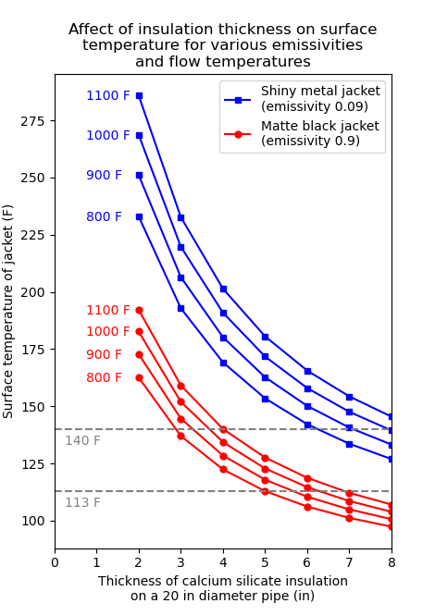

**PART C:**

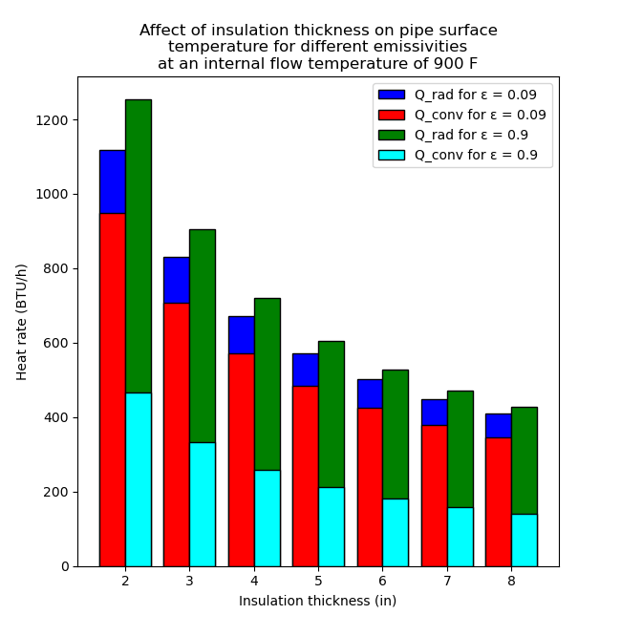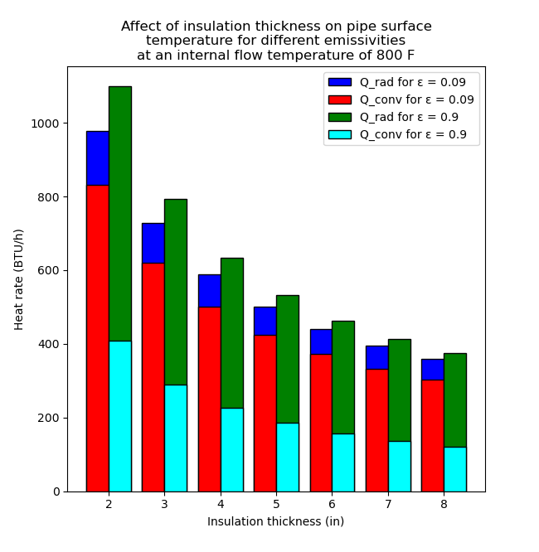

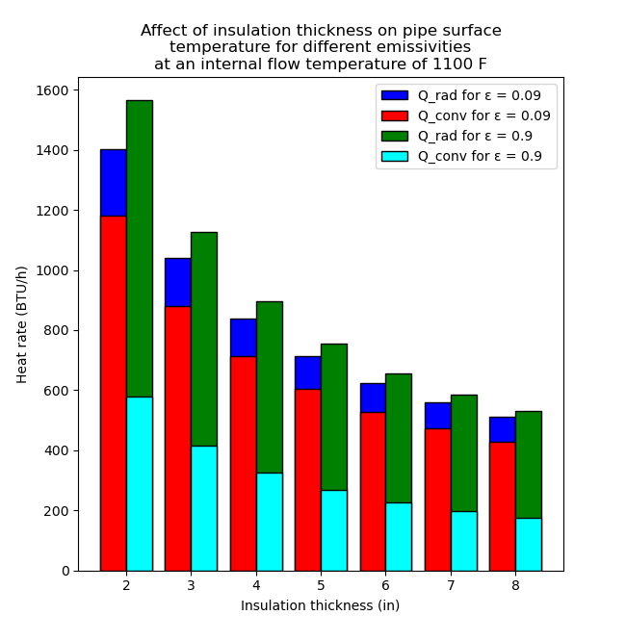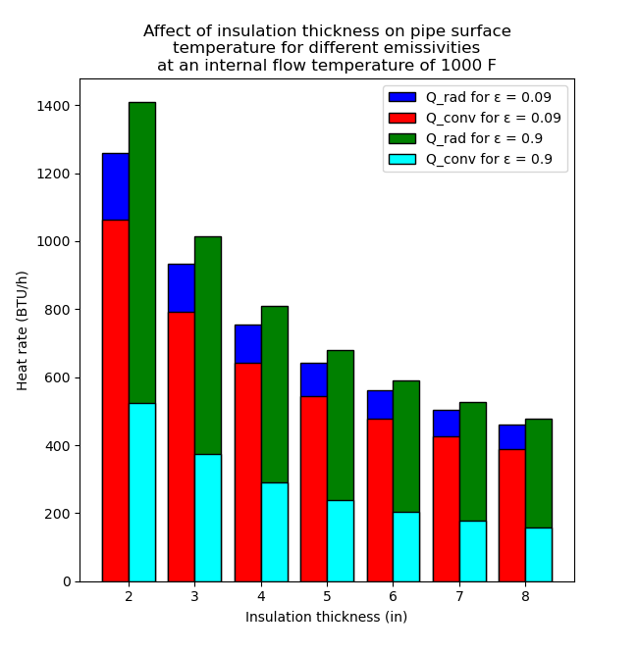

**PART D:**

As the thickness of insulation increases, what happens to the surface temperature?

*The surface temperature decreases as the thickness of insulation increases.*

As the jacket emissivity increases from 0.09 to 0.9, what is the effect on surface temperature and total rate of heat loss? How does this effect tie into selection of appropriate jacket types for safety and proper balance of economics of running a plant?

*As jacket emissivity increases, this causes increased heat flux due to radiation, causing increased heat flow to the surroundings and thus a lower surface temperature.*

*[SAFETY, ECONOMICS, ETC]*

As the jacket emissivity increases from 0.09 to 0.9, what change does it produce on the relative contribution of heat loss by radiation and convection towards the total heat loss? Make an argument to explain this observation.

*As jacket emissivity increases, the share of heat loss by radiation is increased, and the share of heat loss by convection is decreased, and the overall heat loss is slightly increased as well. [MAKE AN ARGUMENT]*