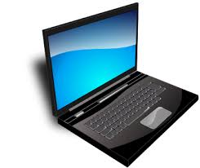
Kyle

Miller

Dedicated to help in the effort of cybersecurity
and collaborate with others.

GitHub
LinkedIn

Experience Skills

- IT Help Desk
August 2025 - Present

Communicative
Organized
Detail-Focused
Task-Driven

Education Certifications

Current student at SWTC for
Cybersecurity Specialist

August 2025 - Present
- CCST Cybersecurity
- FOA CFOT
- FOA CPCT

Personal Values

In the workplace I value my contribution, growth, and the environment I’m in at the company. I want my contribution to be helpful and meaningful to my own personal success and the company. Growth will show that I’ve proven my skills. Environment is important because I like to collaborate with coworkers and achieve something together while also learning from them alongside.

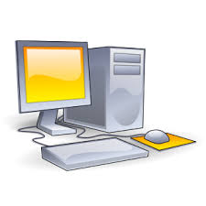
Technical Skills

- Windows 10/11
- Windows Server 2016 (Lab environment)
- PC Hardware
- Azure
- Active Directory
- SharePoint

Example

An example of a technical skill I’ve done was in Windows Server 2016. I successfully installed and tested out WDS (Windows Deployment Service) using PXE booting.

- I have a detailed step-by-step of WDS setup I created in my own OneNote documentation amongst many other services like DFS, GPO’s, Windows Server Backup, and WSUS.

Upcoming Certifications

I’m currently studying Linux Administration and a Cisco Networking and Security class to later take the CCST Networking and LPI Linux Essentials certifications. These are expected by May 2026.

Screenshots

Below are a couple example screenshots from labs that I completed during my Windows Administration class. During that class, I started creating my own personal OneNote documentation.

I installed Chrome ADMX files in Group Policy to set administrative settings for the browser
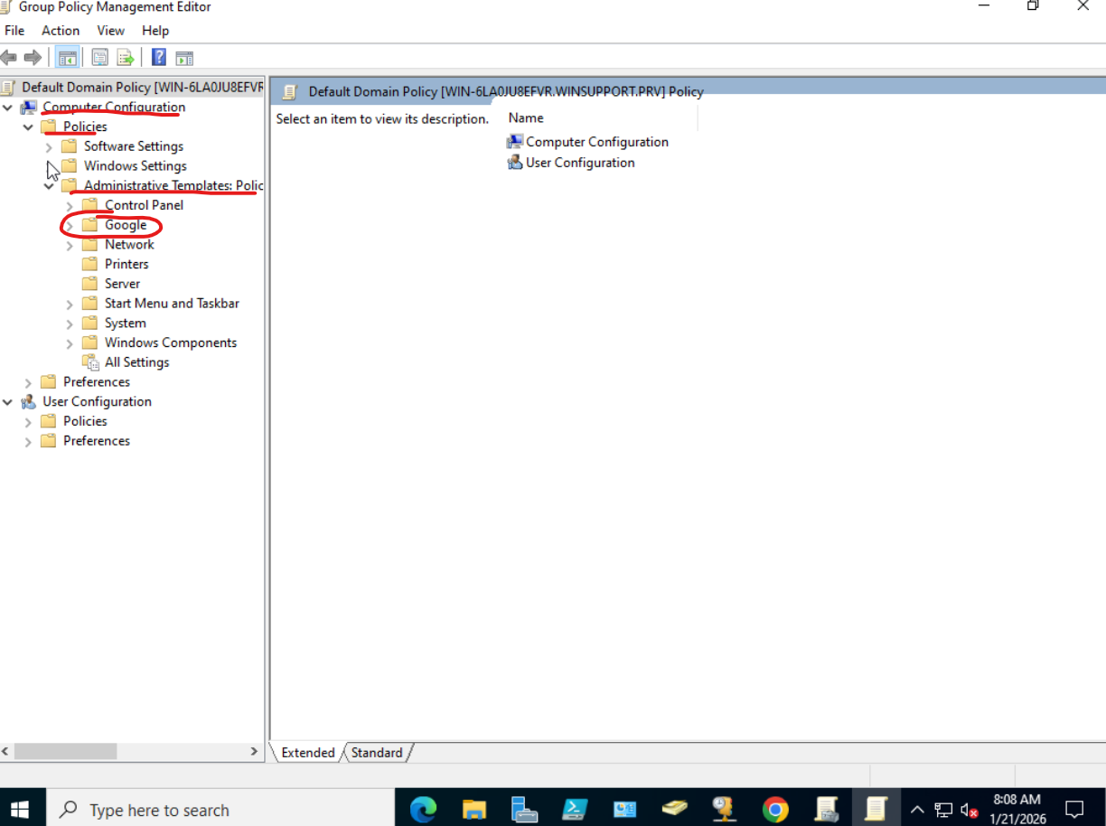

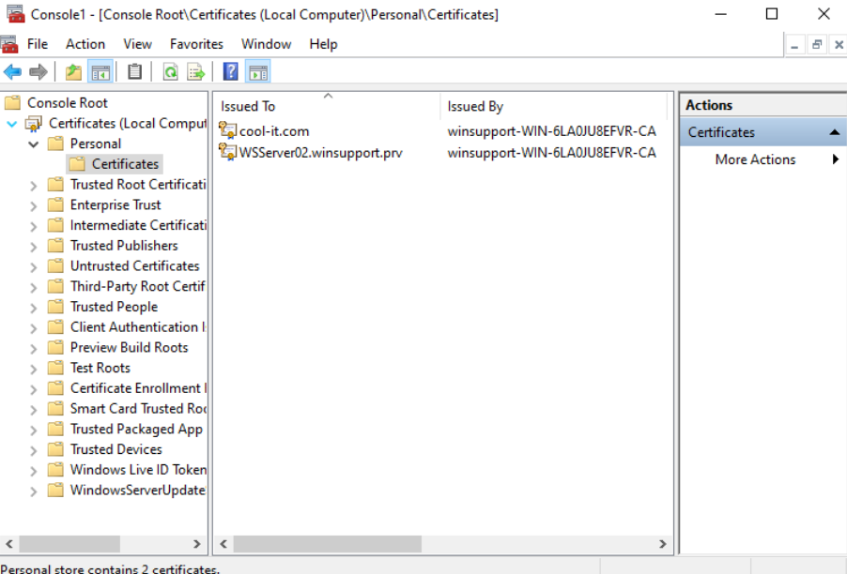
I created certificates for a webserver

