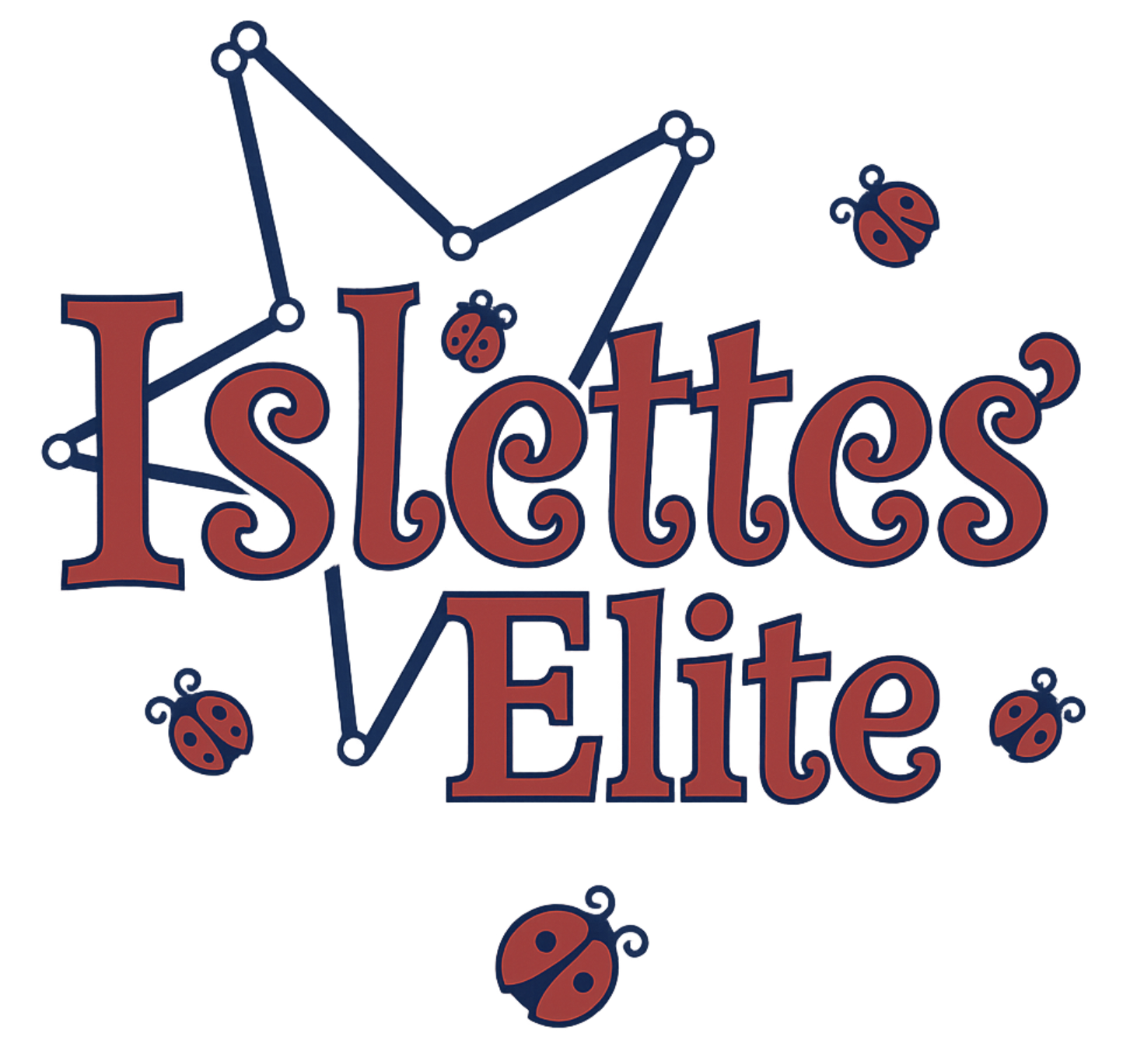

Islettes’ Elite Dance Twirl Team

2025–2026 Team Handbook

TEAM STRUCTURE
Islettes' Elite offers 4 units based on age and ability:
• Starlettes: Pre-K and Kindergarten
• Shooting Stars: 1st Grade
• Rising Stars: 2nd to 5th Grade
• Starfire: 6th Grade through College
All units of the team will participate in local NBTA and TU competitions, as well as local parades and performances.

PRACTICE GUIDELINES & EXPECTATIONS
- Athletes often concentrate better if parents are not present. Parents may drop off their child and return at the end of the session. Please avoid interrupting class with questions or coaching suggestions.
- In addition to scheduled practices, athletes are expected to practice independently at home. During team practices, twirlers should have material memorized from the previous week.
- Individual twirlers must dedicate additional practice time based on their personal goals. Remember: your results reflect the time and commitment you devote to baton twirling.

DRESS CODE
Team members and staff must always follow the dress code. Twirlers who arrive with improper attire or hair may be asked to sit out and observe.
Required Attire:
Starlettes, Shooting Stars & Rising Stars
- Sneakers (No high tops)
- Black leggings
- ’25–’26 Team T-Shirt (Grey)
- Hair up in a ponytail (absolutely mandatory at every practice)

Starfire
- Tan jazz shoes
- Black leggings
- ’25–’26 Team T-Shirt (Grey)
- Hair up in a ponytail (absolutely mandatory at every practice)
If twirlers are cold, they may wear the ’25–’26 Team Sweatshirt or a solid grey sweatshirt.
All twirlers should bring bottled water to every practice.

PRACTICE ATTENDANCE
- The first step to becoming a successful twirler is making a commitment to attend all classes, performances, and competitions.
- Come prepared to learn—free from distractions. Each class is an opportunity to grow and improve at what you love.
- Report absences via text to Heidi Sue (716-868-6320) prior to the start of class.
- Twirlers who miss class should check with teammates or staff to review missed material and choreography. Only brief reviews will be given during subsequent classes.
- Habitual absences may result in removal from certain sections of choreography or routines.
- Twirlers who are ill but not contagious, or are injured, should still attend practice to observe.

COSTUMES
All group costumes will be selected by Miss Heidi Sue and Miss Molly.
Twirlers must wear all parts of the costume as specified, including tights, shoes, makeup, and hair accessories.
We strive to keep costs as low as possible and do not profit from any costume or clothing purchases.

COMPETITIONS, PERFORMANCES & PARADES
Attendance at all competitions, performances, and parades is expected. A calendar will be distributed monthly, including any newly confirmed dates. Missing a competition places stress on the team and may limit routine adaptability.
If a twirler misses more than 25% of events, they may be removed from the team.
If transportation is an issue, other parents are often happy to assist. Please notify Heidi Sue (via text at 716-868-6320) as soon as you know of a potential conflict so we can plan accordingly.

Event Procedures
Upon arrival, locate Heidi Sue or Molly to check in your child. Each staff member supervises a group of twirlers (Molly, Anna, and Alexi), and Starfire members assist their younger “sisters.”
Once your child is checked in, parents should proceed to the bleachers or parade route viewing area. If you wish to walk with the team in a parade, you must wear the ’25–’26 Team Shirt, red/black bottoms, and sneakers. You’ll walk behind the team as part of our new Booster Group.
During performances or competitions, parents may sit in the bleachers. Staff will handle warm-ups and send twirlers back to you between events if time allows. Please remain in designated areas and enjoy all performances.
Big Rules:
- No flash photography at competitions.
- You may only video our team’s performances.
Please avoid comparing our team to others—each has its own goals and training focus. Islettes’ Elite has proudly earned over 20 National Titles, and every generation brings its own strengths and spirit.
We cheer loudly for our girls and always applaud other teams, modeling Christian sportsmanship and positivity.
Twirlers should stay together throughout each event. Times are approximate; exact schedules cannot be guaranteed. If an emergency arises, Molly is the primary contact when Heidi Sue is judging.
All twirlers are expected to remain until the team’s final performance. Once finished, they’ll be released by Molly or Heidi Sue. Awards are typically distributed at a later celebration (e.g., pizza party), where every participating twirler receives a ribbon.

Parades
Twirlers perform throughout the parade route. Labeled water bottles will be provided, and staff will monitor hydration. Staff are positioned throughout the group to ensure safety.
At the end of the parade, twirlers will gather in a circle—youngest in the center, surrounded by older “big girls.” Pickup occurs only when staff personally release your child to you. Please do not enter the street or approach your child before release. We also hold a brief, positive team chat before dismissal.
Your child’s safety is always our top priority.

FEES & PAYMENT
Registration Fees – Due at the first attended class.
Monthly Fees – Envelope provided monthly; payment due by the 2nd practice of the next month.
Fundraiser Payments – Due within two weeks of the fundraiser’s closing date.
Other Fees – May be broken into payments but must be paid before receiving any purchased items.
If you need more time to make a payment, please speak to Miss Heidi Sue in advance—arrangements can be made.
Parents are responsible for competition entry fees (invoiced separately). Occasional small charges (e.g., CDs, supplies) may also apply.
We accept cash, checks, and Venmo.
Fundraising: A few optional fundraisers will be offered throughout the year.

BEHAVIOR
Members of Islettes' Elite are ambassadors of WNY. Twirlers and their families must model positive behavior at all times—at the gym, events, competitions, and online.
We do not tolerate bullying, gossip, foul language, or discrimination. We expect everyone—twirlers and parents—to support a healthy, respectful environment. Any member or parent who cannot uphold these standards may be removed from the team.

COMMUNICATION
Most communication will occur via:
- Your child’s team folder
- Text message
- Remind App (for timely updates)
Please check your child’s folder weekly.

COMMITMENT
Being part of Islettes' Elite is a family commitment. Time and dedication are key to each twirler’s success. Families are encouraged to stay engaged and supportive throughout the season.
Twirler’s Commitment: (Age-appropriate goals)
- Arrive prepared, properly dressed, and ready to work
- Maintain good attendance
- Practice at home (stretching, skills, routines)
- Keep team folder organized and bring it to every practice
- Stay positive — You can do hard things!
- Show respect and support for all teammates
- Remember: Practice = Progress
Parent’s Commitment:
- Bring your twirler prepared and on time
- Encourage practice at home
- Stay informed — check team folder after every practice
- Be an active supporter, including participating in the Parent Support Team for parades
- Show respect, support, and kindness to all members
- Be your twirler’s biggest fan!

CONTACT INFORMATION
Executive Director: Heidi Sue Mumm – 716-868-6320
Assistant Director: Molly Wynne – 716-480-9603
Team Email: isletteselite@aol.com
Website: TBA
Baton twirling is a beautiful blend of artistry and athleticism. It’s a subjective sport, with many factors beyond our control. Remember: this is not a life-or-death contest — it’s a celebration of skill, teamwork, and joy.
Relax, have fun, make friends, and most of all — enjoy the journey!

