Cybersecurity Project
CloudBased AD Setup and User Management

Objective
The objective of this project is to give learners practical, hands-on experience with setting up and managing a cloud-based Active Directory environment—an essential skill for SOC analysts and Windows security practitioners. By completing the lab, learners will gain a solid understanding of core AD concepts such as domains, forests, and user management. They will provision virtual machines in the cloud, install and configure Active Directory Domain Services, and create a functioning domain from scratch. Learners will also join a client computer to the domain, create and manage user accounts, and perform basic administration tasks that mirror real-world enterprise operations. This project prepares learners to monitor domain activities, recognize authentication events, and understand how centralized directory services support security operations within modern organizations.

Required Tools / Prerequisites
To complete this project, learners will need:
- Cloud provider free tier (Azure, AWS, or Google Cloud Platform). Azure offers a 12-month free tier including Windows VMs.
- Two Windows Server VMs (can be trial versions, e.g., Windows Server 2022 Evaluation).
- Remote Desktop (RDP) to access the VMs.
- Basic knowledge of Windows Server and networking.

Common Azure Free Account Blockers (Quick Tips)
During Azure free account creation and initial VM deployment, learners may encounter the following common blockers. These quick tips help prevent setup delays.

Card Verification Issues
Issue: Card is declined during signup.
Workaround: Use a supported card, either credit or debit (Visa, Mastercard, American Express, JCB).

Instructions
Before creating your Windows VMs, you must set up your Azure environment. Azure’s free tier gives you enough credits and resources for this project.

Step A: Create a Microsoft Azure Free Account
- Go to: https://azure.microsoft.com/free
- Click Try Azure for Free
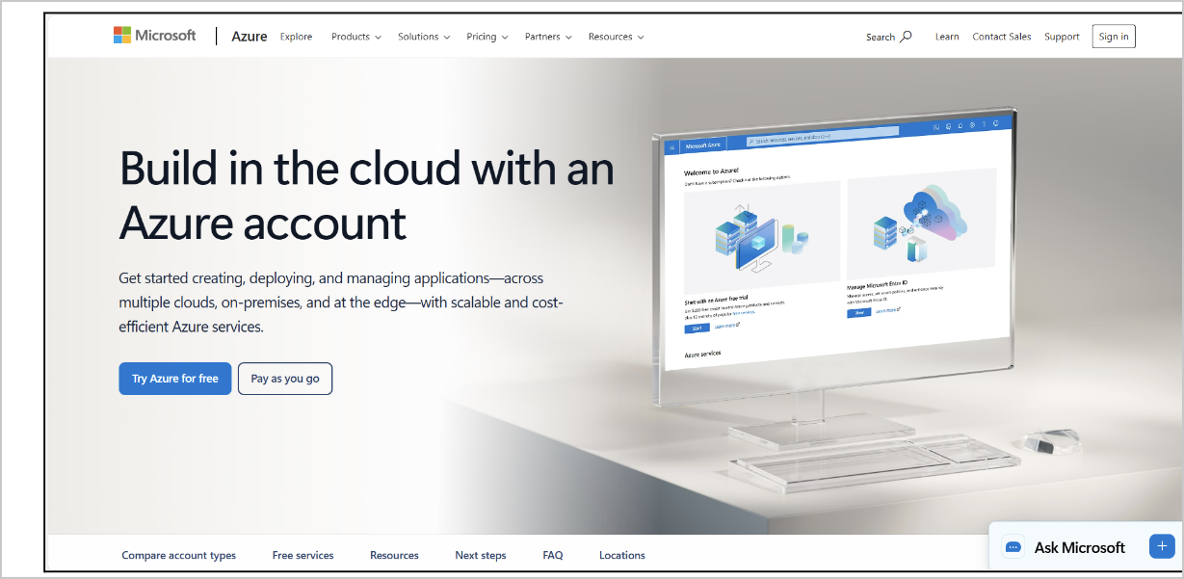
azure.microsoft.com/free — “Try Azure for Free”
- Sign in using a Microsoft account
  - If you don’t have one, click Create one!
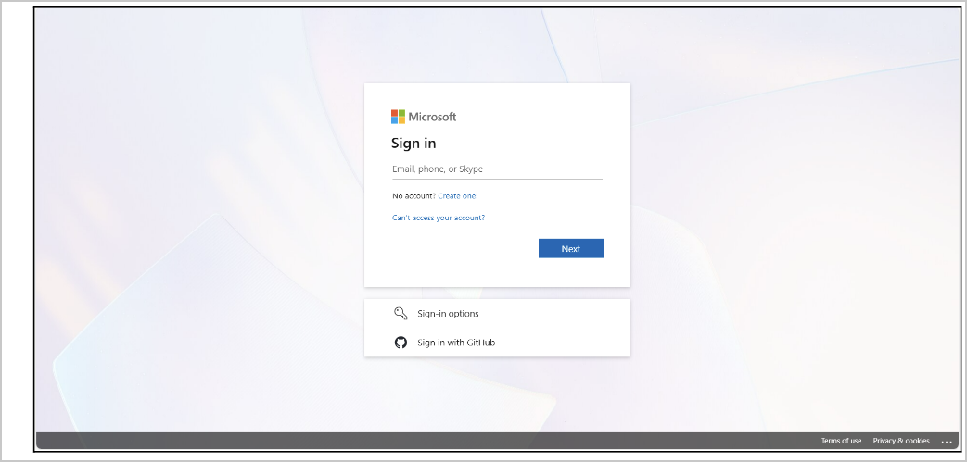
Microsoft sign-in page
- Provide:
  - Use of Azure Account: For Personal Use
  - Country
  - Name
  - Phone number (SMS verification required)
  - Address Information
- Enter payment information
  - Only for identity verification.
  - Only accepts the following cards (Credit or Debit): Visa, Mastercard, American Express, JCB.
  - You will NOT be charged unless you manually upgrade.
- Accept terms → Click Sign Up

Step B: Access the Azure Portal
- Go to https://portal.azure.com
- Sign in to your account
- You should now see the Azure dashboard
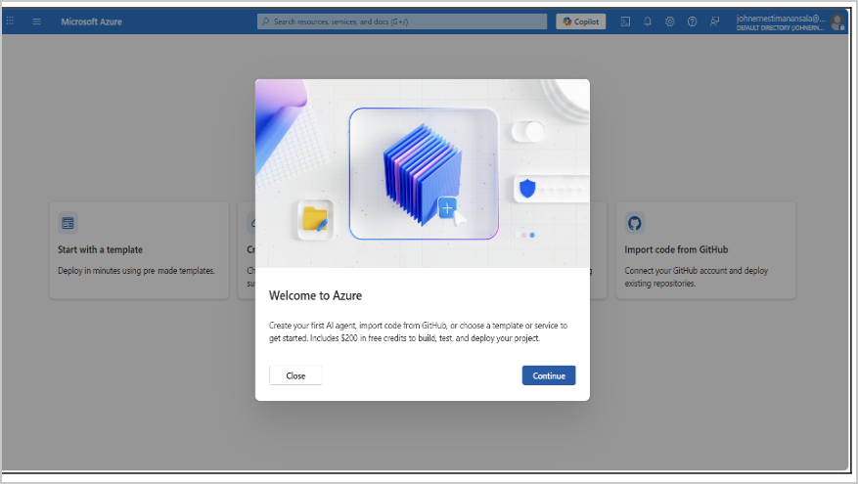
Azure dashboard — “Welcome to Azure”

Step C: Create a Resource Group
- Search for Resource Groups
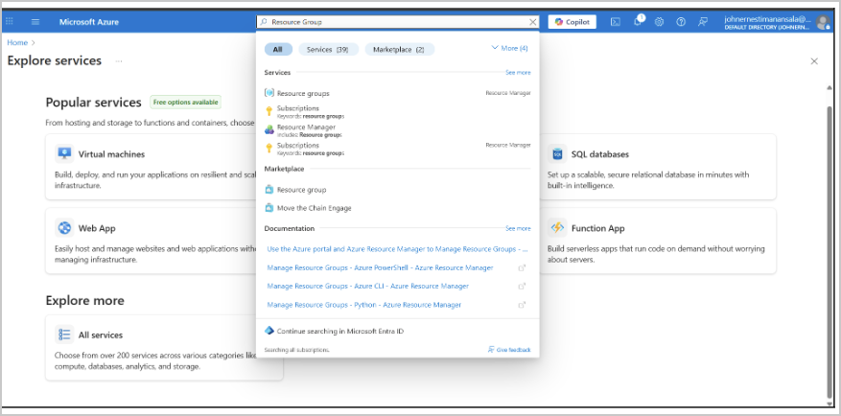
Searching for Resource groups
- Click Create
- Configure:
  - Subscription: Free Trial
  - Resource Group Name: AD-Lab
  - Region: your nearest region (e.g., Southeast Asia)
- Click Review + Create → Create
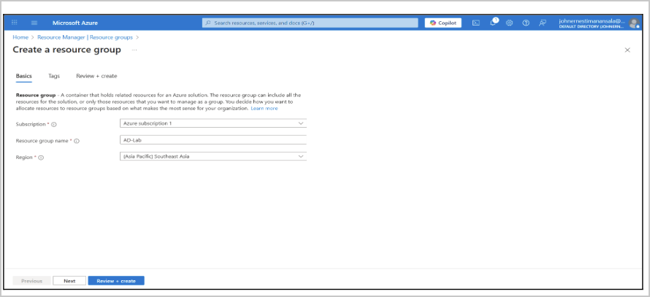
Create a resource group — Basics

Step D: Create a Virtual Network (VNet)
Both VMs must be on the same private network.
- Search for Virtual Network
- Click Create
- Configure:
  - Resource Group: AD-Lab
  - Name: AD-VNet
  - Region: same as Resource Group
- Leave the default Address Space and Subnet
- Click Review + Create → Create
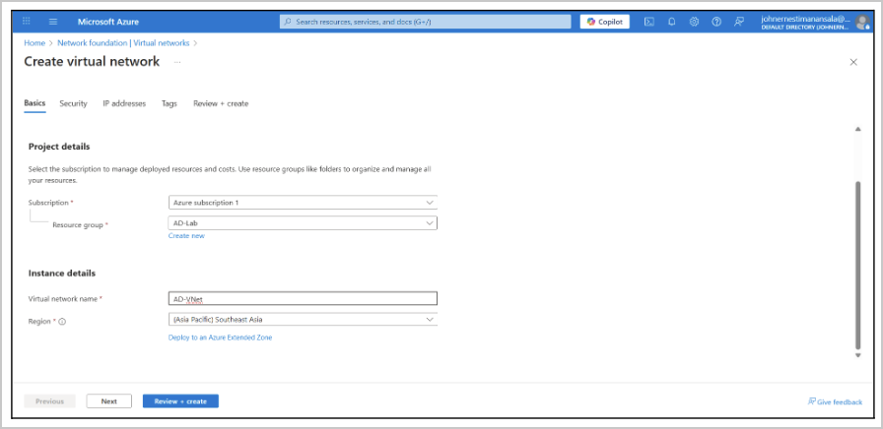
Create virtual network — Basics
With the Resource Group and VNet ready, you can now proceed to Step 1, where you will deploy the Domain Controller and client VM.

Step 1: Provision Cloud Virtual Machines
Create two Windows Server VMs in your account:

VM1 – Domain Controller (DC01)
Purpose: Hosts Active Directory Domain Services (AD DS), DNS, and serves as the primary domain controller for the lab environment.
Before you deploy: Your Image is currently set to “Windows Server 2022 Datacenter Server Core – x64 Gen2.” Server Core has no desktop GUI, so you will not be able to use Server Manager, the Add Roles and Features wizard, or the notifications-flag promotion steps in Step 2 the way this guide describes. Change the Image to “Windows Server 2022 Datacenter – x64 Gen2” (Desktop Experience — the option without “Server Core” in the name) before you click Review + create.
My Configuration (as deployed):
- Virtual machine name: DC01
- Region: (Asia Pacific) New Zealand North
- Availability options: Availability zone → Self-selected zone → Zone 1
  - Optional for a single-VM lab — fine to leave at the default if you’d rather skip zone selection.
- Security type: Trusted launch virtual machines (default — keep this; it enables Secure Boot and vTPM on the Gen2 image).
- Image: Windows Server 2022 Datacenter Server Core – x64 Gen2 — change to the Desktop Experience edition (see note above)
- VM architecture: x64
- Size: Standard_B2als_v2 – 2 vCPUs, 4 GiB memory (~$36.43/month; price varies by region/currency)
- Administrator account: Username azureuser (or your own choice), with a strong password
- Public inbound ports: Allow selected ports → RDP (3389)
  - Azure warns this opens RDP to all IP addresses. For a lab this is common, but consider restricting the source to your own IP under the Networking tab → network security group rules.
- Licensing (Azure Hybrid Benefit): “Use an existing Windows Server license” is checked — leave this unchecked unless you actually hold an eligible on-prem/CSP Windows Server license.
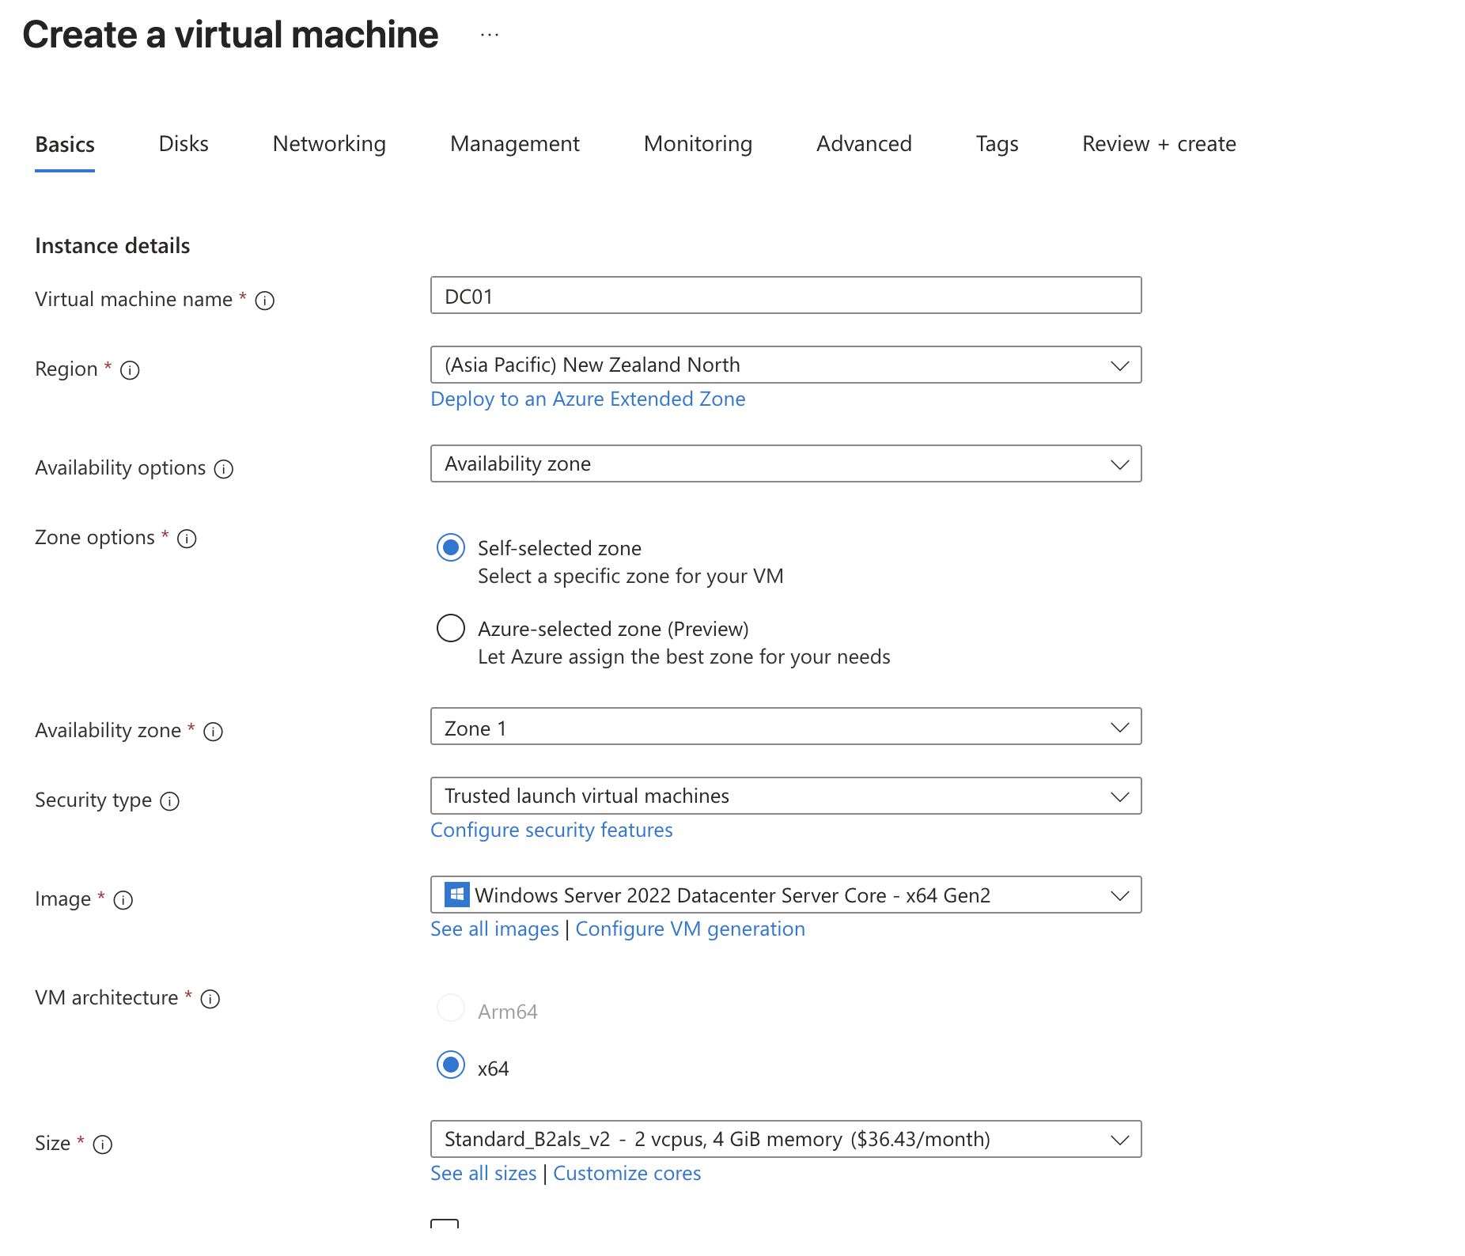
Your Create a virtual machine — Basics (Instance details)
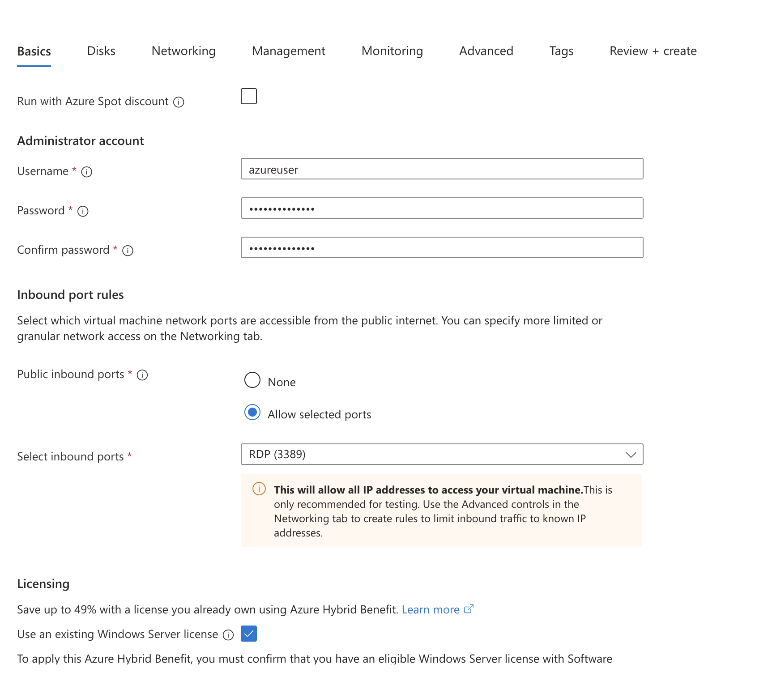
Your Create a virtual machine — Administrator account, inbound ports, licensing
Still to configure (Networking tab — not shown in your screenshots):
- Network: AD-VNet
- Subnet: default
- Public IP: Optional (recommended only for RDP access; use NSG restrictions)
- Private IP: Static (recommended for domain controllers)
- Notes: Ensure time sync and DNS settings point back to the DC itself.

VM2 – Client Machine (CLIENT01)
Purpose: Acts as a domain-joined workstation used to test authentication, Group Policies, and user account management.
Configuration:
- OS: Windows 10, Windows 11, or Windows Server 2022
- Size: B2als_v2
  - vCPUs: 2
  - RAM: 4 GB
  - Temp Storage: 4 GiB
  - Network Bandwidth: 3750 Mbps
  - Cost Estimate: ~$41.17/month
  - Reason for Choosing: Matches DC performance, ensures smooth RDP usage, and is stable for client operations.
- Network: AD-VNet
- Subnet: default
- Private IP: Dynamic is acceptable
- Inbound Ports: RDP (3389)
- DNS Settings: Must point to DC01’s private IP before joining the domain
- Notes: Keep OS patched before domain join for secure configuration.
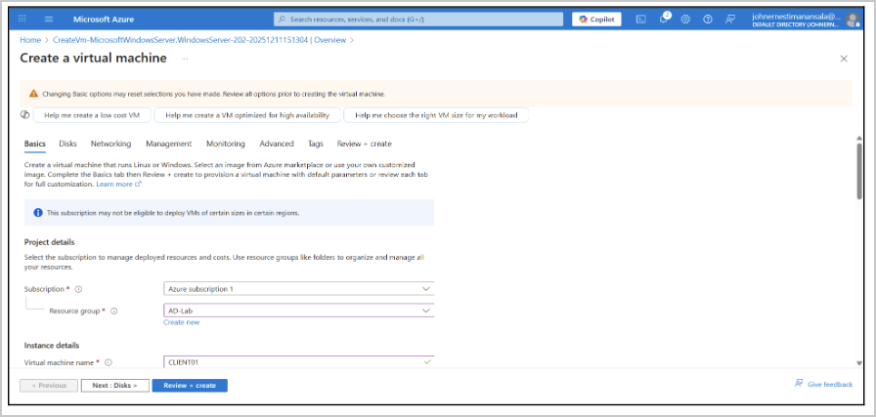
Create a virtual machine — CLIENT01
Both VMs must be in the same virtual network (AD-VNet) and the same region. This allows:
- Domain join
- DNS resolution
- Group Policy communication
- Realistic enterprise LAN simulation

Step 2: Configure Domain Controller
- Log in to VM1 (Domain Controller) via RDP.
  - Go to Virtual Machines → select DC01 → click Connect.
    - Download the RDP file and open it.
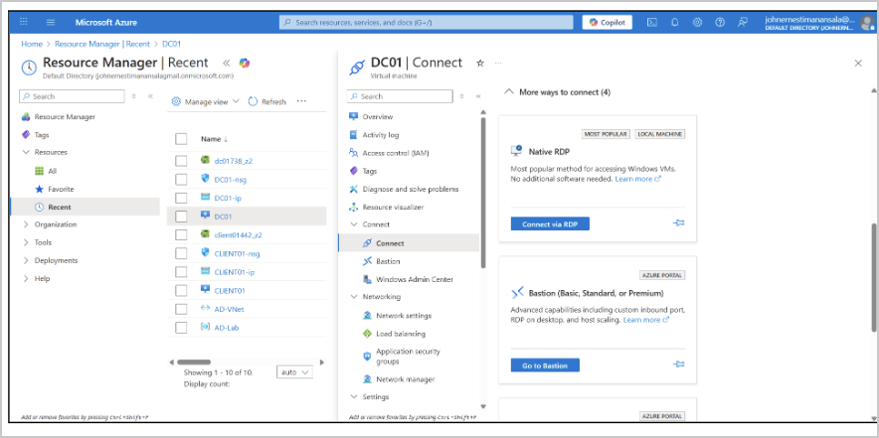
Azure portal — DC01 Connect (Native RDP)
  - Use the credentials you set when creating the VM.
  - The Remote Desktop session will open the Windows Server desktop.
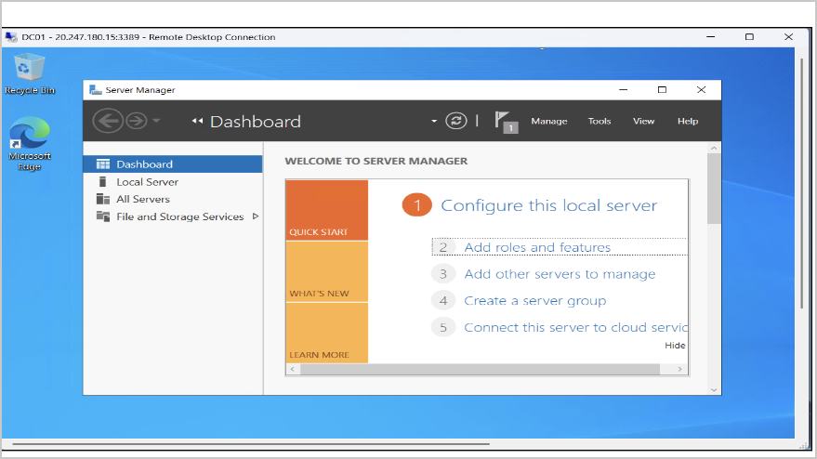
DC01 desktop — Server Manager Dashboard
- Open Server Manager (usually starts automatically at login; if not, click the Start Menu → Server Manager).
  - Click Add Roles and Features.
In the Add Roles and Features Wizard:
  - Installation Type: Select Role-based or feature-based installation → Next.
  - Server Selection: Select DC01 → Next.
  - Server Roles: Check Active Directory Domain Services → a pop-up will ask to add features → click Add Features → Next.
    - Features: Leave default → Next.
  - AD DS: Read description → Next.
  - Confirmation: Check “Restart the destination server automatically if required” → click Install.
Note: The installation might take a few minutes.
- After installation, click the Notifications flag in Server Manager → Promote this server to a domain controller.
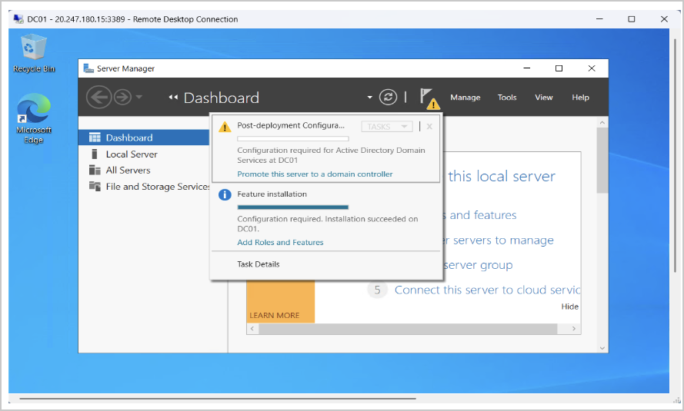
Server Manager notification — Promote this server to a domain controller
  - Deployment Configuration:
    - Choose Add a new forest → Root domain name: corp.local → Next.
  - Domain Controller Options:
    - Forest and Domain Functional Levels: Default (Windows Server 2022).
    - Check DNS Server → Next.
    - Set DSRM password (Directory Services Restore Mode). Remember this password; it’s used for recovery → Next.
  - Additional Options: Leave default → Next.
  - Paths: Leave default (C:\Windows\NTDS, etc.) → Next.
  - Review Options: Confirm → Next.
  - Click Install → The server will automatically reboot after promotion.
  - After reboot, DC01 is now the Domain Controller for the new forest corp.local.
Note: During the domain setup, a domain administrator account named “adminuser” is created. This account has Domain Admin privileges and is used throughout the lab for administrative tasks.
- Verify AD DS and DNS
  - Log back into DC01.
  - Open Server Manager → Tools → Active Directory Users and Computers.
  - You should see your domain corp.local listed.
  - Open DNS from Server Manager → Tools → DNS to check that your domain zones are created automatically.
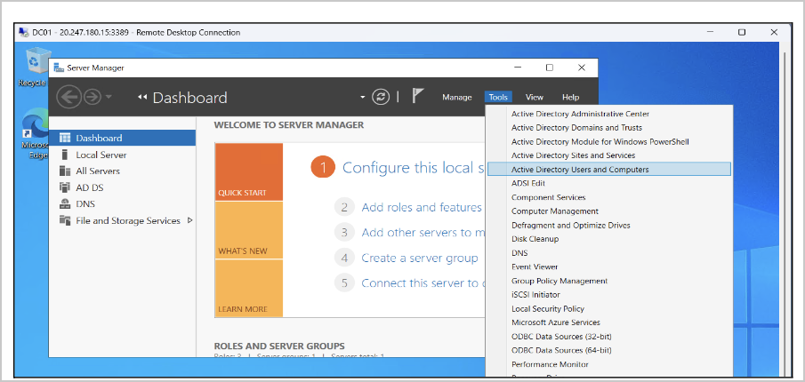
Server Manager → Tools → Active Directory Users and Computers

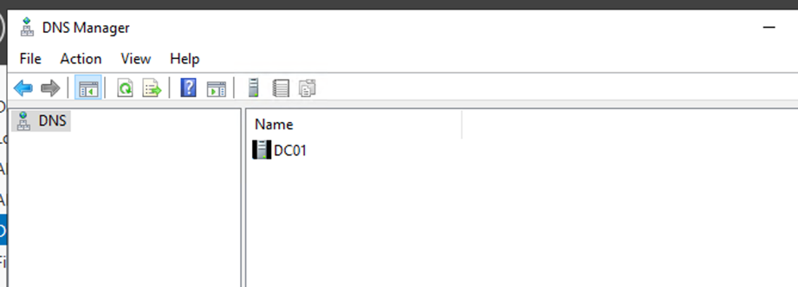
Tools → DNS

Step 3: Join Client VM to the Domain
- Log in to VM2 (Client machine).
  - Do the same with VM1 and download the RDP.
    - Open RDP to CLIENT01 using the credentials set during VM creation.
    - Ensure CLIENT01’s DNS Server is set to DC01’s private IP:
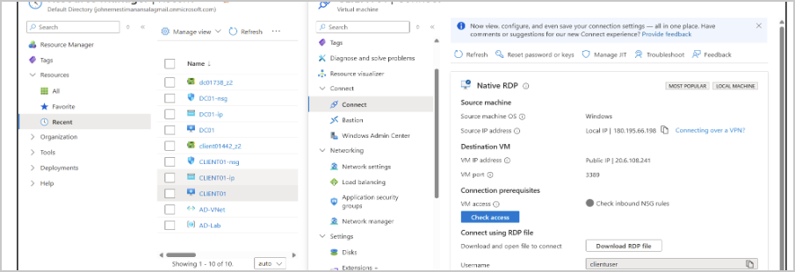
Azure portal — CLIENT01 Connect
  - Open Settings → Network & Internet → Ethernet → Change adapter options → Right-click your adapter → Properties → IPv4 → Properties → Preferred DNS server → Enter DC01 private IP → OK.
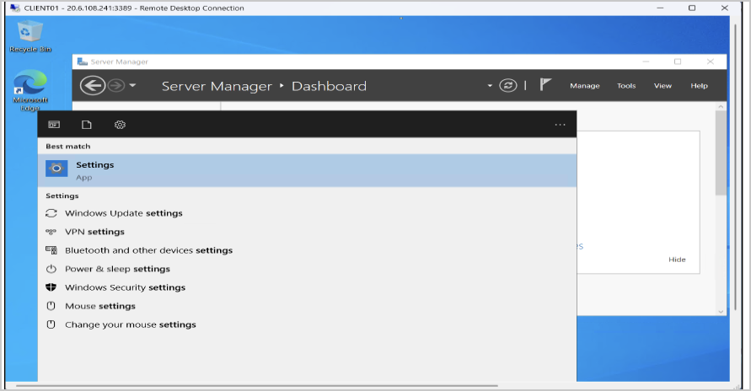
CLIENT01 — searching for Settings

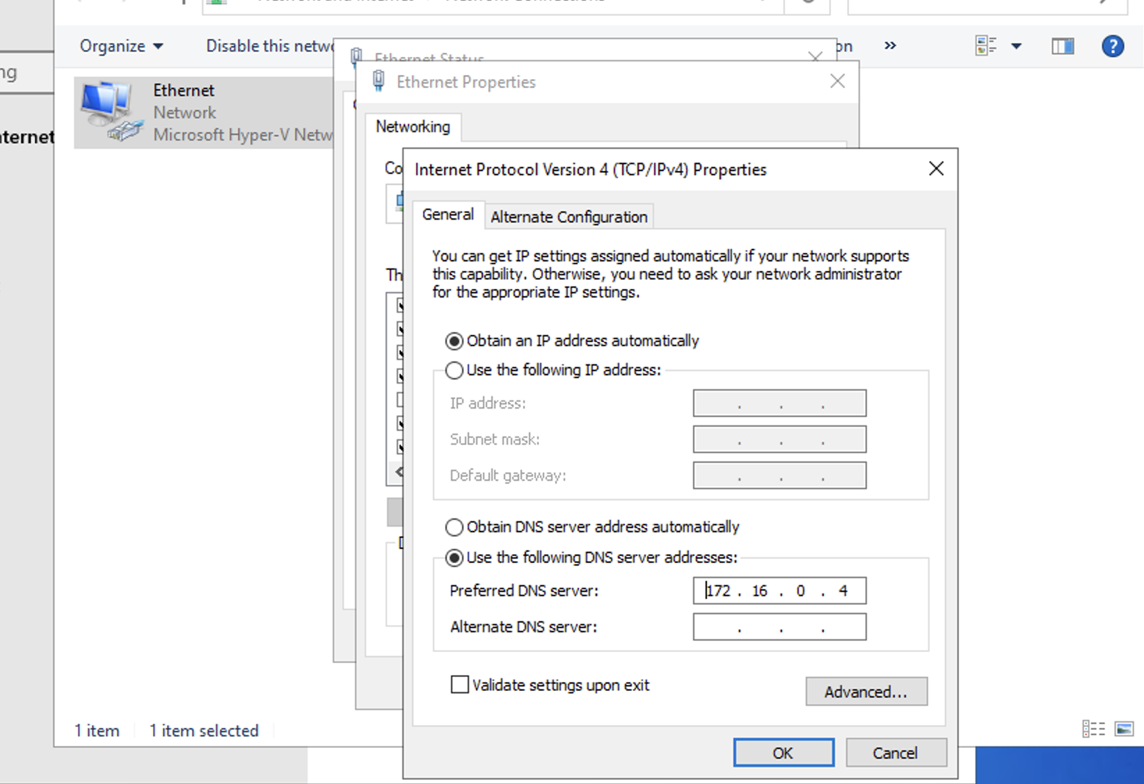
DC01 private IP: 172.16.0.4
- Open System Properties:
  - Right-click This PC → Properties → Advanced system settings → Computer Name tab → Change…
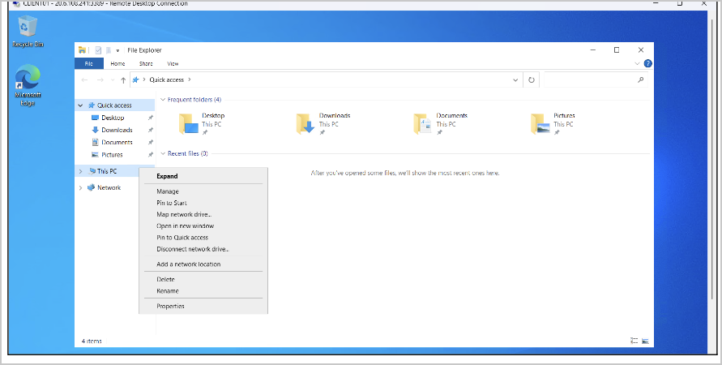
CLIENT01 — This PC → Properties
  - Select Domain
    - Enter the domain: corp.local
    - Click OK.
  - Enter Domain Admin credentials (adminuser) from DC01.
    - A pop-up will ask for credentials → type the Domain Admin username and password from VM1 (DC01)
    - Click OK
  - Restart CLIENT01 to apply domain membership.
    - A message will appear saying the computer must restart to join the domain → click Restart Now
After reboot, the workstation is now domain-joined.
- Verify the Domain Membership
Log in with domain credentials:
  - On the login screen, type:
    - Username: corp\adminuser
    - Password: The same one from DC01
Check the domain account in the Command Prompt:
  - Type: whoami
  - Output: corp\adminuser
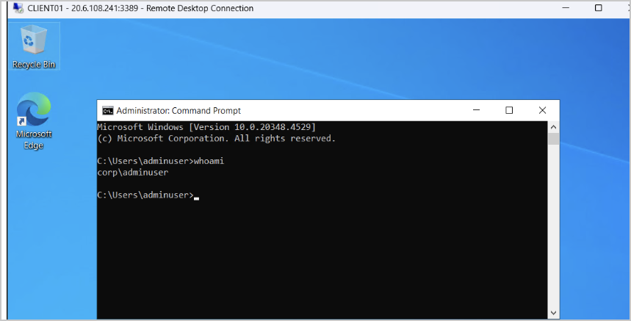
CLIENT01 — whoami confirms domain membership

Step 4: Create Users and Organizational Units (OUs)
- On VM1 (DC01), open Active Directory Users and Computers.
  - Server Manager → Tools → Active Directory Users and Computers (ADUC).
- Right-click your domain → New → Organizational Unit
  - Example: TestUsers
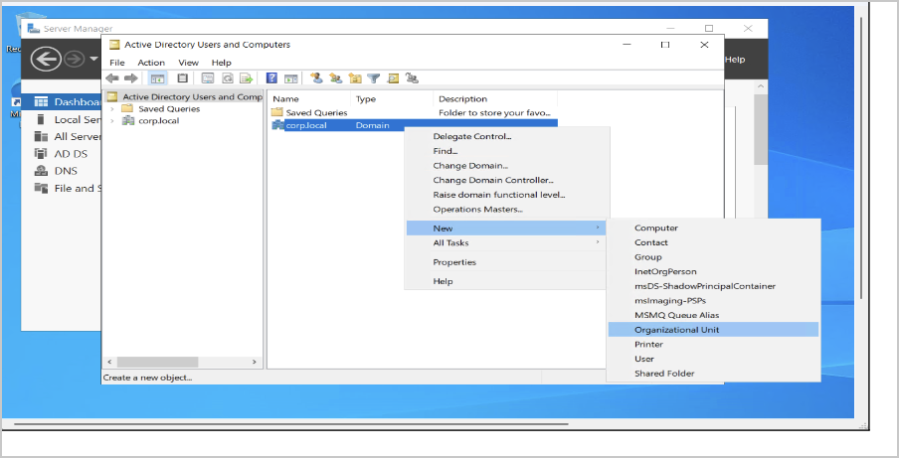
ADUC — New → Organizational Unit
- Right-click TestUsers OU → New → User.
Inside the OU, create users:
- Alice
  - First name: Alice → Last name: N/A → User logon name: alice → Next
  - Set password → Require password change at next login → Next → Finish
  - Repeat for Bob and Charlie.
- Bob
- Charlie
Ensure all users are added to the Domain Users group (default).
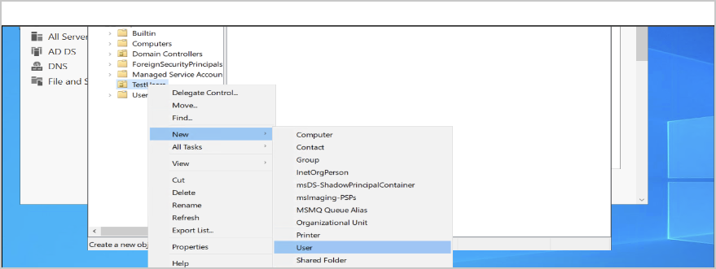
ADUC — New → User

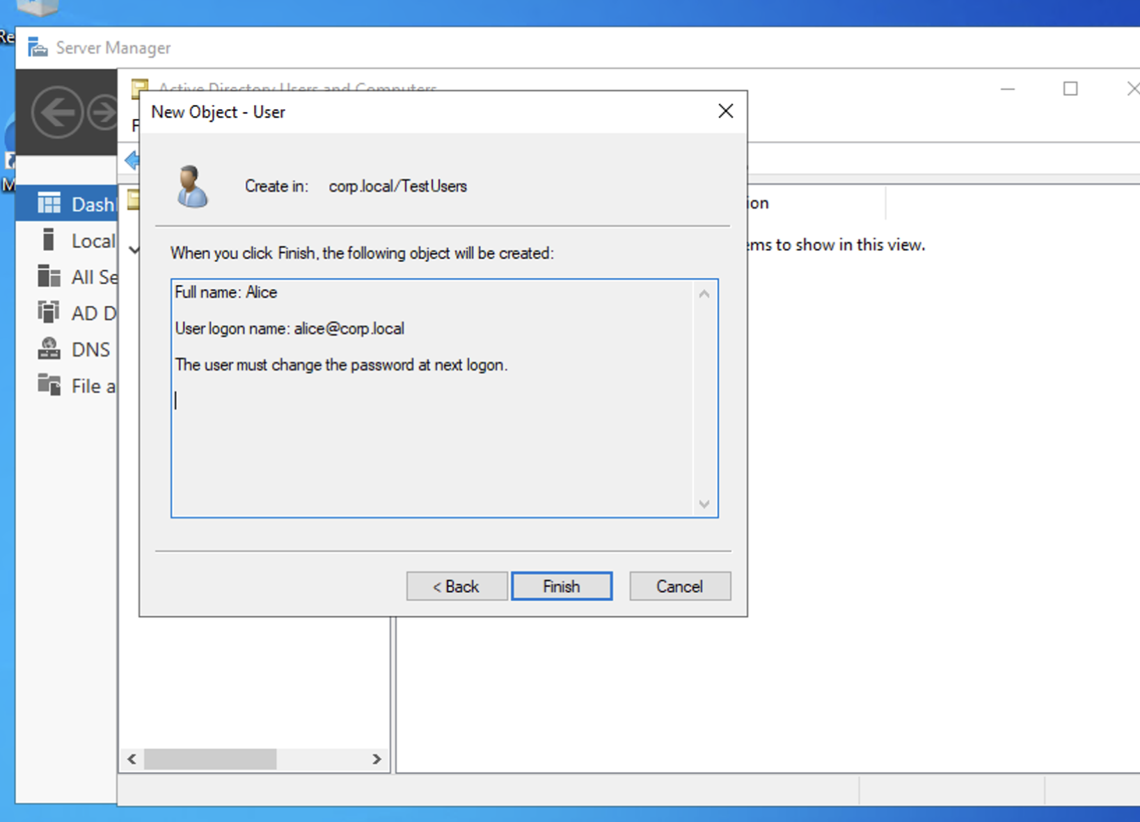
- In ADUC, right-click a user → Properties → Member Of → Add to custom groups if needed.
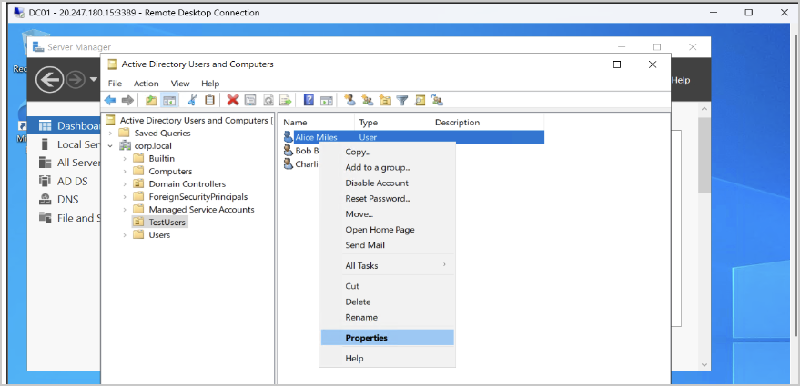
ADUC — user context menu → Properties
This simulates user provisioning and organizational structure, both monitored by SOC analysts during investigations.

Step 5: Reset Password & Add User to “Remote Desktop Users” Group
- On DC01: Open Active Directory Users and Computers
  - Server Manager → Tools → Active Directory Users and Computers
  - Go to: corp.local → TestUsers → alice
  - Right-click Alice → Reset Password
  - Set a new password
  - UNCHECK: User must change password at next logon
  - Click OK
This fixes the issue with changing the password at next logon.
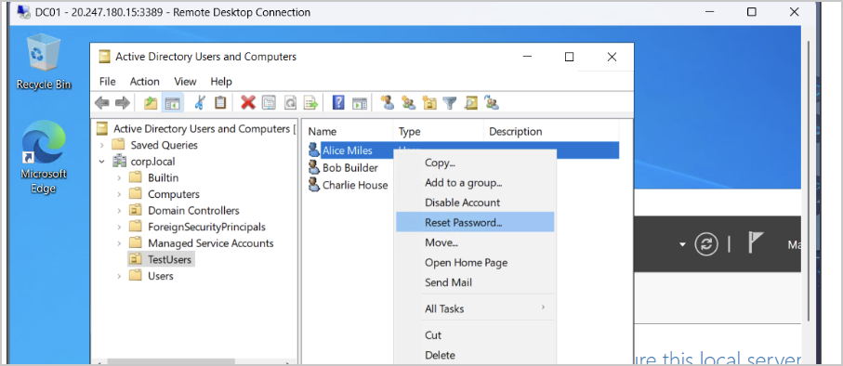
ADUC — Reset Password
- On CLIENT01 (the machine you’re RDPing into):
  - Log in using an Administrator account (adminuser)
    - Example: corp\adminuser
  - Open System Properties
    - Press Win + R
    - Type: sysdm.cpl
    - Press Enter
  - Go to the Remote tab
    - Click Select Users…
    - Click Add
    - Enter: corp\alice
    - Click Check Names → OK → OK
This adds Alice to the Remote Desktop Users local group.
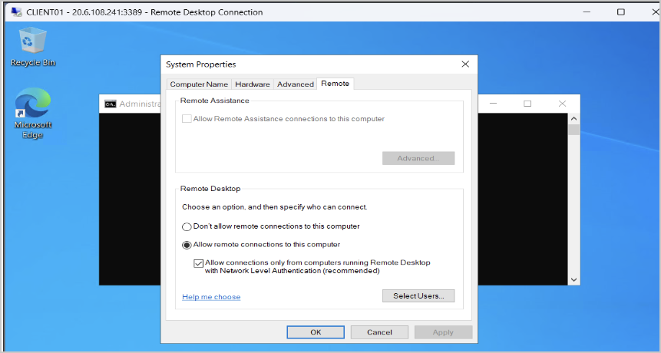
System Properties — Remote tab

Step 6: Test User Accounts
Ensure users can log in and communicate with domain resources.
- On CLIENT01 (VM2), log out of Administrator → log in with a new domain account, e.g., corp\alice.
  - Enter the username and password created in Step 4.
- Verify Domain Access
  - Open Command Prompt → run: whoami
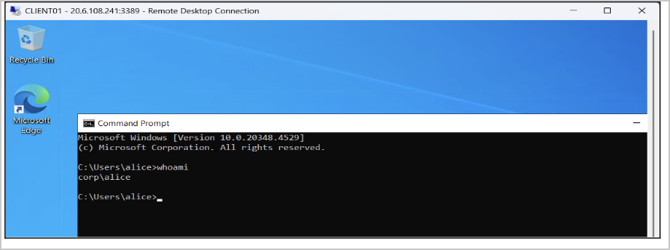
CLIENT01 — whoami as corp\alice
  - Output: corp\alice
  - Test network access:
    - Press Windows + E to open File Explorer
    - Click the address bar at the top
    - Type: \\DC01 → Press Enter
    - Access shared folders (if any), but you may see a blank window (no shares yet)
    - Open Command Prompt again (or reuse the same one)
    - Type: ping <DC01IP Address> → Should reply.
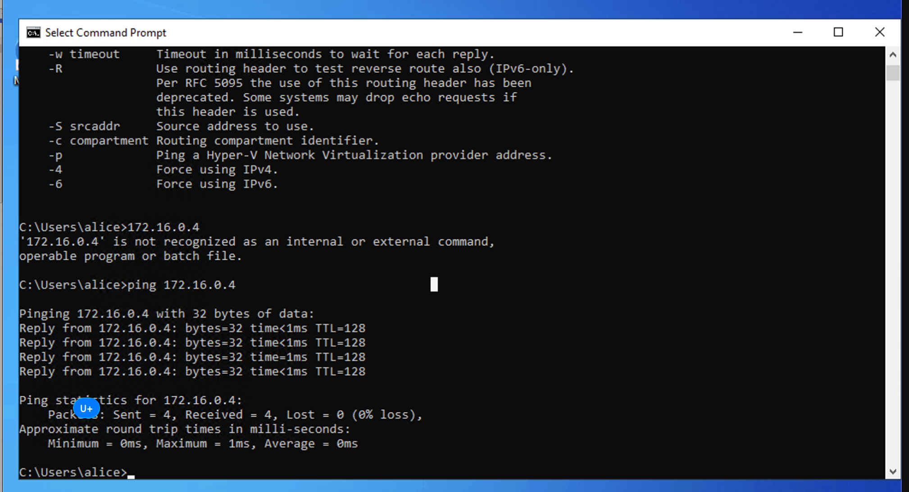
CLIENT01 — ping DC01 succeeds

Step 7: Monitoring
- Review Security Logs on the Domain Controller
  - Log in to DC01 as a domain administrator (adminuser): corp\adminuser
  - Open Event Viewer:
    - Click Start Menu
    - Search for Event Viewer
    - Open the application
  - Navigate to:
    - Event Viewer → Windows Logs → Security
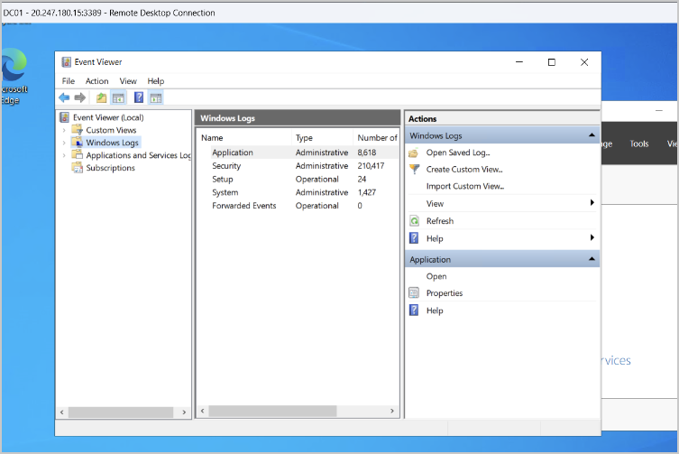
DC01 — Event Viewer → Windows Logs
This log contains authentication events, account management activity, and policy changes, which are critical for SOC investigations.
- Identify Key Active Directory Security Events
Use Filter Current Log… (right panel) and search for the following Event IDs:
Authentication Events
Event ID | Description | SOC Relevance
4624 | Successful logon | Confirms valid user authentication
4625 | Failed logon | Detects brute-force or password guessing
4648 | Logon using explicit credentials | Indicates lateral movement attempts

Account Management Events
Event ID | Description | SOC Relevance
4720 | User account created | Tracks user provisioning
4722 | User account enabled | Detects reactivated accounts
4723 / 4724 | Password change/reset | Monitors credential changes
4725 | User account disabled | Tracks access revocation
4726 | User account deleted | Identifies account removal

Domain & Group Changes
Event ID | Description | SOC Relevance
4732 | User added to a security group | Privilege escalation monitoring
4733 | User removed from a security group | Access change tracking
4735 | Security group modified | Detects group tampering

Important Note: Event ID Variations
Some Windows Security Event IDs may vary depending on:
- Windows Server version (e.g., 2016, 2019, 2022)
- Client OS version (Windows 10 vs Windows 11)
- Domain Functional Level
- Audit Policy configuration (Advanced Audit Policy settings)
- Whether the event occurred on the Domain Controller or the client machine
For example:
- Authentication events (e.g., 4624 / 4625) may appear on both the client and DC, but with different Logon Types.
- Group membership changes (e.g., 4732) may be logged on the Domain Controller even if the action was initiated from a client.
- Password-related events may display as 4723 or 4724, depending on whether the change was initiated by the user or the administrator.
- Correlate Events With Lab Actions
Map events to actions performed earlier:
Lab Action | Expected Event
Password reset | 4724
Account logs in | 4624
Scheduled Task was Updated | 4702
Special privileges assigned to the new logon. | 4672
Group Membership Information | 4627
A new process has been created | 4688

Note: Some events may not appear unless the corresponding action is performed. These examples illustrate what SOC analysts commonly monitor in enterprise environments.
Correlation Tip:
If an expected Event ID is not found, verify:
- The action was performed successfully
- You are reviewing logs on the correct system (DC01 vs CLIENT01)
- Security auditing is enabled for the relevant category
Analysts commonly correlate multiple related events across systems to confirm activity.
- Export Logs for Analysis
  - In Event Viewer → Security
    - Right-click Security
    - Click Save All Events As…
    - Save as: DC01-SecurityLogs.evtx
Analysts often export logs to SIEM platforms such as Splunk, Sentinel, or ELK for centralized analysis and alerting.

Optional Azure Security Tools (Free-Tier Friendly)
In addition to the native Windows Event Viewer, Azure provides built-in security and monitoring tools that can be explored within the free-tier subscription. These tools help learners understand how cloud-native security controls integrate with Active Directory environments.
Explore additional Azure security features within free-tier credits.

1. Microsoft Defender for Cloud
Purpose: Cloud security posture management and basic threat protection.
What can be explored:
- View security recommendations for virtual machines
- Identify exposed management ports (e.g., RDP 3389)
- Review baseline security posture and compliance suggestions
SOC Relevance:
Introduces how security teams identify misconfigurations and prioritize risks in cloud-hosted Windows environments. The free tier includes foundational security posture assessments. Advanced workload protection is optional and not required for this lab.

2. Azure Network Security Groups (NSG)
Purpose: Network-level traffic filtering for cloud resources.
What can be explored:
- Restrict RDP access to a specific IP range
- Understand inbound vs outbound security rules
- Simulate basic perimeter hardening for domain controllers
SOC Relevance:
Demonstrates how access control and network segmentation reduce attack surfaces and support incident response. NSGs are included at no additional cost and are fully usable within free-tier subscriptions.

Summary
By completing this project, learners will:
- Provision and configure a cloud-based Active Directory environment using Microsoft Azure, including virtual networks, resource groups, and Windows virtual machines.
- Install and promote a Windows Server to a Domain Controller, creating a new Active Directory forest and configuring DNS for enterprise identity management.
- Join a client machine to the domain and verify domain membership, authentication, and network communication.
- Create and manage Organizational Units (OUs) and user accounts, simulating real-world user provisioning and access management workflows.
- Troubleshoot common Active Directory issues such as DNS misconfigurations, domain join failures, and user login problems.
- Develop foundational SOC-relevant skills by understanding how centralized identity, authentication events, and domain activity are used to support security monitoring and incident investigations.

