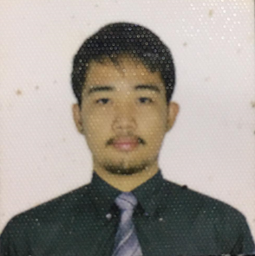

**RAMELB, FRANCIS JOHN M.**

Address: Blk-13 Lot-40 Ph-2 Regina Ville 2000 Brgy. Inocencio Trece Martires City, Cavite  
Email: [ramelbmanaguelodfrancisjohn@gmail.com](mailto:ramelbmanaguelodfrancisjohn@gmail.com)  
Contact Number: 09457483254

## OBJECTIVE

To accept any challenging position where education and accomplishment can be utilized for mutual benefit.

## PERSONAL INFORMATION

Nickname: F J/ John  
Birthdate: September 12, 2002  
Birthplace: Pasay City  
Age: 20  
Height: 5’8  
Weight: 60kg  
Religion: Christian  
Status: Single  
Citizenship: Filipino  
Sex: Male

Mother’s Name: Donabel M Ramelb  
Occupation: House Wife

Father’s Name: Francis C. Ramelb

Occupation: Retired Millitary

## EDUCATIONAL ATTAINMENT

**Collage** Cavite State University Trece Martires City Campus

2022- Present

**Senior High School** Notre Dame Senior High School

Don Bosco Executive Village, Trece Martires City Cavite 2020 up to 2021

Information Communication Technology

**Junior High School Josefin Albano National High School**

2018-2019

Completed as Grade 10 student

**Elementary** Bagong pook Elementary School

2008-2014

Elementary Diploma

## SKILLS

## Time Management

## Excellent in Communication

## Creativity

## Communication Skills