Table of Contents
Table of Contents 2
Question 1 3
client.py 3
WMS_Server.py 4
OUTPUT 8
Question 2 9
bookings.py 9
OUTPUT 12
Question 3 13
generate_certificates.sh 13
tls_client.py 14
tls_server.py 16
OUTPUT 20
Question 4 21
client.py 21
server.py 26
OUTPUT 32
Bibliography 34

Question 1

client.py
""" CLIENT SIDE """
import socket

SERVER_IP = '127.0.0.1'
PORT = 5500

def start_client():
client_socket = socket.socket(socket.AF_INET, socket.SOCK_STREAM)

print("=" * 40)
print("WMS Client")
print("=" * 40)

try:
print(f"Connecting to {SERVER_IP}:{PORT}...")
client_socket.connect((SERVER_IP, PORT))
print("Connected to server\n")

while True:
print(f"What item are you looking for? ('exit' to quit)")
message = input()

if message.strip().lower() == "exit":
print("Disconencting from server")
client_socket.sendall("Exit".encode('utf-8'))
break

if message:
client_socket.sendall(message.encode('utf-8'))

reply = client_socket.recv(1024).decode('utf-8')
print(reply, end='')

except ConnectionRefusedError:
print(f"[ERROR] Could not connect to server at {SERVER_IP}:{PORT}")

except Exception as e:
print(f" Error: {e}")

finally:
# Close connection
client_socket.close()
print("[DISCONNECT] Successful\n")

if __name__ == "__main__":
start_client()

WMS_Server.py
""" SERVER SIDE """
import socket

SERVER_IP = '127.0.0.1'
PORT = 5500

server_running = True

items = {
"Nails": 200,
"Screws": 321,
"Toolkit": 59,
"Wood Planks": 97,
"Sheet Metal": 153,
"Lightbulb": 76,
}

def handle_client(client_socket, client_address):
global server_running

try:
print(f"Client {client_address} connected")
while True:
data = client_socket.recv(1024).decode('utf-8').strip()

# in case client presses enter
if not data:
continue

# Client Exit Code
if data.lower().strip() == "exit":
print(f" [DISCONNECT] {client_address} sent the exit code.")
server_running = False
break

# search through dictionary to find item
if data in items and items[data] > 0:
message = f"[ITEM FOUND] {data} : {items[data]}"
else:
message = f"[ITEM NOT FOUND] {data} is not in stock"

client_socket.sendall((f"{message}\n").encode('utf-8'))
print(f"{message}\n")

except ConnectionResetError:
print(f"Error: Client Closed Connection Upbruptly")
except Exception as e:
print(f"Error: {e}")

def start_server():
"""Start TCP Server"""

server_socket = socket.socket(socket.AF_INET, socket.SOCK_STREAM)
server_socket.setsockopt(socket.SOL_SOCKET, socket.SO_REUSEADDR, 1)

server_socket.bind((SERVER_IP, PORT))

server_socket.listen()
global server_running

# Allows for keyboard interrupt on server side every 1 second
server_socket.settimeout(1.0)

print(f'=' * 40)
print(" TCP WMS Server Started")
print("=" * 40)
print(f" Listening on {SERVER_IP}:{PORT}")

try:
while server_running == True:

try:
client_socket, client_address = server_socket.accept()

# When client connects, remove timeout
client_socket.settimeout(None)

handle_client(client_socket, client_address)

if server_running == False: break

except socket.timeout:
continue

except KeyboardInterrupt:
print(f"\n\n Server interrupted by keyboard input")

finally:
if 'client_socket' in locals():
client_socket.close()
server_socket.close()

print(f" Server Closed\n")

if __name__ == "__main__":
start_server()

OUTPUT
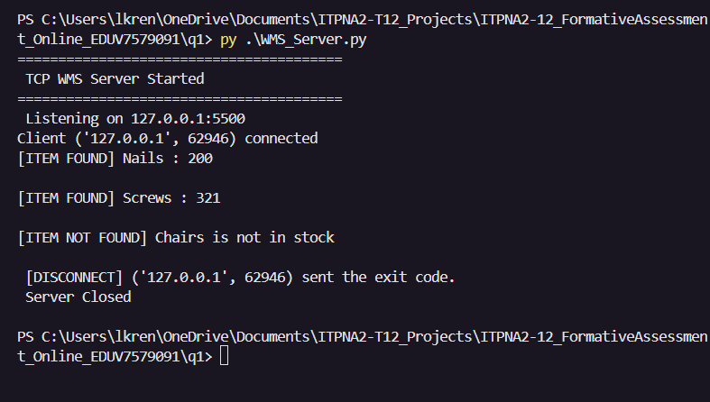
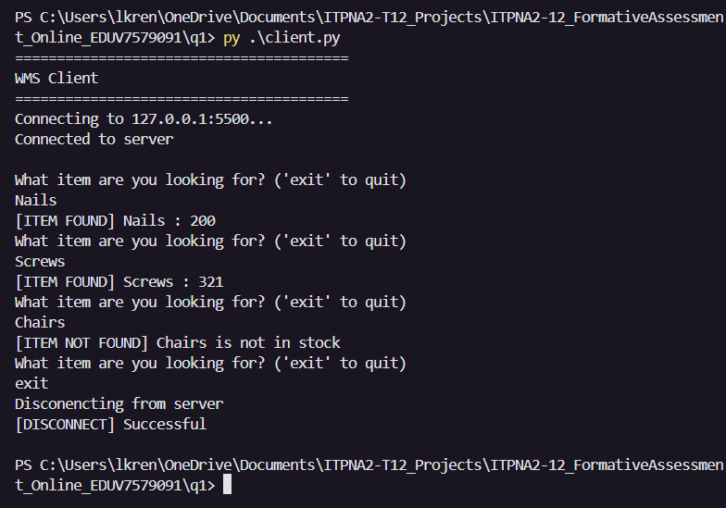

Question 2

bookings.py
# QUESTION 2
from operator import itemgetter
client_data = []
FIXED_PRICE = 20

def handle_input():
print("Client Name:")
c_name = input()

print("\nDestinaion:")
destination = input()

print("\nNumber of Passengers:")
passengers = input()

write_ln = f"{c_name} | {destination} | {passengers}\n"

return write_ln

def handle_file(write_ln):
with open("client_info.txt", "a+") as file:
file.write(write_ln)

def order_data():
with open("client_info.txt", "r") as file:
for line in file:
data = line.strip().split('|')
if data:
client_data.append(data)

for clients in client_data:
total_price = clients[2]
total_price = total_price.lstrip()
total_price = int(total_price)

total_price = total_price * FIXED_PRICE
clients.append(total_price)

client_data.sort(key=itemgetter(3), reverse=True)

print(f"=" * 70)
print(f"{' NAME':<20} {'DESTINATION':<20} {'PASSENGERS':<20} PRICE")
print("=" * 70)
for client in client_data:
output = f" {client[0]:<20} {client[1]:<24} {client[2]:<15} ${client[3]}\n"
print(output)

def start_booking():

while True:
print(f"What would you like to do?")
print("(A) Create a booking\n(B) View Current Bookings\n(C) Exit Application\n")
selection = input().upper()

if selection == 'A':
write_ln = handle_input()
handle_file(write_ln)
print("Client Added Successfully\n")
elif selection == 'B':
order_data()
elif selection == 'C':
break
else:
print("Please Enter a Valid Option\n")

if __name__ == "__main__":
start_booking()
print("Closing Application")

OUTPUT
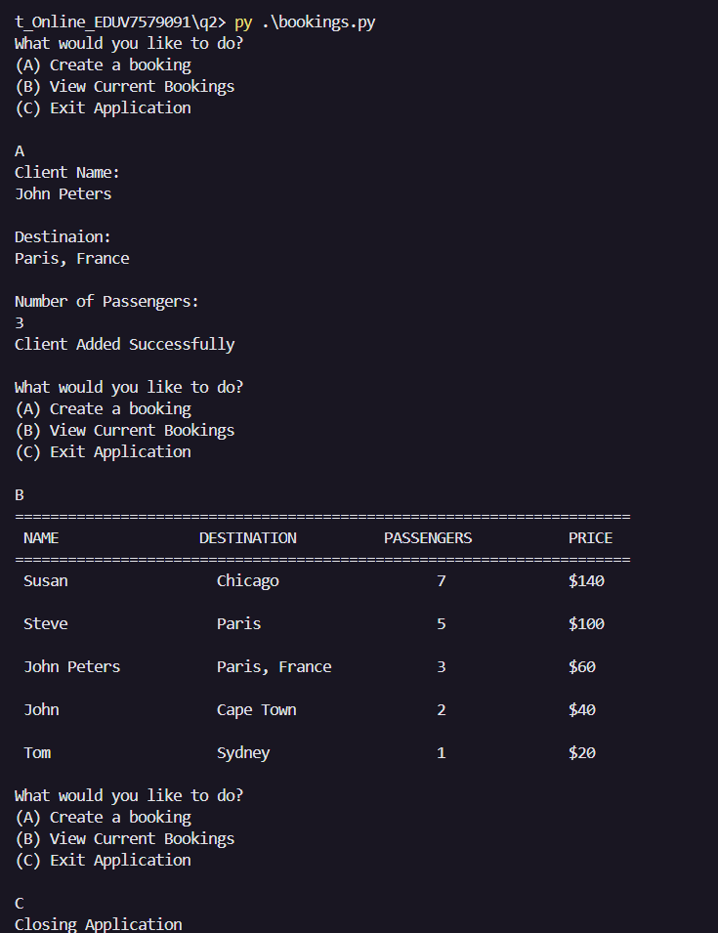

Question 3

generate_certificates.sh
#!/bin/bash
# Generate self-signed certificate for testing

# DO NOT use self-signed certificates in production!

echo "Generating SSL certificate for testing..."

openssl req -x509 -newkey rsa:4096 -nodes -keyout server-key.pem -out server-cert.pem -days 365 -subj "//CN=localhost"

echo "Certificate generated successfully!"

echo "Files created:"

echo " - server-key.pem (private key)"

echo " - server-cert.pem (certificate)"

tls_client.py
import socket
import ssl

SERVER_IP = 'localhost'
PORT = 8443
SERVER_CERT = 'server-cert.pem'

def create_tls_client():
context = ssl.create_default_context(ssl.Purpose.SERVER_AUTH)

# Prevent SSL error without disabling the security checks
context.load_verify_locations(SERVER_CERT)

client_socket = socket.socket(socket.AF_INET, socket.SOCK_STREAM)

tls_socket = context.wrap_socket(client_socket, server_hostname=SERVER_IP)

print(f"[CONNECTING] Connecting to {SERVER_IP}:{PORT}")
tls_socket.connect((SERVER_IP, PORT))
print("[SUCCESS] Connected Successfully")

return tls_socket

def start_client():
print("=" * 60)
print("TLS/SSL Client")
print("=" * 60)

try:
tls_socket = create_tls_client()

cipher = tls_socket.cipher()
if cipher:
print("[SUCCESS] TLS Connection Established:")
print(f"\tCipher {cipher[0]}\n\tProtocol: {cipher[1]}\n\tKey Bits: {cipher[2]}")

message = "Hello from Secure Client ^^"
print(f"\n[SENDING...] '{message}'")
tls_socket.sendall(message.encode('utf-8'))

response = tls_socket.recv(4096)
print(f"[RECEIVED] Response from Server: '{response.decode('utf-8')}'")

tls_socket.close()
print(f"[CLOSED] TLS Socket Closeed Successfully!")

except Exception as e:
print(f"[ERROR] Could not close Connection\n{e}")
print("[TIP] Make sure TLS Server is running")

if __name__ == "__main__":
start_client()

tls_server.py
import socket
import ssl

SERVER = '127.0.0.1'
PORT = 8443
CERT_FILE = 'server-cert.pem'
KEY_FILE = 'server-key.pem'

def create_server():
context = ssl.SSLContext(ssl.PROTOCOL_TLS_SERVER)

try:
context.load_cert_chain(certfile=CERT_FILE, keyfile=KEY_FILE)
except:
print("[ERROR] Certificate files not found")
print("Run generate_certificates.sh first")
exit(1)

context.minimum_version = ssl.TLSVersion.TLSv1_2

server_socket = socket.socket(socket.AF_INET, socket.SOCK_STREAM)
server_socket.setsockopt(socket.SOL_SOCKET, socket.SO_REUSEADDR, 1)

server_socket.bind((SERVER, PORT))

server_socket.listen(5)

server_socket.settimeout(1.0)

return server_socket, context

def handle_client(client_socket, client_address):
print(f"\nConnection from {client_address[0]}:{client_address[1]}")

cipher = client_socket.cipher()
if cipher:
print(f"\tCipher: {cipher[0]}")
print(f"\tTLS Version {cipher[1]}")

try:
data = client_socket.recv(4096)

if data:
message = data.decode('utf-8')
print(f"Received Message: {message}")

response = f"Server Received: {message}"
client_socket.sendall(response.encode('utf-8'))
print(f"\tSent Response")

except Exception as e:
print(f"[ERROR] Client Handle Error: {e}")

finally:
client_socket.close()
print(f"\tClient {client_address[0]} closed")

def start_server():
print("=" * 60)
print(f"TLS/SSL Server")
print("=" * 60)
print(f"Starting TLS/SSL Server on {SERVER}:{PORT}")
print(f"Certificate: {CERT_FILE}")
print(f"Private Key: {KEY_FILE}")

server, context= create_server()

try:
while True:
try:
raw_client_socket, client_address = server.accept()
secure_client_socket = context.wrap_socket(raw_client_socket, server_side=True)
handle_client(secure_client_socket, client_address)
raw_client_socket.close()

except socket.timeout:
continue

except ssl.SSLError as e:
print(f"[SECURITY ALERT] Handshake failed for {client_address[0]}")
print(f"Clear failure message: Unauthorized or bad certificate. Details: {e}")
#raw_client_socket.close()

except Exception as e:
print(f"[ERROR] SERVER ERROR: {e}")

except KeyboardInterrupt:
print("\n\nServer Stopped by user")

finally:
raw_client_socket.close()
server.close()
print("Server Socket Closed")

if __name__ == "__main__":
start_server()

OUTPUT
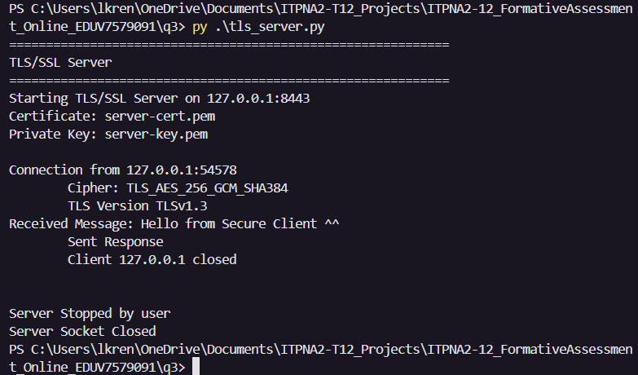

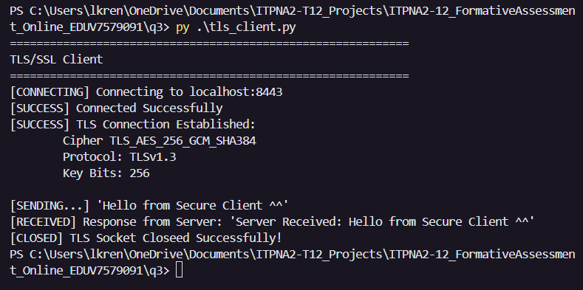

Question 4

client.py
import socket
import os

SERVER_IP = '127.0.0.1'
SERVER_PORT = 5001

FILE_STORE = 'client_files'

def send_files(file_path, client_socket):
try:
file_path = os.path.join(FILE_STORE, file_path)
if not os.path.exists(file_path):
print(f"[ERROR] File not found: {file_path}")
return

file_name = os.path.basename(file_path)
file_size = os.path.getsize(file_path)

print(f"[SENDING...] {file_name} to {SERVER_IP}")
client_socket.sendall(file_name.encode('utf-8'))

print(f"[SENDING...] {file_size} bytes to {SERVER_IP}")
client_socket.sendall(str(file_size).encode('utf-8'))

bytes_sent = 0
with open(file_path, 'rb') as file:
while bytes_sent < file_size:
chunk = file.read(4096)
if not chunk:
break

client_socket.sendall(chunk)
bytes_sent += len(chunk)
progress = (bytes_sent / file_size) * 100
print(f"\rProgress: {progress:.1f}%", end='', flush=True)

print(f"\rProgress: 100.0%")
print(f" Sent {bytes_sent:,} bytes\n")
except Exception as e:
print(f"[ERROR] Send file: {e}")

def req_files(file_name, client_socket):
try:
print(f"[REQUEST] {file_name} from {SERVER_IP}")
client_socket.sendall(file_name.encode('utf-8'))

file_size = int(client_socket.recv(1024).decode('utf-8'))
print(f"\tSize: {file_size:,} bytes ({file_size/1024:.2f} KB)")

file_path = os.path.join(FILE_STORE, file_name)

bytes_received = 0

with open(file_path, 'wb') as file:
print(f" Receiving data...", end='', flush=True)

while bytes_received < file_size:
bytes_to_read = min(4096, file_size - bytes_received)
chunk = client_socket.recv(bytes_to_read)

if not chunk:
print("\nNOT CHUNK")
break

file.write(chunk)
bytes_received += len(chunk)
if bytes_received % 102400 == 0:
progress = (bytes_received / file_size) * 100
print(f"\r Progress: {progress:.1f}%", end='', flush=True)

print(f"\r Progress: 100.0%")

if bytes_received == file_size:
print(f"[SAVED] {file_path}")
print(f"[COMPLETE] {bytes_received:,} bytes\n")
else:
print(f"[INCOMPLETE] File Transfer Incomplete {bytes_received}/{file_size}")

except Exception as e:
print(f"[ERROR] Cannot Receive File\n{e}")

def start_client():
#Start client side
client_socket = socket.socket(socket.AF_INET, socket.SOCK_STREAM)

print("=" * 60)
print("Multi-Client File Transfer Server Started")
print("=" * 60)

try:
print(f"Connecting to {SERVER_IP}:{SERVER_PORT}")
client_socket.connect((SERVER_IP, SERVER_PORT))
print("Connected to Server\n")

print(f"Please Enter your Name:\n")
name = input()
client_socket.sendall(name.encode('utf-8'))

while True:
print("Would you like to send or request a file?")
print(" (1) SEND FILE\n (2) REQUEST FILE\n (3) EXIT PROGRAM\n")
selection = input()
client_socket.sendall(selection.encode('utf-8'))

if selection.strip() == '1':
print("Please enter file path of the file you want to send:")
file_path = input()
send_files(file_path, client_socket)
elif selection.strip() == '2':
print("Please enter requested file name:")
file_name = input()
req_files(file_name, client_socket)
elif selection.strip() == '3':
print("[EXIT] Exit Condition Met\nClosing Client Connection")
break

except ConnectionRefusedError:
print(f"[ERROR] Could not connect to server at {SERVER_IP}:{SERVER_PORT}")

except Exception as e:
print(f" Error: {e}")

finally:
# Close connection
client_socket.close()
print("[DISCONNECT] Successful\n")

if __name__ == "__main__":
start_client()

server.py
import socket
import threading
import os

SERVER_IP = '127.0.0.1'
SERVER_PORT = 5001
FILE_STORE = "server_files"

connected_clients = []
client_names = {}

if not os.path.exists(FILE_STORE):
os.makedirs(FILE_STORE)
print(f"[CREATED] Directory: {FILE_STORE}")

def handle_client(client_socket, client_address):
# handles connecting clients
print(f"[NEW CONNECTION] {client_address} connected")

try:
client_name = client_socket.recv(1024).decode('utf-8').strip()
client_names[client_socket] = client_name

while True:
selection = client_socket.recv(1024).decode('utf-8').strip()
if selection.strip() == '1':
print(f"[RECIEVE] {client_name} is sending a file\n")
file_name = client_socket.recv(1024).decode('utf-8')
rec_files(file_name, client_socket, client_address, client_name)
elif selection.strip() == '2':
print(f"[SEND] {client_name} wants to receive a file\n")
file_path = client_socket.recv(1024).decode('utf-8')
send_files(file_path, client_socket, client_name)
elif selection.strip() == '3':
print(f"[CLIENT DISCONNECT] {client_name} ({client_address[0]}) disconnected from the server")
break
else:
print("Invalid Option")
break

except Exception as e:
print(f"[ERROR] {e}")

def send_files(file_path, client_socket, client_name):
try:
file_path = os.path.join(FILE_STORE, file_path)

if not os.path.exists(file_path):
print(f"[ERROR] File not found: {file_path}")
return

file_name = os.path.basename(file_path)
file_size = os.path.getsize(file_path)

#print(f"[SENDING...] {file_name} to {SERVER_IP}")
#client_socket.sendall(file_name.encode('utf-8'))

print(f"[SENDING...] {file_size} bytes to {client_name}")
client_socket.sendall(str(file_size).encode('utf-8'))

bytes_sent = 0
with open(file_path, 'rb') as file:
while bytes_sent < file_size:
chunk = file.read(4096)
if not chunk:
break

client_socket.sendall(chunk)
bytes_sent += len(chunk)
progress = (bytes_sent / file_size) * 100
print(f"\rProgress: {progress:.1f}%", end='', flush=True)

print(f"\rProgress: 100.0%")
print(f" Sent {bytes_sent:,} bytes\n")

except Exception as e:
print(f"[ERROR] Could not send file\n{e}")

def rec_files(file_name, client_socket, client_address, client_name):
try:

print(f"[RECEIVING...] {file_name} from {client_name}")
print(f"\t({client_address[0]}:{client_address[1]})")

file_size = int(client_socket.recv(1024).decode('utf-8'))
print(f"\tSize: {file_size:,} bytes ({file_size/1024:.2f} KB)")

file_path = os.path.join(FILE_STORE, file_name)

bytes_received = 0

with open(file_path, 'wb') as file:
print(f" Receiving data...", end='', flush=True)

while bytes_received < file_size:
bytes_to_read = min(4096, file_size - bytes_received)
chunk = client_socket.recv(bytes_to_read)

if not chunk:
print("\nNOT CHUNK")
break

file.write(chunk)
bytes_received += len(chunk)
if bytes_received % 102400 == 0:
progress = (bytes_received / file_size) * 100
print(f"\r Progress: {progress:.1f}%", end='', flush=True)

print(f"\r Progress: 100.0%")

if bytes_received == file_size:
print(f"[SAVED] {file_path}")
print(f"[COMPLETE] {bytes_received:,} bytes\n")
else:
print(f"[INCOMPLETE] File Transfer Incomplete {bytes_received}/{file_size}")
except Exception as e:
print(f"[ERROR] Files not Recieved\n{e}")

def start_server():
# Handles server
server_socket = socket.socket(socket.AF_INET, socket.SOCK_STREAM)
server_socket.setsockopt(socket.SOL_SOCKET, socket.SO_REUSEADDR, 1)
server_socket.bind((SERVER_IP, SERVER_PORT))
server_socket.listen(5)

server_socket.settimeout(1.0)

print("=" * 60)
print("Multi-Client File Transfer Server Started")
print("=" * 60)
print(f"List6ting on {SERVER_IP}:{SERVER_PORT}")
print(f"Waiting for Client Connections...\n")

try:
while True:
try:
client_socket, client_address = server_socket.accept()
connected_clients.append(client_socket)

client_thread = threading.Thread(
target=handle_client,
args=(client_socket, client_address)
)
client_thread.daemon = True
client_thread.start()

# Show Active Connections
print(f"[ACTIVE CONNECTIONS] {len(connected_clients)} client(s) connected\n")
except socket.timeout:
continue
except KeyboardInterrupt:
print("\n\n Server Shutting Down")
finally:
for clients in connected_clients:
clients.close()
server_socket.close()
print(" Server Stopped")

if __name__ == "__main__":
start_server()

OUTPUT
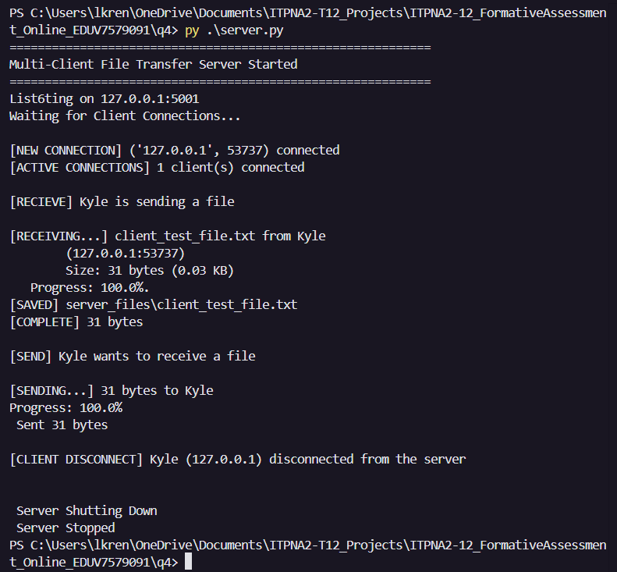
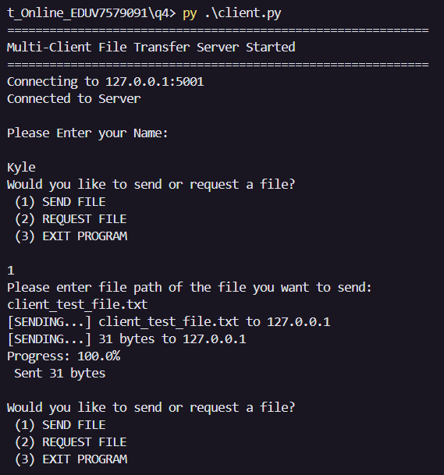
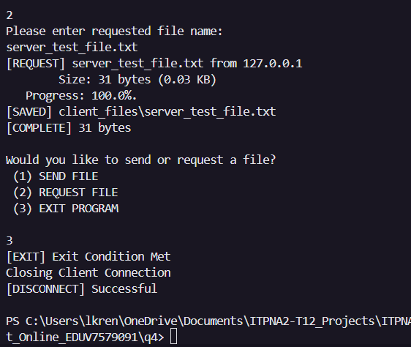
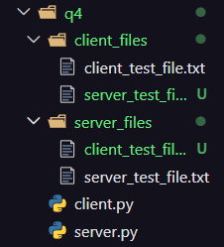

Bibliography
Fadheli, A., 2025. send-receive-files-using-sockets-python. [Online]
Available at: https://thepythoncode.com/article/send-receive-files-using-sockets-python
[Accessed 11 March 2026].
Python Software Foundation, 2026. socket. [Online]
Available at: https://docs.python.org/3/library/socket.html
[Accessed 10 March 2026].
Python Software Foundation, 2026. ssl. [Online]
Available at: https://docs.python.org/3/library/ssl.html
[Accessed 15 March 2026].

