Linux Assembly FAQ – Version 1.0

Linux System Call Table:

https://chromium.googlesource.com/chromiumos/docs/+/master/constants/syscalls.md

Caller/Callee/Function Call registers:

Stolen from:

http://6.s081.scripts.mit.edu/sp18/x86-64-architecture-guide.html
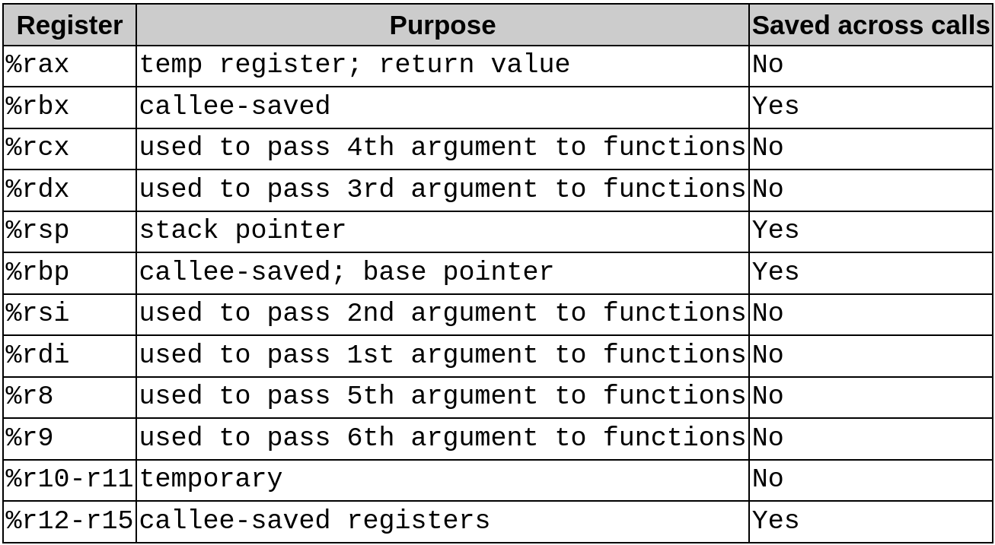

Stolen from:

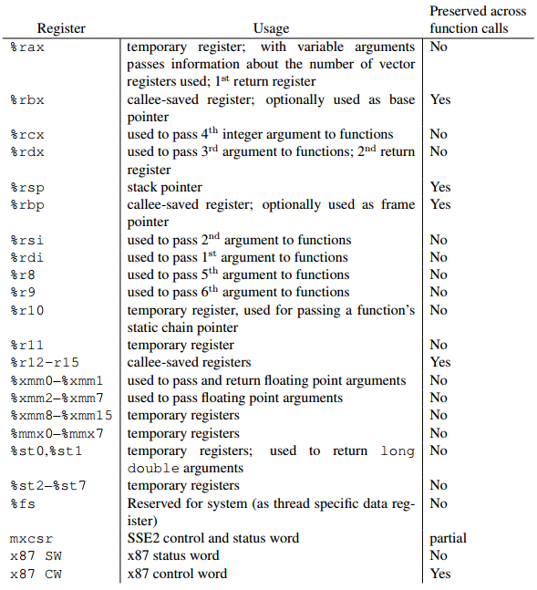
https://stackoverflow.com/questions/38335212/calling-printf-in-x86-64-using-gnu-assembler

; Example using scanf/printf
; stolen from https://sites.google.com/site/progyumming/asm/printf-and-scanf
; Modified by Kenton Groombridge to make pie compliant, and fix exit crash
; assemble with: nasm -f elf64 welcome.asm
; link with:
; ld -pie -z noexecstack -e _start -dynamic-linker /lib64/ld-linux-x86-64.so.2 -o welcome welcome.o -lc

BITS 64

default rel ; default to IP (instruction pointer) relative memory access

extern printf, scanf ; external functions that will be used

GLOBAL _start – Make the _start label global

section .text – program code

_start:
lea rdi, [yourname]
mov al, 0 ; number of floating point arguments
call printf wrt ..plt

lea rdi, [scanstring]
lea rsi, [buf]
mov al, 0 ; number of floating point arguments
call scanf wrt ..plt

lea rdi, [welcome]
lea rsi, [buf]
mov al, 0 ; number of floating point arguments
call printf wrt ..plt

mov rax, 60 ; exit syscall
mov rdi, 0 ; 0 in a Linux shell means all worked well
syscall ; perform exit syscall

SECTION .bss – uninitialized data section
buf: resb 4096

SECTION .data – initialized data section
yourname: db "Your name: ", 0
welcome: db "Welcome %s!", 0xa, 0
scanstring: db "%s"

/* Example using read/write syscall using GNU assembler (as)
* Written by Kenton Groombridge
* assemble with: as welcome.s -o welcome
* link with:
* ld -pie -z noexecstack -e _start -dynamic-linker /lib64/ld-linux-x86-64.so.2 -o welcome welcome.o -lc
*/

.intel_syntax noprefix # Default for GNU as is ATT syntax

.global _start # Make the _start label global

.section .text # program code

_start:
mov eax, 1 # Write syscall, signed extended to all 64 bits
lea rsi, yourname[rip] # Load PC relative address in rsi
mov rdi, 1 # stdout
mov rdx, OFFSET yourname_len # Length of message to write
# The OFFSET keyword is pretty stupid IMHO
# If not used, then gas looks at this as an
# address
syscall

mov eax, 0 # Read syscall, singed extended to all 64 bits
lea rsi, buf[rip] # Load PC relative address of buf in rdi
mov rdi, 0 # stdin
mov rdx, 4096 # Read up to amount
syscall

dec ax # decrement the length by one
# bascially removes newline
mov buf_len[rip], ax # Save the low order 16 bits to buf_len
# No sense in saving more since buf
# is limited to 4096

mov eax, 1 # Write syscall, signed extended to all 64 bits
lea rsi, welcome[rip] # Load PC relative address in rsi
mov rdi, 1 # stdout
mov rdx, OFFSET welcome_len # Length of message to write
syscall

mov eax, 1 # Write syscall, signed extended to all 64 bits
lea rsi, buf[rip] # Load PC relative address in rsi
mov rdi, 1 # stdout
mov rdx, buf_len[rip] # Length of what was entered in buffer
syscall

mov eax, 1 # Write syscall, signed extended to all 64 bits
lea rsi, lastpart[rip] # Load PC relative address in rsi
mov rdi, 1 # stdout
mov rdx, OFFSET lastpart_len # Length of message to write
syscall

mov rax, 60 # exit syscall
mov rdi, 0 # 0 in a Linux shell means all worked well
syscall # perform exit syscall

.section .bss # uninitialized data section
.lcomm buf, 4096
.lcomm buf_len, 2

.section .data # initialized data section
yourname: .ascii "Your name: "
.set yourname_len, . - yourname
welcome: .ascii "Welcome "
.set welcome_len, . - welcome
lastpart: .ascii "!\n"
.set lastpart_len, . - lastpart
NASM stuff (https://www.nasm.us/):

Allocating initialized data (.rodata, .data):

db – define byte (8 bits)
dw – define word (16 bits)
dd – define double word (32 bits)
dq – define quad word (64 bits)

Example:

section .rodata
message: db "The number you entered is: %d", 0x0a, 0
message_len equ $ - message # Length of message

section .data
align 4 ; align on 4-byte boundary to optimize data access
error_code: dq 0
buffer: times 1000 db 0 ; Create a 64 byte buffer that is zeroed out
Allocating uninitialized data (.bss):

resb – reserve byte (8 bits)
resw – reserver word (16 bits)
resd – reserver double word (32 bits)
resq – reserver quad word (64 bits)

Example:

section .bss
buffer: resb 64 ; 64 byte buffer

Relative memory access for relocatable code

NASM defaults to DEFAULT ABS which means to not use program counter (PC) relative code.

Use directive at beginning of code to make all memory access program counter (PC) relative:

default rel

-or-

Specify each memory access instruction to make PC relative:

lea rdi, [rel yourname]

Saving data to a memory location when the target size is unknown:

mov QWORD [rel error_code], -1

BYTE – 8 bits
WORD – 16 bits
DWORD – 32 bits
QWORD – 64 bits
GNU as (gas) stuff (https://ftp.gnu.org/old-gnu/Manuals/gas-2.9.1/html_chapter/as_7.html)

Allocating initialized data (.rodata, .data):

.byte – 8 bits
.word – 16 bits (equivalent to .short and .hword on 64 bit systems)
.long – 32 bits
.quad – 64 bits

.ascii – non-null terminated ascii string
.asciz – null terminated ascii string

Example:

.section .rodata

message1:
.ascii "The number you entered is: %d\n" # Many escape sequences allowed
.set message1_len, . - message1 # length of the message1 string

message2:
.asciz "The number you entered is: %d\n" # Many escape sequences allowed
.set message2_len, . - message2 # length of the message2 string

.section .data
error_code: .zero 8 # Reserve eight bytes and zero it out.

mybyte:
.byte 0x01 /* 8-bit variable */

.align 1 /* Align to a 2-byte (2^1) boundary */
myword:
.word 0x0123 /* 16-bit variable */

.align 2 /* Align to a 4-byte (2^2) boundary */
mylong:
.long 0x01234567 /* A 32-bit variable */

.align 4 /* Align to a 16-byte (2^4) boundary */
myquad:
.quad 0x0123456789 /* A 32-bit variable */

buffer: # Create a 64 byte buffer that is zeroed out
.rept 64
.byte 0
.endr

Allocating uninitialized data (.bss):

Example:

.section .bss
.lcomm buffer, 64 # 64 byte buffer

Relative memory access for relocatable code

Specify each memory access instruction to make PC relative:

lea rdi, yourname[rip]

There doesn’t appear there is a global way of doing this with GNU as at this time.

Saving data to a memory location when the target size is unknown:

mov QWORD PTR error_code[rip], -1

BYTE PTR – 8 bits
WORD PTR – 16 bits
DWORD PTR – 32 bits
QWORD PTR – 64 bits

