Fighter Jet

# Description

# Overview

We plan to pull together a prototype 3D aircraft shooter using the Unity game engine utilizing free assets and scripts written in C# based on our knowledge and findings.

## Function

1. **Main Interface**

When user open the software, it shows a the main interface as follows:

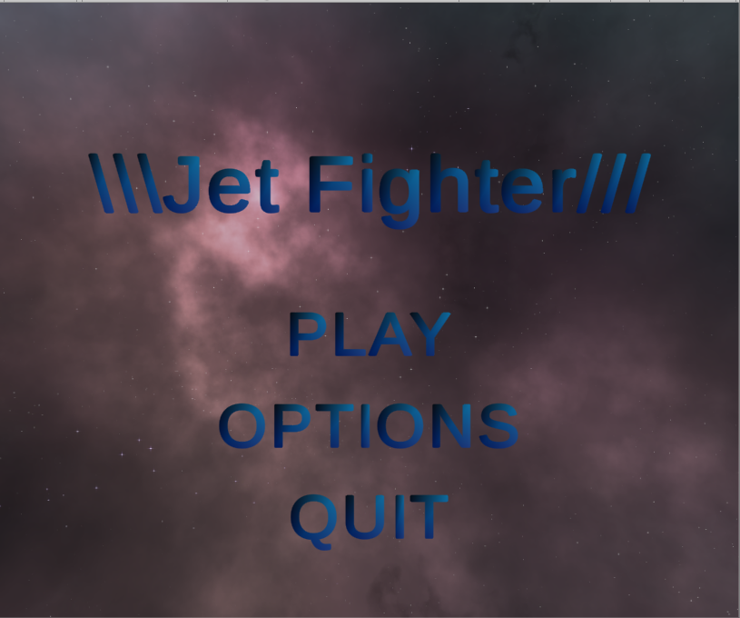

1. **“Options” interface**

If you want to set up volume, click into “OPTIONS” button and adjust it.

This is a main interface for “OPTIONS”

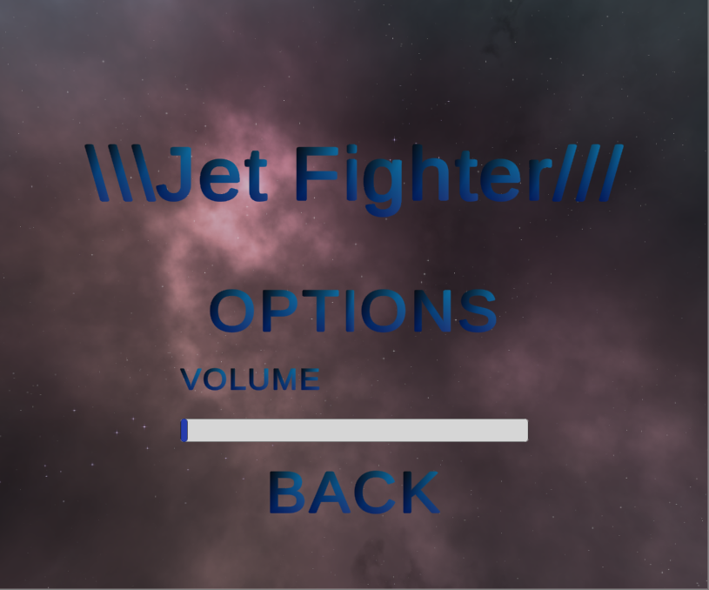

1. **Interface to play**

Then you can play immediately. Click “PLAY” button:

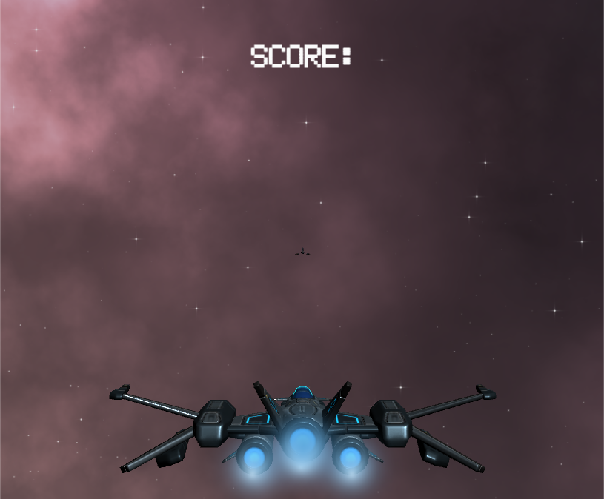

After that you can experience the game.

1. USE CASE DIAGRAM:

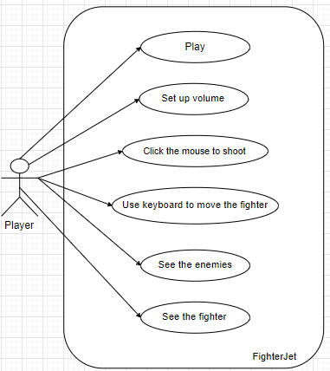

1. Use case descriptions

|  |  |
| --- | --- |
| Title | Play |
| Descriptions | Left click the mouse to shoot the enemies, use buttons A, S, D, W to move the fighter, press or hold the SPACEBAR to speed up. |
| Actor | Player, enemies |
| Pre-Condition | Press the appropriate keys to get respond from the game |
| Post-Condition | The fighter respond as commanded |