EXERCISE 1

1.

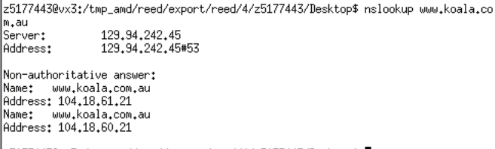

The IP address of [www.koala.com.au](http://www.koala.com.au) is 129.94.242.45.

We can know from the picture above is that this website only has one IP address, The reason of having serval IP addresses is the load-balancing technology. For example, One of the largest website in the world like [www.youtube.com](http://www.youtube.com) has 8 IP addresses to avoid overloading and increase availability. When people all over the world want to watch the videos from youtube at the same time, different IP can handle them well because there will be different servers to respond.

2.

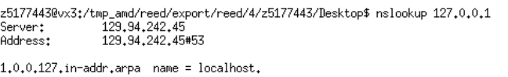

The name of this IP address is localhost.

127.0.0.1 is loopback address which refers to local machine and usually is used to network testing.

And IP will send message to itself when seeing localhost. And all IP addresses are the same which are 127.0.0.1.

EXERCISE 2

Not reachable:

[www.getfittest.com.au](http://www.getfittest.com.au)

[www.hola.hp](http://www.hola.hp)



I think these two websites does not exist.

We can not access these website from our own machine.

[www.kremlin.ru](http://www.kremlin.ru)

We can access this website from our own machine so this website exists.

Therefore, I think this website refuses to respond the request form ping, which means that this machine disabled the ICMP protocol which is used by ping due to security reasons.

And all the other websites are reachable.

<http://www.cse.unsw.edu.au>

<http://www.mit.edu>

<http://www.intel.com.au>

[www.tpg.com.au](http://www.tpg.com.au)

<http://www.telstra.com.au>

[www.amazon.com](http://www.amazon.com)

<http://www.wikileaks.org>

[www.tsinghua.edu.cn](http://www.tsinghua.edu.cn)

http://www.tsinghua.edu.cn [www.kremlin.rus](http://www.kremlin.rus)

EXERCISE 3

1. 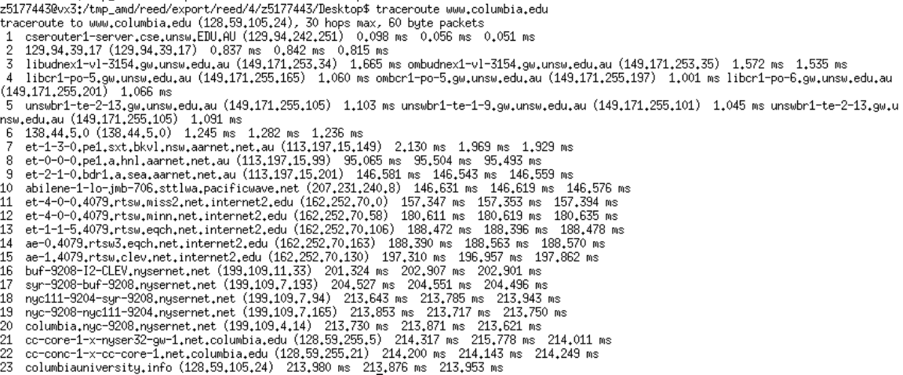

There are 23 routers between my workstation and [www.columbia.edu](http://www.columbia.edu).

5 routers are part of UNSW network, which are the first five(1,2,3,4,5)number.

Between number 7th et-1-3-0.pe1.sxt.bkvl.nsw.aarnet.net.au(113.197.15.149) and number 8th et-0-0-0.pe1.a.hnl.aarnet.net.au (113.197.15.99) these two routers, packets cross the pacific ocean, because there is a relatively huge delay increase which happened between these two routers, which may be caused by the distance. It spends more time when response to my station compared to the other. And I also find that No.10 IP is in America and No.9 IP is in Australia by using whois command. Maybe they cross the Pacific Ocean.

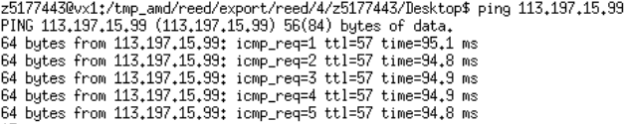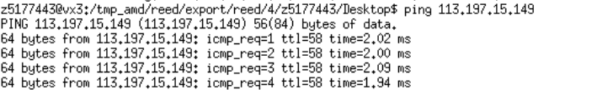

2

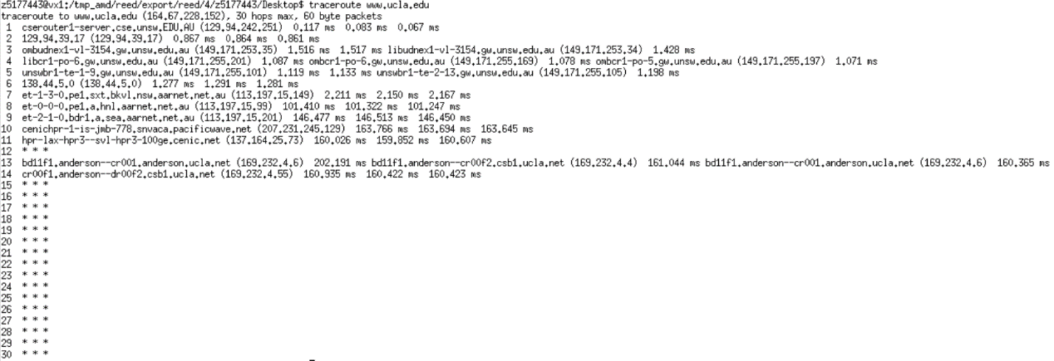

Traceroute to [www.ucla.edu](http://www.ucla.edu) from my machine

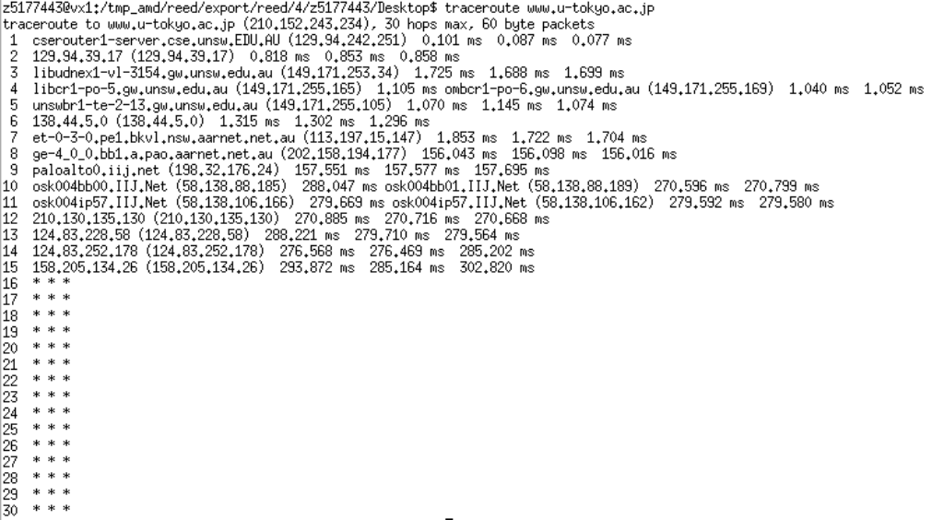

Traceroute to [www.u-tokyo.ac.jp](http://www.u-tokyo.ac.jp) from my machine

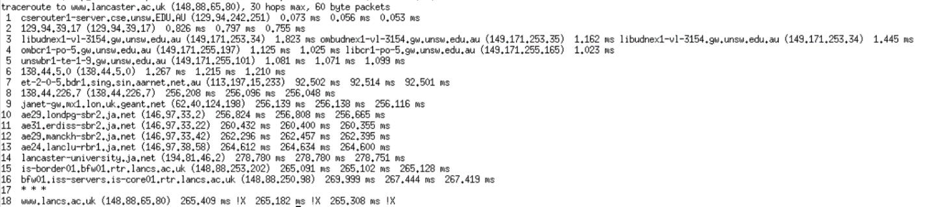

Traceroute to [www.lancaster.ac.uk](http://www.lancaster.ac.uk) from my machine

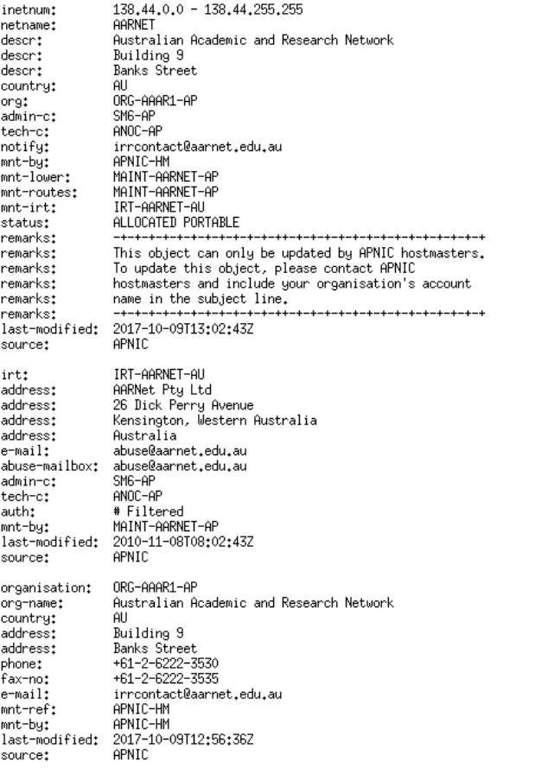

138.44.5.0 is the router which path starts to diverge and it is AARNet Network Operation Center in Australia. The picture above shows the details of this IP which I use ‘whois’ command.

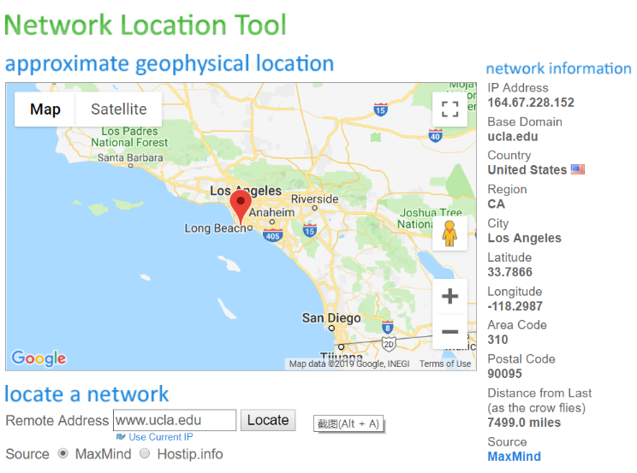

This is the location of www.ucla.edu which I get from Network Location Tool website, and the rest of these two are similar.

10569.8 miles [www.lancaster.ac.uk](http://www.lancaster.ac.uk)

7499.0 miles [www.ucla.edu](http://www.ucla.edu)

4908.7 miles [www.u-tokyo.ac.jp](http://www.u-tokyo.ac.jp)

Therefore, the number of hops on each path is not proportional to the physical distance.

3.

<http://www.speedtest.com.sg/tr.php>

IP：209.15.13.134

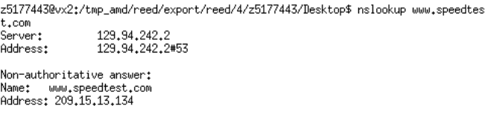

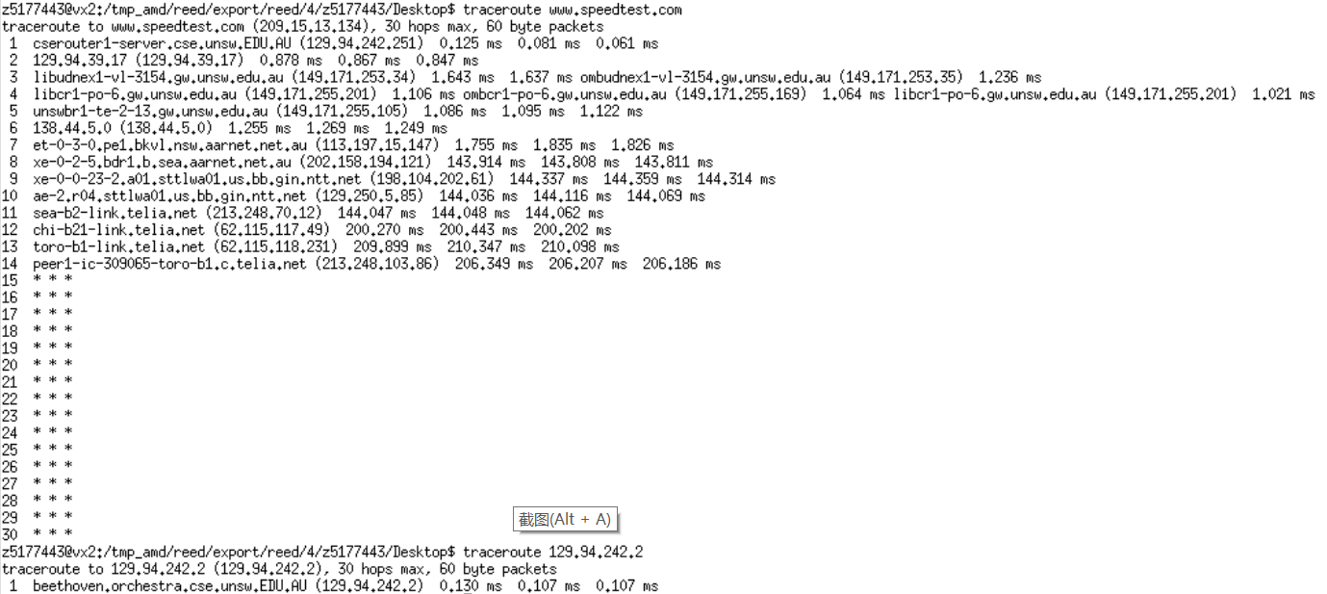

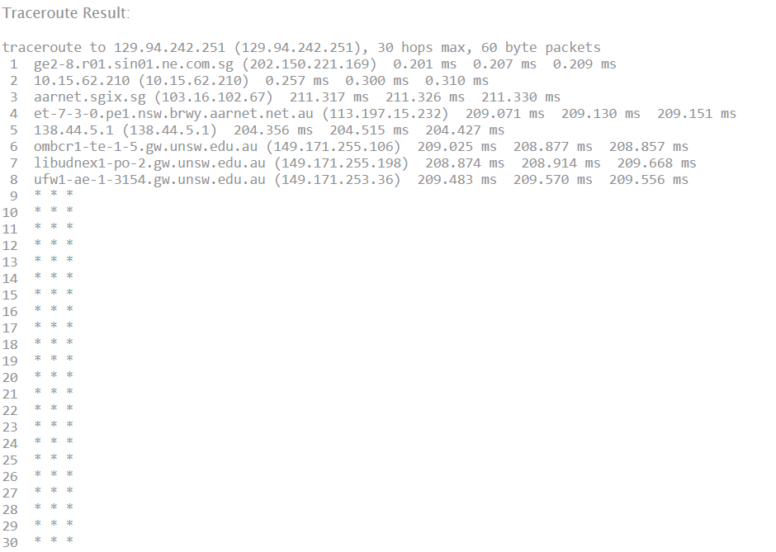

<https://www.telstra.net/cgi-bin/trace>

IP:203.36.190.8

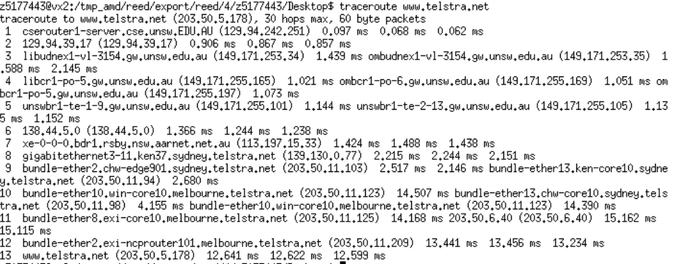

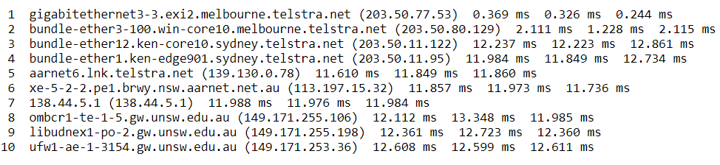

No. It is obvious that the reverse part does not go through the same routers.

Yes. And one website may have many IP address which aim to allocate different interfaces. For every route, it has its own rules and they are determined by default routing, neighbouring networks, metrics and so on. we can see the same IP address when observing common routers along the path. The other reason is that the path is different when trace back form these website to our IP.

EXERCISE 4

1.

Distance:

Brisbane 736 km

Manila: 6260km

Berlin: 16084km

Propagation delay:

T(Brisbane) = 736 * 1000 / 3 * m/s = 2.45ms

T(Manila) = 6260 * 1000 / 3 * m/s = 20.8ms

T(Berlin) =16084 * 1000 / 3 * m/s = 53.6ms

From the corresponding *avg.txt files:

min RRT(Brisbane) = 17.431ms

min RRT(Manila) = 341.482ms

min RRT(Berlin) = 283.792ms

Ratios:

R(Brisbane) = 7.11

R(Manila) = 16.39

R(Berlin) = 5.29

This picture shows the y-axis values are greater than 2, which proves that there may be a congestion in the network and there are many routers along the path

The reason why this ratio is always > 2 is that the speed of packets traveling can not be full light speed because traveling passes through some medium. Another reason is that SP-level routing may not find the least cost path.

2

It will vary over time.

This is because each time the processing and queuing delay are different. This value is relatively random.

3

No, it is not in Switzerland.

We can get the IP address of this website which is 104.20.228.42 using the command ping.

Then using the whois 104.20.228.42 command I get that this website does not from Switzerland but from CloudFlare Company which is a company form the United States.

4.

Transmission delay and processing delay depend on the packet size, while other two do not rely on that. The link such as cable decides the propagation speed and the queuing delay depends on the congestion level. And it will increase along with more traffic in our network.

Processing delay depends on the speed of CPU and packages size.

Transmission delay depends is proportional to the package size and the R value(D = L/R).

