Exercise 3

Question1：

The status code is 200 and the phased which returned from server is OK.

Question2：

Last modified date：Tuesday, 23 September 2003 05:29.00 GMT

Yes, the respond message has a DATE header.

These two fields show the same content in this case. I think the last modified time is the latest time when this website was edited. And the date shows the last time when the message was sent, it is the time the website obtained by users.

Question3：

Persistent. We can find the ‘keep-Alive’ from the connection field and in the same time they all use HTTP 1.1 which is persistent by default.

Question4：

73 bytes.

We can easily find it from content-length field of response message.

Question5：

Text / html data.

<html>

Congratulations. You’ve downloaded the file lab2-1.html!

</html>

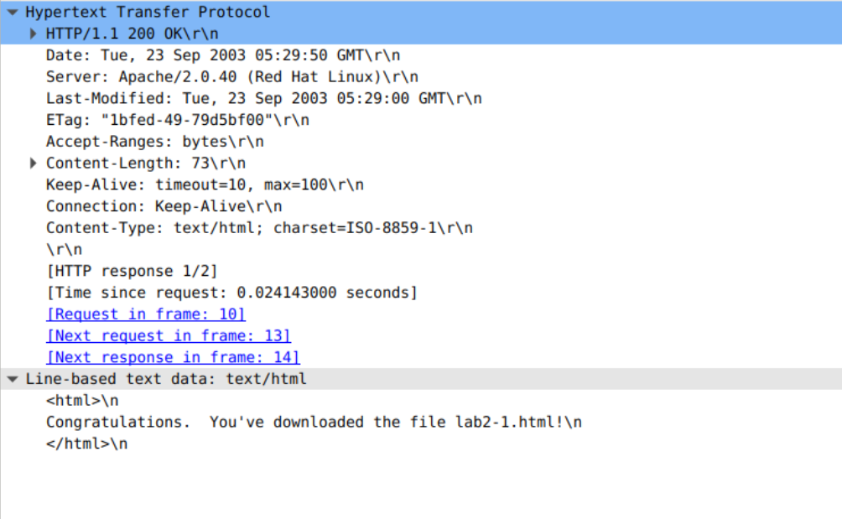

http is readable for humans but relatively not safe.

Exercise 4

Question1:

No, there is no “IF-MODIFIED-SINCE” line in the HTTP GET.

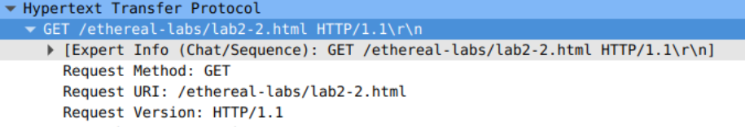

Question2:

Yes. The last modified time is Tuesday, 23 September 2003 05:35:50 GMT



Question3:

Yes. “Tue, 23 Sep 2003 05:35:00 GMT” and “lbfef-173-8f4ae900” respectively from these two fields.



Question4:

The status code is 304 and the response phrase is Not Modified.

Because the Get request is conditional. It can be sent back when the last modified time is later than the request time. This limit can save resources in some extent because there is no need for downloading the page when it hasn’t been changed.



Question5:

“1bfef-173-8f4ae900”.

ETag is the abbreviation of the entity tag which is used for caching resources and conditional requests. And ETag allows the client to perform cache negotiation which makes the cache more efficient and saves bandwidth.



No, it hasn’t change.