EXERCISE3

1:

IP:150.203.161.98. type: A

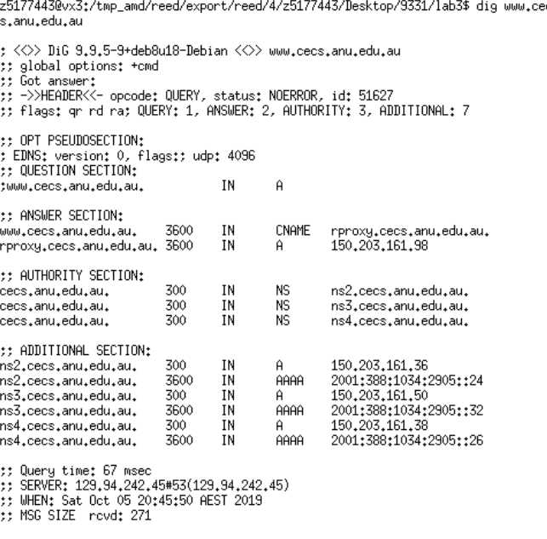

2.

rproxy.cecs.anu.edu.au.

Because the canonical name is hard to understand and remember. The alias name is more readable and easy to remember for human.it is also easy for user when run multiple services from a simple address.

3.

the Authority section: it is the records for authoritative servers, which contains NS resource records for cecs.anu.edu.au domain name. And it has 10 authoritative server name which is r.au, d.au, v.au and so on.

The additional section: It contains the IP address of the authoritative server and AAAA type is to resolve domain name to a specified IPv6 address.

4.

IP: 129.94.242.2

5.

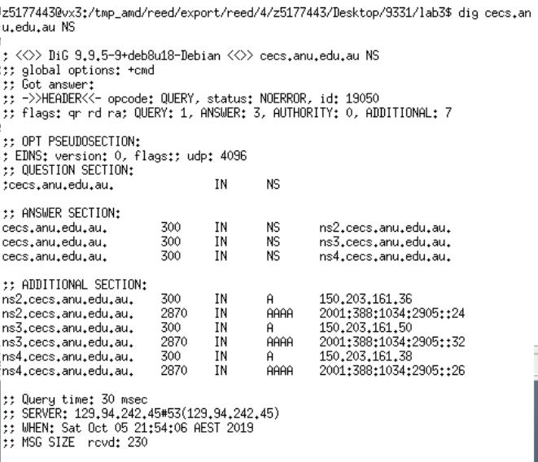

DNS nameserver: ip

ns2.cecs.anu.edu.au, 150.203.161.36

ns3.cecs.anu.edu.au, 150.203.161.50

ns4.cecs.anu.edu.au, 150.203.11.38

Type: NS

dig cecs.anu.edu.au NS

6.

DNS name: webserver.seecs.nust.edu.pk

Type: PTR

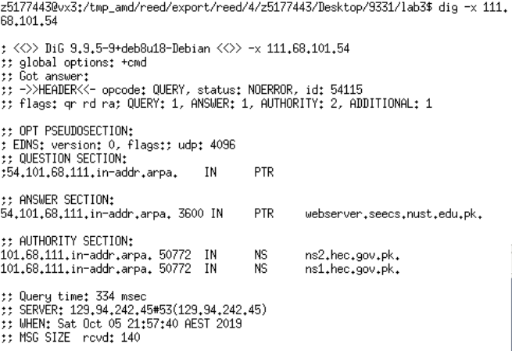

7.

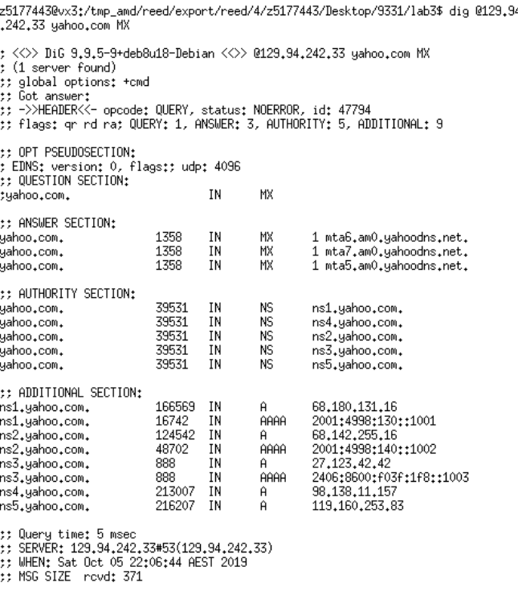

NO. Because the server has no authority for the Yahoo domain.

8.

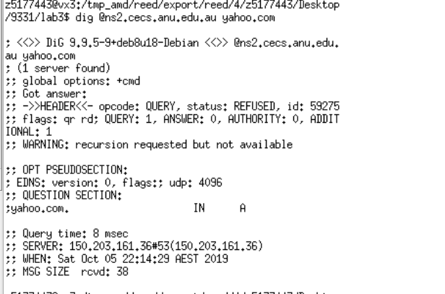

The request is refused. we can not get a response when trying ANU name server for yahoo mail servers. One reason is that the queries which are not from ANU servers are blocked by the secure protection.

9.

Firstly we need to know the nameserver of yahoo.com by using ns command

Then we have to use command mx to find email server.

dig yahoo.com ns

dig @129.94.242.33 yahoo.com mx

10.

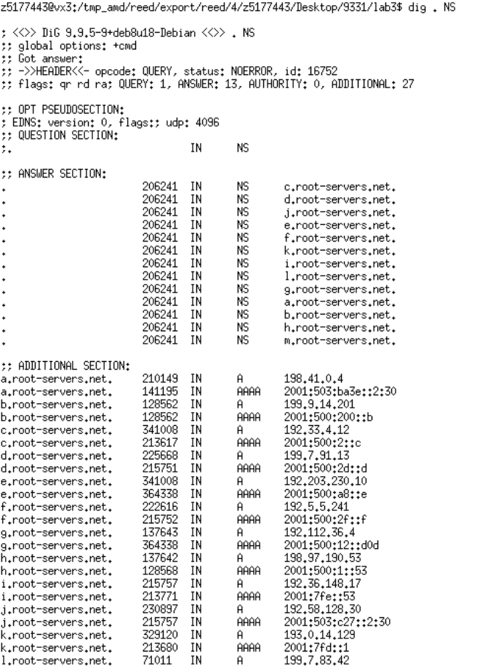

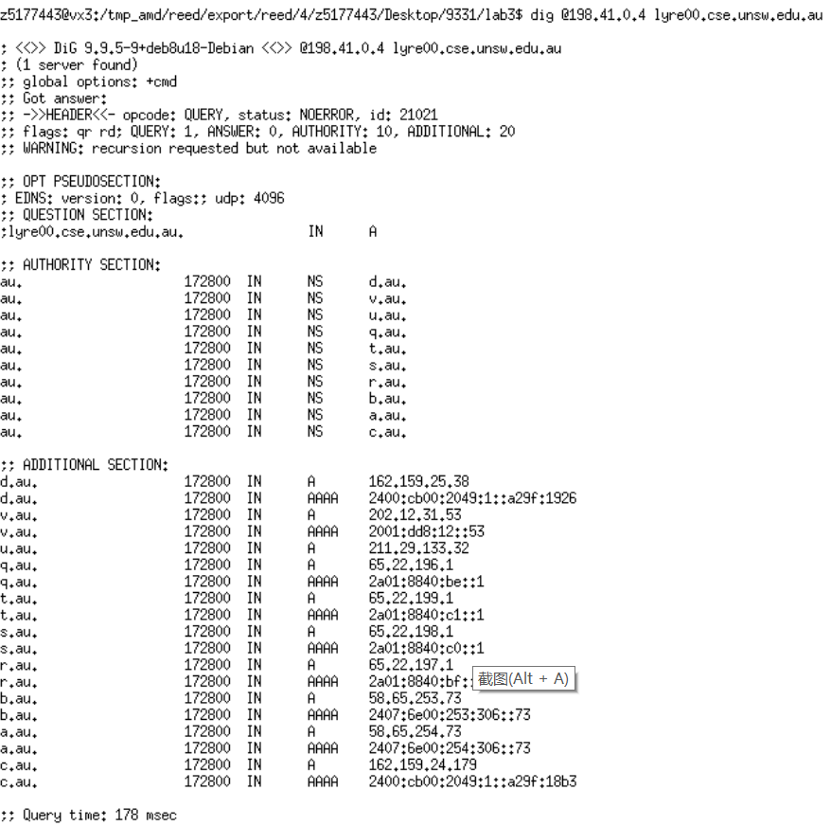

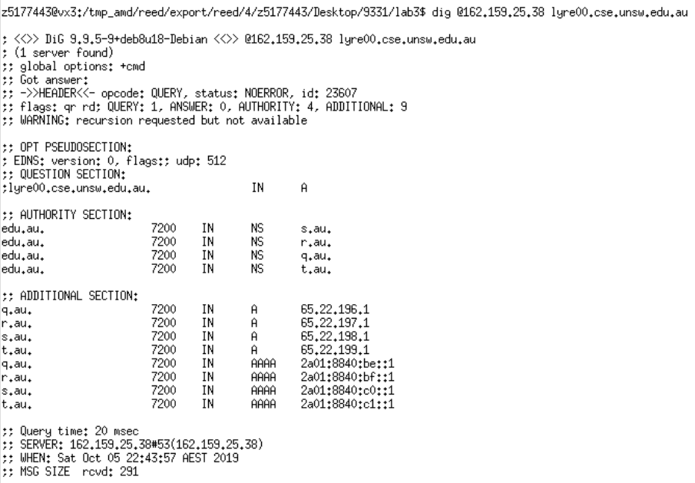

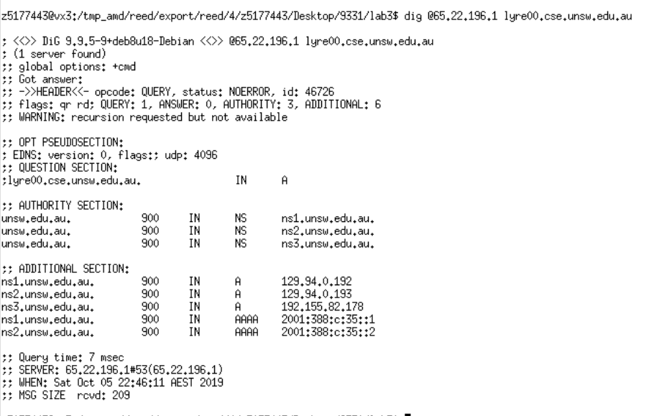

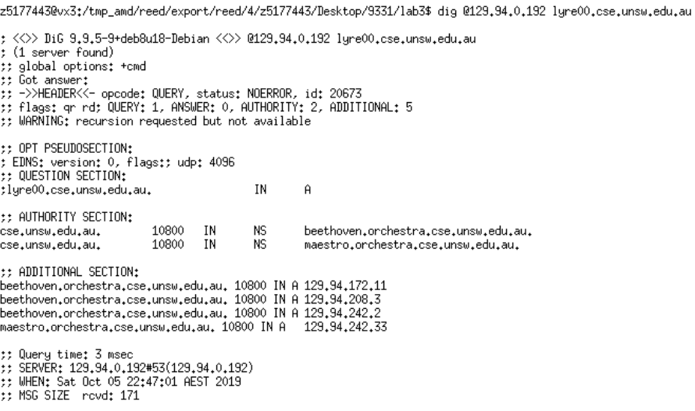

Total queries:5

11.

Yes, it can have several names and/or IP addresses associated with it. A physical machine can have several internet interfaces and each interface can have some IP addresses all the time.