Q1

1.

IP of gaia.cs.umass.edu: 128.119.245.12

port number of gaia.cs.umass.edu:80

IP address of client: 192.168.1.102

port number of client: 1161

2.sequece number:232129013

3.

|  |  |  |  |  |  |
| --- | --- | --- | --- | --- | --- |
| Sequence Number | Segment Sent Time(s) | ACK Receiving Time(s) | RRT  (s) | EstimatedRTT(s) | Length  (bytes) |
| 232129013 | 0.026477 | 0.053937 | 0.027460 | 0.027460 | 565 |
| 232129578 | 0.041737 | 0.077294 | 0.035557 | 0.028472 | 1460 |
| 232131038 | 0.054026 | 0.124085 | 0.070059 | 0.033670 | 1460 |
| 232132498 | 0.054690 | 0.169118 | 0.114428 | 0.043765 | 1460 |
| 232133958 | 0.077405 | 0.217299 | 0.139894 | 0.055781 | 1460 |
| 232135418 | 0.078157 | 0.267802 | 0.189645 | 0.072514 | 1460 |

EstimatedRTT = 0.875*EstimatedRTT + 0.125 *SampleRTT

4.

Already answer in the third question.

5.

The minimum amount of available buffer space advertised at the receiver for the entire trace is 5840, which is equal to 4 MSS packets of 1460 bytes. The lack of receiver buffer space doesn’t throttle the sender. When the receiver window is at lowest value, the sender may be constrained by congestion window. And in another part of the trace, when the congestion window has grown up to a reasonable size, the receiver window is quite large. Therefore, the lack of receiver buffer space doesn’t throttle the sender.

6. 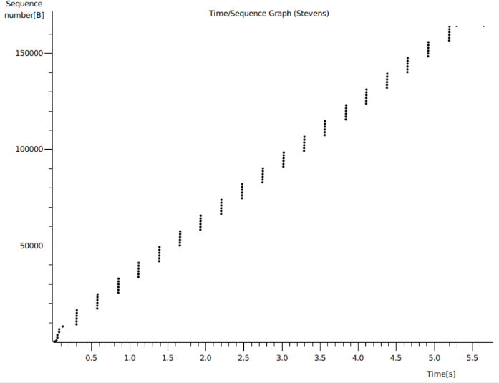

We can infer from the picture that the sequence number always increased, and as the time travels there were no packets in the same sequence number which shows that there were no retransmitted segments. the sequence number of these retransmitted segments will be smaller than their neighbouring segments when exists retransmitted segments.

7.

The receiver typically acknowledge 1460 bytes data in an ACK, which can be determined by investigating the increment of ACK number. We can find that the ACK with the Acknowledge field 232166981 was actually acknowledging two segments with 232164061 and 232165521

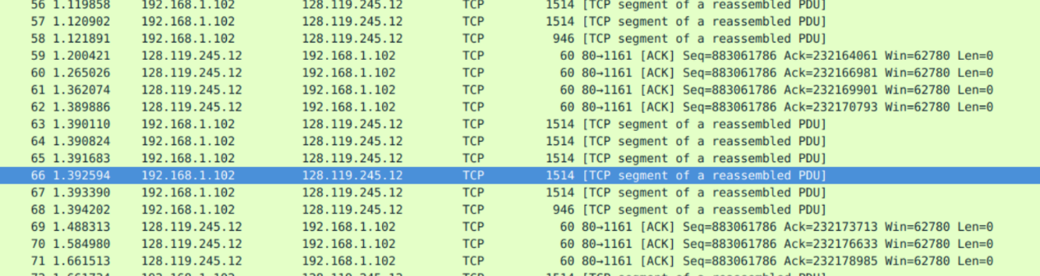

8.

We can conclude from the pictures above that the amount of data is 164091 - 1 =164090 bytes and the time is 5.455830 - 0.026477 = 5.4294s.

Then we can calculate that throughput = 164090 / 5.4294 = 30.222 KB/sec

Q2

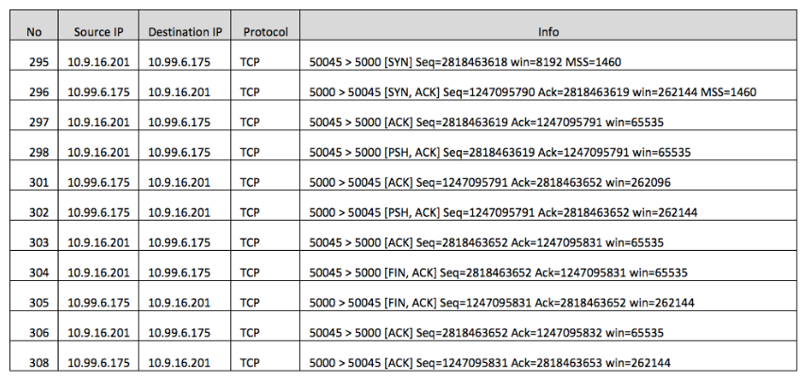

1.

Sequence number:2818463618

2.

Sequence number: 1247095790

Acknowledgement value: 2818463619

The server adds 1 to the sequence number of SYN segment because SYN segment accounts for 1 and no data has been transmitted.

3.

Sequence number: 2818463619

Acknowledgement value: 1247095791

NO, it does not contain any data because 1247095791-1247095790 = 1 which is the ack length

4.

Both the client and the server has done the active close and it is a simultaneous close.

We can infer from the picture that both of them have sent the FINACK segment to each other as their last sending segment, and the ack number is not increased by 1 which indicates that it is a simultaneous close.

5.

Client side:

initial sequence number: 2818463618

final ack number:2818463653

therefore, the data is 2818463653-2818463619- 1(syn)-1(fin) = 33bytes

server side:

initial sequence number: 1247095790

final ack number: 1247095832

therefore, the data is 1247095832-1247095790- 1(syn)-1(fin) =40bytes