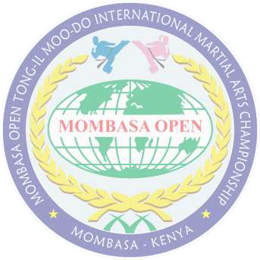

|  |  |  |
| --- | --- | --- |
|  | **WORLD TONG-IL MOO-DO FEDERATION** |  |
| **UNIFIED MARTIAL ARTS** |

MOMBASA OPEN TONG-IL MOO-DO INTERNATIONAL MARTIAL ARTS CHAMPIONSHIP 2024 15TH TO 28TH AUGUST 2024 AGA KHAN ACADEMY MOMBASA   
 TOURNAMENT REGISTRATION FORM - INDIVIDUAL PARTICIPANT   
Please fill this form in capital letters   
Family Name ______________________ Given names __________________________________   
Gender____________ Birthday ______________ Age ______________ Weight ____________   
Nationality _____________________________________________________________________   
Postal Address__________________________________________________________________   
Email _________________________________________________________________________   
Telephone _____________________________________________________________________   
Martial Arts Style ________________________________________________________________   
Instructor __________________________________________ Rank ______________________   
Which Category (Please put check mark)   
Forms Competition: Individual Form { }   
Special Techniques: Individual Special Techniques { }   
Free Sparring: Individual participation { }   
 Competitor’s waiver and release   
In consideration of the acceptance of my entry in the Mombasa Open Tong-IL Moo-Do International Martial Arts Championship 2024. I do hereby release and discharge the organizers of the Mombasa Open Tong-IL Moo-Do International Martial Arts Championship 2024 and its affiliates directly or indirectly from all claims or damages, demands or actions whatsoever in any manner arising from or growing out of my participation in, or while traveling to and from the above-mentioned martial arts tournament. I further attest and verify that I have obtained the necessary medical clearance from my doctor, that I have full knowledge of the risks involved and that I have given my consent for the use of my name and photographs and or videos for publicity purposes.

___________________________________________ Competitor’s complete names

________________________ _________________ Competitor’s Signature Date

________________________________________________________________________________________________