**Bone Mechanobiology**

Kyle Cripps a, Erin Cresswell b,c, Christopher Hernandez b,c

a Department of Mathematical Sciences, El Camino College, Torrance, CA 90506

b Department of Mechanical and Aerospace Engineering, Cornell University, Ithaca, NY 14853

c Menig School of Biomedical Engineering, Cornell University, Ithaca, NY 14853

**ABSTRACT**

Bone is often a source of inspiration in the field of materials science because of its optimized structure and unique adaptive functionality. Bone is both lightweight and strong, allowing for mobility while minimizing fracture risk. Additionally, bone has the unique ability to change its structure in response to the mechanical stress and strain delivered by its environment. For example, physical exercise leads to increased bone density because stronger bone is required to withstand rigorous physical exertion. Conversely, lack of physical exercise will lead to resorption of bone that is not being used. While this behavior of bone has been observed and studied at the macroscopic level, little is known about how bone responds at the local, microscopic level. We can study this behavior by using a specialized device to apply cyclic mechanical loads to vertebral bone in live animals in order to stimulate bone formation. Using high resolution micro-computed tomography (micro-CT) imaging and finite element modeling (FEM) of the vertebrae, we are able to approximate the mechanical stress or strain that each region of bone experiences during bouts of mechanical loading. Using high resolution fluorescent imaging we are also able to identify locations of bone formation and thus are able to spatially associate bone formation and mechanical stress or strain at the microscopic level. Results showed a correlation between increased bone formation and higher SED at the periosteal surface of the vertebrae, but there appeared to be no correlation between bone formation and SED at the endosteal surface. Our results suggest that there may be biological factors that have a greater influence on bone formation responses than mechanical stimulation. Better understanding how bone behaves at the microscopic level may allow for the development of pharmaceuticals that can target specific bone forming pathways and facilitate bone growth in patients with osteoporosis.

\_\_\_\_\_\_\_\_\_\_\_\_\_\_\_\_\_\_\_\_\_\_\_\_\_\_\_\_\_\_\_\_\_\_\_\_\_\_\_\_\_\_\_\_\_\_\_\_\_\_\_\_\_\_\_\_\_\_\_\_\_\_\_\_\_\_\_\_\_\_\_\_\_\_\_\_\_\_

**INTRODUCTION**

Bone is a unique material because it is mechano-responsive, meaning that it has the ability to change physically in response to mechanical stimuli. Within bones is a complex network of specialized cells that are responsible for the formation and removal of bone tissue. Osteoblasts are bone cells that produce new bone matrix, while osteoclasts remove bone where it is no longer needed. It is believed that osteocytes are instrumental in the regulation of bone formation because they are able to sense mechanical stimuli and respond by sending inhibitory or promotion signals to osteoblasts and osteoclasts. Osteocytes in regions of relatively low mechanical stress or strain will send signals that inhibit bone formation, while osteocytes in regions of high mechanical stresses and strains will send signals that promote bone formation. Therefore, regions of bone that experience relatively high magnitudes of mechanical loading will form more new bone than regions of the same bone that experience relatively low magnitudes of mechanical loading.1  Consequently, regions of bone under high stresses and strains will better be able to resist deformation and fractures.

Few in vivo studies have been done on healthy bone at the microscopic level. By conducting experiments on live animals, we can gain a deeper understanding of the processes that regulate bone growth in healthy bone. Once a deeper understanding of healthy bone is developed, it will be easier to conduct studies on osteoporotic bone and to identify differences in how osteoporotic and healthy bone behaves. With these differences identified, bone forming pathways could potentially be targeted by drugs that can allow for the facilitation of bone growth in patients with osteoporosis.

This study focuses specifically on the effects of mechanical loading on the caudal 8 (Cd8) vertebra in rats. Vertebrae are comprised of a dense exterior cortical shell (“compact bone”) filled with a porous cancellous interior (“spongy bone”) and bone marrow. On the interior surface of the cortical shell is a thin membrane called the endosteum, under which the endosteal surface of the cortical shell is found. Likewise, on the exterior surface of the cortical shell is the periosteum, under which the periosteal bone surface can be found (See figure 1). The endosteum and periosteum provide nutrients for the bone cells that reside at the endosteal and periosteal bone surfaces.

C:\Users\Kyle\Google Drive\CCMR_REU_2016\Bone_Mechanobiology_Project\Paper and Presentation\Pics\1UV_0501_RTL06_R53_C8_gray_Coarsened_Cropped.tif

Trabecular or Cancellous Bone

Cortical Bone

Endosteal Surface

Periosteal Surface

Figure 1: Transverse cross section of the caudal 8 vertebrae of a rat

In this study, we used images of bone formation and finite element modeling to analyze the mechano-responsiveness of bone at the endosteal and periosteal surfaces of the Cd8 vertebra in rats.

\_\_\_\_\_\_\_\_\_\_\_\_\_\_\_\_\_\_\_\_\_\_\_\_\_\_\_\_\_\_\_\_\_\_\_\_\_\_\_\_\_\_\_\_\_\_\_\_\_\_\_\_\_\_\_\_\_\_\_\_\_\_\_\_\_\_\_\_\_\_\_\_\_\_\_\_\_\_

**METHODS**

*In vivo mechanical loading and injection of fluorescent dyes*

Prior to mechanical loading, a fluorescent marker (oxytetracycline) was injected into all (pre-loaded and control) rat specimens. Three days later, cyclic mechanical loading was applied to the eighth caudal (Cd8) vertebrae of non-control specimens for three consecutive days (days 0, 1, and 2). Another fluorescent marker, calcein, was injected into all (loaded and control) specimens on day 5, and again on day 10. On day 14, the rat specimens were euthanized and their Cd8 vertebrae were collected for imaging.2 Wherever new bone is formed after the injections, the fluorescent markers will be trapped underneath new bone, while the fluorescent marker will be “cleaned away” by natural processes where no new bone is formed.

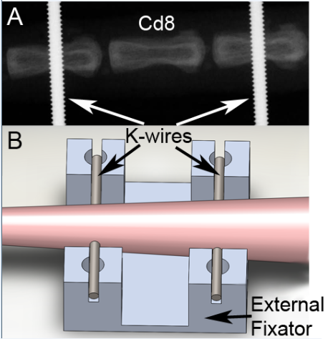

Figure 2: Device used to apply cyclic mechanical loading to Cd8 vertebrae in rats2

*Micro-CT scans and high resolution serial milling*

The Cd8 vertebrae of the specimens were cleaned and micro-CT images with a voxel resolution of 11x11x11 microns were taken. Serial milling was then used to obtain high resolution (0.7x0.7x5.0 microns) fluorescent images of the vertebrae.2 The oxytetracycline and calcein bone markers injected into the rats are known to fluoresce at different wavelengths, so for each cross sectional slice of the vertebrae, a different colored light was used to obtain each set of calcein and each set of oxytetracycline images. Because two fluorescent markers were injected at different time points prior to and following mechanical loading, we are (in theory) able to differentiate between natural bone forming events that were already in progress before loading and new bone forming events that were stimulated by mechanical loading (we were not able to implement this in our analysis due to time constraints).

*Finite Element Modeling*

Finite element models were then generated from the micro-CT images of each specimen to determine the stresses and strains at each individual bone voxel.2

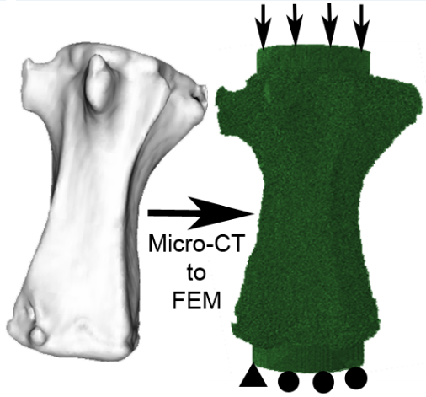

Figure 3: Finite element models were generated from micro-CT images2

*Resampling and Image Registration*

At this point, all necessary data had been acquired, but we could not conduct an analysis because our FEM, micro-CT, and bone formation (fluorescent) images were not on the same coordinate axis and did not have the same pixel size, so we could not do an analysis relating these different sets of images. This problem was easily resolved by resampling (or “resizing”) the images and image registration. Micro-CT and FEM image stacks were resampled to the same voxel size as the fluorescent images and affine registration was performed on the micro-CT and FEM image stacks to find the matrix of transformation for each specimen. Transformation matrices were then applied to the image stacks resulting in a one-to-one correspondence between each voxel in FEM, fluorescent, and micro-CT image stacks of each specimen.

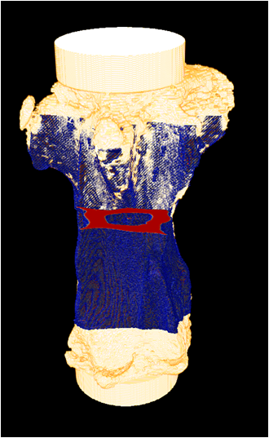

Figure 4: Micro-CT images were resampled and transformed onto the same coordinate axis as fluorescent images

*Image Processing*

Following resampling and image registration, Matlab software was written to process images and extract data to be analyzed. Some Matlab code was adapted from a previous study involving only the cancellous bone of the rat vertebrae.2

1. Prior to image processing, masks of the cancellous regions were traced so that cancellous bone could be studied separately from cortical bone.3 See figure A.
2. Cancellous masks and micro-CT bit masks were combined to remove cancellous bone and a majority of background noise from the fluorescent images. See figures B, C, D, and E.
3. Remaining artifacts were removed from the background of the image and small holes (caused by nutrient foramen) were removed from the interior of the cortical shell. See figure E.
4. A sobel edge detection algorithm was used on a bit mask of the resulting cortical shell to identify edges, resulting in two sets of edges.
5. Additional algorithms were applied to separate the endosteal and periosteal edges so that they could be analyzed separately.
6. Bit masks of endosteal and periosteal edges were combined with bone formation and FEM images to gather data relating bone formation with strain energy density at the endosteal and periosteal surfaces of each specimen. See figures F and G.

C:\Users\Kyle\Google Drive\CCMR_REU_2016\Bone_Mechanobiology_Project\Paper and Presentation\Pics\2RTL06_R53_C8_inv_inner_mask_0500_Coarsened.tif C:\Users\Kyle\Google Drive\CCMR_REU_2016\Bone_Mechanobiology_Project\Paper and Presentation\Pics\3CT_Binary_Registered_0500_Coarsened.tifFigure A : traced cancellous mask Figure B: micro-CT mask

C:\Users\Kyle\Google Drive\CCMR_REU_2016\Bone_Mechanobiology_Project\Paper and Presentation\Pics\CT_plus_cancellous_mask_Coarsened.tif Figure C: mask of cortical shell

C:\Users\Kyle\Google Drive\CCMR_REU_2016\Bone_Mechanobiology_Project\Paper and Presentation\Pics\CT_plus_cancellous_mask_Coarsened.tif C:\Users\Kyle\Google Drive\CCMR_REU_2016\Bone_Mechanobiology_Project\Paper and Presentation\Pics\1UV_0501_RTL06_R53_C8_gray_Coarsened_Cropped.tif

Figure C **(+ additional filtering)** Figure D: original image

C:\Users\Kyle\Google Drive\CCMR_REU_2016\Bone_Mechanobiology_Project\Paper and Presentation\Pics\4RTL06_R53_C8_UV_Cortical_Shell_0500_Coarsened.tif Figure E: final image of cortical shell

**(+ edge detection and fluorescent images of bone formation markers)**

C:\Users\Kyle\Google Drive\CCMR_REU_2016\Bone_Mechanobiology_Project\Paper and Presentation\Pics\6Endosteal_MsBs_0500_Coarsened.tif C:\Users\Kyle\Google Drive\CCMR_REU_2016\Bone_Mechanobiology_Project\Paper and Presentation\Pics\6Periosteal_MsBs_0500_Coarsened.tif

Figure F: Bone formation on endosteal surface Figure G: Bone formation on periosteal surface

An important measurement that we collected from our data was the amount of mineralizing surface (where new bone was formed) per bone surface (total bone surface, including newly formed bone and old bone), which will be abbreviated as MS/BS. We expect the loaded specimens to have higher MS/BS values due to the adaptive response by cells in the bone. Another important measurement we collected from our data, specifically from the finite element models (FEM), was the strain energy density (or SED) of each bone voxel. A detailed understanding of SED is not necessary: For the purposes of this paper, it is sufficient to know that higher SED values correspond with regions of higher mechanical stresses and strains, while lower SED values correspond with regions of lower mechanical stresses and strains. We expect bone forming surfaces to be at a higher SED than surfaces which did not form new bone.

\_\_\_\_\_\_\_\_\_\_\_\_\_\_\_\_\_\_\_\_\_\_\_\_\_\_\_\_\_\_\_\_\_\_\_\_\_\_\_\_\_\_\_\_\_\_\_\_\_\_\_\_\_\_\_\_\_\_\_\_\_\_\_\_\_\_\_\_\_\_\_\_\_\_\_\_\_\_

**RESULTS**

It was found that the average MS/BS of the endosteal surface in the loaded specimens was 3.34% while the average MS/BS of the endosteal surface in the control specimens was 3.20% (See figures 6 and 8). The average MS/BS of the periosteal surface in the loaded specimens was 53.01% while the average MS/BS of the periosteal surface in the control specimens was 48.60% (See figures 7 and 8).

Histograms were generated to gather the following data relating SED and bone forming and non-bone-forming surfaces of the cortical shell. Due to the nature of the histograms (having right-skewed distributions in most cases (see figure 4 below)), the geometric mean will be used to describe the data rather than arithmetic mean, which is not very representative of a skewed distribution.

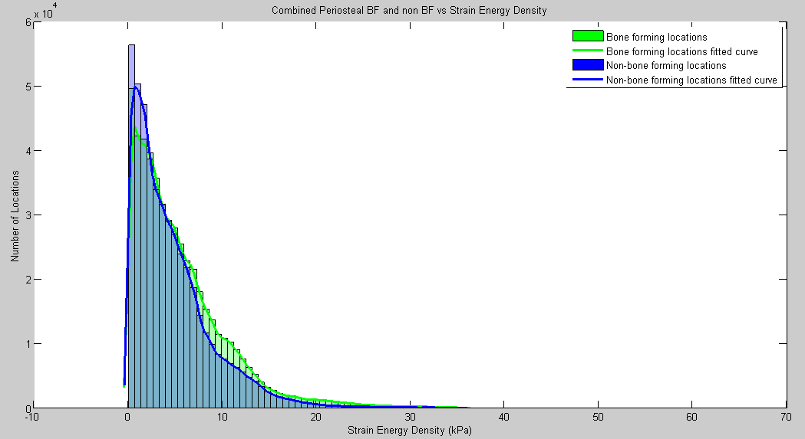

Figure 5: Right-skewed histogram of SED values at bone-forming and non-bone-forming locations on the periosteal surface

The geometric mean strain energy density (SED) at the periosteal surface was 3.34e+3 Pascals (Pa) while the geometric mean SED at the endosteal surface was 3.64e+3 Pa (See figure 9).

The geometric mean of the SED at bone forming locations on the periosteal surface was 3.29e+3 Pa while the geometric mean SED at non-bone forming locations on the periosteal surface was 2.68e+3 Pa (See figure 10).

The geometric mean of the SED at bone forming locations on the endosteal surface was 2.52e+3 Pa while the geometric mean SED at non-bone forming locations on the endosteal surface was 3.12e+3 Pa (See figure 11).

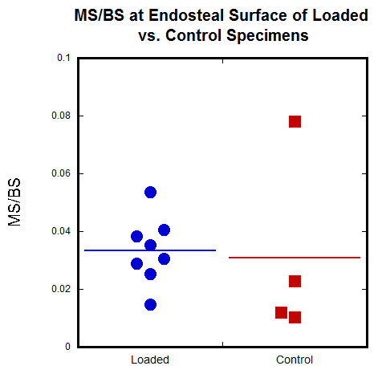 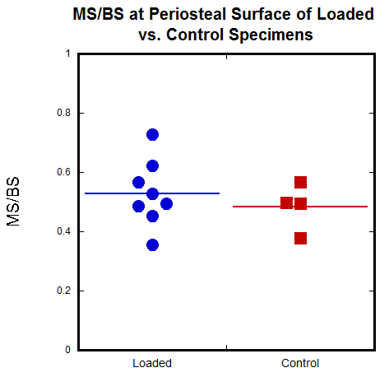

Figure 6 Figure 7

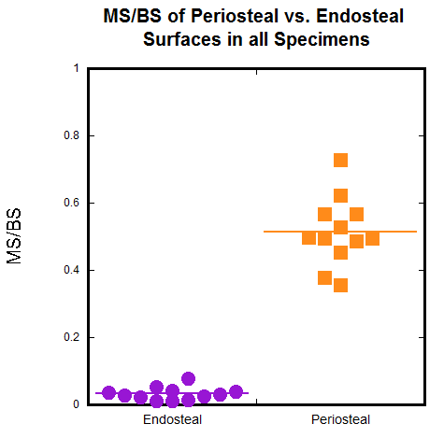 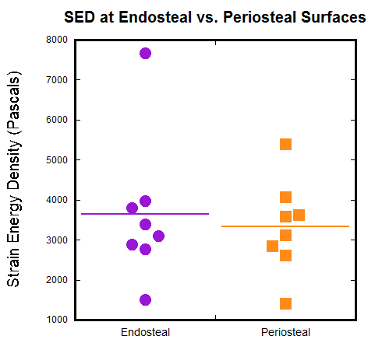

Figure 8 Figure 9

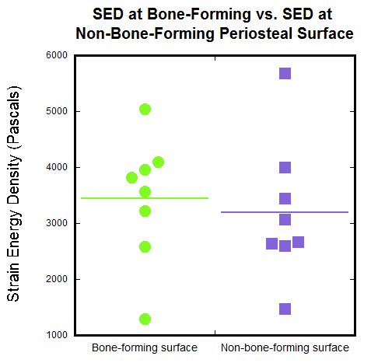 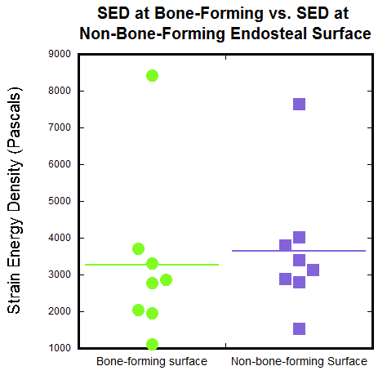

Figure 10 Figure 11

**\_\_\_\_\_\_\_\_\_\_\_\_\_\_\_\_\_\_\_\_\_\_\_\_\_\_\_\_\_\_\_\_\_\_\_\_\_\_\_\_\_\_\_\_\_\_\_\_\_\_\_\_\_\_\_\_\_\_\_\_\_\_\_\_\_\_\_\_\_\_\_\_\_\_\_\_\_\_**

**DISCUSSION, SIGNIFICANCE, AND FUTURE ANALYSIS**

Although there was an overall slight increase in bone forming surface in the loaded specimens, it is questionable whether this increase is large enough to definitively say that mechanical loading directly influenced bone formation in the loaded specimens. This may be due to other biological factors that significantly influence bone formation at these surfaces. For example, osteocytes at the endosteal and periosteal surfaces may be more sensitive to fluid flow than to mechanical stimulation.

From a mechanics standpoint, one would expect the periosteal surface to be at an overall higher SED than the endosteal surface. Since the endosteal surface is closer to the central axis of the vertebrae, it should experience less stresses and strains because it will bend slightly less than the periosteal surface during mechanical loading. However, results show that the periosteal surface is at equal or slightly lower SED magnitudes than the endosteal surface. This suggests that the difference between SED at the periosteal and endosteal surfaces may be too small to be able to accurately observe with our data. However, from our data we know that more new bone was formed at the periosteal surfaces than at the endosteal surfaces. This could mean that mechanical stimulation does not play a very strong role in bone formation and that maybe more studies need to be done to identify important differences in the biological environments at the endosteal and periosteal surfaces.

At the periosteal surface, bone forming locations are, on average, at higher SED levels than non-bone forming locations. This is consistent with the idea that mechanical loading stimulates bone formation at the local level. However, data relating bone formation and SED at the endosteal surface show the opposite effect. Also, there was much more bone formed at the periosteal surfaces than at the endosteal surfaces in all specimens. These data suggest that the endosteal surface may be much less mechano-responsive than the periosteal surface, possibly due to the differences in the biological environments at each surface. At the endosteal surface, bone is formed by osteoblasts that need to be recruited from deeper in the bone marrow by osteocytes. At the periosteal surface, osteoblasts reside in the periosteum, and are readily available to form new bone when they are needed. Therefore the endosteal surface may be less sensitive to mechanical stresses and strains than the periosteal surface, and may instead be more sensitive to fluid flow within the bone marrow, for example.

Using the images that have been acquired following the in vivo rat experiments, and using Matlab software that a colleague has been developing3, we will also able to identify osteocyte lacunae (microscopic caves in bone in which osteocytes reside). Now that we have spatially associated stress and strain (SED) and bone formation at the endosteal and periosteal surfaces, the next step will be to determine how osteocyte lacunar density correlates with SED levels and bone formation locations. Incorporating osteocyte lacunar density into our overall analysis may provide some additional insights into the bone forming processes of the intricate network of cells in bone.

**Acknowledgements**

Live animal experimentation and image acquisition were done by graduate students in the Hernandez Lab prior to my work. I was mentored and advised by graduate student Erin Cresswell and faculty member Christopher J. Hernandez. This work was supported by the Cornell Center for Materials Research with funding from the NSF Research Experience for Undergraduates program (DMR-1460428 and DMR-1120296).

**References**

1. Bettine Willie; Georg N. Duda; Richard Weinkamer. *Bone Structural Adaptation and Wolff’s Law*. 2013.
2. E.N. Cresswell; M.G. Goff; T.M. Nguyen; W.X. Lee; C.J. Hernandez. *Spatial Relationships between bone formation and mechanical stress within cancellous bone*. 2016.
3. Adrian Alepuz (Undergraduate from the Department of Mechanical and Aerospace Engineering at Cornell University)