**Advanced Features**

Advanced features are ones that we estimate would require significant efforts and a deep understanding of the Xfig architecture. Nonetheless, instructors could still assign them to students as part of a course project or teach a lesson with them if this is possible on the course schedule and desired.

***#1 Quick Menu:***

The quick menu is a feature that is designed to increase a user’s potential efficiency while using Xfig by allowing them to directly access and draw objects or editing actions from anywhere in the drawing canvas. The quick menu shall be accessed by double clicking on the canvas (to draw new objects) or objects (to edit existing objects), and the menu should be displayed with its upper left hand corner placed wherever the user clicked. This is useful as modern users have been used to having this feature elsewhere. A challenge is to assign mouse actions to functionalities since, for example, the right mouse click has been used to cancel the drawing after picking up a drawing object from the Drawing Mode Panel .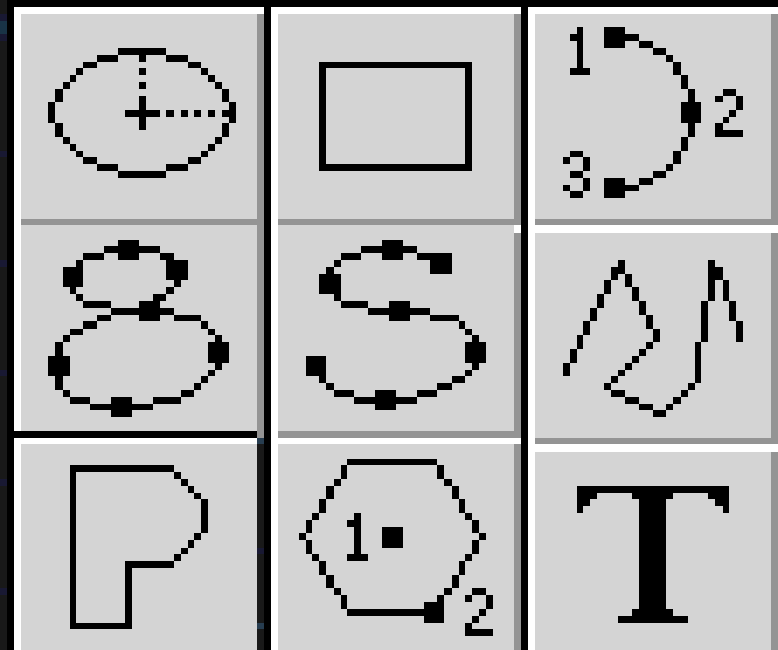

*Figure 1: Mockup Quick Menu*

The quick menu shall be a 3 x 3 square grid of tiles (i.e., 9 items in total), each of which is labeled with the icon of the drawing objects (from Drawing Mode Panel) or editing actions (from Editing Mode Panel) already used by Xfig.

Quick menu feature is a good case of refactoring the architecture. Similarly, free selection can be applied to both “send to back” and any legacy feature.

***#2 Table:***

Currently, Xfig does not have a drawing object to create a table on the canvas. To support creating a table, a new button in the Drawing Mode Panel will be added for this feature. Also, two user inputs are needed in the Indicator Panel at the bottom of Xfig. These inputs shall allow the user to specify the number of rows and columns of the table. After the user creates the desired rectangle size, the tool shall auto-generate the table in the canvas with the specified number of rows and columns based on the dimensions the user chooses.