**Software Change Request**

| **Software** | **Baseline Version** | **Feature Name** | **Difficulty** |
| --- | --- | --- | --- |
| Xfig | 3.2.8a | Enhanced Rotation | Low (Est. 2 files; 18 LOC) |

***Current Behaviors:***

Currently all Xfig objects can only be rotated along a user-selected point by a preset degree either clockwise or counterclockwise (0, 90, 180, and 270). Figure 1 illustrates rotation of a rectangle by 90 degrees. However, angles other than the preset four values are not supported. In fact, when a user attempts to enter any unsupported angle through the angle setting window shown in Figure 2, Xfig will disable this feature by ignoring it.

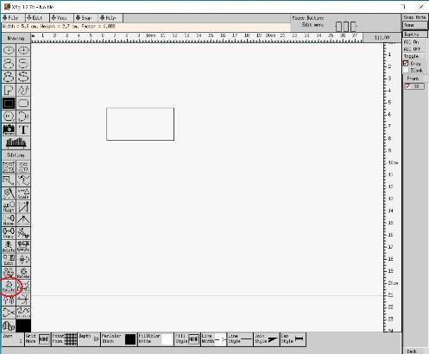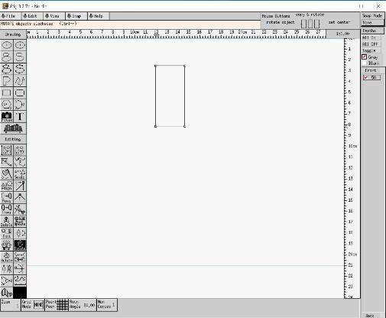

*Figure 1: The state before rotate and the rotate button (left), the state after clicking the rotate button (right)*

***Expected Behavior:***

Enhance the current rotation feature by adding support for any angles in either clockwise or counterclockwise direction, e.g., 30 or 45 degrees. Once the user enters the angle in the angle setting window shown in Figure 2, the object should rotate by the specified degree and direction, rather than having this feature disabled. 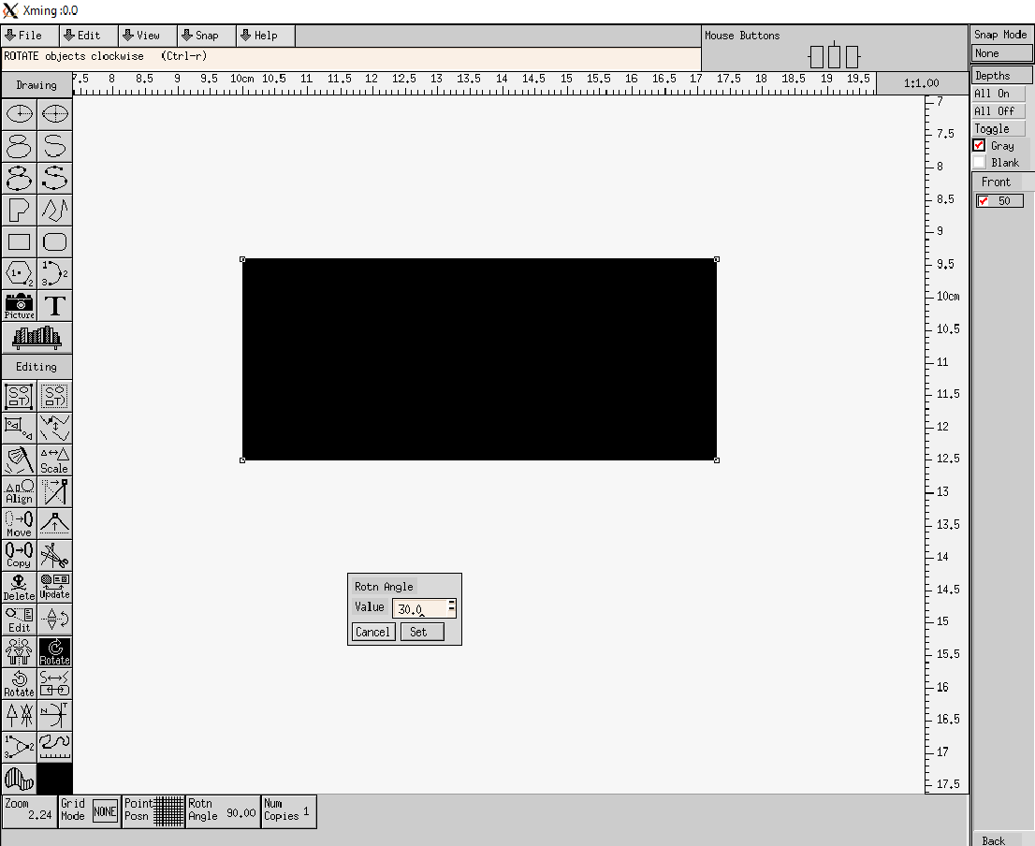

***Solution Hints for Instructor:***

The current implementation of the rotation operation is located in source code files *e_rotate.c* and *e_rotate.h*. Interestingly enough, xfig is already capable of rotating rectangles by any angle, but actively disables doing so. Enabling this feature is as simple as removing the checks: one in e_rotate.c and one in w_indpanel.c:

**e_rotate.c:**

int

valid_rot_angle(F_compound *c)

{

- F_line *l;

- F_compound *c1;

- if (fabs(act_rotnangle) == 90.0 || fabs(act_rotnangle) == 180.0)

- return 1; /* always valid

- for (l = c->lines; l != NULL; l = l->next)

- if (l->type == T_ARCBOX || l->type == T_BOX)

- return 0;

- for (c1 = c->compounds; c1 != NULL; c1 = c1->next)

- if (!valid_rot_angle(c1))

- return 0;

//make every angle valid!

return 1;

}

**w_indpanel.c:**

static void

show_rotnangle_0(ind_sw_info *sw, int panel)

/* called from panel? */

{

int i;

if (cur_rotnangle < -360.0)

cur_rotnangle = -360.0;

else if (cur_rotnangle > 360.0)

cur_rotnangle = 360.0;

if (panel)

put_msg("Angle of rotation %.2f", cur_rotnangle);

if (cur_rotnangle == old_rotnangle)

return;

/* write the rotation angle in the background pixmap */

for (i = 0; i < 8; i++)

indbuf[i] = '\0';

sprintf(indbuf, "%6.2f", cur_rotnangle);

update_string_pixmap(sw, indbuf, sw->sw_width - 40, 22);

- if (panel) {

/* change markers if we changed to or from 90/180 degrees (except at start)

- if (old_rotnangle != -1.0) {

- if (fabs(cur_rotnangle) == 90.0 || fabs(cur_rotnangle) == 180.0)

- update_markers(M_ALL);

- else if (fabs(old_rotnangle) == 90.0 || fabs(old_rotnangle) == 180.0)

//update_markers(M_ROTATE_ANGLE);

- update_markers(M_ALL);

- }

- }

old_rotnangle = cur_rotnangle;

}