**Software Change Request**

| **Software** | **Baseline Version** | **Feature Name** | **Difficulty** |
| --- | --- | --- | --- |
| Xfig | 3.2.8a | Send to Back & Bring to Front | High (Est. 5 files; 272 LOC) |

***Current Behaviors:***

Currently each Xfig object (e.g., arc, line, rectangle) has a property called depth, which is used to group objects that share the same depth into the same layer. This feature is used to organize objects in a hierarchical fashion. To change the layer that an Xfig object belongs to in the hierarchy, a user changes its depth through the Depth Panel shown in the right hand side of Xfig (Figure 1). However, it is not convenient, especially when users want to reorganize multiple objects that share the same depth and when objects overlap each other.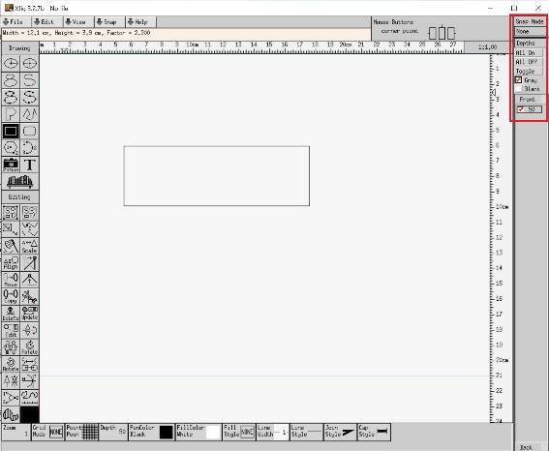

*Figure 1: The Depth Panel of Xfig*

***Expected Behavior:***

To provide users with a more flexible and efficient workflow, a better way is to add two new shortcut buttons called “send to back” and “bring to front” in the Editing Mode Panel on the left hand side of Xfig. These buttons will change the depth of the selected object and other relevant objects to put the selected one to the bottom/top layer on the canvas.

***Solution Hints for Instructor:***

The interaction with the compound object feature needs to be considered. The compound object consists of multiple regular objects but is treated as a single one.

Also, the boundary case needs to be considered, in which the depth of an object is either 0 or 999.

Moreover, adding one shortcut button rather than two of them is an alternative and more effective solution, in which mouse left and right clicking can be used to distinguish the feature of “send to back” and “bring to front”. The user interface of this solution is shown in Figure 2.

Logistically, the solution works by determining either the highest or lowest appropriate depth an object can be sent to using the built in **object_depths** array. Once determined, the selected object’s depth is modified, along with **object_depths** being updated using the **add_depth** and **remove_depth** built-in functions.

This works for most objects, but since compounds can contain objects on multiple levels, they need to be handled separately. For example, in order to move a compound to the front, an offset must be calculated to determine how much each object’s depth must be decreased by. This is done by first determining the difference in max and min depths within the selected compound. If the difference is less than the min depth, an offset is calculated to move each element in front of the highest object. This difference represents the height of the compound. If the height is too large, we move the compound as high as we can by setting the offset to the minimum depth of the compound.

Another feature added in the solution which is not required by the feature description adjusts the depth of a selected object to be the same as the currently set depth value. This functions in the same way that “send to back” and “bring to front” do.

Aside from these functions, code in w_icons.h, w_icons.c, and w_modepanel.c was added to add a button to the edit mode panel. Adding a button is done by creating an icon struct in w_icons.c (in bitmap format), declaring it as an external struct in w_icons.h, and adding an entry to the end of the **mode_switches** array in w_modepanel.c.

Modified Files:  
e_depthctrl.h (new) w_icons.h w_modepanel.c

e_depthctrl.c (new) w_icons.c