**Software Change Request**

| **Software** | **Baseline Version** | **Feature Name** | **Difficulty** |
| --- | --- | --- | --- |
| Xfig | 3.2.8a | Exporting to VDX Format | High (Est. 10 files; 969 LOC) |

***Current Behaviors:***

As shown in Figure 1, currently Xfig allows a user to export a figure into multiple figure formats, such as PNG, EPS, JPG, PDF, and SVG, but does not support VDX, a well-documented [XML](https://en.wikipedia.org/wiki/XML) Schema-based format that is supported by Microsoft Visio, the successful drawing tool in the MS Office suite. 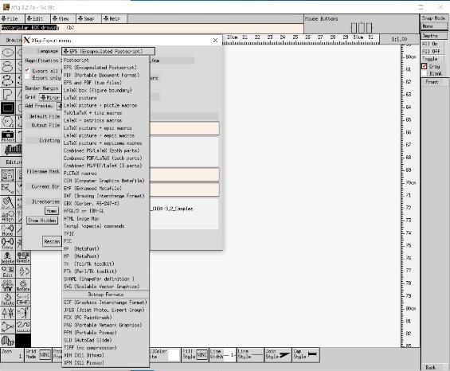



*Figure 1: the list of supported export formats*

***Expected Behavior:***

Add the VDX export format into Xfig. Once Xfig can export figures into VDX format, a user can use the MS Visio tool to edit figures generated by Xfig. Note that the new version of VDX has been renamed to VSDX (Visio XML file format [1]) since 2013. Although we still call it VDX here, students need to follow the latest VDX specification, i.e., VSDX. Figure 2 shows the sample VDX export window. 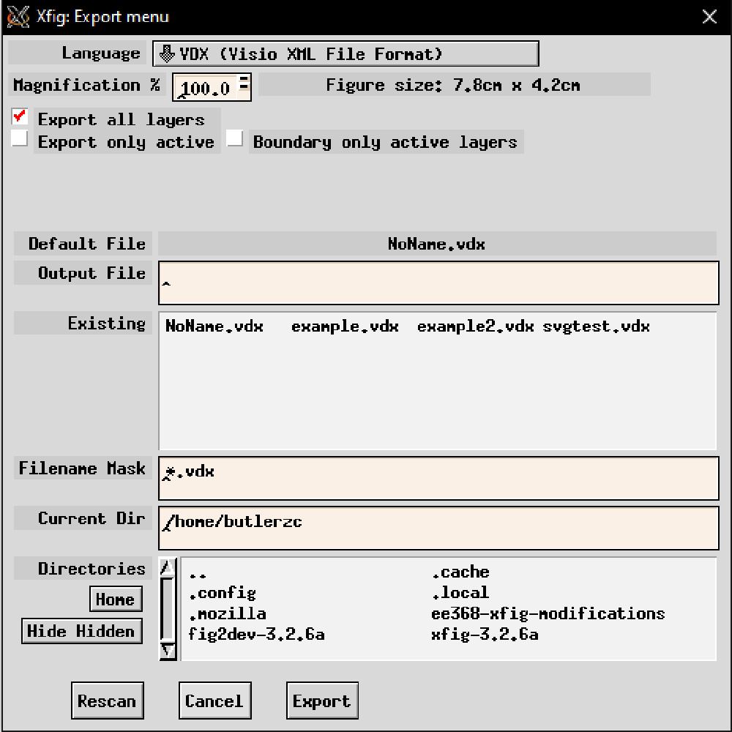

*Figure 2: the sample VDX export window*

***Solution Hints for Instructor:***

Besides revising the Xfig source codes to add the VDX into the export list, students need to modify another program named *fig2dev* as well. *fig2dev* translates from the Xfig figure format into the specified graphics language and puts them in an out-file [2]. In *fig2dev*, each export format supported by Xfig has a file to support the interpretation and translation, e.g., *gensvg.c* is for exporting an Xfig file into the svg format.

Note that the scope of the VDX specification is large. If the project schedule does not allow students to implement the entire VDX specification, they can implement it partially which will result in missing some figure objects or figure properties during the exporting.

The minimal changes in Xfig are located in mode.c, mode.h, and w_export.c. These changes add the vdx export option to the export popup.

It should be mentioned that testing this feature requires fig2dev to be configured correctly. This can be done by setting the environment variable “FIG2DEV_DIR” to the path of the fig2dev directory:

export FIG2DEV_DIR='/home/<PATH>/fig2dev-3.2.8a/fig2dev

***References:***

[1]. Microsoft VSDX specification: <https://docs.microsoft.com/en-us/openspecs/sharepoint_protocols/ms-vsdx/50c23601-c943-4ff2-b4a1-02445f52daf0>

[2]. Linux fig2dev man page: <https://linux.die.net/man/1/fig2dev>