Influence of Income on Birth Rate and Death Rate

Kyle Mulvihill

Institute of Technology Tralee
Kyle.mulvihill@students.ittralee.ie

Abstract
This report aims to prove there is a direct correlation between the amount people earn and their respective death and birth rates. This report will prove or disprove this statement through performing data analytics over a dataset that contains birth rate and death rate data for four separate income levels, these are, low income, low & middle income, middle income and high income. The analyzed data will be visualized in graphs to give further clarity to readers. This report will hope to find significant differences between the four categories of income and discuss why this could be or why this is. This report will also discuss other reports on the same or a similar topic to see what knowledge has been discovered on the topic and to see if other academics reports agree with, or disagree with the findings in this report.

Introduction
The population has been steadily rising since 1960 when the population was 3 billion until recently with the population over 7 billion. The population is rising in 2017 at a rate of 1.11% a year. (Worldometers, 2017) There are many possible factors that influence the birth rate and death rate, such as, income and social class. This report will discuss the influence of income on birth rate and death rate through four categories which are, low income, low & middle income, middle income and high income. This is a relevant topic across the world and this report hopes to prove that there is a direct correlation between the amount of income a person has and birth rate and death rate. Looking at the countries with the highest birth rates, most, if not all countries with a high birth rate are underdeveloped which in turn would suggest that most people here receive low income. (statista, 2015) The same can also be said for death rate as countries with the highest death rates are mainly underdeveloped countries. (Spicer, 2016) This report also hopes to prove this hypothesis and find probable reasons as to why this is or why this isn’t the case. It is also a goal of this report to forecast the population for the year 2020. Following the KDD data analytics project life cycle, this report will identify the problem that needs to be proved or disproved and detail preprocessing of the data, preforming analytics over the data and visualizing the data. These steps will be completed using either Excel or R programming language.

Approach
The approach used in this report follows steps from the KDD data analytics project life cycle. (Marbán, 2009) The first steps were to identify the problem, which in this case was to prove there is a direct correlation between the amount of income people earn and their birth and death rate. The second step was to design the data requirements which meant examining the data and deciding which data is needed to best prove the issue that has been identified earlier. The next step was to preprocess the data, this meant cleaning incomplete records by either adding data to them or removing them, this also meant separating the important data that was selected in the previous step and separating it from the data that was irrelevant to the issue that is being analyzed. The following step is to perform data analytics over the preprocessed data and then to visualize the data that has been analyzed.
To analyze and visualize the dataset, the dataset was plotted with a trend line over years. This was done using the ggplot function which is part of the ggplot2 package. This was vital in understanding the data and to be able to draw conclusions. The p-value algorithm was also used to find any significant differences in birth rate and death rate between the four different income categories. Kmeans clustering was also introduced to further prove the differences in birth rate and death rate in relation to income category and possibly, to detect abnormal data that goes against the norm.

Background
To get a better understanding of the topic of this report, other reports were examined. This was necessary to see what information is available on the topic and what information is needed or is yet to be established. This useful to attain whether the topic or issue is possible to prove or disprove. Obviously gaining as much knowledge on the topic is of value and any conclusions that can be drawn from analyzing the topic that correspond with other academic reports or papers can further enhance the reliability of the knowledge that has been discovered in this report.
Other reports on this topic have continuously stated that there is a direct correlation between income and birth rates. Throughout the developing world declining birth rates and rising living standards have gone hand in hand. (Sinding, 2008)
As economic development gets going, country after country has experienced what is known as the demographic transition: fertility drops from around eight to near one and a half. Other studies have come up with possible explanations for this, for example, this is that there are, broadly speaking, two ways of reproducing. One way is to churn out offspring in large numbers, turn them out into an uncaring world, and hope that one or two of them make it. The other is to have but a few children and to dote on them, ensuring that they grow up with every possible advantage for the ensuing struggle with their peers for mates and resources. (The Economist, 2009)
Studies done in the US have shown that people with higher incomes have a lower people rate than the opposite. This can be seen in the chart below.

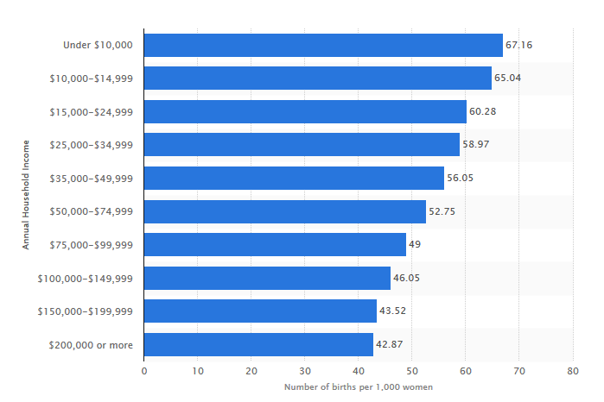
Birth rates in the US in 2014, by household income. (statista, 2015)

There are also many studies and reports that have analyzed the effect of income on death rates. It is also widely reported that there is a direct positive correlation between life expectancy and income. It can also be seen that a list of countries with the highest death rates is mostly made up of underdeveloped countries, where we would assume that income levels are low. This can be seen in many studies. A research team from Columbia University’s Mailman School of Public Health in New York City has estimated that 875,000 deaths in the US in 2000 could be attributed to a cluster of social factors bound up with poverty and income inequality. (Watson, 2011) Also ,a study in Canada concluded that if all Canadians were as healthy as the top 20 per cent of income earners, there would be approximately 40,000 fewer deaths each year, every year. The same study also concluded that a poor male has a 67 per cent greater chance of dying each year and a poor woman has a 52 per cent greater chance than their wealthy counterparts. (Raphael, 2014)

The figure below illustartes the disparity between themortality rates of people with low income and those with high income. (Cheng, 2012)

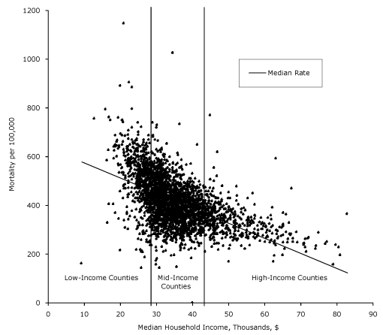
Source: (Cheng, 2012)

Identifying the Problem/Topic to Analyze
To identify a topic to analyze involves examining the dataset to see what data is missing or what knowledge can be discovered through analyzing the dataset. For this report, it was decided that the impact of income on death rate and birth rate would be analyzed to prove this statement.

Designing the Data Requirements
To design the data requirements to be analyzed, understanding and identifying the problem or topic is vital. A dataset was downloaded from Kaggle containing the birth rates and death rates from many countries as well as categories of income. The death rates and birth rates in relation to categories of income were the most interesting and useful for the topic. Other reports were examined to see what has been already done on the topic and where it can go. This has been discussed further in the background section.

Preprocessing
The dataset used in this report was obtained from Kaggle and had 89011 rows and 61 columns. The first column was a variable called X that contained a unique identifier for each record, with the next four columns being, Country Name, Country Code, Indicator Name and Indicator Code and the rest being 1960 all the way to 2015. Country Name contained the different countries around the world, plus many other categories, four of which are the categories used in this report, low income, low & middle income, middle income and high income. There were many incomplete records and there were a wide range of indicators, however, this report only discusses the records that were in relation to low income, low & middle income, middle income and high income with the indicators of Birth rate, crude (per 1,000 people) and Death rate, crude (per 1,000 people). To start the preprocessing three packages were installed in R studio. These packages were dplyr, ggplot2 and reshape. The dataset used for this report was called data.csv. The first column was a numeric type and the next four columns were all the basic type character with the next fifty-seven being numeric. The last two columns were removed as there was little to none data in them. This was done before omitting all NA’s so that it would minimize the number of rows removed from the dataset. As mentioned before many of the records in the dataset were incomplete or irrelevant to the topic this report will discuss. To make the dataset easier to read, all incomplete records were removed from the dataset and the dataset was converted back to a .csv file called MyData1.csv to be examined in Excel.
When it was decided, what were the relevant records in relation to the topic that is being discussed, it made more sense to extract the relevant records into new data frames as opposed to deleting the huge amount of records that could still become useful further into this report. The datasets created from the original dataset were income_data which held all records that contained the values ‘Low income’, ‘Low & middle income’, ‘Middle income’ and ‘High income’ under the variable Country.Name and containing the values ‘Birth rate, crude (per 1,000 people)’ and ‘Death rate, crude (per 1,000 people)’ under the variable Indicator.Name. To give an idea of what this looks like there is an image below showing up to the first year the records started, which was 1960.

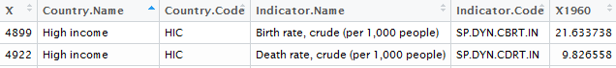

This dataset was preprocessed further in able to get rid of the unwanted columns such as, ‘X’, ‘Country. Code’ and ‘Indicator. Code’. The dataset was also pivoted using the melt function written by Hadley Wickham so that a row was added for each year with the corresponding values in the same row, commonly known as long format. This preprocessing made the dataset easier to understand, as well as, making it possible to use ggplot2. This dataset contained everything needed to be able to provide comprehensive conclusions on the topic being discussed. The image below shows the contrasting difference between the image of the dataset above before the preprocessing continued.

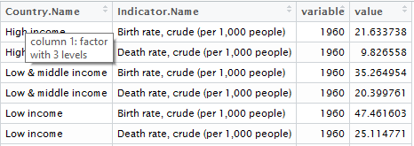

Further preprocessing was needed on this dataset as analytics was performed. This dataset was filtered to provide two datasets with the same variables under the condition of ‘Indicator.Name == "Birth rate, crude (per 1,000 people)"’ which provided the birth_data dataset and the second dataset which contained the death rate date, which used the same method as the birth_data dataset, this dataset was called death_data. The final bit of preprocessing was done to be able to utilize the Kmeans clustering algorithm which would only take numerical data. This was done simply by piping the fourth columns of the previous two datasets, which contained the values into new datasets called kc_birth and kc_deaths respectively.

Findings
Upon analyzing and visualizing the dataset it was possible to prove that there is a direct correlation between income levels and death rates and birth rates. There is however, many conclusions that can be drawn as to why this is, but for now the findings will be examined.

Below is graph with a trend line showing the birth rate of the four different income levels over the years 1960 to 2014.

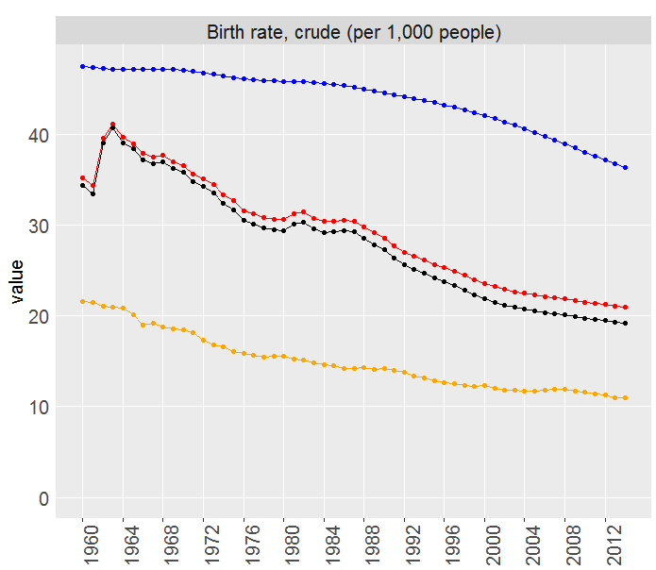

It can be easily seen from the graph that there is a significant difference in birth rates between the three of the four income levels, with no significant difference obvious for low & middle income and middle income. Low income families have a much larger birth rate than that of high income families, with low & middle income and middle income families splitting the low income and high income trend lines. It can also be observed that there is a continuous trend of declining birth rates across all income levels over the years. It can also be seen that the gap between middle income and high income in regards to birth rate is slowly reducing over time and that the largest drop in birth rate over time belongs to the middle-income families.
To quantify the significant differences between the four income levels, the P value is calculated. A P value score of greater than 0.05 shows that there is no significant difference.

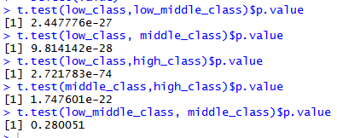

It can be seen from the figure above that there are significant differences between all income levels except low income and low & middle income as this scored a value of 0.280051which is greater than the previously mentioned 0.05 score. All other scores were under the 0.05 score so it can be said that there are significant differences between them.
To further extenuate the differences in the income levels in regards to birth rate cluster analysis was used. The images below show us the disparity between income levels except between low & middle income and middle income. And with a goodness score of 94.6% it can be said to be accurate.
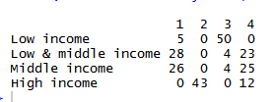

The boxplot below also shows the disparity between income levels in regards to birth rate and shows the median of each separate group with an interquartile range of 18.90348.

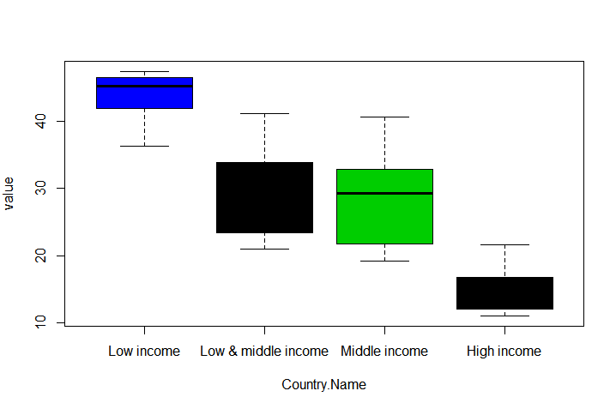

Below is graph with a trend line showing the death rate of the four different income levels over the years 1960 to 2014.

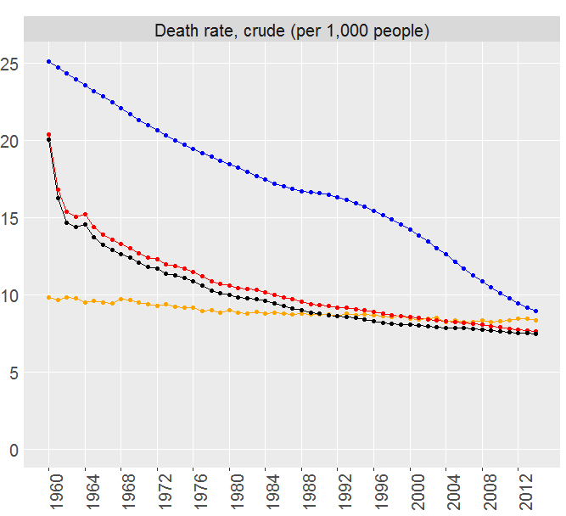

It can be seen from the graph that there was a significant difference between low income and high income in relation to death rate in 1960. It can also be seen that this gap has been closing ever since the year 1960 and there is very little difference in death rates between income levels in 2014. Low & middle income and middle income decrease to levels like high income around 1985, which was much sooner than the low-income level, who only managed to close the gap to that of high income in 2014. It can also be seen that the high-income level maintained its death rate with only a slight decrease in death rate over the 54-year period. Unlike the low-income level people whose death rate has dramatically decreased over the 54-year period by at least 60%. It can also be seen that there is no significant difference between low & middle income and middle income throughout the time scale.
To quantify the significant differences between the four income levels, the P value is calculated. A P value score of greater than 0.05 shows that there is no significant difference.

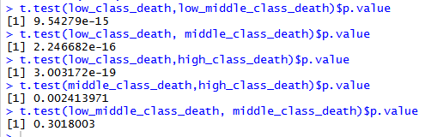

This again shows that there are significant differences between all income levels except between low & middle income and middle income.
To further extenuate the differences in the income levels in regards to birth rate cluster analysis was used. The images below show us the disparity in regards to death rate between income levels except between low & middle income and middle income. And with a goodness score of 94.3% it can be said to be accurate.

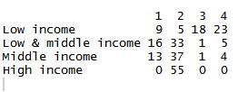

The boxplot below also shows the disparity between income levels in regards to death rate and shows the median of each separate group with an interquartile range of 5.005909. It can also be seen that there are outliers present in this boxplot which means they are outside 1.5 times the interquartile range above the upper quartile and bellow the lower quartile.

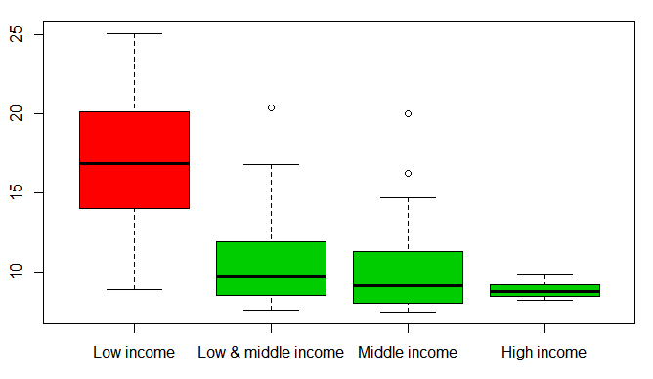

Conclusions
From the findings, there is a large difference between three of the four income levels in regards to birth rate and that families in all income categories are lower at present than in the past. There are many possibilities as to why this is. Lower birth rates could be a result of more families moving from rural to urban areas thus negating the need for extra children to help on the farm and resulting in greater income as urban areas have higher averages wages than rural areas. Also for women the cost of opportunity to have a child is much greater as this will hinder if not stop their career, thus leading to less income. There is also the possibility that some people have greater income simply because they don’t have the expenditure that people with children would have. There is also the likelihood that birth rates could be higher in low income families due to the welfare support offered by governments to poor parent or single parents. It is also likely that those with high income do more family planning so as not to negatively impact their careers. Another factor for the overall decrease in birth rate could be contraceptive innovation and acceptance as opposed to the past. A problem the lowering birth rates could bring in the future is an aging population as tax rates might have to be increase to help the workforce population support the elderly in regards to, pensions, healthcare and other government benefits for the elderly.
It can also be seen from the findings section that there was a significant difference between three of the four income categories in the past that is presently not so significant. The reason for this is most likely the change in technology and medicine that was previously only available to the rich has now become more accessible to the poor. This could be said to a lesser degree to people in countries where medical care is expensive such as, America.

References
Cheng, E. R. (2012, November 9). Disparities in Premature Mortality Between High- and Low-Income US Counties. Retrieved from CDC: https://www.cdc.gov/pcd/issues/2012/11_0120.htm
Marbán, Ó. (2009, January 1). A Data Mining & Knowledge . Retrieved from intech open science: http://cdn.intechopen.com/pdfs/5937/InTech-A_data_mining_amp_knowledge_discovery_process_model.pdf
Raphael, D. (2014, November 23). Income inequality is killing thousands of Canadians every year. Retrieved from thestar.com: https://www.thestar.com/opinion/commentary/2014/11/23/income_inequality_is_killing_thousands_of_canadians_every_year.html
Sinding, S. W. (2008). Population, Poverty and Economic Development. California: Bixby Forum.
Spicer, B. (2016, May 10). Top Ten Countries With Highest Death Rate. Retrieved from Maps of World: http://www.mapsofworld.com/world-top-ten/countries-by-highest-death-rate.html
statista. (2015). Ranking of the 20 countries with the highest average birth rate from 2010 to 2015 . Retrieved from statista: https://www.statista.com/statistics/264704/ranking-of-the-20-countries-with-the-highest-birth-rate/
The Economist. (2009, August 6). A link between wealth and breeding. Retrieved from The Economist: http://www.economist.com/node/14164483
Watson, D. (2011, July 13). The dramatic effect of poverty on death rates in the US. Retrieved from World Socialist Website: https://www.wsws.org/en/articles/2011/07/pove-j13.html
Worldometers. (2017, April 1). Current World Population. Retrieved from Worldometers.org: http://www.worldometers.info/world-population/

