Distributed Computing

I have been asked to develop a client and server using UDP. My objectives are to have a user log in to the server using a username and password that will be validated on the server side to access their folder. If it is a new user, their username and password will be saved in a text file on the server with the other user’s usernames and passwords and a folder will be created on the server using their username. I then hope to present the user with the options to upload and download to their folder, as well as log out of the server.

Login

Message: Please enter L to Login, U to Upload, D to download or Q to log off:
Description: The user can log into the server with a username and password
Code/Number: 100
Text: Login
Message Parameters: username and password (single string)
Response Message
Code: 101
Text: Login Successful!
Response Message
Code: 102
Text: Login Unsuccessful. Using credentials to set up account.

The client sends a single string to the server.
This string contains the login code and the username and password.
Example “100:Login kyle 123”
The code is stripped off using substring(0,3) to enter the switch case 100:
The username and password are separated using split().
The user connects to the server on the server side by a function called login() which takes a two strings, username and password.
checks if username and password exists in checklogin().
if exists return 101: login successful
setLoggedIn(true)
if doesn’t exist return 102: login unsuccessful. Using credentials to set up account.
save the username and password in text file by using writeFile().
create folder with username using the createDir().
setLoggedIn(true)

Client Server

100:Login kyle 123

101:Login Successful

Logout

Message: Please enter L to Login, U to Upload, D to download or Q to log off:
Description: The user can log off by typing ‘Q’
Code/Number: 400
Message Parameters: “Q” single string
Response Message
Code: 401
Text: Logging Off
Response Message
Code: 402
Text: Incorrect input!! Logging Off

The user inputs the character ‘Q’ to log off from server.
This calls the method logoff() on the server side which in turn calls the method setLoggedIn(false).
The server returns code 401:Logging off

The user inputs unspecified character.
This goes to the default switch case on the server.
This calls the method logoff() on the server side which in turn calls the method setLoggedIn(false).
The server returns code 402:Incorrect input!! Logging off

Client Server

400:Logout request

401:Logging Off

Upload
Message: Please enter L to Login, U to Upload, D to download or Q to log off:
Description: The user can Upload a file by typing U
Code/Number: 200
Message Parameters: file name to be uploaded. (String)
Response Message
Code: 201
Text: File name “ filename ” has been uploaded to server
Response Message
Code: 202
Text: The file already exists

The user choses to upload by pressing “U”, the user is prompted for a file name from the C drive.
The uploadFile() within the ClientHelper takes two parameters, the message containing the protocol code and the filename. Eg. 200:upload ‘filename’.
The filename is used for the path to the file.
The files data is loaded into a byte array, which is stored in a string called fileData.
The filename and the fileData are both appended to the message already containing the protocol code, which is then sent to the server.
The server checks the protocol code using substring(0,3) so it know which switch case to enter.
The server then unpacks both the filename and fileData using message.split(“ ”)[1]
The server finds the path or creates it if it doesn’t exist.
The server writes the data into the file on the specified path.
The server returns a conformation message “201:File name: ‘filename’ has been uploaded to server”.
Or if the file already exists the server return message “202:The file already exists”

Client ClientHelper Server

200:Upload + filename
200:Upload + filename + data

201:File Name: filename has been uploaded to server

Download
Message: Please enter L to Login, U to Upload, D to download or Q to log off:
Description: The user can Download a file by typing D
Code/Number: 300
Message Parameters: file name to be downloaded. (String)
Response Message
Code: 301
Text: File name “ filename ” has been downloaded from the server
Response Message
Code: 302
Text: The file already exists

The user choses to download by pressing “D”, the user is prompted for a file name from their own directory on the server.
The downloadFile() within the ClientHelper takes two parameters, the message containing the protocol code and the filename. Eg. 300:download ‘filename’.
The filename is used for the path to the file.
The files data is loaded into a byte array, which is stored in a string called fileData.
The filename and the fileData are both appended to the message already containing the protocol code, which is then sent to the server.
The server checks the protocol code using substring(0,3) so it know which switch case to enter.
The server then unpacks both the file and data using message.split(“ ”)[1]
The server finds the path or creates it if it doesn’t exist.
The server writes the data into the file on the specified path.
The server returns a conformation message “301:File name: ‘filename’ has been downloaded to server”.
Or if the file already exists the server return message “302:The file already exists”

Client ClientHelper Server

300:Download + filename
300:Download + filename + data

301:File Name: filename has been downloaded to server

Implementation
I used seven classes to implement my udp protocol.
For my client the presentation logic is simply a compiler in Intelji.
It uses readline() to take data from the user.
The Application logic is the ClientHelper which contains all the methods to send and receive messages and files. The Application logic does this through the service layer which create datagram sockets for the datagrams to travel in.

Client-Side Software
Presentation Logic | Client.java
Application Logic | ClientHelper.java
Service Logic | MyClientDatagramSocket.java

The presentation logic for the server is unnecessary as long as the server is running.
I did however use the complier in Intelji to be able to see the protocol codes coming through.
The Application layer is both server.java and UserAcc.java as Server.java keeps the server open and has code to be able to receive files and send files. The UserAcc.java helps take care of the validating the username password and creating directories for the user.
The service logic is MyserverDatagramSocket.java and DatagramMessage which create the sockets for the datagrams to travel in and to get the sender’s address and port as well as the message.

Server-Side Software
Presentation Logic | Server.java
Application Logic | Server.java  UserAcc.java
Service Logic | MyServerDatagramSocket.java  DatagramMessage.java

UML diagram of server side

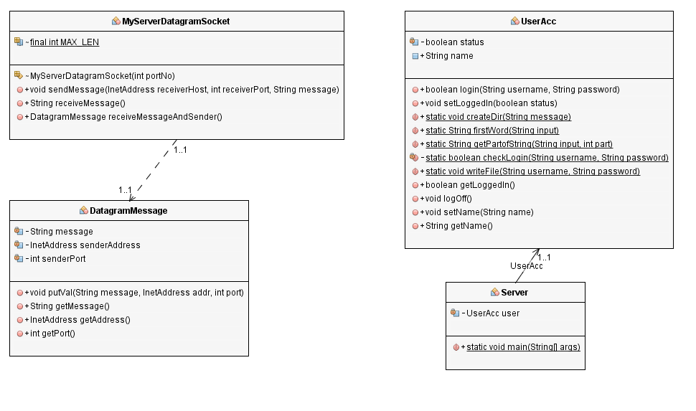

UML diagram of Client side
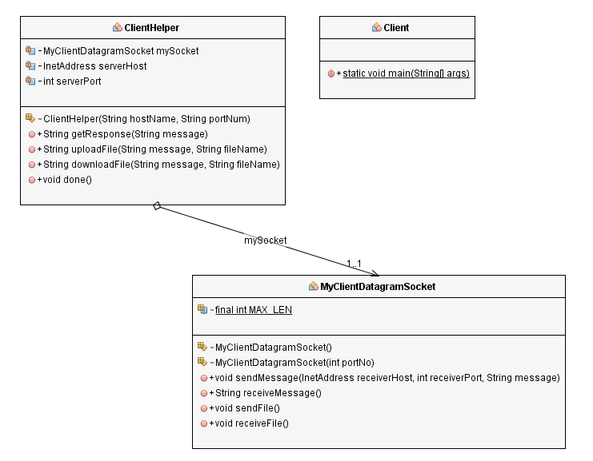

Login

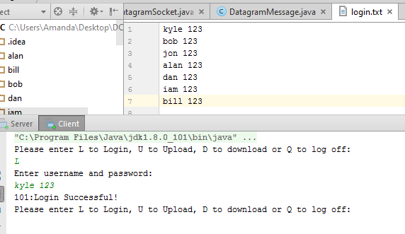

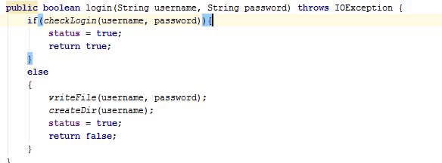
This method checks if the login is valid
Else
Writes username password to login.txt
And creates a directory on the server using username

Logout
The code in the server simply sets the status of the user to false when the logout() method is called.
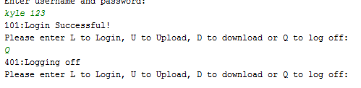

Upload
(N.B I have hardcoded the path on my laptop. To use it you will have to change where it says Amanda to your Tnumber.)

This method is in ClientHelper and this takes two the parameters the message which contains “200:Upload” and the filename which contains “abc.txt”.
It extracts the data from inside the file which is “hello”.
It then packs all these in a message and sends to the server.
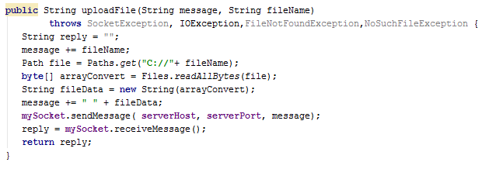
This code is in the server.java
This receives the message from the ClientHelper
The first part of the message is stripped to get the code 200 so it can enter the switch case.
The code uses the user’s name and filename to append to the file path.
The data containg “hello” is added to the file after it is created.
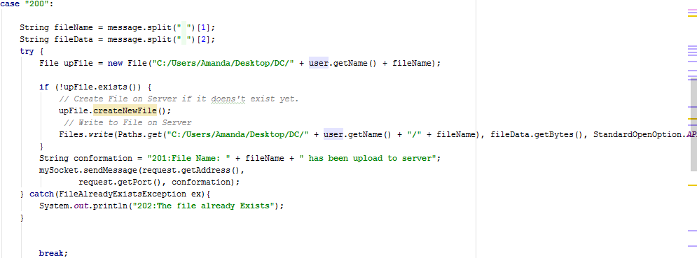
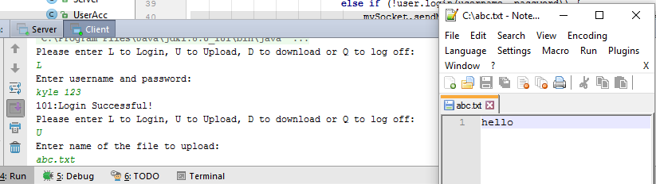

Download
(N.B I have hardcoded the path on my laptop. To use it you will have to change where it says Amanda to your Tnumber.)
I also struggled to use the getName() method I have in UserAcc because I didn’t think it should be instantiated here so I hardcoded my name kyle which Is my directory on the server.
This method is in the ClientHelper.
It takes two parameters the message containing “300:Downlod” and the filename.
It adds the filename to the path to find the file.
It then reads all the bytes in the file and converts them to a string called fileData.
The message sent to the server contains the “300:Download” the filename and the file data.
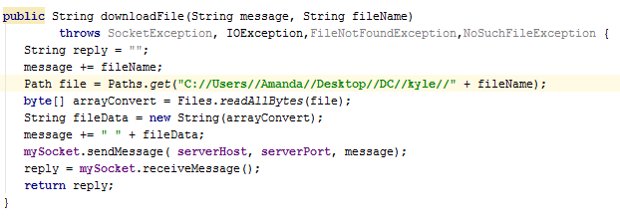
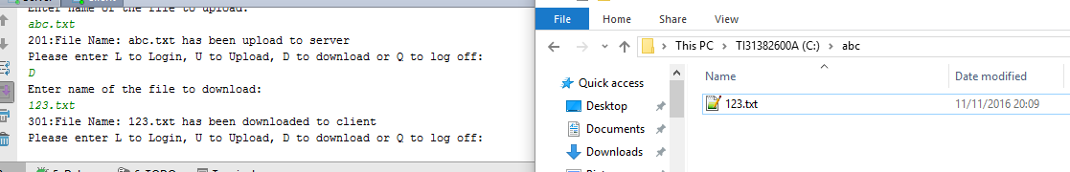

This code is in the server.java
This receives the message from the ClientHelper
The first part of the message is stripped to get the code 300 so it can enter the switch case.
The code uses the file name to add on to the end of the path which is inside a folder on my C drive called abc.
It creates the file if it doesn’t exist and adds the data to it.
It then sends a conformation message back.

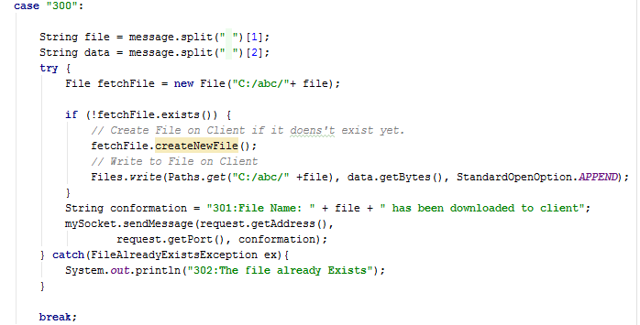

Conclusion
I found this project very beneficial as I gained a better understanding of the different layers that go into making a client-server file manager system using datagrams. I earnt a lot about the different layers used in such a system, such as the presentation layer, application layer and the service layers. It helped me understand how datagrams move across the network and gave me a good insight to what happens from a technical standpoint when moving files using a UDP protocol. I am reasonably pleased with my project however I lost a lot of time due to my while loop doubling up requests to the server. However, this did benefit me a lot in the process of fixing it but didn’t allow me time to develop a GUI or to transfer bigger files.

