1. 1. 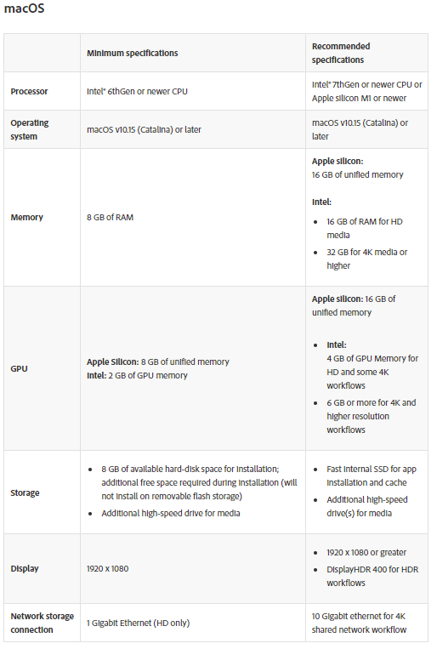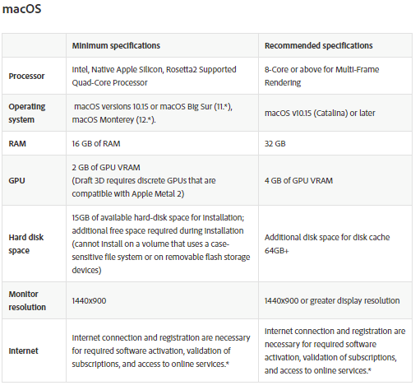
2. 1. I would recommend the MacBook Pro 14. Because it would store up the projects and misc that you can do. This has the minimum requirements for your work and pet projects.