**Lab 2: Game Control with Joy Stick, Gyro and Accelerometer**

**EECE. 4520 Micro­­­­processor II and Embedded System Design**

**0. General Information**

Student Name:

Student ID Number:

Team Name/Number: Team SJK

Team member names: Sua Jung, Julie Dawley, Kyle Purcell

Date of completion: March 28, 2021

Demonstration method: recorded video

**1. Design**

**1.1 Hardware Design**

photo:

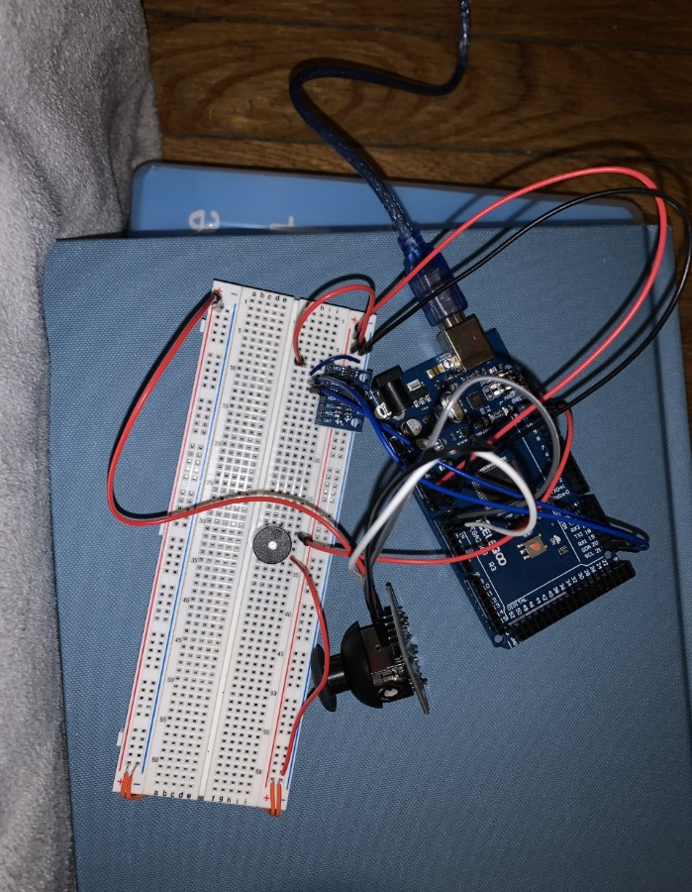

circuit diagram:

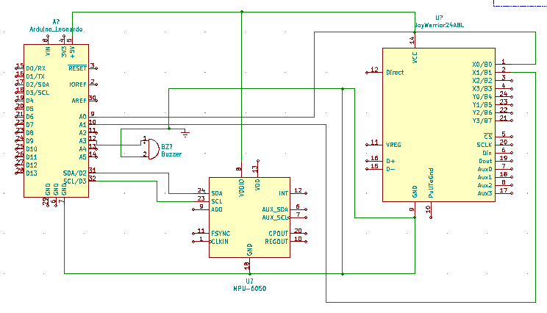

Explanation: The Arduino connects to a buzzer, joystick control, and an accelerometer. By reading in data from the joystick and accelerometer, it runs the classic game Snake and provides audio output through the buzzer.

**1.2 Software Design**

**GitHub URL:**

<https://github.com/Kylepurcell10/MicroprocessorsII/tree/main/Lab2>

The GitHub URL contains a public repository that holds the most up to date folder of Lab2 that includes the .ino file, snake.py and an image of the circuit.

**Pin Assignments:**

* Analog pins A0 (9) and A1 (10) connect to pins 3 and 4 respectively on the joystick control board with pin 1 being connected to ground and pin 2 being connected to 5V DC.
* Pins SDA (20) and SCL (21) connect to pins 3 and 4 respectively on the accelerometer control board and pin 1 is connected to 5VDC and pin 2 is connected to ground.
* The buzzer is assigned to digital pin 12.

Explanation: Two separate flow diagrams control this system. The first (leftmost) diagram determines the direction the snake is currently facing and moving to depending on the most recent control input. When a collision or pellet events occur, the game either ends or increases the length of the snake and score as controlled by the rightmost diagram.

**Flow Diagram:**

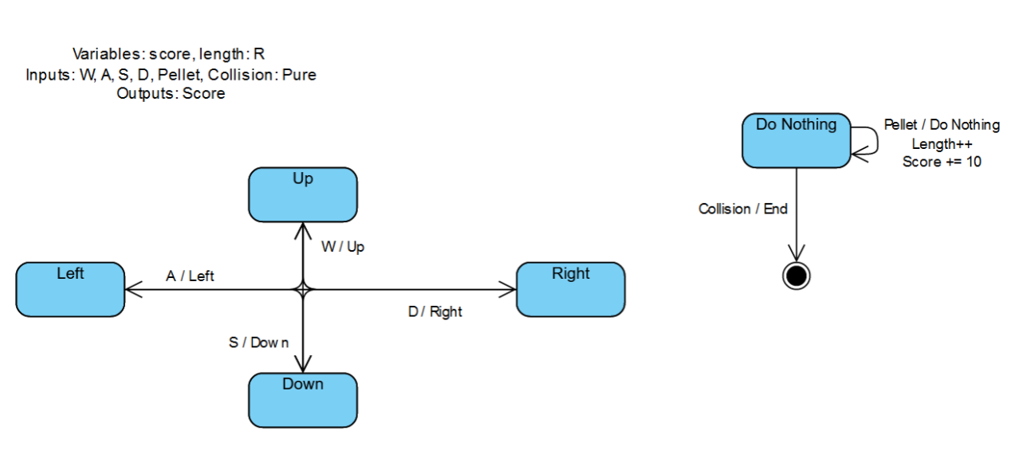

**1.3 Results**

brief explanation: The circuit functioned properly, and the joystick moved the snake in the game as the user’s direction and played the game as expected.

video link: <https://www.youtube.com/watch?v=YXimNpnsPic>

**2. Problem Encountered and Solved**

The problem encountered during Lab 2 was that the joystick takes into the account diagonal directions whereas snake does not. This problem could be solved by reducing the value required to indicate desired turn so it didn’t need to be 100% in the or Y direction. The other problem was that the actual chip used for the gyroscope is not actually a mpu-6050 but it was GY521. The second problem could be solved by doing research to find similar products that we had.

**3. Personal Contribution to the Lab**

Sua Jung

: Wrote the initial snake.py code, debugged the final code, made circuit diagram with KiCad

Julie Dawley

: Debugged the final code, constructed the circuit, made flow diagram.

Kyle Purcell

: Wrote the Arduino code, constructed circuit diagram, recorded the photo and video.

**4. Lessons Learnt**

We could understand the way of using the joystick with gyro and accelerometer to complete the snake game. Using python and Arduino together was helpful to understand how microcontrollers work together in the game controller.

The free flow-diagram creation tool “Online State Machine Diagram Tool” by “Visual Paradigm Online” was explored and used to create the flow diagram for this lab. While simple to use and straightforward with a web interface, this program fails to allow for bidirectional arrows and does not clearly demonstrate the directionality of some state changes. Exploration of other software for creating state/flow diagrams is necessary.

(https://online.visual-paradigm.com/diagrams/features/state-machine-diagram-software/)