**15.1 - Describe the worst interface that you have ever worked with and critique it relative to the concepts introduced in this chapter. Describe the best interface that you have ever worked with and critique it relative to the concepts introduced in this chapter.**

Bad Interface:

RIT’s Student Information System, a student enrollment and course information tool, is largely perceived to have quite an unsatisfying user interface. Beyond its outdated style, it certainly does have some fundamental problems when considering the “golden rules.”

1. Place the user in control

* Unnecessary actions: When searching for a class, the user must often specify search criteria which should not be necessary. For example, one cannot simply search based on a course attribute. Additional criteria must be specified before any results are shown to the user.

1. Reduce the user’s memory load

* Confusing shortcuts: There are a large number of shortcuts in the header which all have yet another set of shortcuts associated to them displayed when the user clicks on them. This requires the user to remember the sometimes counterintuitive steps necessary to achieve a certain goal. For example, to view a weekly class schedule, the user must click “Self service,” then “Enrollment,” then “My Weekly Schedule.”

1. Make the interface consistent

* Inconsistency with product line: While the SIS application being discussed is a subset of RIT’s larger Student Info System, it seems to have little consistency with the rest of the web applications in the pool. It is, after all, named identically to the larger system that it is a part of, which is rather confusing. As for the other apps in the pool, such as eServices and the new TigerCenter, SIS has little to no consistency. SIS remains the only app to have such an outdated look and feel, and seems to have identical functionality to TigerCenter in its class management capabilities.

Good Interface:

Trello is one application that has a very satisfying and effective user interface. It allows users and teams to collaborate in a unique yet easy manner. Its use of “boards” and “cards” to organize information, while different at first, provides an intuitive and effective method of collaboration.

1. Place the user in control

* No unnecessary or undesired actions: All actions are specific and useful, and can be done simply by clicking on the card on which the user wants to perform the actions. Cards can be moved around to different boards via dragging, can be renamed simply by clicking on the name and can be commented on simply by clicking on the card, to cite a few examples.

1. Reduce the user’s memory load

* Visual layout based on real-world metaphor: The visual organization of boards and cards is not unlike a system of sticky notes that would be used in an office. This allows for the user to learn how to use the application quickly and with little instruction. The instructions that are included are brief and concise, making the interface not only easy to learn but fun and satisfying to use.

1. Make the interface consistent

* Tasks are in meaningful context: The user does not have to go through many different screens to achieve complex tasks. Rather, all tasks feel like they are being completed within the main context of the application, making it easy for the user to remember what is being done and why. When attaching a file to a card, for example, the main interface remains visible while the option to attach the file is displayed in a popover fashion.

**15.9 - Develop a set of screen layouts with a definition of major and minor menu items for our HealthNet project.**

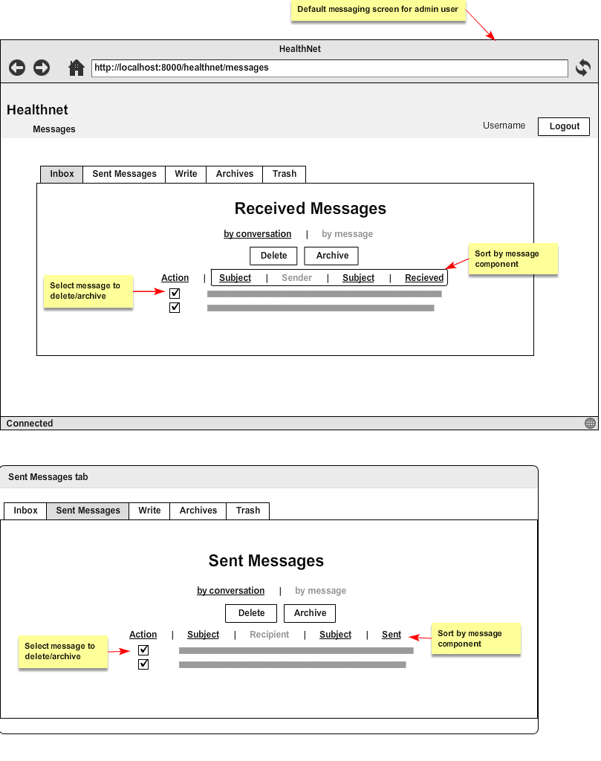

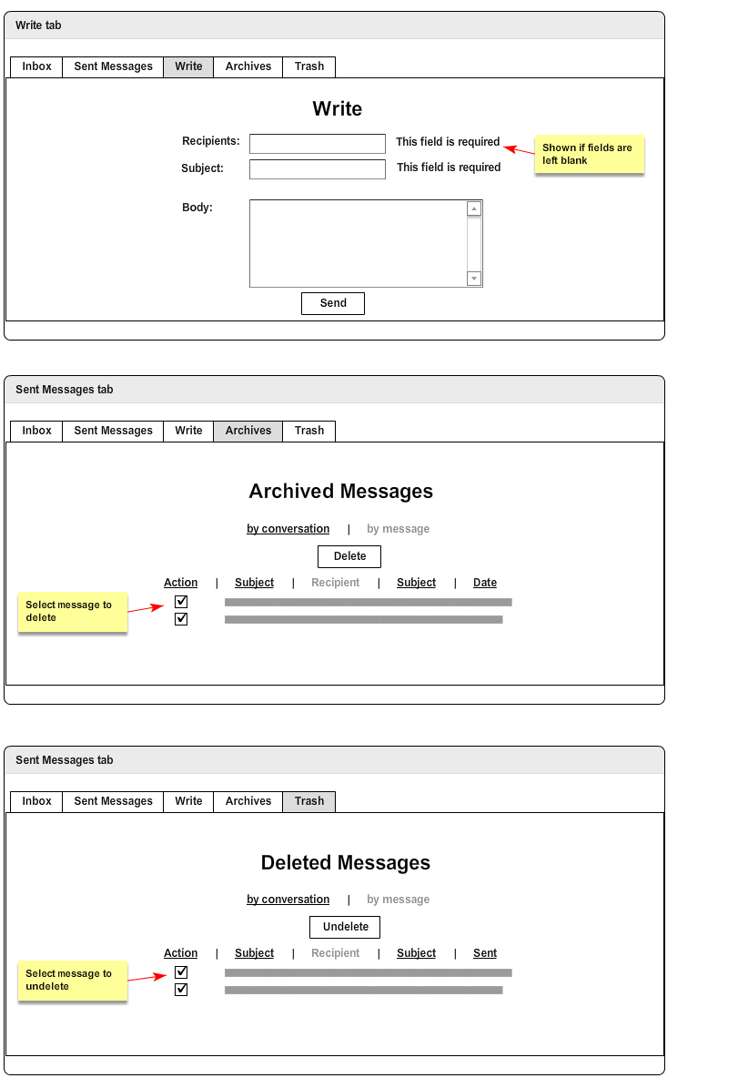

**19.1 - Describe how you would assess the quality of a university before applying to it. What factors would be important? What factors would be critical?**

Important Factors

* Housing: How are the housing accommodations at the university? I would want to ensure that where I would be living at the university is comfortable and will allow me to focus on my school work. This includes a desk with enough space to have a computer and do work and a comfortable bed in order to get enough rest.
* Location: Where is the school located? Some people would prefer to live in the city and attend school in the city, while others would prefer a university in a more remote area. Personally, I would not enjoy living and attending school in the city.
* Accreditation: Is the school accredited? Many universities are given accreditation by the US Department of Education recognizing that the university provides a high quality education.
* Admission Rate: What is the admission rate at the university? If the admission rate is low, it may not even be worth applying.
* Graduation Rate: What is the graduation rate at the university? If I do get into the college, what are my chances of graduating on time? Some colleges have significantly higher graduation rates than others, which shows that these university tend to support their students more. A high graduation rate is favorable to me.
* Class Size: What is the average class size and student to teacher ratio? I would prefer being in a smaller class compared to a large lecture hall as it enhances the learning environment.

Critical Factors

* Major: Does the university have the major I want? It’s crucial that a school has the major I want to study in before applying to it. Without having it, what’s the point of attending the school? This is definitely the most important factor.
* Academic Success: Will the university help facilitate my academic success? The main reason for attending a university is to receive a degree. It’s critically important that the university helps with getting the degree.
* Cost: How much will attending the university cost? This will call for a cost-benefit analysis. Is how much I will pay for the university worth the knowledge and experience that I am going to get from it? Schools cost an exuberant amount of money, so it’s crucially important that cost is heavily considered before applying.
* Financial Aid: What opportunities are available for financial aid/scholarships? To help keep the cost of the education down, it’s important to consider what opportunities are possible for help provided by the school. If the school does not offer much financial aid to me and I am ineligible for scholarships, it would definitely influence my decision.

**19.3 Using the definition of software quality proposed in section 19.2, do you think it’s possible to create a useful product that provides measurable value without using an effective process? Explain your answer.**

Ideally, software quality is achieved through an effective software process that creates a useful product which provides value for the producers and the end-users.

It is difficult to produce a useful product without using effective process because:

* An effective software process provides an infrastructure for creating a high-quality software.
* Regular checks and balances created as part of management help in avoiding chaos.
* Through the various guidelines and practices involved with an effective software process, the developers are better able to analyse the problems and design the solutions.
* Further, the various testing and umbrella activities associated with software processes such as the technical reviews, inspections, etc. result in achieving a quality product.

Although, it is possible to create a useful product without using an effective software process, using one ensures that a high-quality product is built and provides the content, features and functions that the users desire.

**19.9 -** **What is 'good enough' software? Name a specific company and specific product that you believe were developed using good enough philosophy.**

The ‘good enough’ philosophy is a software quality concept where the software product is delivered to the end user with known bugs. The developers recognise that the delivered products does not cater to all the requirements and standards and plan for the fixes and improvements in the next version release.

This is done in order to keep up with the market where a good enough product with few bugs is more valuable than a delay caused in the process of creating a perfect solution.

Example: One of the companies that followed this philosophy was Pure Digital Technologies which brought in a product called Flip Video ,a Pure Digital Point and Shoot camera, in a market that had experts like Sony,Nikon and Canon. The Flip Video was a basic digital camcorder with a poor video quality compared to the existing cameras but it was cheap and served as a perfect Youtube camera which lead to its popularity.