1. Program Input/ Output
   1. Program 1

This program takes in three numbers from the console and returns the answer to the formula provided. If the program encounters a division by zero it will return a message saying that there was an error.

* 1. Program 2

This program takes in data about two processors. First being Instruction count, the second being clocks per instruction, and the clock rate. Then each processor's CPU time is calculated and then compared to each other. It then returns the relationship between their speeds.

1. Program Design
   1. Program 1  
      This program starts by printing a message to the screen asking for input for each number. Then it checks if the divisor in the formula is a zero, if so it jumps to a process that prints a divide by zero error message to the screen. If not, it finishes the calculation and returns it and the remainder from the division.
   2. Program 2

This program starts by prompting each of the processor's CPU data with a subroutine that will store the values of each into a specific register. Those values are passed into another routine that will calculate their cpu time. If the cpu times of each are equal then the program returns that and exits. If not it checks to see which is faster and will print out how many times faster it is than the other.

1. Symbol Table
   1. Program 1

| $s0 | Stores the A Value |
| --- | --- |
| $s1 | Stores the B Value |
| #s2 | Stores the C Value |
| #s3 | Result of a + b*b |
| #s4 | Result of c - (a*a) |
| #s5 | quotient |
| #s6 | remainder |
| #s7 | Result of 3 * A |
| #a0 | Syscall variable |
| #v0 | Syscall variable |

* 1. Program 2

| $f1 | Stores the Instruction count |
| --- | --- |
| $f2 | Stores the Clocks per Instruction |
| $f3 | Stores the clock rate |
| $f4 | Processor 1 CPU Time Result |
| $f5 | Processor 2 CPU Time Result |
| $f12 | Used to print Floating point ops |
| $a0 | Syscall Variable |
| $a1 | Holds the address of one or two for output |
| $v0 | Syscall variable |

1. Learning coverage
   1. I learned how to divide and multiply floating point numbers
   2. I learned how to compare floating point numbers
   3. I learned how to branch on floating point logic comparisons
   4. I learned how to get the remainder from division operations
   5. I learned how to print floating point numbers to the console
2. Test Results
   1. Program 1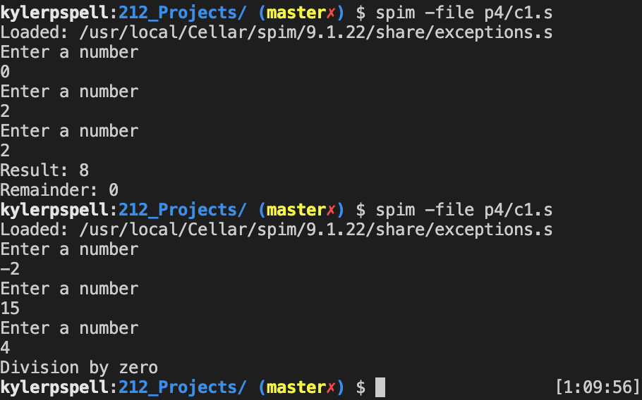
   2. Program 2

