Shifts in shape and size distributions of the coral community in response to disturbances

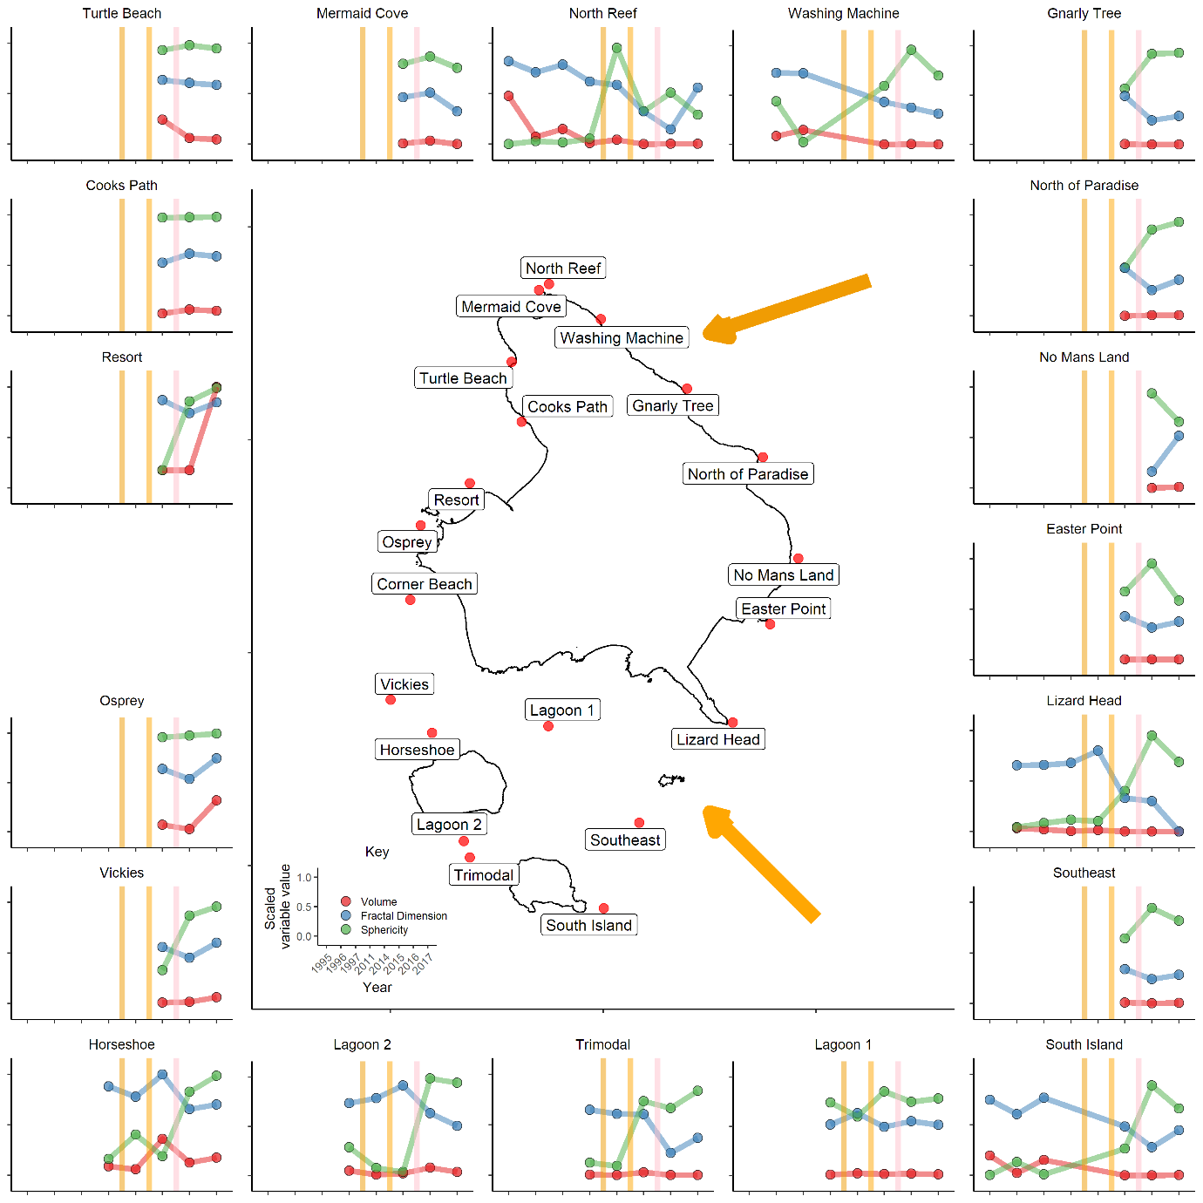

Fig. 1. Changes in shape and size distributions of coral communities for 19 sites around lizard island in response to disturbances. Vertical coloured bars in outside plots, and arrows on map indicate disturbance type and time; dark orange, cyclone Ita, a category 4 cyclone that struck the north east of the island in 2014, light orange, cyclone Nathan, a category 4 cyclone that struck the south east of the island in 2015, pink, the 2016 mass bleaching event. The three variables are the weighted averages of size and shape of the coral community at each site for a given year, with colonies weighted by transect intercept length. Volume, the estimated volume of the coral, an indicator of body size; sphericity, a measure of volume compactness, with higher sphericity indicating more compact colonies; fractal dimension, a measure of surface complexity, with higher values indicating that the surface of the colony is distributed more complexly in space. Note that the average shape of colonies changed in proximity to each cyclone, with the north-east reefs effected by Ita and the south-east reefs effected by Nathan. The response to bleaching however is distributed around the island, with most sites effected by the cyclone.