**PL SQL**

Q1>

Scenario 1:

Code:

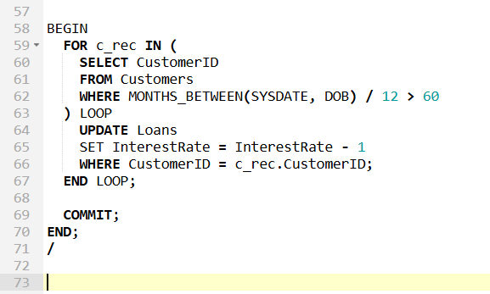

Output:

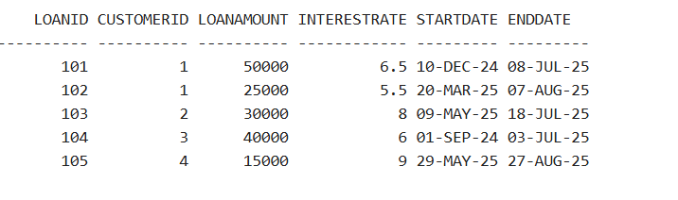

Scenario 2

Code:

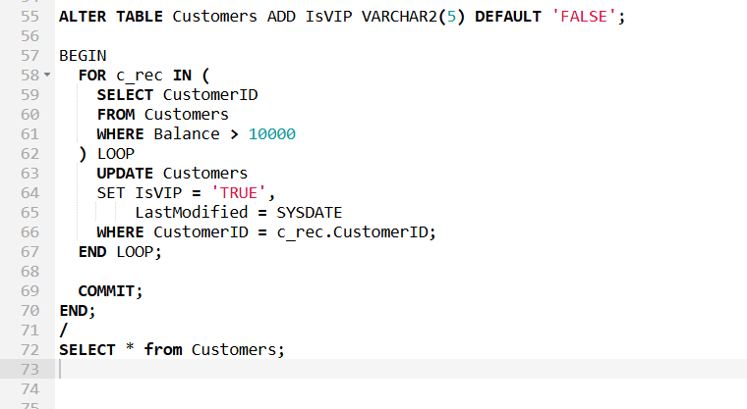

Output:

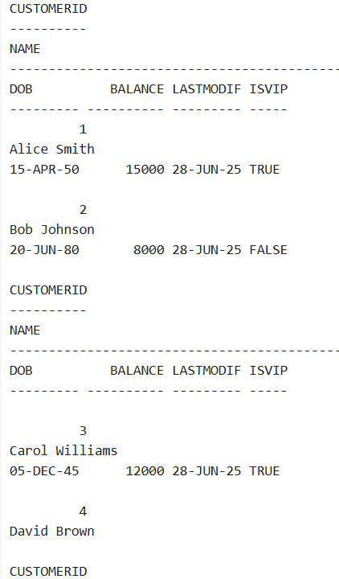

Scenario 3:

Code:

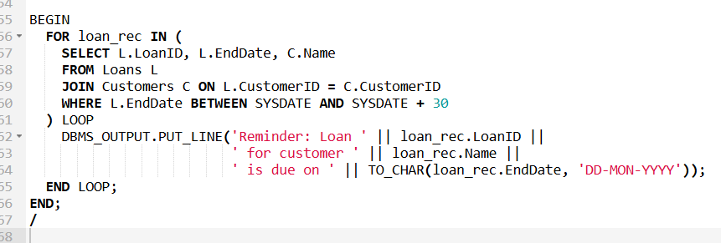

Output:

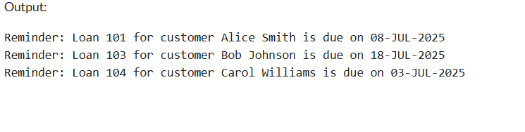

Q3>

Scenario 1

Code:

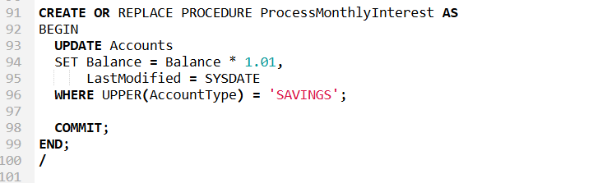

Scenario 2

Code:

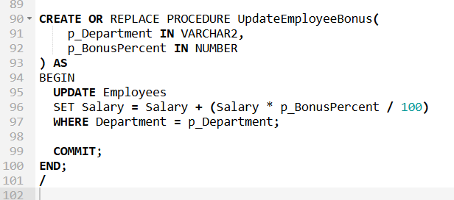

Scenario 3:

Code:

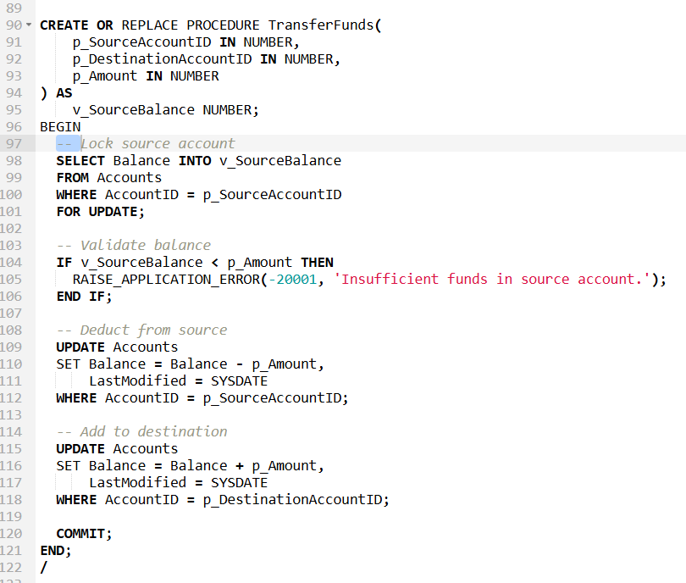

**TDD using JUnit5 and Mockito**

**JUnit Testing Exercises**

**Ex1>**

**Code:**

Calculator.java

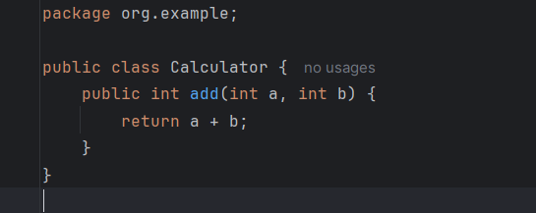

CalculatorTest.java

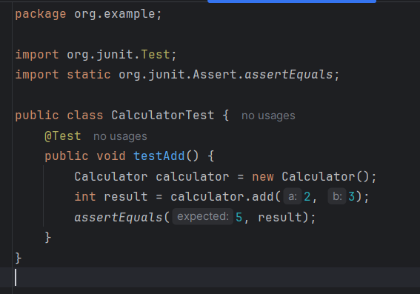

Output

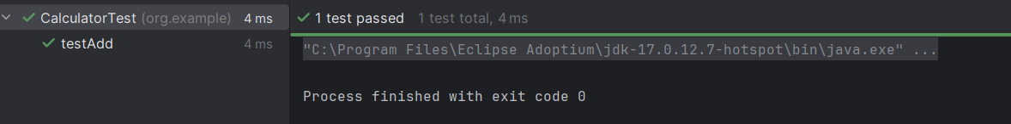

Ex3>

Code:

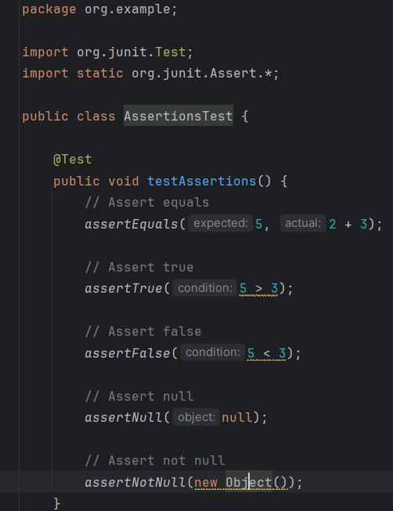

Output:

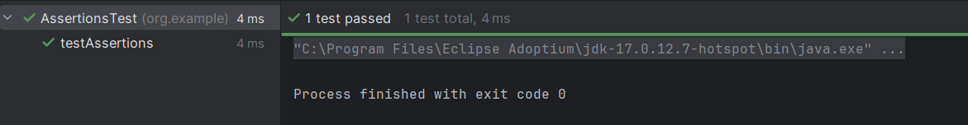

**Ex4>**

**Code:**

Calculator.java

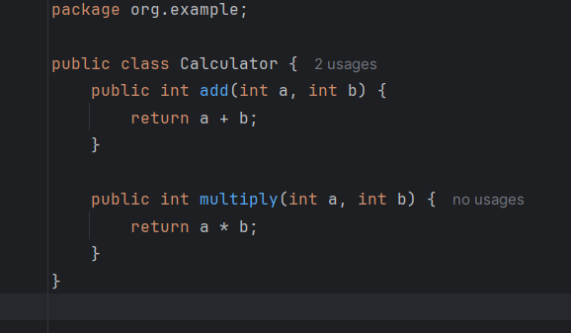

CalculatorTest.java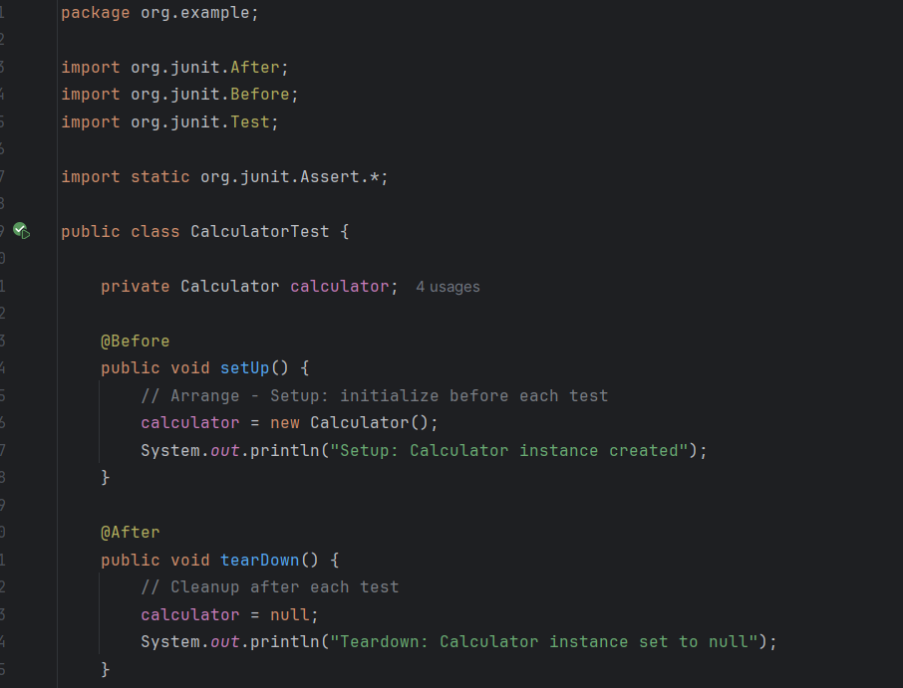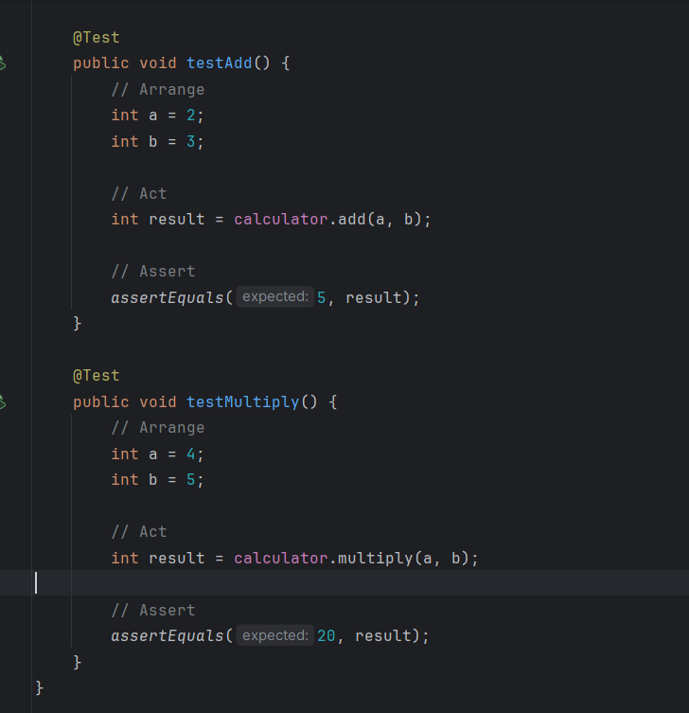

Output:

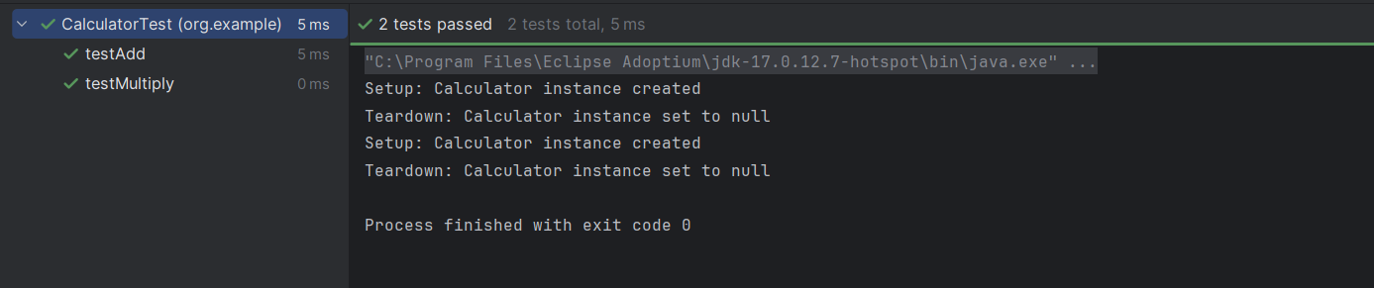

**3.Mockito exercises**

**Ex1>**

Code:

ExternalApi.java

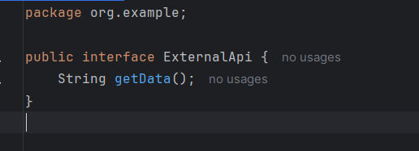

MyService.java

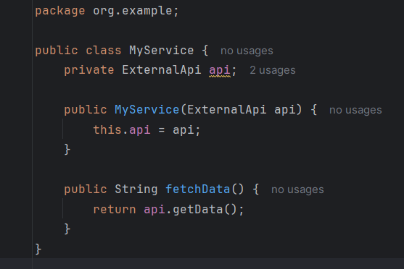

MyServiceTest.java

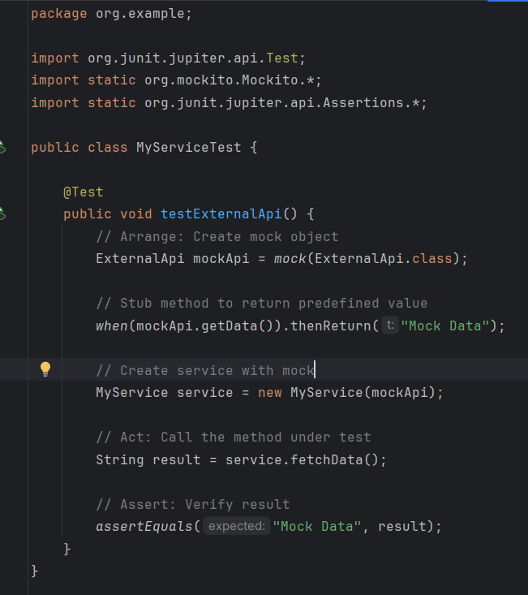

Output

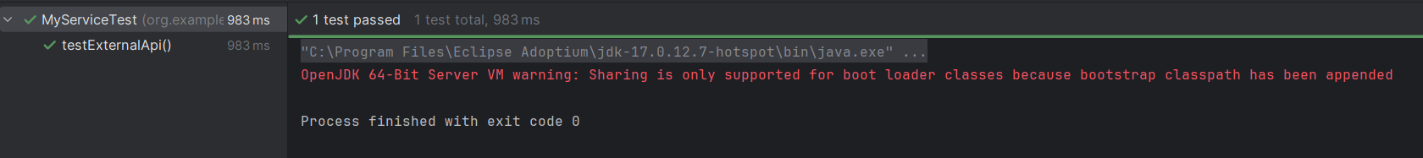

Ex2>

Code

ExternalApi.java

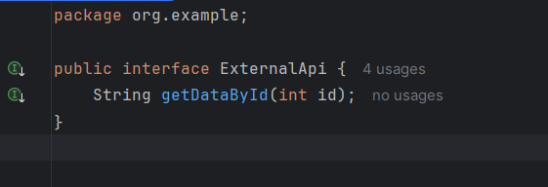

MyServiceTest.java

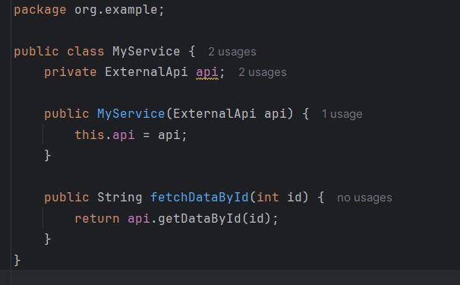

MyServiveTest.java

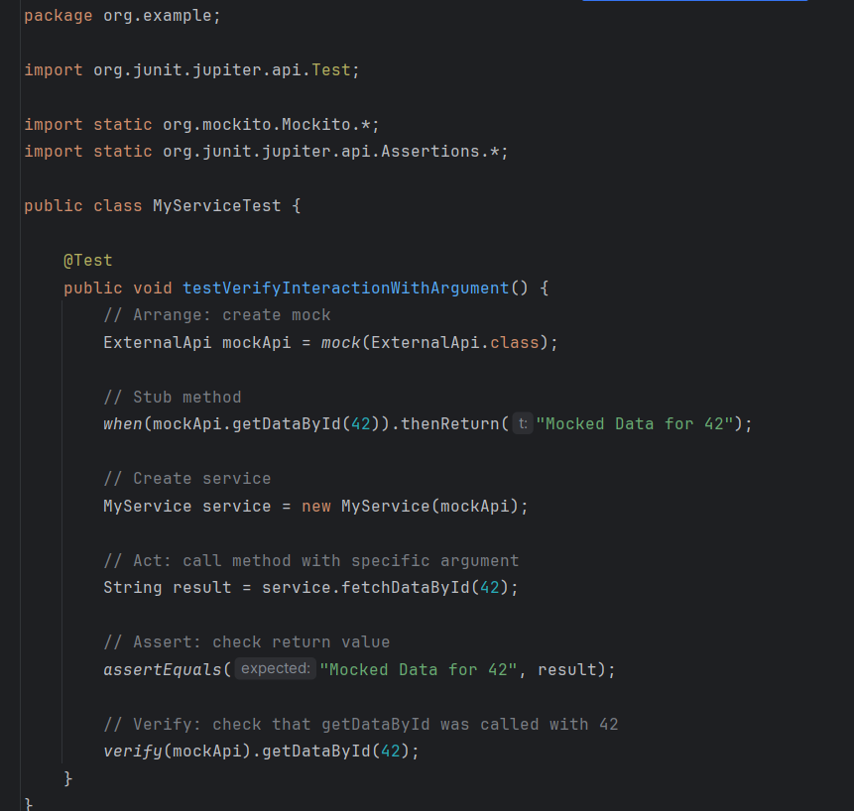

Output



**6. SL4J Logging exercises**

**Ex1>**

**Code:**

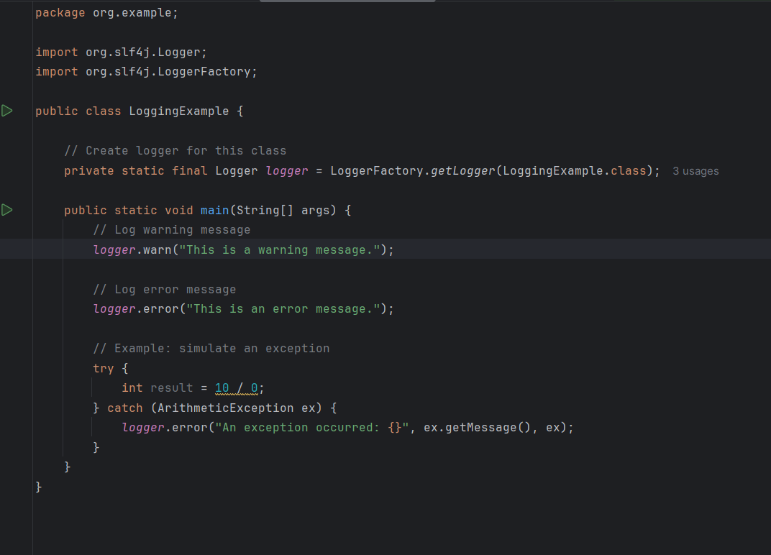

Output:

