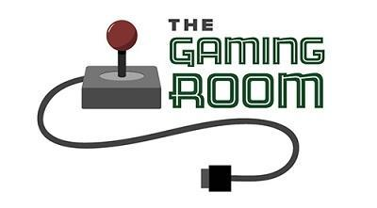

Draw It or Lose It
Kylie Reiter
05-22-2025

CS 230 Project Software Design Template
Version 1.0

Table of Contents

CS 230 Project Software Design Template 1
Table of Contents 2
Document Revision History 2
Executive Summary 3
Requirements 3
Design Constraints 3
System Architecture View 3
Domain Model 3
Evaluation 4
Recommendations 5

Document Revision History

Version | Date | Author | Comments
1.0 | 05/22/2026 | Kylie Reiter | Initial submission for Project One

Instructions
Fill in all bracketed information on page one (the cover page), in the Document Revision History table, and below each header. Under each header, remove the bracketed prompt and write your own paragraph response covering the indicated information.

Executive Summary

The Gaming Room is expanding its mobile game, Draw It or Lose It, to a web-based version that can support multiple platforms. As a technology consultant, I am designing and developing a prototype for this game using key software patterns like Singleton and Iterator. The Singleton pattern ensures only one instance of the game controller (GameService) runs in memory. The Iterator pattern ensures that all game and team names are unique. This design prepares the application to scale across devices and platforms efficiently.

Requirements

- A game can have multiple teams
- Each team contains multiple players
- Game and team names must be unique
- Only one instance of GameService can exist in memory
- Code must use Singleton and Iterator patterns

Design Constraints

- The application must be able to scale for multiple devices.
- Only one instance of the game controller is allowed (Singleton pattern).
- Game, team, and player names must be unique (Iterator pattern).
- Classes must use inheritance for shared functionality (via the Entity superclass).
- The solution must work across distributed, web-based environments.

System Architecture View

Please note: There is nothing required here for these projects, but this section serves as a reminder that describing the system and subsystem architecture present in the application, including physical components or tiers, may be required for other projects. A logical topology of the communication and storage aspects is also necessary to understand the overall architecture and should be provided.

Domain Model
The UML diagram illustrates the relationship between the main components: GameService, Game, Team, and Player. Each of the three entity classes (Game, Team, and Player) inherits from a base class called Entity, which provides a unique id and name.
The GameService class is a singleton that manages all games and assigns unique IDs. A game contains multiple teams, and a team contains multiple players.
The diagram demonstrates object-oriented principles such as inheritance (via Entity), encapsulation (private variables with getters), and design patterns like Singleton and Iterator to manage state and uniqueness efficiently.

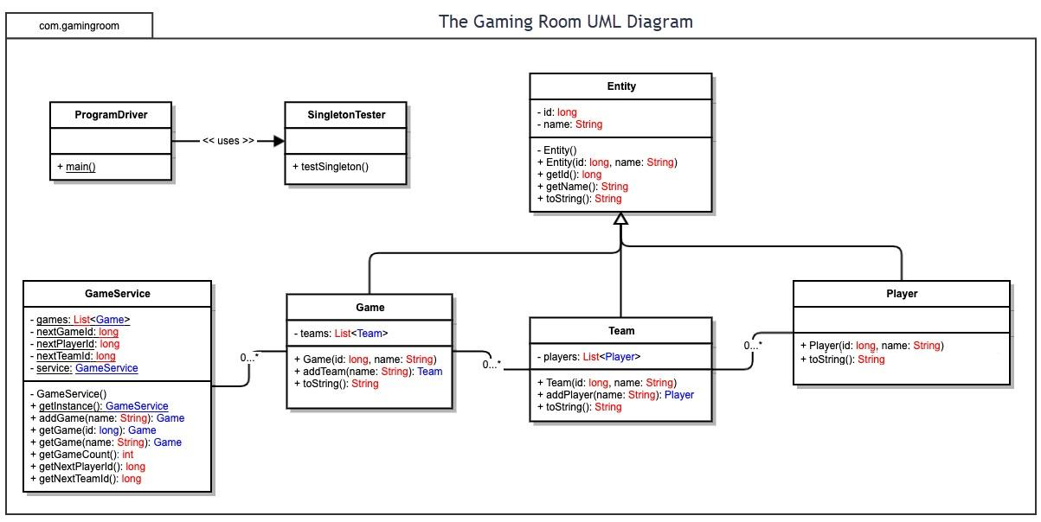

Evaluation

When selecting platforms for The Gaming Room’s game Draw It or Lose It, it’s important to evaluate cost, scalability, ease of development, and platform reach.

Linux is the strongest choice for server-side hosting due to its open-source nature, high stability, strong community support, and excellent performance for scalable, cloud-based applications.
Windows is valuable for local testing and enterprise support but comes with higher licensing costs and greater vulnerability to malware.
Mac is ideal for design and Apple-focused development, though less common in enterprise hosting due to hardware limitations and cost.
Mobile devices (Android and iOS) are crucial for expanding audience reach. Android offers flexibility and broad adoption; iOS offers performance and user loyalty, though with stricter publishing rules.

Overall, a Linux-based server infrastructure, paired with a web-based responsive front end for Windows, Mac, and mobile, offers the most efficient and scalable approach. Development can be done on Windows or Mac depending on team needs, while mobile support should use cross-platform tools to streamline production.
The table below evaluates each platform—Mac, Linux, Windows, and Mobile—based on server-side deployment, client-side compatibility, and development tooling.

Development Requirements | Mac | Linux | Windows | Mobile Devices
Server Side | macOS is Unix-based and supports tools like Apache, MySQL, and Java. However, it’s less common in enterprise environments. Hosting is possible but not widely adopted due to cost and compatibility limitations. | Linux is the most popular OS for web servers. It is open-source, secure, customizable, and supports Apache, MySQL, and PHP. It's the preferred choice for hosting web applications due to its stability and cost-efficiency. | Windows supports IIS (Internet Information Services), .NET applications, and SQL Server. It's commonly used in enterprise settings, but licenses can be expensive and it's more prone to malware. | Mobile devices are not typically used for server hosting due to limited resources and lack of server-grade features. They are better suited as client platforms.
Client Side | Developers must ensure web apps function on Safari and Chrome. Costs are higher for Mac devices, and development tools like Xcode are Mac-specific. Useful for Apple ecosystem testing. | Linux is open-source and customizable. Fewer users run Linux desktops, so it's less common for client-side testing. Useful for developers but not a target client base. | Windows is the most widely used desktop OS. Web apps must be compatible with browsers like Edge and Chrome. Supports many dev tools and is vital for testing. | Mobile is a major platform. Apps must run on mobile browsers and screen sizes. Android and iOS require cross-platform support and responsiveness in web app design.
Development Tools | Tools: Xcode, IntelliJ IDEA, Eclipse, Git, Terminal, Homebrew. Languages: Swift, Java, Python, JavaScript. | Tools: Eclipse, IntelliJ, NetBeans, Vim, Git. Languages: Java, Python, C++, JavaScript. Preferred by developers for customization. | Tools: Visual Studio, Eclipse, IntelliJ, Git, PowerShell. Languages: C#, Java, Python, JavaScript. Excellent .NET support. | Tools: Android Studio, Xcode (for iOS dev on Mac), GitHub Mobile. Languages: Java, Kotlin (Android), Swift (iOS), JavaScript for hybrid apps.

Recommendations

Operating Platform
To support the cross-platform expansion of Draw It or Lose It, I recommend using a cloud-based Linux server hosted on Amazon Web Services (AWS). AWS offers scalable infrastructure, global availability zones, and flexible deployment options that make it an ideal backbone for multi-platform games. Linux is open-source, cost-effective, and highly customizable, which aligns well with the needs of a growing game like this.

Operating Systems Architectures
The Linux operating system uses a monolithic kernel architecture, which allows all core functions such as device drivers, memory management, and file systems to run in kernel space. This design supports high performance and efficient interprocess communication (IPC), which is crucial for fast-paced, multiplayer game instances like Draw It or Lose It. The modular nature of the Linux kernel also supports loading and unloading components on demand, which is useful for scaling services in response to player traffic.

Storage Management
A reliable and cost-efficient storage solution for the game would be Amazon Elastic File System (EFS) or Amazon S3 (Simple Storage Service). S3 is ideal for storing the 200+ high-definition image assets (~8MB each) needed in gameplay. EFS can be used for structured data such as game states, player progress, and real-time assets across multiple application instances. Both are secure, highly available, and integrate seamlessly with Linux on AWS.

Memory Management
Linux implements advanced virtual memory management using paging, allowing it to efficiently allocate memory across multiple processes. The game engine can take advantage of Linux’s Least Recently Used (LRU) page replacement algorithm to prioritize memory usage for active game sessions. Using in-memory caching solutions like Redis can further improve performance by holding frequently accessed data such as session data or player stats in RAM for quick retrieval.

Distributed Systems and Networks
To support multiplayer gameplay across devices and platforms, Draw It or Lose It should use microservices architecture with containerized services deployed via Docker and orchestrated with Kubernetes. This allows for isolated game instances, efficient scaling, and load balancing across servers. AWS Elastic Load Balancer can distribute traffic, and Amazon CloudFront CDN can serve static assets globally with low latency. WebSockets or gRPC are recommended for real-time communication between clients and servers.
Dependencies between components should be minimized through RESTful APIs or message queues (e.g., Amazon SQS or RabbitMQ) to decouple services and improve fault tolerance. Failover systems and health checks should be in place to handle connectivity issues or service outages gracefully.

Security
Security should be built into every layer of the architecture. AWS supports IAM (Identity and Access Management) for strict user role permissions. User data should be encrypted at rest (via AWS KMS) and in transit using TLS 1.2+. Multi-factor authentication (MFA) should be enabled for admin accounts. Player authentication can be managed using OAuth 2.0 or OpenID Connect. All user inputs should be sanitized to prevent SQL injection or XSS attacks, and regular penetration testing should be scheduled to assess vulnerabilities.
For extra protection, services like AWS WAF (Web Application Firewall) and Amazon GuardDuty can monitor for malicious activity and provide real-time threat detection.

