Figure 1: Login Screen
Displays the login interface where users can enter a username and password or create a new account.
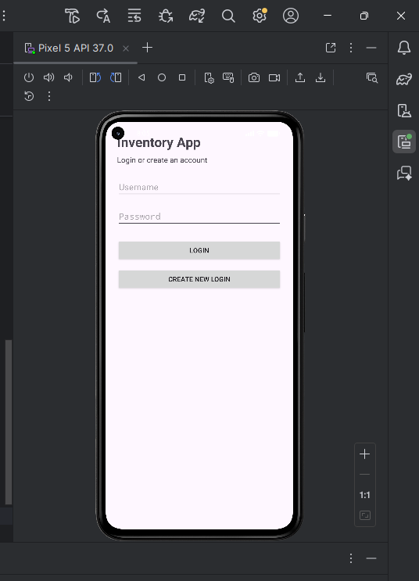

Figure 2: Inventory Dashboard
Shows the main inventory screen where items are listed. Users can view item names, quantities, update quantities, or delete items.
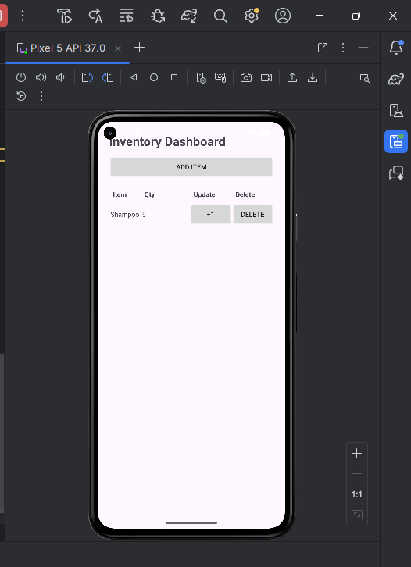
Figure 3: Add Item Screen
Allows users to input a new item name, category, and quantity, then save it to the inventory database.
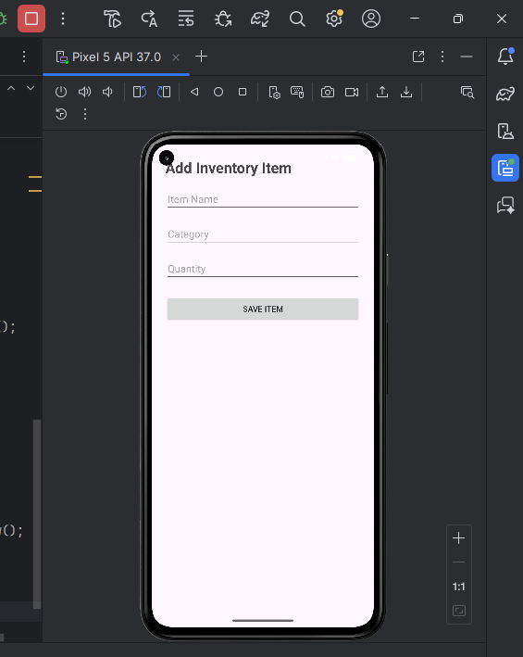
Figure 4: Inventory After Adding Item
Displays the inventory after a new item has been successfully added to the database. The item name and quantity are shown in the table.
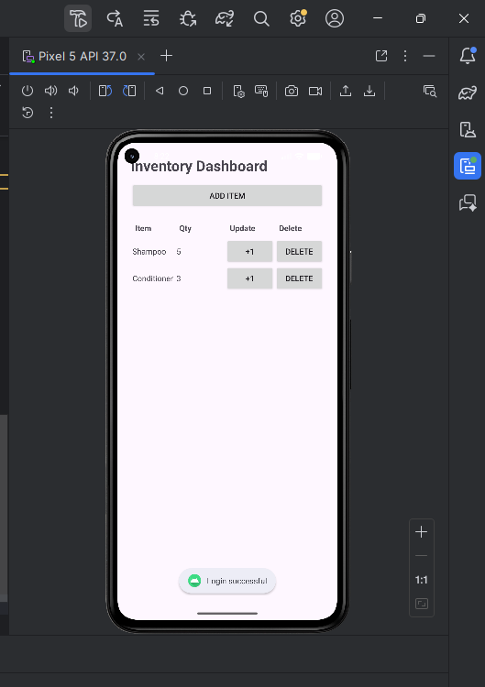

Shows the updated inventory after pressing the +1 button, increasing the item quantity.
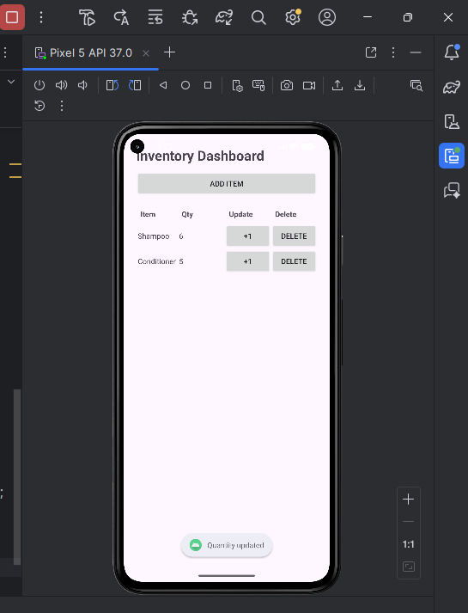
Displays the inventory after an item has been removed using the delete button.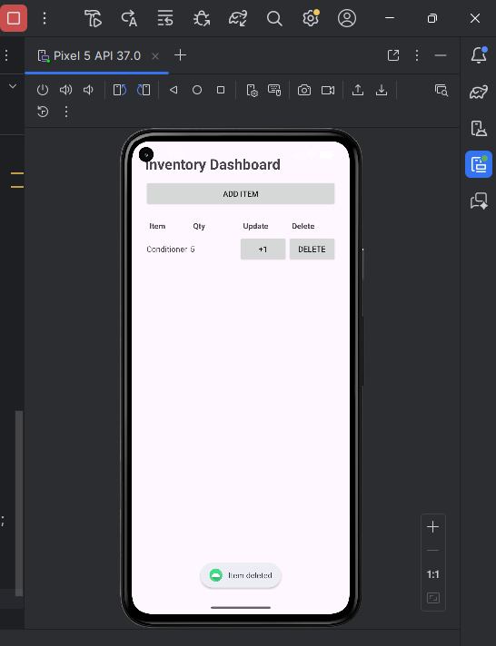

This application allows users to create an account, log in, and manage an inventory system. Users can add items with a name, category, and quantity, which are stored in a local SQLite database. The app also allows users to update item quantities and delete items. This demonstrates the use of activities, user input handling, and database integration in Android development.

