Cuevas Kyllian
Mirbey Thomas

N-Lateration for Positioning Systems

The 3D N-Lateration Positioning System determines the position of a mobile device (represented in purple) by measuring distances from multiple access points. The system stores and processes data as follows:
Storage Mechanism:
- AccessPoint Class: Each access point has an ID, coordinates (x, y, z), a radius (distance to the mobile phone), and a color for visualization.
- List of AccessPoint Objects: A list stores all reference access points used for positioning.
- Estimated Position (trilaterate function output): The estimated (x, y, z) coordinates of the mobile phone.
Processing Flow:
- Distance Calculation:
  - The system uses the Euclidean distance formula to compare actual and estimated distances.
  - The difference between measured (radius) and computed distances is used as the error metric.
- Optimization with minimize():
  - The trilaterate function minimizes the error function (calculate_error) to find the most likely phone position.
  - The optimization algorithm iteratively adjusts (x, y, z) to minimize the sum of squared distance errors.
- Visualization (draw function):
  - The 3D plot shows access points as spheres and the estimated position as a cross.
  - The plot dynamically adjusts limits based on access point positions.

2. Implementation Details
2.1 Computing Distance Errors
- Each access point's actual distance (radius) is compared with the calculated distance from an estimated phone position.
- The squared error is computed as:

- This error is minimized using the SciPy minimize() function.
2.2 Finding the Best Position (Trilateration)
- The function trilaterate() finds the (x, y, z) position by minimizing calculate_error().
- The initial guess is (0,0,0), and the optimizer iteratively refines the estimate.
2.3 Visualization (3D Plot)
- The draw() function creates a 3D scatter plot:
  - Spheres: Represent access points.
  - Crosses: Indicate the estimated phone position.
  - Color Coding: Differentiates access points.
2.4 Main Execution
- The script initializes access points with known positions and distances.
- It computes the estimated phone position (trilaterate).
- The estimated position is printed and plotted in 3D.

3. Results and Analysis
- The estimated phone position depends on:
  - The accuracy of RSS measurements.
  - The number and placement of access points.
- The method balances computational efficiency and accuracy.
- Future improvements may include refining weight functions or filtering noisy signals.

5. Code Overview
The implementation consists of the following key functions:
- calculate_error() – Computes the squared error between measured and calculated distances.
- trilaterate() – Uses optimization to find the best (x, y, z) position.
- draw() – Visualizes access points and estimated phone position.
- AccessPoint class – Stores access point information and provides a method to draw spheres.
6. Diagrams and Figures
Class Diagram:
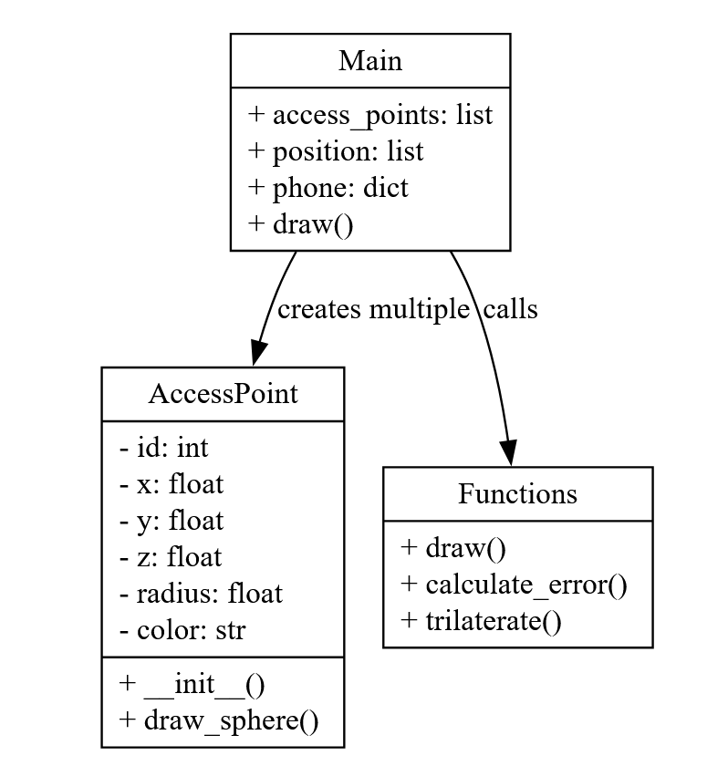

Flowchart:
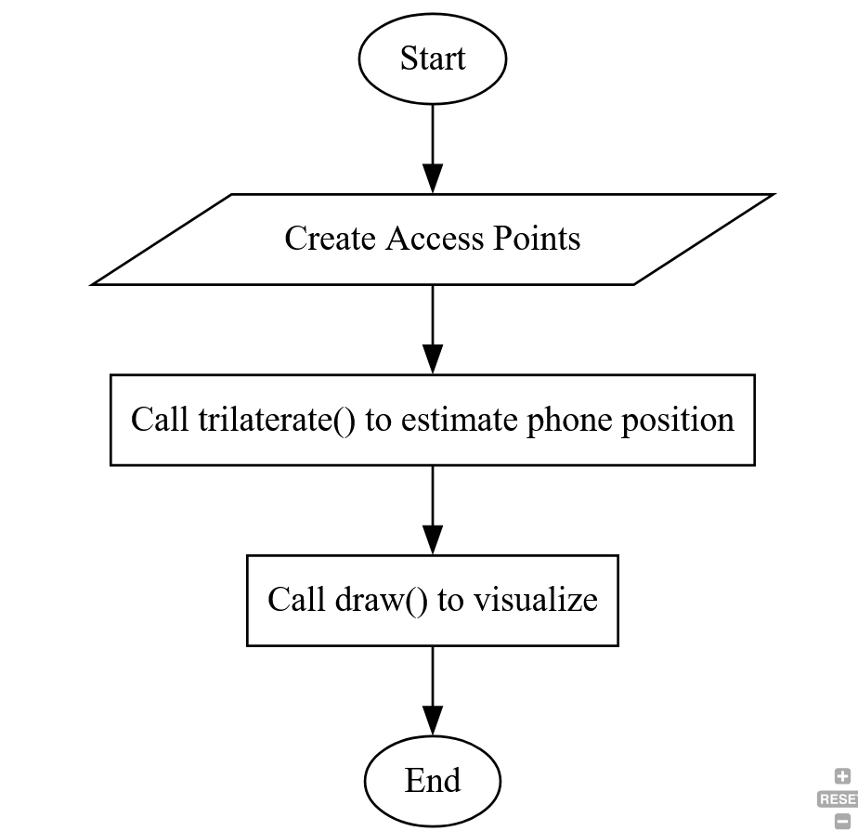
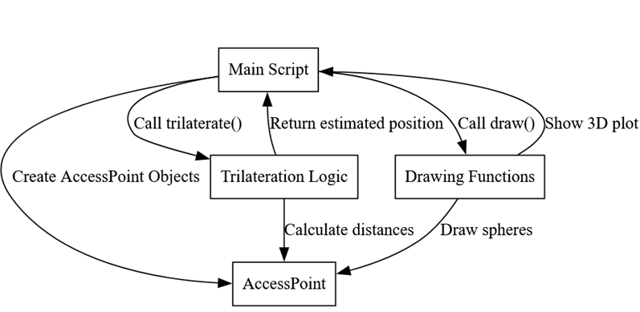
Interaction diagram:
1
2
3
4
5
6
7

