UM TAGUM COLLEGE
BACHELOR OF SCIENCE IN COMPUTER SCIENCE
Department of Computing Education
Visayan Village, Tagum City, Philippines


Course Requirements
in
CCE 106/L - 1767
APPLICATION DEVELOPMENT & EMERGING TECHNOLOGIES
SAGIP: OFFLINE-FIRST DELAY-TOLERANT
EMERGENCY COMMUNICATION SYSTEM
Submitted To:
MARICEL A. TIMBAL
Submitted By:
ARCHE, ALEXANDER L.
PEDOTIM, JERVIS JAMES T.
PIZON, KYNE ANTHONY F.
VILLA, GERALD ANDREI P.
September 29, 2026

TABLE OF CONTENTS
List of Tables 1
List of Figures 2
CHAPTER ONE 3
INTRODUCTION 3
PROJECT OVERVIEW 3
REQUIREMENTS 4
CHAPTER TWO 7
ARCHITECTURE 7
DESIGN 8
DEVELOPMENT PROCESS 14
CHAPTER THREE 16
TESTING 16
DEPLOYMENT 17
MAINTENANCE 19
CONCLUSION 20
REFERENCES 20

List of Tables
Table No. | Title | Page No.
Table 1 | Functional Requirements | 5
Table 2 | Non-functional and Safety Requirements | 6
Table 3 | Technology Stack | 8
Table 4 | Local SQLCipher Data Model | 10
Table 5 | PostgreSQL Data Model | 11
Table 6 | Protocol Families | 11
Table 7 | Backend HTTP Interface | 13
Table 8 | Delivery State Meanings | 14
Table 9 | Current Host Validation Results | 16
Table 10 | Field Acceptance and Production Gates | 17

List of Figures
Figure No. | Title | Page No.
Figure 1 | SAGIP System Architecture | 7
Figure 2 | Emergency Delivery and Acknowledgement Flow | 8
Figure 3 | Local and Server Persistence Design | 10
Figure 4 | Development Milestone Timeline | 15

CHAPTER ONE
INTRODUCTION
Disasters can interrupt mobile data, power, routing, and normal emergency channels. An emergency application must continue to protect an SOS report when the network fails.
SAGIP is an offline-first emergency communication system for Android devices. It persists each SOS report before it starts network, radio, location, or signing work.
SAGIP first tries direct internet delivery when a usable network exists. If direct delivery fails, Bluetooth Low Energy can transfer the same report to another SAGIP device.
The SAGIP server validates the signed report and stores one canonical incident. Authorized responders use a web console to inspect incidents and record operational status.
The interface keeps each delivery state separate. A local save, peer relay, server acceptance, and responder acknowledgement are different events.
PROJECT OVERVIEW
The system has a civilian Android application, an Android Survival Core, a Node.js backend, PostgreSQL storage, and a responder web console.
The civilian application collects emergency type and urgency. It can also attach a best-available location when Android permission and a stored location are available.
The Survival Core owns durable emergency behavior. It stores data in an encrypted local database and continues delivery work outside the React Native screen lifecycle.
The coordination layer accepts immutable signed envelopes, prevents duplicate incidents, and stores responder state. The backend also serves the responder console and public report status.
The current runtime prepares SGP1 envelopes with SRP1 plaintext payloads. SGP2 and SRE2 encryption support exists in code, but production emission is not active.
Current field qualification is incomplete. The full two-phone BLE custody and return-acknowledgement path still requires physical end-to-end validation on the current revision.

Current end-to-end flow
1. The user selects an emergency type and urgency.
2. The Android Survival Core persists the SOS report in one local transaction.
3. The core prepares and stores one signed SGP1 envelope.
4. The delivery worker tries direct HTTPS delivery when a network is usable.
5. BLE can transfer the same persisted envelope to a nearby SAGIP relay device.
6. A relay device can later forward the same envelope to the SAGIP server.
7. The server persists one canonical incident and returns server acceptance.
8. An authorized responder records a status in the responder console.
9. The origin receives the status directly or through the SGA1 BLE return path.

Platform scope
The current safety-critical native implementation targets Android API 24 or later. The Android build uses compile SDK 36 and target SDK 36.
The repository includes an iOS React Native scaffold. The documented Survival Core, BLE relay, SQLCipher migration, and Android background services are Android implementations.
REQUIREMENTS
ID | Function | Requirement | Status
FR-01 | Create an SOS report | The user selects one emergency type and one urgency level. | Implemented
FR-02 | Persist before success | The system reports success only after the local database transaction commits. | Implemented
FR-03 | Restore saved reports | The application loads persisted SOS reports after process restart. | Implemented
FR-04 | Capture location without blocking | The system can attach the best last-known GPS or network location. Missing location does not block the SOS. | Implemented
FR-05 | Prepare one signed envelope | The system prepares SRP1 data and signs one SGP1 envelope with the Android Keystore identity. | Implemented
FR-06 | Reuse immutable bytes | Retries and BLE relay use the stored envelope bytes instead of creating new bytes. | Implemented
FR-07 | Deliver through internet | A device posts a due envelope directly to the server when a usable network exists. | Implemented
FR-08 | Relay through BLE | A nearby SAGIP device can take durable custody of an envelope when direct delivery is unavailable. | Implemented, physical end-to-end test pending
FR-09 | Persist before custody ACK | The relay device stores the full valid envelope before it reports BLE custody success. | Implemented
FR-10 | Forward relay custody | A relay device forwards a stored inbound envelope when it later gains internet access. | Implemented
FR-11 | Prevent duplicate incidents | The server treats exact retries as the same logical message and receipt. | Implemented
FR-12 | Support responder operations | Authorized responders can list incidents, inspect detail, filter status, and record acknowledgement states. | Implemented
FR-13 | Return responder status | The origin can obtain status from the server or through the 56-byte SGA1 BLE return frame. | Implemented, physical return test pending
FR-14 | Recover background work | Android restores network scheduling after reboot or package replacement. BLE relay can restart when active work and permissions allow it. | Implemented
FR-15 | Encrypt local emergency storage | The Android local database uses SQLCipher with a random key that Android Keystore protects. | Implemented, current connected migration test pending
Table 1. Functional Requirements.
ID | Area | Requirement
NFR-01 | Durability | Internet, BLE, location, signing, and server availability must not be required for local SOS persistence.
NFR-02 | Truthful status | The user interface must distinguish local save, pending delivery, peer relay, server acceptance, responder acknowledgement, and permanent failure.
NFR-03 | Idempotency | Retries, duplicate relays, lost responses, and repeated responder updates must not create duplicate logical incidents.
NFR-04 | Input bounds | The complete transport envelope must not exceed 8192 bytes. Binary and HTTP inputs must use strict size and range checks.
NFR-05 | Security | Production Android builds must use HTTPS. Private signing and database wrapping keys must remain in Android Keystore.
NFR-06 | Access control | Responder incident APIs require a bearer token or a valid browser session. The backend stores token and session hashes.
NFR-07 | Battery use | BLE scan and advertise activity must reduce after the urgent delivery window while active work remains retryable.
NFR-08 | Accessibility | Critical controls need readable labels, live status announcements, practical touch targets, and non-color status meaning.
NFR-09 | Compatibility | Existing SGP1, SGC1, and SGA1 formats must not change without coordinated versioned updates and compatibility tests.
NFR-10 | Release control | A production release must use explicit version data, approved signing material, an HTTPS backend, and separate readiness evidence.
Table 2. Non-functional and Safety Requirements.

Technical terms
- Durable local commit: the local database completed the SOS transaction and can restore it after restart.
- Envelope: the signed binary message that carries one SOS revision through internet or BLE transport.
- Relay device: another SAGIP Android device that stores an envelope and forwards the same bytes later.
- Custody ACK: BLE evidence that the receiver stored the complete envelope before it reported success.
- Server acceptance: the SAGIP server validated and stored the envelope and returned its canonical receipt.
- Responder acknowledgement: an authorized responder recorded an operational state for the incident.

CHAPTER TWO
ARCHITECTURE
SAGIP separates presentation, survival behavior, and coordination. This boundary keeps emergency persistence independent from the React Native screen lifecycle.
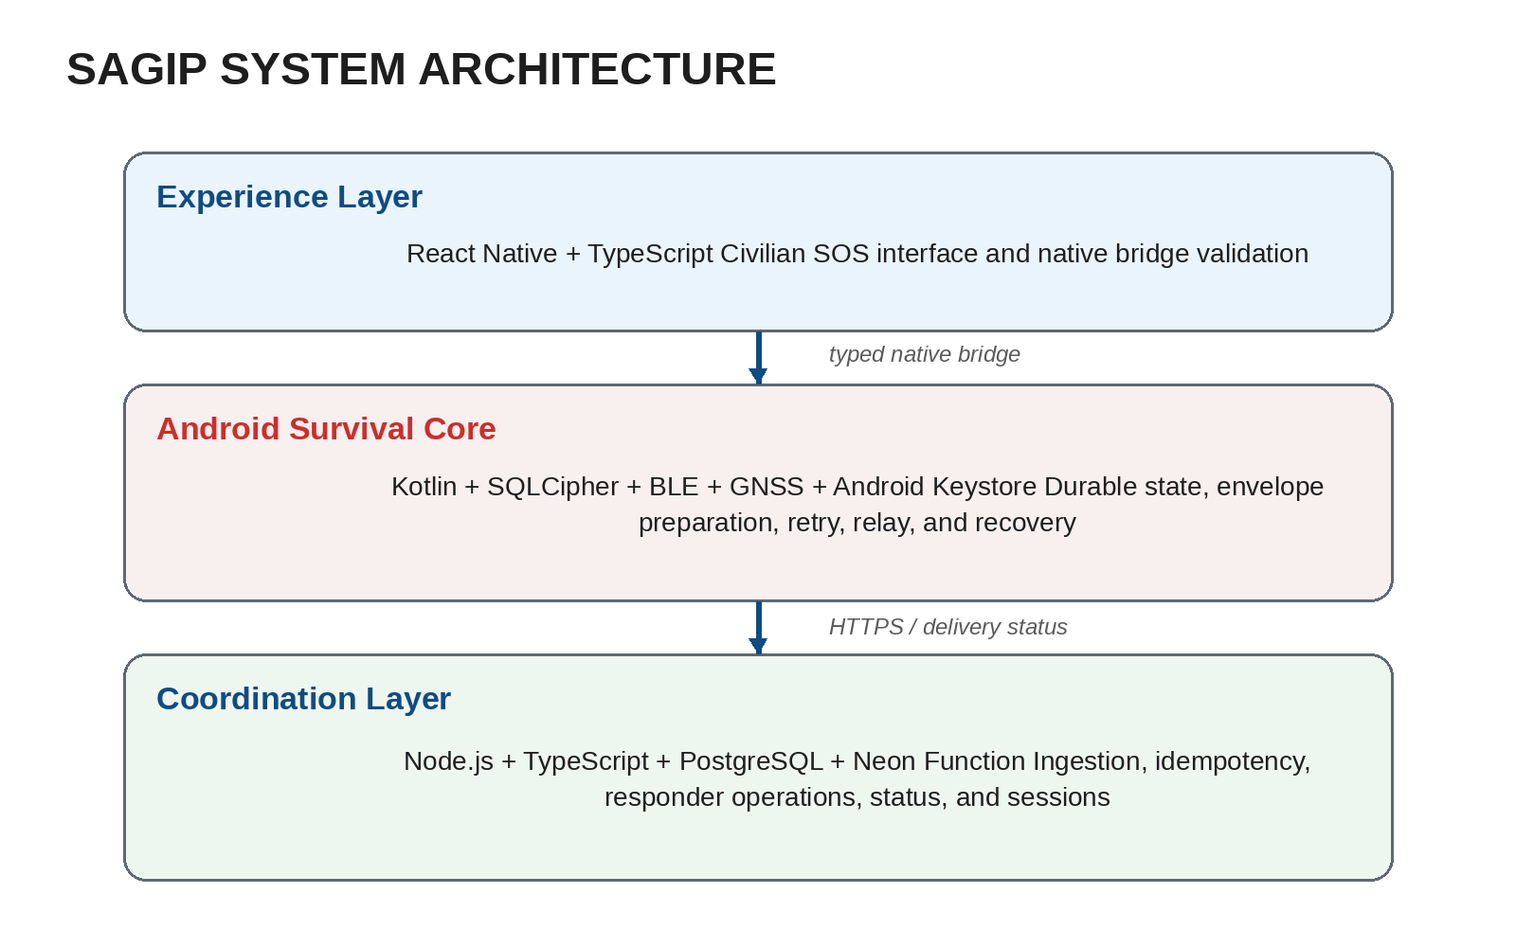
Figure 1. SAGIP System Architecture.
Layer | Technology | Primary responsibility
Civilian UI | React Native 0.87.1, React 19.2.3, TypeScript | SOS input, status display, permission prompts, bridge response validation
Android core | Kotlin 2.2.0 | Persistence, signing, delivery, BLE, recovery, and Android services
Local database | SQLCipher for Android 4.17.0, SQLite schema v7 | Authoritative emergency state and encrypted local storage
Origin identity | Android Keystore, P-256 ECDSA | Non-exportable signing key for SGP1 and SGP2 envelope signatures
Payload encryption support | Google Tink 1.23.0 | SRE2 recipient encryption and SGP2 support. Production emission is gated.
Backend | Node.js 24+, TypeScript 6.x | Envelope ingestion, API routing, responder operations, and rate limiting
Server database | PostgreSQL | Incidents, receipts, responder identities, rate windows, and browser sessions
Hosted runtime | Neon Function and Neon PostgreSQL | Current hosted backend deployment target
Android build | SDK 36, min SDK 24, Java 17 CI runtime | Application and instrumentation builds
Table 3. Technology Stack.

Delivery architecture
The local commit is the first success boundary. Transport starts only after the report, revision, optional location, outbound message, and local event are persisted.
Direct internet delivery and BLE relay are independent paths. A nearby SAGIP device is not required when the origin can reach the server directly.
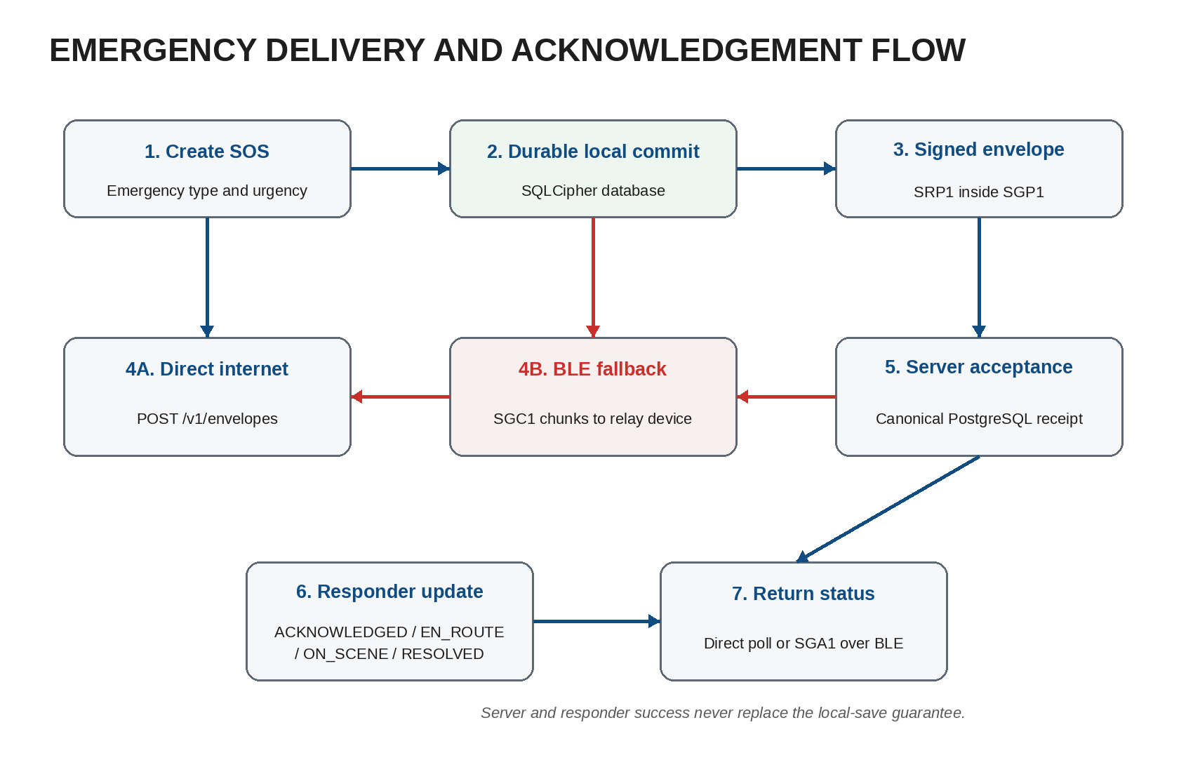
Figure 2. Emergency Delivery and Acknowledgement Flow.
DESIGN

Civilian application
The civilian screen places SOS creation first. The current flow asks for emergency type and urgency before it calls the native Survival Core.
- Emergency types: Medical, Flood, Fire, Trapped, Violence or threat, and Other emergency.
- Urgency levels: Immediate danger and Need assistance.
- Successful save message: SOS saved on this device. You do not need internet.
- Delivery summary: Pending delivery, Relayed to another SAGIP device, Server accepted, Responder acknowledged, or Permanent delivery failure.
- Nearby relay card: permission state, Bluetooth state, scan and advertise activity, duty-cycle pause, and peer count.
The application does not use the word sent as a general success state. Each visible status comes from persisted native state.

Responder console
The SAGIP backend serves the responder console at /responder. The console starts a short-lived browser session from a provisioned responder token.
- The backend stores only the responder bearer-token hash.
- A browser session lasts 12 hours unless it expires or the responder disconnects.
- The browser receives the session token in an HttpOnly, Secure, SameSite=Strict cookie.
- The console shows queue counts, urgency, incident age, best available location, revision history, and acknowledgement history.
- A responder can record ACKNOWLEDGED, EN_ROUTE, ON_SCENE, or RESOLVED with an optional note.
A responder update is persisted before the backend returns success. Repeating the same responder, report, and status transition is idempotent.

Local persistence design
The Android local database is the authoritative emergency state store. SQLCipher encrypts the database file and its normal journal or WAL pages.
A random 256-bit database key protects SQLCipher. Android Keystore stores a non-exportable AES-GCM wrapping key that protects the database key metadata.
Existing plaintext SAGIP databases use a crash-aware migration. The migration verifies the encrypted copy before it replaces the plaintext database.
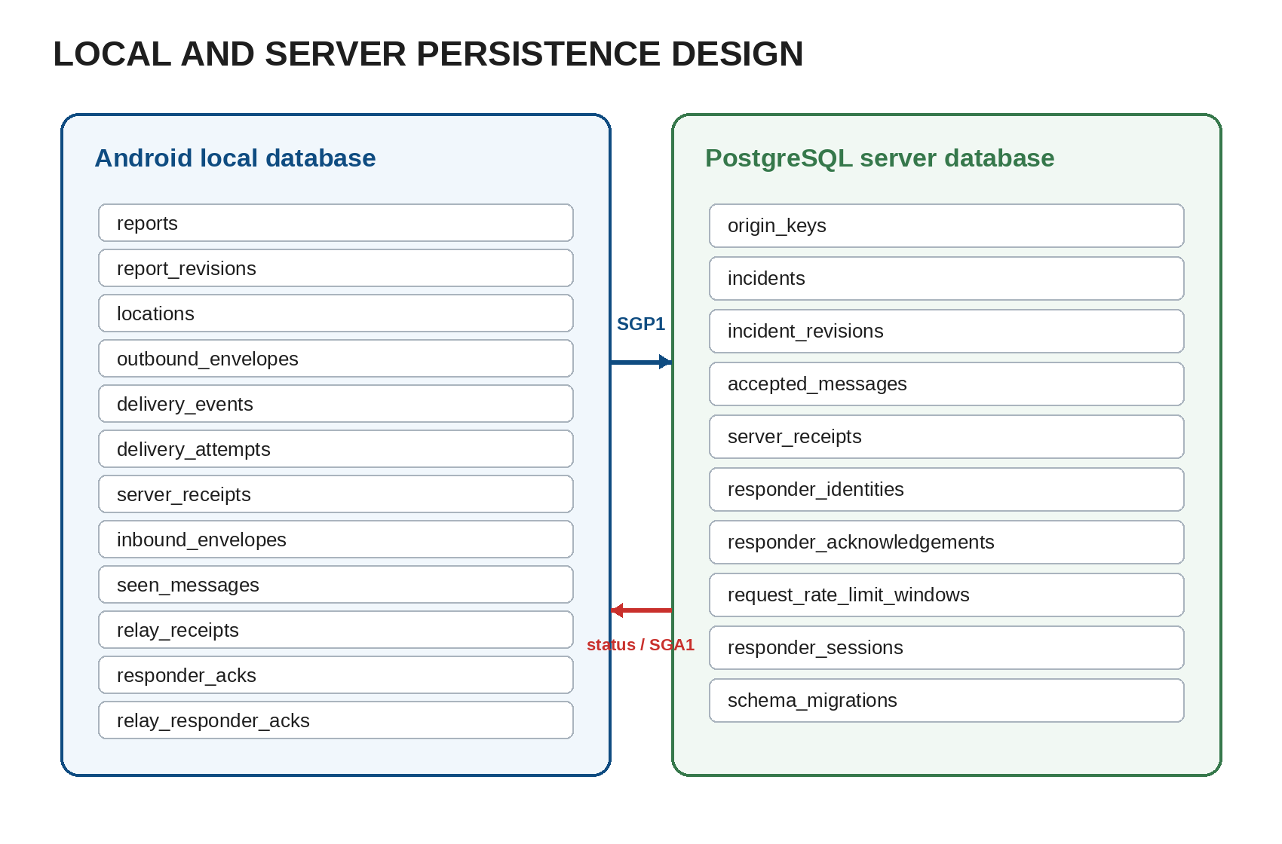
Figure 3. Local and Server Persistence Design.
Entity | Purpose
reports | One row for each local SOS report and its lifecycle state.
report_revisions | Immutable logical revisions for emergency type and urgency.
locations | Optional best-available location for a local report.
outbound_envelopes | Stable message identity, persisted envelope bytes, retry state, and delivery state.
delivery_events | Append-style evidence for important delivery state changes.
delivery_attempts | Transport attempt, timing, outcome, and retry classification.
server_receipts | Canonical server acceptance receipts for locally originated messages.
inbound_envelopes | Durable custody for reports that originated on another SAGIP device.
seen_messages | Message identity and digest data for duplicate and loop suppression.
relay_receipts | Evidence that another device took durable custody of a local message.
responder_acks | Responder state for reports that originated on this device.
relay_responder_acks | Responder state held for another device and eligible for return relay.
Table 4. Local SQLCipher Data Model.

Server persistence design
The backend uses PostgreSQL migrations with checksums. The migration runner serializes migration work with a PostgreSQL advisory lock.
Entity | Purpose
origin_keys | Origin public keys and key identifiers for signature continuity.
incidents | One canonical logical incident for each report ID.
incident_revisions | Validated SRP1 fields, location data, and payload digest for SGP1 revisions.
accepted_messages | Exact envelope bytes, message identity, envelope hash, and acceptance time.
server_receipts | One canonical SERVER_ACCEPTED receipt for each accepted message.
responder_identities | Responder callsign, role, token hash, and registration time.
responder_acknowledgements | Responder operational states with an idempotent uniqueness rule.
request_rate_limit_windows | Shared PostgreSQL rate-limit windows for multi-instance enforcement.
responder_sessions | Hashed browser session tokens and expiry data.
schema_migrations | Applied migration names, checksums, and timestamps.
Table 5. PostgreSQL Data Model.

Transport and protocol design
Protocol | Role | Current use
SRP1 | Emergency payload v1 | Emergency type, urgency, and optional location. Active inside SGP1.
SGP1 | Signed transport envelope v1 | Stable message and report IDs, timestamps, public origin key, payload digest, payload, and P-256 signature. Active.
SGC1 | BLE chunk frame | Sequential chunk index, total count, data length, chunk bytes, and CRC32. Active.
SGK1 | BLE custody ACK | 44-byte durable custody response with message ID, receipt ID, and acceptance time. Active.
SGA1 | Responder return ACK | 56-byte report status frame with callsign, status, ETA field, timestamp, and CRC32. Active.
SRE2 | Encrypted payload container | HPKE recipient entries for encrypted SRP1 content. Implemented in code, not active for production traffic.
SGP2 | Signed encrypted envelope v2 | Signed envelope that carries SRE2 ciphertext. Verification support exists, but production emission and responder decryption are gated.
Table 6. Protocol Families.
The complete transport envelope limit is 8192 bytes. Existing v1 field order, widths, byte order, signatures, digests, and CRC behavior are compatibility contracts.

BLE store-carry-forward
BLE uses one process-level relay runtime. The foreground relay service and React Native bridge share the same scanner, advertiser, and GATT ownership.
1. A SAGIP device advertises the SAGIP BLE service.
2. A nearby device offers a message ID and payload digest.
3. The receiver rejects a message that it already holds.
4. The sender transfers SGC1 chunks in sequence.
5. The receiver validates the completed envelope and persists it in inbound_envelopes.
6. The receiver returns SGK1 custody success only after the database commit.
7. The origin records the relay receipt and shows Relayed to another SAGIP device.
Android 12 or later requires BLUETOOTH_SCAN, BLUETOOTH_ADVERTISE, and BLUETOOTH_CONNECT. Android 11 and earlier use fine location permission for BLE scanning.
BLE activity changes with active emergency age. The first 15 minutes use a low-latency profile. The system then reduces scan duty to conserve battery.
Active work age | Radio profile | Software duty cycle
0 to 15 minutes | Low latency | Effectively continuous
15 minutes to 24 hours | Balanced | 5 seconds active, 25 seconds paused
More than 24 hours | Low power | 5 seconds active, 115 seconds paused
No active timestamp | Low power | 5 seconds active, 115 seconds paused
Table 6A. BLE Duty-Cycle Profiles.

Internet delivery and retry
The delivery worker treats network connectivity as a hint. Actual HTTP results decide success, retry, or permanent failure.
- Accepted or exact duplicate: persist SERVER_ACCEPTED and its canonical receipt.
- Transient network, server, or database failure: keep the immutable envelope retryable.
- Malformed, unsupported, signature-invalid, or conflicting data: record permanent failure for the same bytes.
- A lost server response is safe because the backend returns the same canonical receipt for an exact retry.
Delivery attempts use durable retry metadata. Abandoned attempts can recover after the delivery lease expires.

Location design
Location capture never blocks SOS persistence. The current provider reads Android last-known GPS and network locations only when location permission exists.
A location is fresh when its capture time is no more than five minutes old. The selector prefers freshness, accuracy, and then capture time.
The current civilian interface does not provide a dedicated location-permission request flow. The stored location can therefore be absent.

Background processing and recovery
- SurvivalCoreRuntime owns one process-level database, repository, and BLE relay runtime.
- EmergencyRelayService runs as an Android connectedDevice foreground service when BLE readiness allows it.
- EmergencyJobScheduler registers persisted job ID 54420 and requires a network connection.
- The periodic Android job uses the platform minimum interval of 15 minutes.
- SurvivalRecoveryReceiver restores scheduling after BOOT_COMPLETED and MY_PACKAGE_REPLACED.
- The recovery receiver starts BLE relay only when persisted active work and runtime readiness allow it.

Security design
- The origin signing private key is non-exportable in Android Keystore.
- The local SQLCipher database uses a random 256-bit key that an Android Keystore AES-GCM key wraps.
- Production Android builds reject a missing or non-HTTPS backend URL.
- Production release builds reject missing release signing settings and verify the expected signing certificate.
- Responder bearer tokens are stored as SHA-256 hashes in PostgreSQL.
- Browser responder sessions store only a hash and use an HttpOnly, Secure, SameSite=Strict cookie.
- Production backend instances use a shared PostgreSQL sliding-window rate limiter.
- Responder console assets use restrictive browser security headers and no-store caching.
SRE2 and SGP2 code adds recipient encryption support. The system does not activate SGP2 until trusted responder keys, ciphertext persistence, and responder-side decryption are complete.
SGA1 uses CRC32 but does not provide application-layer confidentiality or cryptographic authentication. A later protocol version is required if the deployment threat model needs these properties.

Backend HTTP interface
Method | Path | Access | Purpose
GET | /healthz | No | Return lightweight service health.
POST | /v1/envelopes | No | Accept one application/octet-stream envelope with an 8192-byte limit.
GET | /v1/reports/:reportId/status | No | Return server acceptance and latest responder acknowledgement for one report.
GET | /responder | No | Serve the responder console HTML.
POST | /v1/responder/session | Bearer token in body | Create a 12-hour browser responder session.
GET | /v1/responder/session | Browser session | Restore the current responder session.
DELETE | /v1/responder/session | Browser session | Revoke the current responder session.
GET | /v1/incidents/summary | Responder | Return queue counts and urgency summary.
GET | /v1/incidents | Responder | Return bounded incident list with optional status filter.
GET | /v1/incidents/:reportId | Responder | Return incident detail, revisions, location, and acknowledgement history.
POST | /v1/incidents/:reportId/ack | Responder | Persist a responder status and optional note.
Table 7. Backend HTTP Interface.

Delivery state meanings
State | User meaning
DELIVERY_PENDING | The SOS is saved locally. SAGIP is still searching for a delivery path.
RELAYED_TO_PEER | Another SAGIP device stored a copy. The server or responder may not have it yet.
SERVER_ACCEPTED | The SAGIP server validated and stored the report. Responder acknowledgement can still be pending.
RESPONDER_ACKNOWLEDGED | A responder status is durably available for the report.
PERMANENT_FAILURE | The same stored envelope cannot continue automatic delivery. The local SOS remains stored.
Table 8. Delivery State Meanings.

Accessibility
Emergency controls use explicit accessibility roles, labels, hints, and disabled states. Dynamic emergency status uses polite or assertive live-region announcements when appropriate.
The interface uses text with color and does not rely on color alone. Critical controls use practical touch targets near 48 by 48 density-independent pixels or larger.
DEVELOPMENT PROCESS
SAGIP used milestone-based incremental development. Each milestone added one delivery or safety boundary and added tests for that boundary.
Milestone | Implemented scope
September 5-6, 2026 | Durable local SOS, SRP1 and SGP1, backend ingestion, direct delivery pipeline
September 20, 2026 | BLE store-carry-forward, responder operations, SGA1 return path, background hardening
September 25, 2026 | Physical-device readiness, hosted Neon field-test deployment, release workflow
September 28, 2026 | Responder console hardening, production signing workflow, SQLCipher, SRE2 and SGP2 support, distributed rate limiting
September 29, 2026 | Current host validation and consolidated system documentation
Table 8A. Development Milestones.
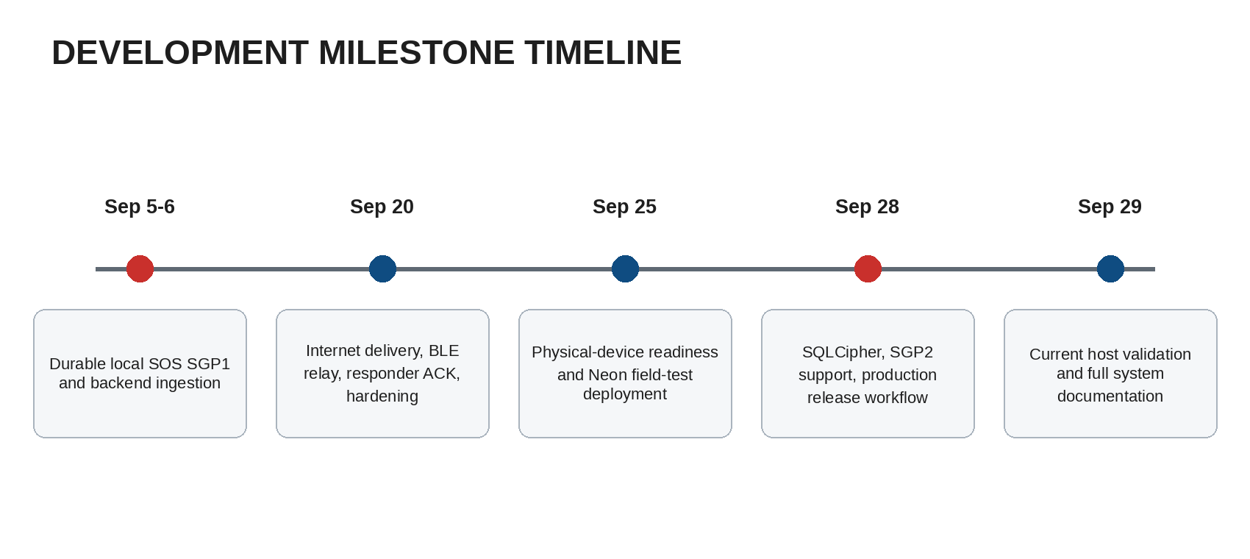
Figure 4. Development Milestone Timeline.
Protocol and persistence work used compatibility tests before later transport changes. Current source and tests remain the authority when older planning documents differ from code.

CHAPTER THREE
TESTING
SAGIP uses separate tests for presentation, native emergency behavior, binary protocols, backend ingestion, responder operations, security bounds, and release builds.
Host tests verify deterministic behavior without claiming radio or field conditions. Physical-device tests are separate acceptance evidence.

Current host validation
Check | Scope | Result | Date
React Native Jest | 25 tests in 3 suites | Pass | 2026-09-29
Root TypeScript | npx tsc --noEmit | Pass | 2026-09-29
Root ESLint | 0 errors, 5 warnings | Pass with warnings | 2026-09-29
Backend tests | 43 tests | Pass | 2026-09-29
Backend TypeScript | npm --prefix backend run typecheck | Pass | 2026-09-29
Backend ESLint | npm --prefix backend run lint | Pass | 2026-09-29
Android unit tests | 87 tests | Pass | 2026-09-29
Android debug app | assembleDebug | Pass | 2026-09-29
Android instrumentation APK | assembleDebugAndroidTest | Pass | 2026-09-29
Table 9. Current Host Validation Results.
The Android Gradle validation completed 165 actionable tasks. Fifteen tasks executed and 150 were up to date.

Protocol and security validation
- Backend tests cover SRP1 parsing, SGP1 golden vectors, P-256 verification, idempotent ingestion, and duplicate conflicts.
- Backend tests cover SRE2 framing and SGP2 signature and digest validation without server-side SRP1 decryption.
- Backend tests cover distributed PostgreSQL rate limiting and browser responder session constraints.
- Android unit tests cover delivery, retry, BLE framing, duty cycles, return acknowledgement behavior, and encrypted payload support.
- Android instrumentation source includes SQLCipher migration, wrong-key, missing-key, and wrapped-key corruption tests.

Connected-device evidence
An earlier field-readiness revision passed 16 of 16 connected instrumentation tests on a POCO F6 with Android 16. The same count passed on a Pixel 4 Android 12 emulator.
The foreground connectedDevice relay service also started on the POCO without fresh Android runtime or Bluetooth errors in that test session.
The current revision added SQLCipher and related security changes after that evidence. The current connected SQLCipher migration suite still requires execution on representative devices.

Field acceptance
The first complete field milestone requires two physical Android phones and a live PostgreSQL-backed server. Emulator tests do not replace this acceptance path.
Gate | Acceptance condition | Class | Current status
Offline origin save | Phone A saves an SOS with no internet. | Required | Not complete on current full field path
Physical BLE custody | Phone A transfers the exact envelope to Phone B. B persists before custody success. | Required | Pending full two-phone acceptance
Gateway server delivery | Phone B later sends the stored envelope to a live server. | Required | Implementation exists. Full field path pending
Duplicate convergence | Repeated server delivery produces one incident and one canonical receipt. | Required | Verified in earlier live Neon test and host tests
Responder acknowledgement | Authorized responder stores a report status. | Required | Backend and console implemented
Physical SGA1 return | Phone B returns responder status to offline Phone A over BLE. | Required | Pending physical two-phone acceptance
Current SQLCipher device migration | Plaintext local database migrates and reopens on representative devices. | Production gate | Pending connected execution on current revision
SGP2 production encryption | Trusted responder key directory, ciphertext persistence, and responder-side decryption are active. | Production gate | Not activated
Service operations | Monitoring, uptime target, incident response, and responder credential procedures are field-ready. | Production gate | Operational evidence still required
Table 10. Field Acceptance and Production Gates.
DEPLOYMENT

Development environment
Development requires Node.js, Java, the Android SDK, and the React Native Android toolchain. A local backend also requires PostgreSQL through DATABASE_URL.
npm ci
npm --prefix backend ci
npm start
npm run android

The Android debug build uses http://10.0.2.2:8080 when no backend override exists. Physical devices need a reachable backend URL.

Local backend
DATABASE_URL=<private PostgreSQL URL>
PORT=8080
npm --prefix backend run migrate
npm --prefix backend run dev

The development server can provision the development responder identity used by engineering tests. Production does not create that development token automatically.

Field-test release
A Git tag that matches field-test-* starts the field-test workflow. The workflow verifies backend health, runs host validation, builds a debug-signed APK, and publishes a GitHub pre-release.
The field-test artifact is not a production emergency-service release. It exists for controlled physical-device testing.

Production Android release
The production workflow is manual. It requires explicit version values, an HTTPS backend, an approved signing certificate fingerprint, and production signing secrets.
- SAGIP_BACKEND_BASE_URL
- SAGIP_RELEASE_CERT_SHA256
- SAGIP_RELEASE_KEYSTORE_BASE64
- SAGIP_RELEASE_KEYSTORE_PASSWORD
- SAGIP_RELEASE_KEY_ALIAS
- SAGIP_RELEASE_KEY_PASSWORD
- SAGIP_VERSION_CODE
- SAGIP_VERSION_NAME
The workflow builds a signed APK and AAB, verifies the APK signer, verifies the AAB signature, and creates SHA-256 checksums.
Production publication requires an explicit readiness confirmation. The workflow can also publish a signed pre-release without claiming production readiness.

Backend deployment
The production workflow can link the configured Neon project and production branch. It applies PostgreSQL migrations before it deploys the Neon Function.
Post-deployment checks verify /healthz, /responder, and unauthorized access behavior for responder incident APIs.

Responder provisioning
DATABASE_URL=<private production PostgreSQL URL>
RESPONDER_CALLSIGN=RESCUE-ALPHA-1
RESPONDER_ROLE=DISPATCHER
npm --prefix backend run provision-responder

The command displays the raw bearer token once. PostgreSQL stores only its SHA-256 hash. Operators must transfer the raw token through an approved secret channel.

Secret handling
Do not place database URLs, responder tokens, Neon API keys, keystore files, or signing passwords in public source, release notes, or application artifacts.
The production workflow materializes signing material only in the temporary runner environment. Long-term signing recovery must use a separate protected backup process.
MAINTENANCE

Application and signing maintenance
- Keep the same approved production signing identity for normal Android upgrades.
- Increase Android version code for each distributed production build.
- Do not distribute a corrective build with a lower version code.
- Re-run host and device validation after safety-critical persistence, BLE, protocol, or lifecycle changes.

Local database maintenance
- Current local schema version is 7.
- Migrations are non-destructive and forward-only in the application.
- Database downgrade is rejected.
- If the encrypted database key metadata and Android Keystore state disagree, the application fails closed instead of creating an empty replacement database.
- Migration cleanup must remove temporary plaintext database artifacts after verified replacement.

Backend database maintenance
Backend migrations are checksum-protected history. Do not edit an already applied migration to simulate rollback.
A backend rollback must remain compatible with the current database schema. Database repair requires a new reviewed migration.

Protocol maintenance
- Do not change SGP1, SGC1, SGK1, or SGA1 byte layouts in place.
- Keep the 8192-byte outer envelope limit across Android, BLE, and backend code.
- Persist READY envelope bytes and reuse them for retry and relay.
- Use a new protocol version when confidentiality or authentication changes alter a wire contract.
- Keep compatibility tests for old protocol vectors after each protocol extension.

Responder operations maintenance
- Provision responder bearer tokens from an authorized environment only.
- Revoke or replace credentials when an operator or device no longer needs access.
- Use browser session disconnect to revoke the current server-side session.
- Keep responder status meaning consistent with the backend status values.
- Do not place incident secrets or raw credentials in routine logs.

Known current limitations
- The complete current-revision two-phone BLE custody and SGA1 return path is not field-qualified.
- Current SQLCipher migration tests compile but still need representative connected-device execution.
- SGP2 production emission, trusted responder key distribution, server ciphertext storage, and responder-local decryption are not active.
- SGA1 is not confidential or cryptographically authenticated at the application layer.
- The civilian interface does not yet include a dedicated location-permission request flow.
- Repository test and build success does not prove a production uptime or emergency-service availability target.
CONCLUSION
SAGIP preserves an SOS report on the Android device before it depends on transport or external services. The same persisted report can continue through direct internet delivery or BLE store-carry-forward.
The server provides idempotent acceptance and responder coordination. The responder console records operational status and exposes it to online origins or relay devices.
The current code also encrypts local emergency storage and contains SGP2 encryption support. Production activation of end-to-end payload encryption still requires the remaining responder key and ciphertext paths.
Physical two-phone acceptance, current connected SQLCipher migration validation, and production operational evidence remain required before real emergency-service deployment.
REFERENCES
SAGIP source repository, main branch, current baseline commit 90fef4d.
SAGIP DESIGN.md. Canonical product and architecture intent.
SAGIP TRANSPORT_ENVELOPE_V1.md. SRP1 and SGP1 transport format.
SAGIP DELIVERY_PIPELINE.md. Internet delivery and persisted retry behavior.
SAGIP BLE_STORE_CARRY_FORWARD_V1.md. BLE custody and relay specification.
SAGIP BACKEND_INGESTION_V1.md. Backend validation and idempotent PostgreSQL ingestion.
SAGIP RESPONDER_OPERATIONS_V1.md. Responder API and acknowledgement specification.
SAGIP HARDENING_AND_SURVIVAL_V1.md. Android background, retry, recovery, and accessibility requirements.
SAGIP PHYSICAL_TESTING_RUNBOOK.md. Two-device field acceptance procedure.
SAGIP RESPONDER_CONSOLE.md. Current responder console session and operations behavior.
SAGIP SECURITY_ARCHITECTURE_V2.md. SQLCipher, SRE2, SGP2, key distribution, and production security design.
SAGIP PRODUCTION_RELEASE.md. Production signing, CI/CD, deployment, rollback, and release gates.
React Native project configuration, package.json, version 0.87.1.
Android build configuration, compile SDK 36, target SDK 36, minimum SDK 24.
Backend package configuration, Node.js 24+, TypeScript, PostgreSQL pg driver.

