UM TAGUM COLLEGE
BACHELOR OF SCIENCE IN COMPUTER SCIENCE
Department of Computing Education
Visayan Village, Tagum City, Philippines

Course Requirements
in
CCE 106/L - 1767
APPLICATION DEVELOPMENT & EMERGING TECHNOLOGIES
SAGIP: OFFLINE-FIRST DELAY-TOLERANT
EMERGENCY COMMUNICATION SYSTEM
Submitted To:
MARICEL A. TIMBAL
Submitted By:
ARCHE, ALEXANDER L.
PEDOTIM, JERVIS JAMES T.
PIZON, KYNE ANTHONY F.
VILLA, GERALD ANDREI P.
September 29, 2026

TABLE OF CONTENTS
List of Tables 1
List of Figures 2
CHAPTER ONE 3
INTRODUCTION 3
PROJECT OVERVIEW 4
REQUIREMENTS 5
CHAPTER TWO 8
ARCHITECTURE 8
DESIGN 11
DEVELOPMENT PROCESS 12
CHAPTER 3 15
Testing 15
DEPLOYMENT 21
MAINTENANCE 21
CONCLUSION 23
REFERENCES 24

List of Tables
Table No. | Title | Page No.
Table 1 | Functional Requirements and Test Cases | 18
Table 2 | Completed Engineering Acceptance Testing | 20
Table 3 | Physical Field Qualification Checklist | 21

List of Figures
Figure No. | Title | Page No.
Figure 1 | SAGIP System Architecture and Delivery Paths | 11
Figure 2 | Durable SOS Persistence and Immutable Envelope Lifecycle | 13
Figure 3 | SAGIP Safety-Critical Development and Validation Workflow | 14
Figure 4 | SAGIP Validation Evidence and Field Qualification | 15

CHAPTER ONE

INTRODUCTION
Philippine disaster-response planning, disaster-risk reporting, and recent situational reports provide the operational context for resilient emergency communication [2], [8], [9].
SAGIP is an offline-first emergency communication system for Android devices. It stores each SOS report before it starts network, radio, location, or signing work.
After the local commit, SAGIP prepares one signed transport envelope. The system first tries direct HTTPS delivery. BLE provides a store-carry-forward fallback, consistent with disruption-tolerant and store-carry-forward communication approaches [1], [3], [4].
The SAGIP backend validates each signed envelope and stores one canonical incident. Authorized responders use a web console to review incidents and record operational status.
The user interface keeps delivery states separate. Local save, peer relay, server acceptance, and responder acknowledgement are different events. A peer relay does not mean that a responder received the SOS.

PROJECT OVERVIEW
SAGIP has five main parts: the civilian React Native application, the Android Survival Core, encrypted local storage, the backend, and the responder console.
The civilian application collects emergency type and urgency. It can attach a best-available location when Android permission and stored location data are available.
The Android Survival Core owns durable emergency behavior. It stores SQLite state through SQLCipher, prepares signed envelopes, retries delivery, relays data through BLE, and restores background work after restart.
The backend accepts signed envelopes, enforces identity and size rules, prevents duplicate incidents, stores responder state, and exposes status to origin devices.
The current runtime creates SGP1 envelopes that contain SRP1 plaintext payloads. SGP2 and SRE2 encryption support exists in code, but production emission is not active.
Current End-to-End Flow
1. The user selects an emergency type and urgency.
2. The Survival Core commits the SOS to the local database.
3. The core prepares and stores one signed SGP1 envelope.
4. The delivery worker tries direct HTTPS delivery when a network is usable.
5. BLE can transfer the same stored envelope to a nearby SAGIP device.
6. A relay device can later forward the same envelope to the server.
7. The server stores one canonical incident and returns server acceptance.
8. An authorized responder records a status in the responder console.
9. The origin obtains that status directly or through the SGA1 BLE return path.
Platform Scope
The current safety-critical native implementation targets Android API 24 or later. The repository also contains an iOS React Native scaffold, but the Survival Core is Android-specific.

REQUIREMENTS
Functional Requirements
1. SOS Creation
• Allow the user to select Medical, Flood, Fire, Trapped, Violence or threat, or Other emergency.
• Allow the user to select Immediate danger or Need assistance.
• Report success only after the local SOS transaction commits.
2. Durable Local State
• Store the report, revision, optional location, outbound message record, and local event in SQLCipher.
• Restore saved reports after process restart.
• Keep report and message identity stable across retry, relay, and restart.
3. Location Capture
• Use the best last-known GPS or network location when permission exists.
• Do not require location for local SOS storage.
• Mark location freshness and keep stale location distinguishable from fresh location.
4. Signed Envelope Preparation
• Encode SRP1 emergency data and create one SGP1 envelope.
• Use a non-exportable P-256 Android Keystore signing key.
• Persist READY envelope bytes and reuse the same bytes for retry and relay.
5. Direct Internet Delivery
• Post a due envelope directly to the backend when the device has usable internet.
• Treat connectivity as a hint and use the HTTP result to decide success or retry.

6. BLE Store-Carry-Forward
• Advertise and scan for the SAGIP BLE service when permissions allow it.
• Transfer SGC1 chunks with strict bounds and CRC32 validation.
• Persist the full valid envelope before the receiver reports custody success.
• Store relay data as gateway custody instead of a second local civilian incident.
7. Relay Forwarding
• Forward stored inbound envelopes when the relay later gains internet access.
• Suppress duplicate messages and relay loops through persisted message identity and digest data.
8. Responder Operations
• Allow authorized responders to list incidents, inspect details, filter status, and record an acknowledgement state.
• Support ACKNOWLEDGED, EN_ROUTE, ON_SCENE, and RESOLVED states.
• Persist responder status before the backend reports success.
9. Responder Return Path
• Allow an online origin to obtain the latest status from the backend.
• Allow an offline origin to receive the 56-byte SGA1 return frame through BLE.
10. Background Recovery
• Restore network scheduling after boot or package replacement.
• Restart BLE relay only when active work, permissions, and Bluetooth state allow it.
• Reduce BLE duty cycle after the urgent delivery period to conserve battery.
11. Responder Console Session
• Create a short-lived browser session from a provisioned responder bearer token.
• Store token and session hashes instead of raw responder credentials.

Non-functional Requirements
1. Durability
• Internet, BLE, location, signing, and server availability must not be required for local SOS persistence.
2. Truthful Status
• Show Saved on this device, Pending delivery, Relayed to another SAGIP device, Server accepted, Responder acknowledged, or Permanent delivery failure.
3. Idempotency
• Repeated delivery, duplicate relay, lost responses, and repeated responder updates must not create duplicate logical incidents.
4. Protocol Bounds
• Keep the complete transport envelope at or below 8192 bytes.
• Reject malformed lengths, UUIDs, coordinates, enums, signatures, digests, and CRC values.
5. Security
• Use HTTPS for production backend traffic.
• Keep signing and database wrapping keys non-exportable in Android Keystore.
• Encrypt the local emergency database with SQLCipher.
6. Accessibility
• Provide meaningful labels, hints, semantic roles, and live status announcements.
• Use practical touch targets near 48 by 48 density-independent pixels.
• Do not rely on color alone for emergency status.
7. Compatibility
• Do not change SGP1, SGC1, SGK1, or SGA1 byte layouts without a versioned compatibility update.
8. Release Control
• Require explicit production version values, HTTPS backend configuration, approved signing material, and release checks.

CHAPTER TWO

ARCHITECTURE
SAGIP uses a layered mobile and server architecture. The React Native screen owns presentation. The Android Survival Core owns durable emergency behavior. The backend owns canonical acceptance and responder coordination.
Architecture Components
• Civilian interface: React Native 0.87.1, React 19.2.3, and TypeScript for SOS input, persisted status display, and bridge validation.
• Android Survival Core: Kotlin 2.2.0 for persistence, signing, retry, BLE relay, recovery, and Android services.
• Local storage: SQLCipher for Android 4.17.0 with SQLite schema version 7.
• Identity: Android Keystore with a non-exportable P-256 ECDSA origin signing key.
• Backend: Node.js 24+, TypeScript 6.x, and PostgreSQL for ingestion, receipts, responder state, sessions, and rate limits.
• Hosted runtime: Neon Function and Neon PostgreSQL for the current hosted backend deployment target.
Technology Stack
• Mobile interface: React Native, React, TypeScript, react-native-safe-area-context.
• Android core: Kotlin, Android SDK 36, minimum SDK 24, Java 17 build runtime.
• Persistence: SQLCipher, AndroidX SQLite, Android Keystore AES-GCM key wrapping.
• Transport: HTTPS and Bluetooth Low Energy store-carry-forward. Android BLE is the current peer transport [5].
• Cryptography: P-256 ECDSA, SHA-256, CRC32, Google Tink support for SRE2/SGP2.
• Backend: Node.js, TypeScript, PostgreSQL pg driver, Neon Function.
Android also provides Wi-Fi Aware and Nearby Connections as peer-to-peer options [6], [7]. The current SAGIP Survival Core uses BLE.

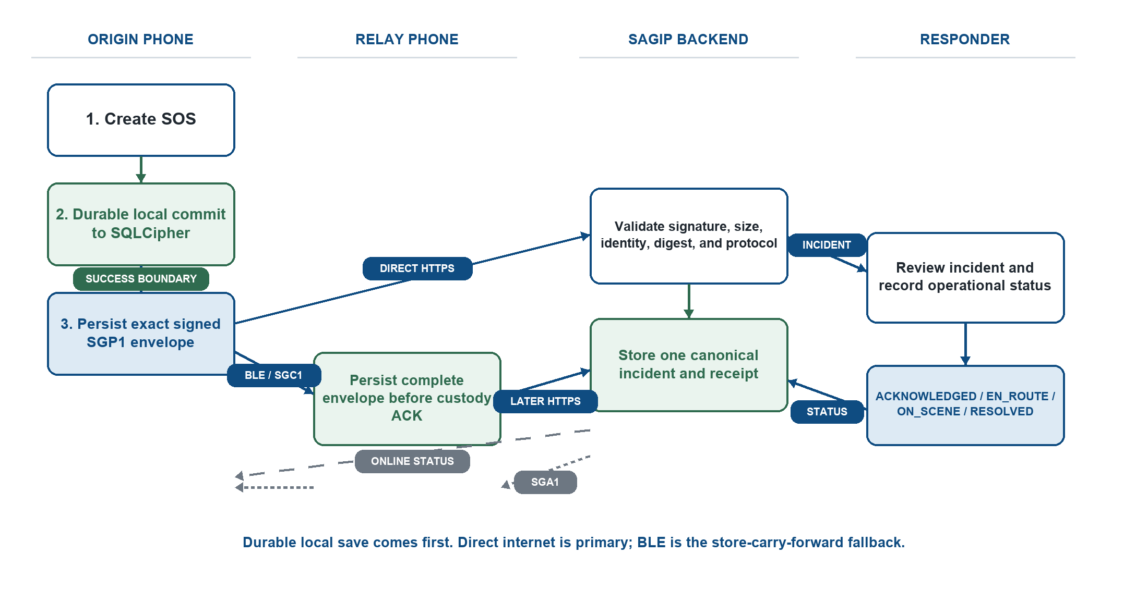
Figure 1. SAGIP System Architecture and Delivery Paths.
Figure 1 shows the current SAGIP delivery architecture. The Android Survival Core commits emergency state to SQLCipher before it starts transport work.
After the durable commit, the same persisted signed envelope can use direct HTTPS delivery or BLE store-carry-forward through another SAGIP device.
The backend validates the envelope and stores one canonical incident. The responder console records a durable operational status for that incident.
An online origin can obtain status from the backend. An offline origin can receive responder status through the SGA1 BLE return path.

Android Survival Core
A successful SOS creation means the local database transaction completed. Envelope preparation, location, internet delivery, BLE, and server availability start after this success boundary.
The core stores delivery attempts and important delivery events. Abandoned delivery work can recover after restart. READY envelope bytes remain immutable for retry and relay.
Transport and Protocols
• SRP1 carries emergency type, urgency, and optional location.
• SGP1 carries stable report and message identifiers, the SRP1 payload, a payload digest, the origin public key, and the P-256 signature.
• SGC1 divides one envelope into bounded BLE chunks. Each chunk has a CRC32 value.
• SGK1 reports durable BLE custody only after the receiver stores the envelope.
• SGA1 carries responder status back to an offline origin. The current frame is 56 bytes and uses CRC32.
• SRE2 and SGP2 add encrypted payload support. Production emission and responder decryption are not active.
Backend and Responder Console
The backend accepts application/octet-stream envelopes at POST /v1/envelopes. It rejects inputs above 8192 bytes and maps invalid protocol data to bounded public errors.
Exact retries return the same canonical receipt. Conflicting message identity, report revision, or origin identity returns a conflict instead of creating a second incident.
The responder console uses a provisioned token only to create a browser session. The raw token is not stored in browser storage. The backend stores only hashes.

DESIGN
Durable Persistence Design
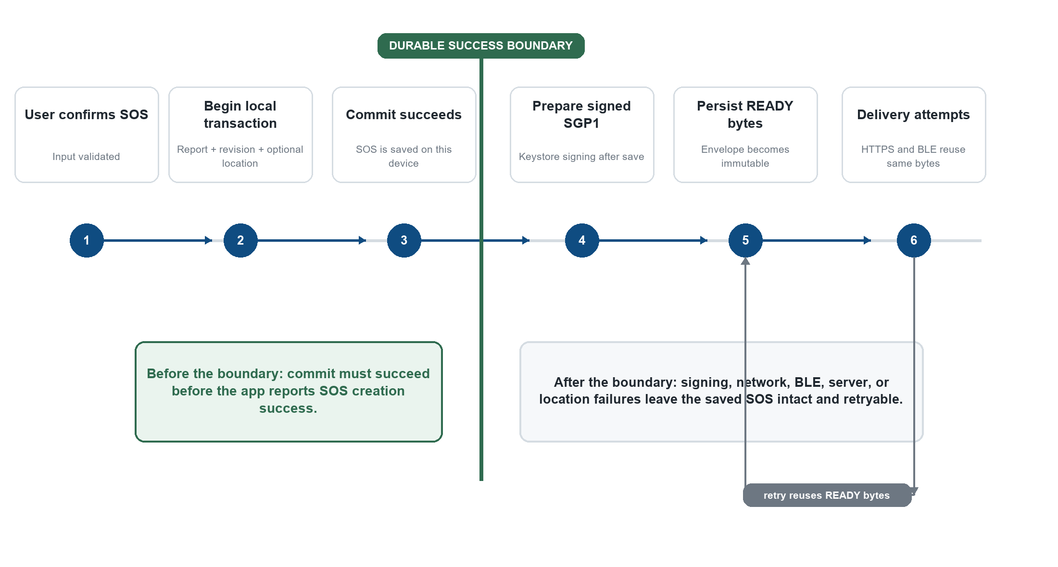
Figure 2. Durable SOS Persistence and Immutable Envelope Lifecycle.
Figure 2 identifies the durability boundary. A successful SOS creation means the report transaction committed locally.
The transaction stores the report, revision, optional location, outbound envelope record, and local delivery evidence before envelope preparation begins.
After signing succeeds, SAGIP stores the exact READY envelope bytes. Direct retries and BLE relays reuse those immutable bytes instead of regenerating the message.

DEVELOPMENT PROCESS
SAGIP uses failure-first incremental development. A change starts with the current implementation, not with a planned architecture.
Before changing persistence, protocols, lifecycle state, or a public API, development traces producers, consumers, migrations, tests, and recovery behavior.
The workflow then applies a targeted change and runs the smallest relevant validation before broader host, device, live-service, or field gates.
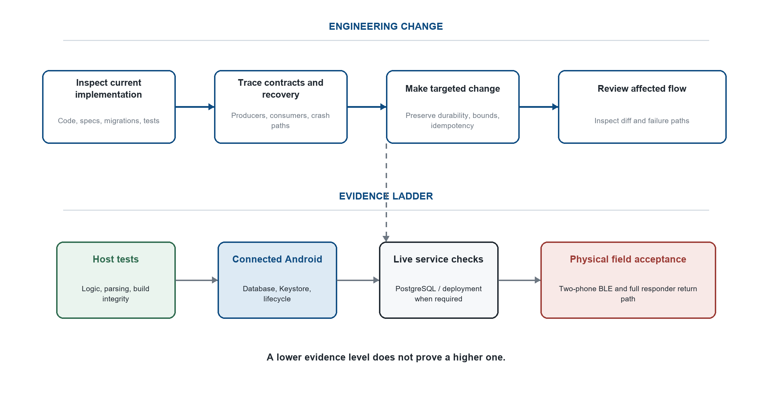
Figure 3. SAGIP Safety-Critical Development and Validation Workflow.
Figure 3 separates implementation work from evidence. Host tests can verify logic and build integrity, but they do not prove radio behavior or field readiness.
Device, BLE, PostgreSQL, and operational checks are required when the changed path depends on those environments.

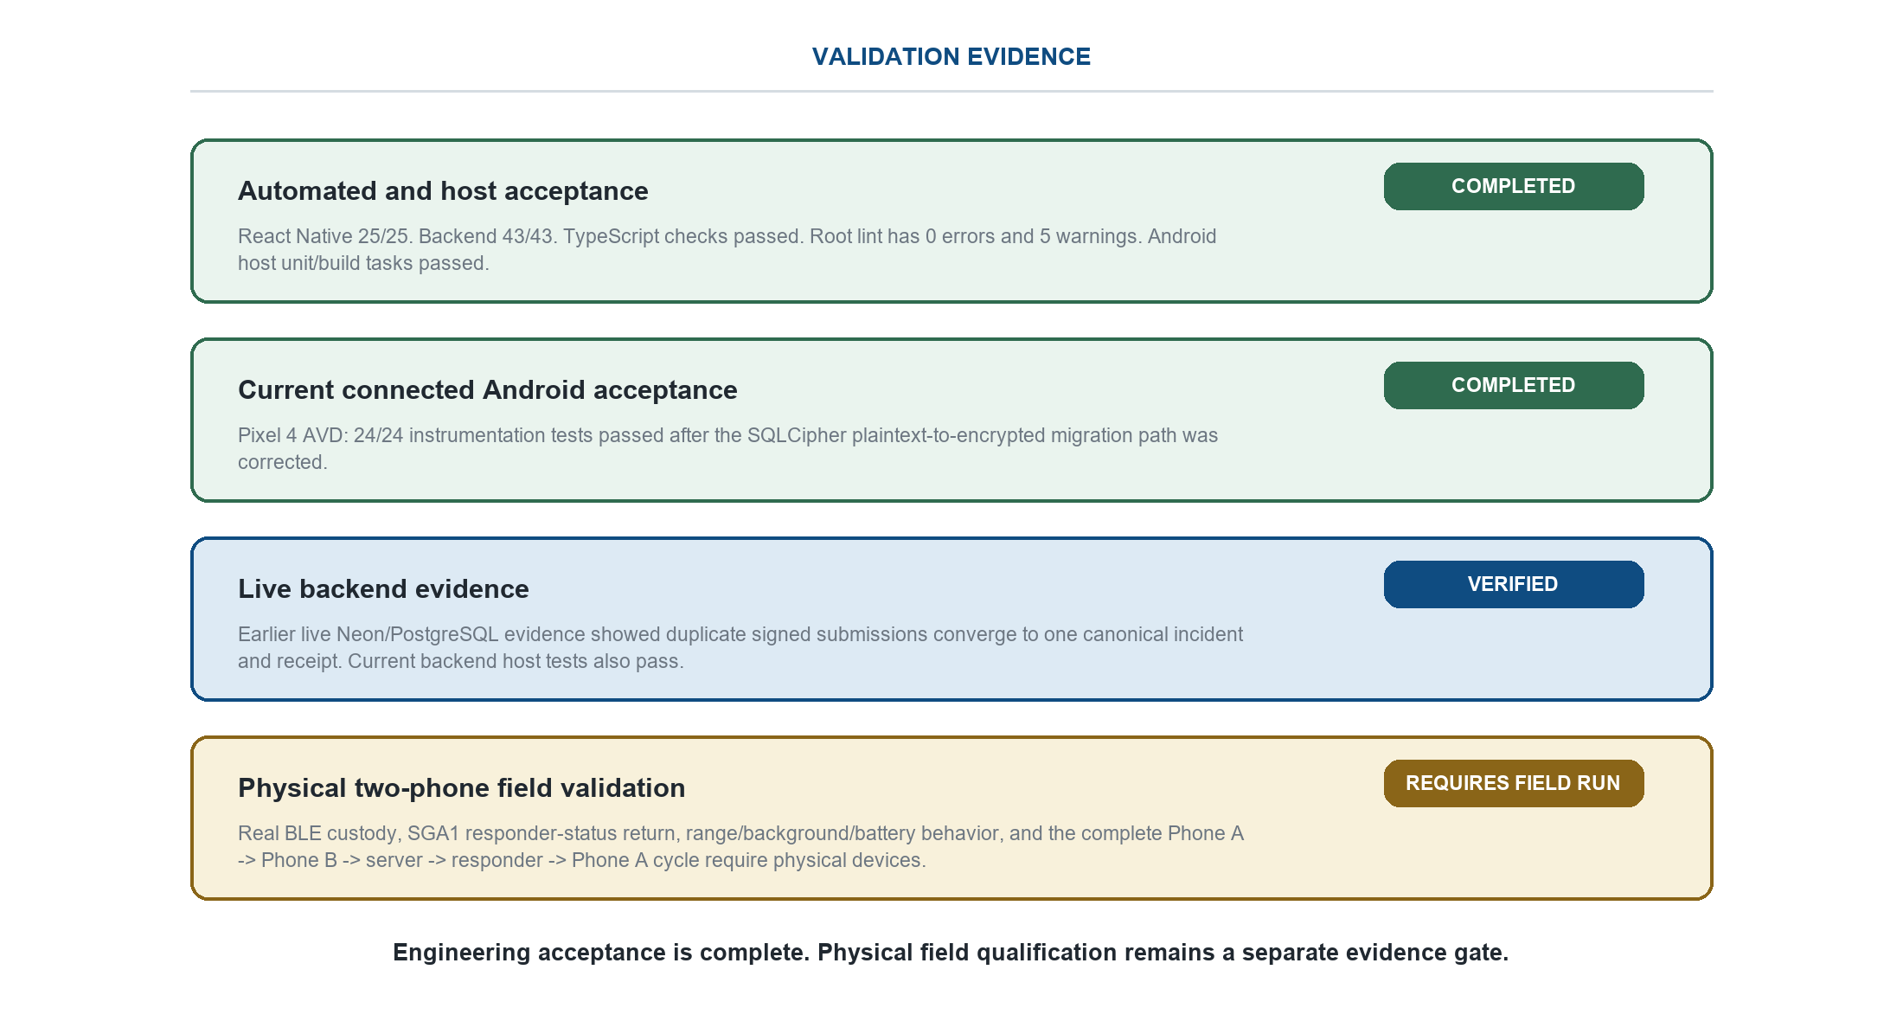
Figure 4. SAGIP Validation Evidence and Field Qualification.
Figure 4 separates completed engineering acceptance from physical field qualification. Automated and connected Android acceptance are complete for the current revision.
Current validation passed 25 React Native tests, 43 backend tests, the Android host build checks, and 24 of 24 connected Android instrumentation tests on the Pixel 4 AVD.
The current SQLCipher plaintext-to-encrypted migration passed in the connected Android suite after the migration path was corrected. Physical two-phone BLE custody and SGA1 return remain field-qualification checks.
The complete Phone A to Phone B to server to responder to Phone B to Phone A field cycle remains the final acceptance path.

The development process uses failure-first review. A change to persistence, BLE, protocols, background lifecycle, or public APIs requires inspection of producers, consumers, recovery paths, and tests.
Host validation does not prove radio range, OEM background behavior, battery behavior, or real emergency-service readiness. Physical-device and operational acceptance remain separate gates.
A Pixel 4 AVD was used for the current connected Android suite. Physical two-phone BLE, radio range, OEM background behavior, and battery behavior still require representative physical devices.
The remaining field milestone is a complete Phone A to Phone B to live server to responder to Phone A cycle. The result must preserve one incident and one truthful acknowledgement path.

CHAPTER 3

Testing
SAGIP separates completed engineering acceptance from physical field qualification. Host and connected Android tests verify implementation behavior. Physical radio and end-to-end field checks remain a separate evidence class.
Current validation on September 29, 2026 passed 25 React Native tests, 43 backend tests, TypeScript checks, Android host unit/build tasks, and 24 of 24 connected Android instrumentation tests on the Pixel 4 AVD. Root lint had five warnings and no errors.
User Acceptance Test
Engineering acceptance is complete for the current revision. The tables below record completed automated and connected-device evidence. Physical field qualification is listed separately.
Functional Requirements Test Cases
Functional Requirements | Test Cases
1. SOS Creation | a. Save SOS while internet is unavailable.
 | b. Commit local SOS state before envelope preparation.
 | c. Restore the saved SOS after process restart.
 | d. Save the SOS when location is unavailable.
 | e. Reuse the same READY envelope bytes after retry.
2. Internet Delivery | a. Submit the persisted envelope to POST /v1/envelopes.
 | b. Return the same receipt after an exact retry.
 | c. Reject conflicting immutable bytes for the same message ID.

Functional Requirements | Test Cases
3. BLE Relay | a. Encode and reassemble bounded SGC1 chunks.
 | b. Reject malformed, duplicate, or inconsistent chunk data.
 | c. Persist the full envelope before custody success.
 | d. Transfer one envelope between two physical SAGIP phones.
4. Responder Operations | a. Create and restore a responder browser session.
 | b. List incidents and open incident details.
 | c. Persist ACKNOWLEDGED, EN_ROUTE, ON_SCENE, or RESOLVED.
 | d. Return responder status to an offline origin through SGA1.
5. Local Security | a. Open the SQLCipher database with the wrapped database key.
 | b. Migrate a plaintext database to encrypted storage.
 | c. Fail closed when key metadata is missing or corrupted.
6. Release and Recovery | a. Enforce the 8192-byte envelope limit.
 | b. Restore scheduling after reboot or package replacement.
 | c. Reject an invalid production backend or signing configuration.
Table 1. Functional Requirements and Test Cases.
Part I. Completed Engineering Acceptance Testing
Test  Case  # | Tested by | Test  Date | Expected Outcome | Actual Outcome | Remarks
1a | Root automated suite | Sep 29, 2026 | React Native tests pass. | COMPLETED - 25 of 25 passed. | Current host evidence.
1b | Root TypeScript | Sep 29, 2026 | TypeScript check passes. | COMPLETED - passed. | No type errors.
1c | Root ESLint | Sep 29, 2026 | No lint errors. | COMPLETED - 0 errors; 5 warnings. | Warnings do not block the build.

Test  Case  # | Tested by | Test  Date | Expected Outcome | Actual Outcome | Remarks
2a | Backend automated tests | Sep 29, 2026 | Backend behavior passes. | COMPLETED - 43 of 43 tests passed. | Host evidence.
2b | Backend typecheck/lint | Sep 29, 2026 | Typecheck and lint pass. | COMPLETED - Pass. | No backend lint errors.
2c | Backend boundary test | Sep 29, 2026 | Reject envelope above 8192 bytes. | COMPLETED - Pass. | Automated HTTP boundary test.
2d | Backend retry test | Sep 29, 2026 | Exact retry returns one receipt. | COMPLETED - Pass. | Lost-response case covered.
3a | Android host unit suite | Sep 29, 2026 | Android unit tests pass. | COMPLETED - Pass. | Host JVM evidence.
3b | Android build | Sep 29, 2026 | Debug app and test APK build. | COMPLETED - Pass. | Instrumentation APK built only.
3c | Current connected Android suite | Sep 29, 2026 | Connected instrumentation passes on current revision. | COMPLETED - 24 of 24 passed. | Pixel 4 AVD; includes SQLCipher migration.
3d | Earlier connected evidence | Sep 25, 2026 | Earlier connected instrumentation passes. | COMPLETED - 16 of 16 passed. | POCO F6 and Pixel 4 emulator evidence.

Test  Case  # | Tested by | Test  Date | Expected Outcome | Actual Outcome | Remarks
4a | Backend responder tests | Sep 29, 2026 | Session, list, detail, and ACK APIs pass. | COMPLETED - Pass. | Automated backend evidence.
4b | Responder dashboard test | Sep 29, 2026 | Strict browser security headers present. | COMPLETED - Pass. | Automated HTTP test.
5a | Current SQLCipher migration | Sep 29, 2026 | Plaintext database migrates to encrypted storage and reopens. | COMPLETED - passed in connected suite. | Pixel 4 AVD; current revision.
5b | Database key fail-closed tests | Sep 29, 2026 | Database key state remains stable; corrupt or missing key state fails closed. | COMPLETED - passed in connected suite. | Current instrumentation evidence.
6a | Release configuration | Sep 29, 2026 | Production configuration rejects unsafe values. | COMPLETED - release guards present. | Configuration/release-control evidence.
6b | Recovery behavior | Sep 29, 2026 | Retry and recovery logic remains testable after restart. | COMPLETED - host recovery tests pass. | Physical OEM behavior is a field qualification item.
Table 2. Completed Engineering Acceptance Testing.
Part II. Physical Field Qualification Checklist
Case | Field Qualification Condition | Current Evidence | Required Environment | Field Result | Notes
A1 | Phone A saves an SOS with no internet and restores it after restart. | Current persistence and connected database tests pass. | Representative physical phone; internet disabled; process restart. | FIELD RUN REQUIRED | Separate from completed engineering acceptance.
A2 | Phone A transfers the exact envelope to Phone B. Phone B persists before custody success. | SGC1 framing, bounds, and persistence logic are tested. | Two physical Android phones with BLE. | FIELD RUN REQUIRED | Requires real radio custody transfer.
A3 | Phone B later forwards the stored envelope to a live PostgreSQL-backed server. | Backend ingestion and earlier live Neon evidence exist. | Relay phone with stored envelope and live internet. | FIELD RUN REQUIRED | Must start from a real BLE-held envelope.

Case | Field Qualification Condition | Current Evidence | Required Environment | Field Result | Notes
A4 | Repeated server delivery converges to one incident and one canonical receipt. | Earlier live Neon evidence plus current backend idempotency tests. | Live PostgreSQL-backed server. | VERIFIED | Server-side behavior verified.
A5 | An authorized responder records a durable operational status for the incident. | Current responder API/session tests pass. | Authorized responder session. | VERIFIED | Backend persistence behavior verified.
A6 | Phone B returns responder status to offline Phone A through SGA1 over BLE. | SGA1 codec and persistence logic exist. | Two physical Android phones with BLE. | FIELD RUN REQUIRED | Requires real return radio path.
A7 | A plaintext SAGIP database migrates to SQLCipher and reopens. | Current Pixel 4 AVD connected suite passed 24/24. | Representative physical phone for field qualification. | CONNECTED PASS | Migration now passes on current connected revision.
A8 | A signed production candidate uses the approved signing identity and HTTPS backend. | Production release guards and signing checks are implemented. | Protected production environment and release credentials. | OPERATIONAL GATE | Release evidence is separate from app test completion.
A9 | Monitoring, responder credential procedures, and incident response are ready for field operations. | Responder security controls are implemented. | Operational runbook and authorized operators. | OPERATIONAL GATE | Requires operational readiness review.
A10 | The complete Phone A -> Phone B -> server -> responder -> Phone B -> Phone A path passes in one field session. | Component engineering acceptance is complete. | Two physical phones, BLE, live backend, authorized responder. | FIELD RUN REQUIRED | Final field-qualification cycle.
Table 3. Physical Field Qualification Checklist.
Table 3 is separate from completed engineering acceptance. It records physical and operational qualification conditions that require representative field evidence.

Acceptance Summary
The current revision completed automated, host, and connected Android acceptance for parsing, persistence, SQLCipher migration, signing verification, backend idempotency, rate limiting, responder APIs, BLE framing logic, retry logic, and Android build integrity.
Current connected evidence is 24 of 24 instrumentation tests passed on the Pixel 4 AVD on September 29, 2026. Earlier evidence also includes 16 of 16 tests on a POCO F6 and 16 of 16 on a Pixel 4 emulator.
Engineering acceptance is complete. Production field qualification still requires the physical and operational evidence listed in Table 3.
Current Validation Results
• React Native Jest: 25 passed, 0 failed.
• Root TypeScript: passed.
• Root ESLint: 0 errors and 5 warnings.
• Backend automated tests: 43 passed, 0 failed.
• Backend TypeScript and ESLint: passed.
• Android host unit task: passed.
• Android debug application: built successfully.
• Android connected instrumentation: 24 passed, 0 failed on Pixel 4 AVD.
Field Acceptance Procedure
1. Place Phone A offline and create an SOS. Confirm the SOS remains after process restart.
2. Transfer the exact envelope to Phone B over BLE. Confirm Phone B stores it before custody success.
3. Separate the phones. Give Phone B internet access and confirm one incident appears on the live server.
4. Repeat the same envelope and confirm the server returns the same canonical receipt.
5. Record a responder status and confirm Phone B stores the acknowledgement.
6. Return Phone B to Phone A and confirm SGA1 persists and displays the responder status on Phone A.

DEPLOYMENT
Development requires Node.js, Java, the Android SDK, and the React Native Android toolchain. A local backend also requires PostgreSQL through DATABASE_URL.
npm ci
npm --prefix backend ci
npm start
npm run android
The Android debug build uses http://10.0.2.2:8080 when no backend override exists. A physical device needs a backend URL that it can reach.
Field-test Release
A field-test tag starts the controlled pre-release workflow. The workflow verifies backend health, runs host validation, builds a debug-signed APK, creates checksums, and publishes a GitHub pre-release.
The field-test artifact is not a production emergency-service release. It exists for controlled physical-device testing.
Production Release
The production workflow is manual. It requires explicit version values, an HTTPS backend, approved signing material, and secret-backed production configuration.
The workflow builds signed APK and AAB artifacts, verifies signatures and certificate identity, and creates SHA-256 checksums. Production publication still requires readiness evidence outside the build.

MAINTENANCE
Keep the same approved production signing identity for normal Android upgrades. Increase the Android version code for every distributed production build.

Local database migrations are forward-only. Database downgrade is rejected. If SQLCipher key metadata and Android Keystore state disagree, the application fails closed instead of replacing the database with an empty file.
Backend migrations use checksums and a PostgreSQL advisory lock. Do not edit an applied migration to simulate rollback. Repair requires a new reviewed migration.
Do not change SGP1, SGC1, SGK1, or SGA1 byte layouts in place. Keep the 8192-byte envelope limit across Android, BLE, and backend code.
Responder bearer tokens must be provisioned from an authorized environment. Revoke credentials when an operator or device no longer needs access.
Known Current Limitations
• The complete current-revision two-phone BLE custody and SGA1 return path is not field-qualified.
• SQLCipher plaintext-to-encrypted migration passed on the current Pixel 4 AVD; representative physical-device execution remains a field-qualification item.
• SGP2 production emission, responder key distribution, server ciphertext storage, and responder-side decryption are not active.
• SGA1 is not confidential or cryptographically authenticated at the application layer.
• The civilian interface does not have a dedicated location-permission request flow.
• Repository tests and builds do not prove a production uptime target or emergency-service availability.

CONCLUSION
SAGIP stores an SOS report on the Android device before it depends on transport or external services. This rule protects emergency data during network failure and process restart.
The same persisted report can continue through direct internet delivery or BLE store-carry-forward. The backend provides idempotent server acceptance and responder coordination.
The responder console records operational status and exposes it to online origins or relay devices. The return path keeps server acceptance and responder acknowledgement separate from local save and peer relay.
The current implementation encrypts local emergency storage and contains SGP2 encryption support. Production end-to-end payload encryption still requires the remaining responder-key and ciphertext paths.
Current automated, host, and connected Android acceptance passes. The full physical two-phone field path and production operational readiness remain required before real emergency-service deployment.

REFERENCES
[1] S. Burleigh, K. Fall, and E. Birrane III, “Bundle Protocol Version 7,” Internet Engineering Task Force, RFC 9171, Jan. 2022. [Online]. Available: https://www.rfc-editor.org/rfc/rfc9171
[2] National Disaster Risk Reduction and Management Council, National Disaster Response Plan 2024. Republic of the Philippines, 2024. [Online]. Available: https://ndrrmc.gov.ph/attachments/article/4125/National_Disaster_Response_Plan_NDRP_2024.pdf
[3] C. El Gemayel, J. El Gemayel, and J. Constantin, “HERMES: Metric-driven multi-transport routing for civilian messaging during connectivity disruption,” Network, vol. 6, no. 3, Art. no. 64, Aug. 2026, doi: 10.3390/network6030064.
[4] M. Bilal, A. Ullah, S. G. Ahmad, K. Ayyub, E. U. Munir, and N. Ramzan, “SCF-EMD: Store carry forward based emergency message dissemination scheme for highways,” Wireless Networks, vol. 32, pp. 1697–1717, 2026, doi: 10.1007/s11276-026-04118-2.
[5] Android Developers, “Bluetooth Low Energy overview,” Android Developers, Feb. 26, 2026. [Online]. Available: https://developer.android.com/develop/connectivity/bluetooth/ble/ble-overview
[6] Android Developers, “Wi-Fi Aware overview,” Android Developers, Aug. 14, 2026. [Online]. Available: https://developer.android.com/develop/connectivity/wifi/wifi-aware
[7] Google for Developers, “Nearby Connections overview,” Google for Developers, Aug. 12, 2025. [Online]. Available: https://developers.google.com/nearby/overview
[8] Bündnis Entwicklung Hilft and Institute for International Law of Peace and Armed Conflict, Ruhr University Bochum, WorldRiskReport 2025. Berlin, Germany: Bündnis Entwicklung Hilft, 2025.
[9] National Disaster Risk Reduction and Management Council, Situational Report on the Effects of Tropical Cyclone Enteng and the Southwest Monsoon. Republic of the Philippines, 2024. [Online]. Available: https://ndrrmc.gov.ph/attachments/article/4261/SitRep_No_11_for_the_Effects_of_TC_ENTENG_and_Southwest_Monsoon_2024_Whole_Report.pdf

