UM TAGUM COLLEGE
BACHELOR OF SCIENCE IN COMPUTER SCIENCE
Department of Computing Education
Visayan Village, Tagum City, Philippines

Course Requirements
in
CCE 106/L - 1767
APPLICATION DEVELOPMENT & EMERGING TECHNOLOGIES
SAGIP: AN OFFLINE-FIRST, DELAY-TOLERANT EMERGENCY COMMUNICATION SYSTEM
Submitted To:
[INSTRUCTOR NAME]
Submitted By:
[PROPONENT NAME/S]
September 2026
TABLE OF CONTENTS
CHAPTER ONE 3
INTRODUCTION 3
PROJECT OVERVIEW 4
REQUIREMENTS 6
Functional Requirements 6
Non-Functional Requirements 8
CHAPTER TWO 11
ARCHITECTURE 11
Architecture Components 11
Technology Stack 11
Experience Layer Technologies 11
Native Android Technologies 11
Backend Technologies 12
Communication and Protocol Technologies 12
DESIGN 13
Database Structure 13
DEVELOPMENT PROCESS 14
CHAPTER THREE 17
TESTING 17
Testing Approach 17
Functional Requirements Test Cases 17
Automated Verification 18
Current Verification Evidence 19
Field Acceptance Testing 20
DEPLOYMENT 20
Deployment and Production Readiness Gates 21
MAINTENANCE 21
REFERENCES 23

CHAPTER ONE

INTRODUCTION
Communication is essential during an emergency. People need a reliable way to report their condition, location, and need for help. Disasters can also damage communication infrastructure and interrupt information flow [1]-[4].
Mobile data can fail during a disaster. Network infrastructure can fail or become congested. A mobile device can also move between covered and uncovered areas. These conditions can block normal applications from reaching remote servers [1], [3], [4].
SAGIP uses an offline-first and delay-tolerant design. A user can create an emergency report without an active internet connection. The system stores the report on the device first. It then attempts delivery when a communication path becomes available [5]-[7].
SAGIP uses local storage as the first protection against message loss. The system reports successful SOS creation only after the local database stores the report. Internet access is not required for this local operation. Bluetooth, location data, and server availability are also not required.
When internet access is available, SAGIP can send the report directly to its coordination backend. When internet access is unavailable, SAGIP can search for nearby SAGIP devices through Bluetooth Low Energy (BLE). A nearby compatible device can receive and store the report. Android provides BLE APIs for nearby-device discovery and data transfer [8], [9].
The relay device can carry the report while both devices remain offline. When the relay later gains internet access, it can send the stored report to the backend. This behavior follows a store-carry-forward model [5]-[7].
The system separates each delivery stage. Local storage does not mean that the server received the report. Relay custody also does not mean that a responder received the report. SAGIP shows separate states for local storage, pending delivery, relay custody, server acceptance, and responder acknowledgement.
SAGIP must handle interrupted transfers and repeated delivery attempts. The system keeps stable report and message identifiers across retries and relay operations. These stable identifiers help the backend treat repeated copies as one logical incident.
The mobile application uses React Native and TypeScript for the civilian interface. A native Android Survival Core uses Kotlin for lifecycle-sensitive functions. These functions include local persistence, BLE communication, delivery retries, cryptographic operations, background work, and recovery after interruptions.
The backend uses Node.js, TypeScript, and PostgreSQL. It validates emergency envelopes and stores accepted incidents. It also suppresses duplicate logical records and supports responder operations. An authorized responder can acknowledge an incident after backend acceptance.
SAGIP combines local persistence, direct network delivery, BLE relay, backend coordination, and responder acknowledgement. The project evaluates these mechanisms under temporary, unreliable, or unavailable network connectivity.

PROJECT OVERVIEW
SAGIP is an offline-first emergency communication system for disaster-affected communities. It preserves emergency reports and continues delivery attempts during network disruption.
The system starts with local storage. SAGIP stores each new SOS in the device database before any delivery operation starts. This rule protects SOS creation from network failure.
The local database is the authoritative source of emergency state on the device. The system restores stored reports after an application restart. It keeps the same report and message identities during retry and relay operations.
After the local save, SAGIP prepares the emergency data for delivery. The system can use two main delivery paths.
The first path uses an internet connection. SAGIP sends the prepared emergency envelope when the coordination backend is reachable. If a temporary condition causes failure, the system keeps the report eligible for another attempt.
The second path uses Bluetooth Low Energy. SAGIP can search for nearby compatible devices when direct internet delivery is unavailable. A nearby SAGIP device can receive the emergency envelope through BLE.
The receiving device must store the complete valid envelope before it reports custody to the sender. This rule is the durable-before-acknowledgement rule. It prevents a successful relay state before the receiving device preserves the data.
A relay device can later become a gateway. When the relay gains internet access, it sends the stored emergency envelope to the backend. The gateway sends the original envelope instead of creating a new incident.
The SAGIP backend validates the received envelope and stores the incident in PostgreSQL. The backend uses idempotent processing. Repeated delivery of the same logical message must not create separate incidents.
Authorized responders can access accepted incidents through responder services. A responder can record ACKNOWLEDGED, EN_ROUTE, ON_SCENE, or RESOLVED as the operational status.
Responder acknowledgement is separate from server acceptance. The application must not show responder acknowledgement when only the server accepted the report.
A relay device can obtain responder status for a report from another phone. It stores this acknowledgement separately from its own civilian reports. The relay can later return the acknowledgement to the origin device through BLE.
The intended complete flow is:
Create SOS -> store locally -> prepare emergency envelope -> use internet or BLE relay -> reach gateway -> reach backend -> record responder acknowledgement -> return acknowledgement toward the origin
The current implementation contains the main software components for this flow. Automated tests cover many system functions. Android instrumentation tests also verify important native functions.
The project has physical-device evidence for selected Android functions. It also has live PostgreSQL and backend evidence. The complete flow has not passed the required two-phone physical field test.
The remaining field test must use two physical Android phones. Phone B must take BLE custody from offline Phone A. Phone B must later send the report to the live backend. A responder must acknowledge the incident. Phone B must return the acknowledgement to Phone A through physical BLE.
Current main contains newer security work. Android Keystore protects the Android signing identity [10]. The SGP2 code signs envelopes with ECDSA P-256 and SHA-256 [11].
The SGP2 payload path also uses Tink hybrid encryption. HPKE defines this class of hybrid public-key encryption [12]. Tink documents its HPKE-based hybrid primitive [13]. SGP2 production emission remains disabled.
OWASP MASVS separates secure storage, cryptography, and key management as mobile security controls [14]. SAGIP also implements SQLCipher-backed local database encryption [15]. Connected-device tests must still qualify migration and recovery behavior. Until then, SQLCipher is not field-qualified.

REQUIREMENTS
The SAGIP requirements support one main objective. The system must preserve an emergency report and continue delivery attempts when network access is unavailable.
The requirements are divided into functional and non-functional requirements.

Functional Requirements
- Emergency Report Creation
  - The system shall allow a user to create an SOS.
  - The user shall be able to select an emergency type.
  - The user shall be able to select an urgency level.
  - The system shall allow SOS creation without internet access.
  - A location failure shall not prevent the system from saving the SOS.
- Durable Local Persistence
  - The system shall store the emergency report before it reports successful creation.
  - The system shall keep stored reports after an application restart.
  - SQLite shall serve as the authoritative local emergency database.
  - The system shall keep stable report and message identifiers across retries.
  - The system shall keep stable identifiers across relay operations.
- Location Capture
  - The system shall attempt to obtain GPS or GNSS location data when available.
  - Location capture shall use a best-effort process.
  - The system shall store available location accuracy information.
  - The system shall store the location capture time when available.
  - An SOS without location data shall remain valid.
- Direct Network Delivery
  - The system shall attempt direct backend delivery when network access is available.
  - A temporary delivery failure shall not delete the emergency report.
  - The system shall keep failed temporary deliveries eligible for another attempt.
  - The system shall reuse the prepared emergency envelope during retries.
  - The system shall store server acceptance separately from local creation.
- Bluetooth Low Energy Relay
  - The system shall search for nearby compatible SAGIP devices through BLE.
  - A compatible relay device shall be able to receive an emergency envelope without internet access.
  - The relay device shall validate the complete envelope before it accepts custody.
  - The relay device shall store the complete envelope before it returns a custody acknowledgement.
  - The system shall detect duplicate messages when possible.
  - BLE permission failure shall not prevent local SOS creation.
- Store-Carry-Forward Delivery
  - A relay device shall retain an accepted emergency envelope after the originating device leaves BLE range.
  - The relay device shall send the stored envelope when internet access becomes available.
  - The relay device shall preserve the original report identity.
  - The relay device shall preserve the original message identity.
  - Repeated server delivery shall not create duplicate logical incidents.
- Responder Coordination
  - Responder operations shall require authentication.
  - An authorized responder shall be able to view accepted incidents.
  - An authorized responder shall be able to record an operational status.
  - The system shall support the defined responder states.
  - Responder acknowledgement shall remain separate from server acceptance.
- Return Acknowledgement
  - A gateway shall be able to request responder status for a relayed report.
  - The gateway shall store the responder acknowledgement before BLE return delivery.
  - A gateway-held acknowledgement shall not create a local civilian incident.
  - The gateway shall make the stored acknowledgement available for BLE return.
  - The origin device shall store a valid acknowledgement before it displays responder acknowledgement.
  - Duplicate acknowledgement delivery shall not create duplicate logical acknowledgement records.
- Background Operation and Recovery
  - Critical emergency delivery work shall not depend only on the React Native JavaScript lifecycle.
  - Native Android components shall manage lifecycle-sensitive delivery work.
  - The system shall retain emergency state after supported process interruptions.
  - The system shall restore applicable delivery scheduling after device restart.
  - BLE relay recovery shall depend on valid permission and Bluetooth readiness.
- Delivery Status Presentation
  - The system shall show when an SOS is saved on the device.
  - The system shall show when delivery is pending.
  - The system shall show when another SAGIP device accepted relay custody.
  - The system shall show when the server accepted the report.
  - The system shall show when a responder acknowledged the incident.
  - The system shall not use one general "sent" state for different delivery stages.

Non-Functional Requirements
- Reliability Requirements
  - The system shall preserve a valid emergency report after local commit.
  - A temporary network failure shall not silently remove emergency data.
  - An interrupted delivery shall remain recoverable when the design permits a retry.
  - Repeated delivery shall preserve logical incident identity.
  - Critical state changes shall use durable storage.
- Security Requirements
  - The system shall verify the integrity of supported emergency envelopes.
  - The system shall verify origin signatures for supported signed envelopes.
  - Android signing keys shall use Android Keystore protection.
  - The application repository shall not contain production private keys.
  - The repository shall not contain production responder bearer tokens.
  - The repository shall not contain private database credentials.
  - The repository shall not contain Android production signing credentials.
  - New encrypted transport functions shall remain gated until their required key infrastructure is available.
- Privacy Requirements
  - Relay devices should not require emergency plaintext to forward protected payloads when the protocol supports opaque relay.
  - Logs shall not expose private cryptographic keys.
  - Public release artifacts shall not contain responder credentials.
  - Public release artifacts shall not contain database credentials.
  - Diagnostic information shall avoid unnecessary private incident data.
- Performance Requirements
  - The transport envelope shall not exceed the defined 8192-byte maximum.
  - BLE transfer shall use bounded binary frames.
  - Retry operations shall avoid unnecessary envelope regeneration.
  - The system shall limit unnecessary mobile CPU and radio use.
- Battery Requirements
  - BLE activity shall adapt to active emergency work.
  - The system shall use higher BLE activity during recent urgent work.
  - The system shall reduce BLE activity during longer offline periods.
  - Battery conservation shall not delete active emergency work.
  - Completed historical incidents shall not keep the radio in a high-power state.
- Compatibility Requirements
  - The system shall preserve compatibility with established protocol versions when required.
  - Protocol changes shall use explicit versioning.
  - Android BLE permission handling shall account for Android version differences.
  - Persisted database upgrades shall use defined migrations.
  - Existing emergency envelope data shall not be silently rewritten during normal migration.
- Usability Requirements
  - Emergency controls shall use clear labels.
  - The interface shall use plain status descriptions.
  - The interface shall avoid unnecessary transport terminology for civilian users.
  - Critical actions shall use practical touch-target sizes.
  - Status information shall not depend only on color.
- Accessibility Requirements
  - Important controls shall provide accessibility labels.
  - Important controls shall provide accessibility hints when required.
  - Delivery updates shall support accessible status announcements.
  - Critical text shall remain readable with supported accessibility settings.
  - Emergency status shall use both text and visual indicators.
- Idempotency Requirements
  - Repeated network submission shall not create duplicate logical incidents.
  - Repeated BLE encounters shall not create unnecessary duplicate custody records.
  - Repeated responder acknowledgement delivery shall not create duplicate logical acknowledgement state.
  - Server retry processing shall return consistent canonical results when applicable.
- Maintainability Requirements
  - The system shall use explicit local database migrations.
  - The backend shall use explicit PostgreSQL migrations.
  - React Native shall remain responsible for the main user experience.
  - Native Kotlin shall remain responsible for lifecycle-sensitive survival functions.
  - The backend shall remain responsible for coordination and canonical server state.
  - Protocol behavior shall remain documented as a compatibility contract.
- Field-Validation Requirements
  - Automated tests shall not count as complete physical field validation.
  - Emulator BLE results shall not replace a two-device physical BLE test.
  - A foreground-service test shall not prove BLE custody between devices.
  - The first milestone shall use two physical Android phones.
  - The relay path shall use a live PostgreSQL-backed backend.
  - The test shall include physical BLE custody from Phone A to Phone B.
  - The test shall include server acceptance.
  - The test shall include responder acknowledgement.
  - The test shall include physical acknowledgement return from Phone B to Phone A.
  - The project shall keep the milestone status incomplete until the complete path passes.

CHAPTER TWO

ARCHITECTURE
SAGIP uses an offline-first and delay-tolerant architecture for disrupted communication [5]-[7]. The system combines a React Native interface, an Android Survival Core, durable local storage, BLE, and a coordination backend. These components preserve emergency reports and continue delivery attempts until a communication path becomes available.
SAGIP treats local persistence as the first successful stage of emergency reporting. The system commits a new SOS to the local database before delivery starts. Internet availability does not control this local transaction. After the commit, SAGIP can try direct internet delivery or BLE relay [8], [9].
The architecture contains three main layers. The Experience Layer provides the user interface through React Native and TypeScript. The Survival Core uses Kotlin for lifecycle-sensitive Android functions. The Coordination Layer uses Node.js, TypeScript, and PostgreSQL for message ingestion, canonical incident state, duplicate suppression, and responder operations.

Architecture Components
• Experience Layer - Provides the civilian interface, emergency-report workflow, report status, relay readiness, and responder acknowledgement presentation.
• Android Survival Core - Manages durable local persistence, envelope preparation, BLE relay, delivery scheduling, retry handling, location capture, Android lifecycle recovery, and cryptographic operations.
• Local Storage Layer - Uses the current SQLCipher-backed SQLite implementation to preserve reports, revisions, locations, delivery state, relay data, receipts, and acknowledgement records.
• Communication Layer - Supports direct network delivery and BLE store-carry-forward relay when direct internet access is not available.
• Coordination Layer - Uses Node.js and PostgreSQL to validate messages, perform idempotent ingestion, store incidents and receipts, authenticate responders, and record responder acknowledgements.

Technology Stack

Experience Layer Technologies
• React Native
• TypeScript

Native Android Technologies
• Kotlin and Android SDK
• SQLite with SQLCipher
• Bluetooth Low Energy
• GPS/GNSS
• Android Keystore
• Android foreground services and JobScheduler

Backend Technologies
• Node.js and TypeScript
• PostgreSQL

Communication and Protocol Technologies
• HTTPS network delivery
• SRP1 emergency payload
• SGP1 operational transport envelope
• SGC1 BLE chunk framing
• SGA1 responder return acknowledgement
The established emergency-envelope path uses SGP1. SGP2 and encrypted-payload mechanisms are implemented in current source. Normal envelope preparation still produces SGP1. This chapter therefore does not present SGP2 as the active field-delivery path.
Figure 1. Data Flow Diagram.
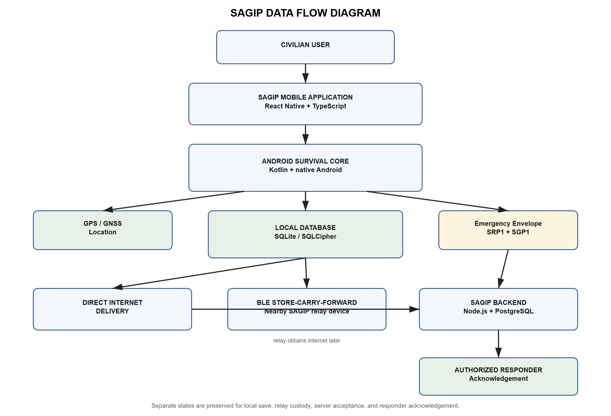
The Data Flow Diagram shows how an emergency report moves from the origin user to the backend and responder. The civilian enters emergency information in the React Native application. The application sends the request to the Android Survival Core. The Survival Core owns the durability-critical path.
The Survival Core first stores the report in the local database. This local commit is the primary success boundary for SOS creation. No internet connection is required for this save. The system captures location on a best-effort basis and stores it when available.
After local storage, SAGIP prepares an emergency transport envelope. When network connectivity is available, the system can try direct backend delivery. If the backend accepts the message, SAGIP stores the server receipt. The application can then show server acceptance.
When direct internet delivery is unavailable, SAGIP can use BLE to locate another compatible device. The receiving device validates and stores the complete envelope before acknowledging custody. The relay can later send the stored envelope when it gains internet access.
After server acceptance, an authorized responder can acknowledge the incident. Server acceptance and responder acknowledgement remain separate states. A gateway can store acknowledgement data for a relayed incident. It can later return this data to the origin through BLE. The origin stores a valid acknowledgement before showing responder acknowledgement.

DESIGN

Database Structure
SAGIP uses separate local and backend databases because they have different responsibilities. The mobile database preserves emergency information and delivery state while offline. The backend database maintains canonical incidents, accepted messages, responder identities, and responder acknowledgements.
The current on-device schema is version 7. Reports and report revisions form the main local records. The database stores location data separately. Outbound envelopes keep stable delivery identity. Delivery events and attempts preserve transport history. Server receipts preserve backend acceptance evidence.
The database stores relay information separately from reports that originated on the current phone. Inbound envelopes contain messages accepted from another SAGIP device. Seen-message records support duplicate suppression. Relay receipts record durable peer acceptance. This separation prevents a gateway from treating another person's emergency as its own report.
The database also separates responder acknowledgements by ownership. responder_acks stores acknowledgements for reports that originated on the current phone. relay_responder_acks stores temporary acknowledgements for reports that originated on another device.
The backend PostgreSQL database stores origin keys, incidents, incident revisions, accepted messages, server receipts, responder identities, responder acknowledgements, and distributed rate-limit state.
Figure 2. Entity Relationship Diagram.
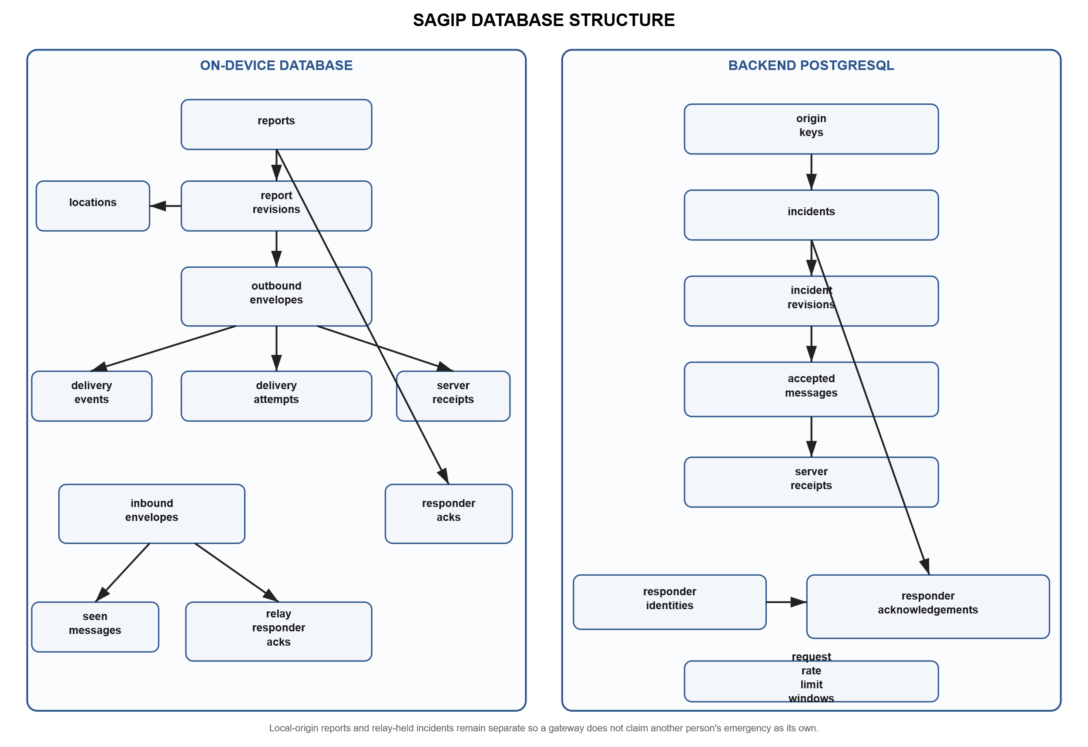
The Entity Relationship Diagram shows separate local and backend persistence boundaries. The local side handles report creation, outbound delivery, relay custody, and acknowledgement return. The backend side handles canonical incidents, accepted transport messages, responder identity, and responder acknowledgement.
This design supports a key SAGIP rule. A relay phone must not convert another user's incident into its own civilian report. Relay-held records remain separate from local-origin report state. They preserve the identifiers required for backend delivery and acknowledgement return.

DEVELOPMENT PROCESS
SAGIP development used an iterative, specification-driven, and test-driven process. The project first defined the emergency communication problem. It also defined the rule that local SOS storage must occur before network delivery. The team then implemented and integrated major capabilities in stages.
Development activities overlapped instead of following a strict sequence. Mobile, Android, backend, BLE, testing, security, and documentation work could proceed in parallel. Several components were testable before full integration.
Testing occurred throughout development. Automated tests first verified individual components. Unit and instrumentation tests checked Android functions where applicable. Backend tests ran before live database and server validation. The project records automated, emulator, physical-device, and live-backend evidence as separate levels.
Figure 3. SAGIP Development and Validation Process.
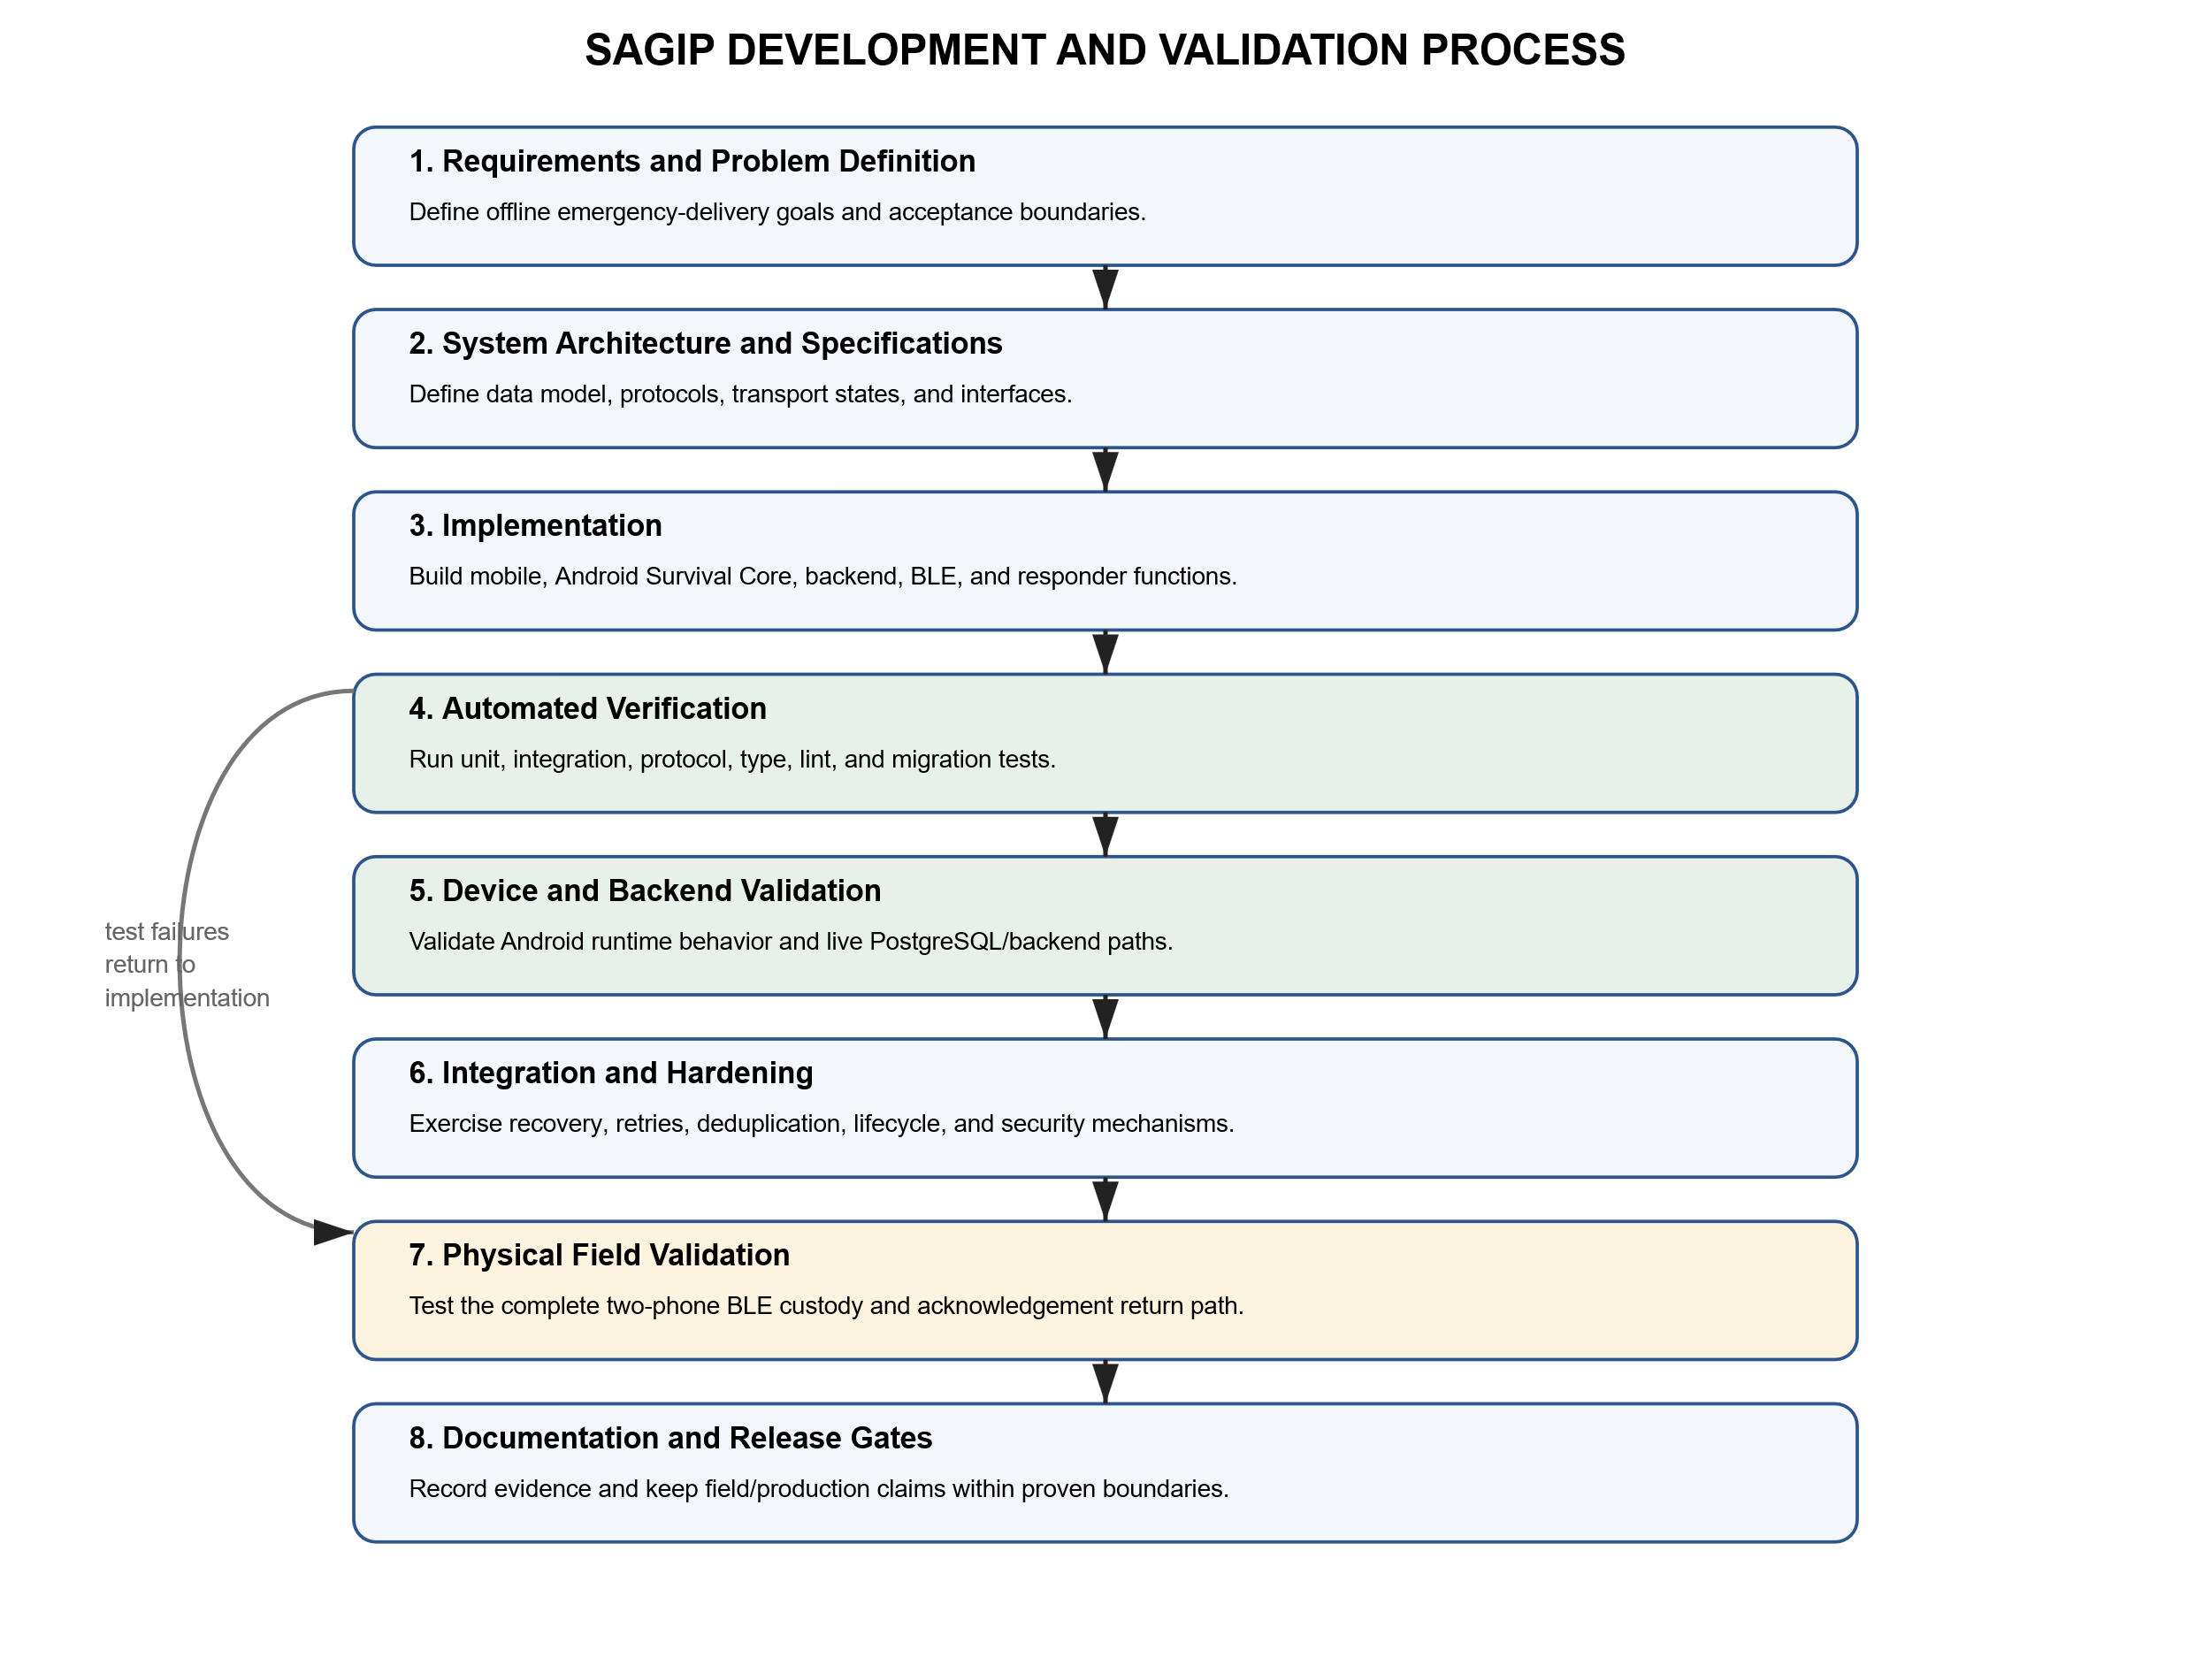
The process begins with requirements analysis and system architecture. Technical specifications define stable interfaces and protocol behavior. Automated verification tests individual functions and integration paths. Runtime validation then checks Android-specific behavior and backend operation.
Integration and hardening focus on retries, duplicate suppression, lifecycle recovery, relay persistence, and security boundaries. Physical field validation is a separate acceptance stage. Automated or one-device tests cannot prove the complete two-phone store-carry-forward path.
The first milestone is not field-proven until the complete path succeeds on two physical Android phones. The test must include real BLE custody, live-backend delivery, responder acknowledgement, and physical acknowledgement return.
Figure 4. Project Development Timeline.
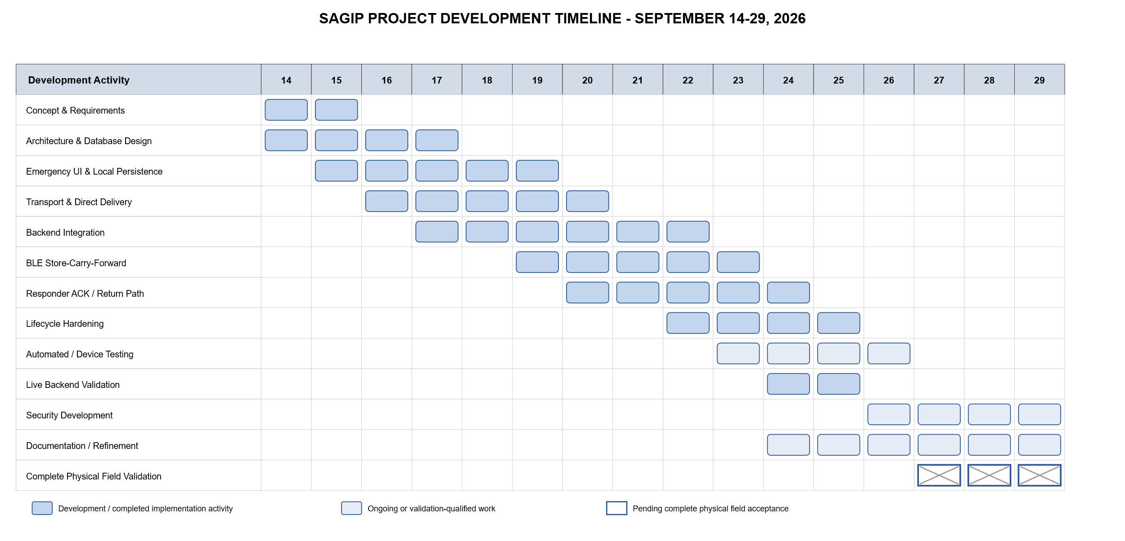
The SAGIP development timeline covers September 14 to September 29, 2026. Major activities overlapped because the development period was short. Requirements, architecture, mobile, backend, BLE, testing, security, and documentation work therefore progressed in parallel.
Development began on September 14 with concept refinement, requirements analysis, architecture, and database design. Work then moved to the emergency interface, durable local storage, envelope preparation, direct delivery, backend ingestion, and PostgreSQL integration.
BLE store-carry-forward and responder acknowledgement work followed. Backend and mobile integration continued in parallel. Later work focused on Android lifecycle hardening, testing, live-backend validation, security, encrypted storage, and documentation.
As of September 29, 2026, the main first-milestone software path is substantially implemented. Major parts have automated, physical-device, and live-backend evidence. Complete field acceptance remains pending. The remaining test must show the complete Phone A to Phone B relay and acknowledgement-return path.

CHAPTER THREE

TESTING
SAGIP testing checks emergency behavior under degraded conditions. It checks local persistence, transport integrity, retry behavior, BLE relay, backend ingestion, responder acknowledgement, recovery, and truthful status presentation.
SAGIP uses evidence levels to prevent overstated test claims. An implemented function is not automatically field-verified. The project records automated, emulator, physical-device, live-backend, and field-acceptance evidence separately. The first milestone remains pending until the complete two-phone path succeeds.

Testing Approach
The verification approach follows the system architecture. React Native tests check user-facing state and accessibility. Kotlin tests check the Survival Core, SQLite state, retries, binary protocols, BLE framing, background operation, and recovery. Backend tests check envelope validation, authentication, idempotency, responder operations, database behavior, and request bounds. Physical and live-backend tests support claims that host tests cannot establish.

Functional Requirements Test Cases
Functional Requirement | Test Case | Expected Result
1. Durable Offline SOS | Create SOS with no internet | Report is durably stored before any delivery attempt
1. Durable Offline SOS | Restart after local save | Same report and message identity remain available
2. Direct Network Delivery | Retry the same prepared envelope | Server acceptance remains idempotent
3. BLE Store-Carry-Forward | Transfer complete envelope to a peer | Peer persists valid envelope before custody success
3. BLE Store-Carry-Forward | Repeat peer encounter | Duplicate logical custody is suppressed
4. Gateway Delivery | Restore internet on relay phone | Stored envelope is delivered without changing origin identity
5. Responder Coordination | Acknowledge accepted incident | Authenticated responder status is stored separately from server acceptance
6. Return Acknowledgement | Return SGA1 from gateway to origin | Origin validates and durably stores responder acknowledgement
7. Recovery | Kill and restart after active work | Durable state remains recoverable without duplicate incident creation
8. Security and Protocols | Tamper with signature digest or frame | Invalid input is rejected within defined bounds
9. Delivery Status | Move report through delivery states | UI distinguishes local save relay server acceptance and responder acknowledgement
Table 1. Functional Requirements and Test Cases.

Automated Verification
The repository contains automated tests for the React Native interface, backend, and Android Survival Core. Other tests cover transport protocols, encryption, database migration, retries, idempotency, BLE framing, return acknowledgement, and recovery. These tests provide repeatable implementation evidence. They do not replace physical radio transfer or complete field acceptance.
The current canonical project status records root Jest, TypeScript, and ESLint as passing. Backend tests, backend type checking, and backend lint also pass. Android unit tests and debug build checks pass. Connected instrumentation passes on one physical POCO F6 and one Pixel 4 emulator. Live PostgreSQL validation remains separate from these automated and device results.

Current Verification Evidence
Area | Evidence | Evidence Level | Current Interpretation
Civilian React Native | Automated UI and accessibility tests exist | Automated Verified | Implementation behavior has automated coverage
Android runtime | 16 of 16 instrumentation tests previously passed on physical POCO F6 Android 16 | Physical-Device Verified | Selected Android runtime paths are verified on one physical phone
Android emulator | 16 of 16 instrumentation tests previously passed on Pixel 4 Android 12 AVD | Emulator Verified | Useful runtime evidence but not physical BLE field proof
Foreground relay | EmergencyRelayService previously ran on the physical POCO with connectedDevice foreground-service state | Physical-Device Verified | Proves service startup and ownership but not peer RF transfer
Live backend | Real migrations and deployed function previously exercised against Neon PostgreSQL | Live-Backend Verified | Proves migration and runtime connectivity for the tested path
Backend idempotency | Eight concurrent duplicate submissions converged on one canonical logical incident in live PostgreSQL | Live-Backend Verified | Verified duplicate-ingestion scenario only
SGP2 and SRE2 | Implementation and automated protocol or HPKE tests are present | Automated Verified | Not activated as the normal production envelope path
SQLCipher | Implementation and migration instrumentation tests are present | Automated Verified | Representative physical-device migration qualification is still required
Two-phone BLE loop | Complete A to B custody and B to A SGA1 return not yet demonstrated as one integrated run | Pending Field Validation | First-milestone field acceptance remains pending
Table 2. Current Verification Evidence.

Field Acceptance Testing
The final acceptance test must use two physical Android phones and a live PostgreSQL-backed SAGIP server. Phone A must remain offline when it creates the SOS. Phone B must take physical BLE custody while offline. Phone B must later deliver the same stored envelope to the backend. A responder must acknowledge the incident. Phone B must return that acknowledgement to Phone A through physical BLE. No separate test can replace this complete path.
Stage | Acceptance Condition | Status
A - Offline Origin | Phone A creates and durably stores an SOS with no internet | Implemented and separately verified
B - Physical Custody | Phone A transfers the envelope to Phone B and B persists before ACK | Pending integrated two-phone field run
C - Separation | Phones separate after custody so later delivery does not depend on continuous contact | Pending integrated field run
D - Gateway Delivery | Phone B later obtains internet and live backend accepts exactly one logical incident | Components verified separately - integrated run pending
E - Responder Action | Authorized responder records acknowledgement for the accepted incident | Implemented - integrated field run pending
F - Gateway ACK Storage | Phone B polls and durably stores the responder ACK for the relayed report | Implemented - integrated field run pending
G - Physical Return | Phone B returns to range and transfers SGA1 to offline Phone A | Pending integrated two-phone field run
H - Origin Confirmation | Phone A durably records and displays responder acknowledgement | Implemented path - final integrated proof pending
Recovery | Restart and retry do not create duplicate logical incidents | Automated evidence exists - field recovery remains part of acceptance
Table 3. Final Field Acceptance Testing.
The project shall mark the first milestone complete only after one field run verifies every stage in Table 3. Until then, the project state is Pending Field Validation.

DEPLOYMENT
SAGIP separates field-test deployment from production release. Field-test releases support the physical acceptance runbook. The workflow checks the hosted backend and runs application and backend checks. It builds a debug Android APK with the HTTPS backend configuration. It also computes a checksum and publishes a pre-release asset. The field-test APK uses debug signing and is not a production artifact.
A separate production workflow exists for signed Android artifacts and backend deployment. Release configuration requires an HTTPS backend, version metadata, and an approved Android signing identity. The workflow can apply PostgreSQL migrations and deploy the backend to the pinned Neon target. It also checks release artifacts and basic backend health. A successful workflow does not prove production emergency-service readiness.

Deployment and Production Readiness Gates
Gate | Required Evidence | Current Treatment
Field-test artifact | Automated checks plus configured hosted backend plus APK checksum | Available for field validation
Production Android signing | Owner-approved private release keystore and verified certificate fingerprint | Production-gated
Live production backend | Reviewed migrations plus deployed function plus verified health and authorization boundaries | Partially evidenced but not sufficient alone
Two-phone physical BLE | Real A to B custody and B to A return acknowledgement | Pending field validation
Encrypted local storage | Representative real-device SQLCipher migration and reopen testing | Production-gated
Encrypted incident delivery | SGP2 emission plus ciphertext persistence plus responder-local decryption and key custody | Not operational as the normal field path
Responder operations | Controlled credential and key provisioning with operational procedures | Production-gated
Service readiness | Monitoring uptime incident response and recovery expectations with operational evidence | Production-gated
Table 4. Deployment and Production Readiness Gates.

MAINTENANCE
SAGIP maintenance must preserve the emergency-delivery invariants. Local database changes must use explicit non-destructive migrations. PostgreSQL changes must use checksum-tracked migrations. Maintenance must not rewrite immutable emergency envelopes to simulate compatibility with a new protocol.
Protocol maintenance must preserve established compatibility paths. SGP1 remains the normal path unless current production configuration proves otherwise. SGP2 and SRE2 are not operational until production emission, ciphertext persistence, responder decryption, key distribution, and required device tests are active. SGA1 remains a plaintext CRC-protected status frame. It is not cryptographically confidential or authenticated.
Android maintenance must test permissions, BLE operation, foreground-service ownership, JobScheduler recovery, process restart, database migration, and OEM background restrictions.
Backend maintenance must preserve input bounds, signature and digest checks, idempotent ingestion, responder authentication, migration integrity, and sanitized public errors. Live deployment evidence must remain separate from host or in-memory tests. Production evaluation must cover load, concurrency, rate limiting, monitoring, and incident response.
Documentation is part of maintenance. PROJECT_STATUS.md must describe the current state after meaningful changes. PROGRESS_LOG.md must record the change and exact evidence. Affected protocol or architecture documents must also be updated. This process prevents historical results from appearing as current behavior.

REFERENCES
[1] International Telecommunication Union, “Emergency telecommunications,” May 2025. [Online]. Available: https://www.itu.int/en/mediacentre/backgrounders/Pages/emergency-telecommunications.aspx.
[2] J. T. B. Fajardo, K. Yasumoto, N. Shibata, W. Sun, and M. Ito, “Disaster information collection with opportunistic communication and message aggregation,” J. Inf. Process., vol. 22, no. 2, pp. 106–117, Apr. 2014, doi: 10.2197/ipsjjip.22.106.
[3] S. Saha, S. Nandi, P. S. Paul, V. K. Shah, A. Roy, and S. K. Das, “Designing delay constrained hybrid ad hoc network infrastructure for post-disaster communication,” Ad Hoc Networks, vol. 25, pt. B, pp. 406–429, Feb. 2015, doi: 10.1016/j.adhoc.2014.08.009.
[4] M. A. Hossain, S. K. Ray, and J. Lota, “SmartDR: A device-to-device communication for post-disaster recovery,” J. Netw. Comput. Appl., vol. 171, Art. no. 102813, Dec. 2020, doi: 10.1016/j.jnca.2020.102813.
[5] K. Fall, “A delay-tolerant network architecture for challenged internets,” in Proc. ACM SIGCOMM 2003, 2003, pp. 27–34, doi: 10.1145/863955.863960.
[6] V. Cerf, S. Burleigh, A. Hooke, L. Torgerson, R. Durst, K. Scott, K. Fall, and H. Weiss, “Delay-Tolerant Networking Architecture,” RFC 4838, Apr. 2007, doi: 10.17487/RFC4838.
[7] S. Burleigh, K. Fall, and E. Birrane III, “Bundle Protocol Version 7,” RFC 9171, Jan. 2022, doi: 10.17487/RFC9171.
[8] F. Álvarez, L. Almon, H. Radtki, and M. Hollick, “Bluemergency: Mediating post-disaster communication systems using the Internet of Things and Bluetooth Mesh,” in Proc. 2019 IEEE Global Humanitarian Technology Conf. (GHTC), Seattle, WA, USA, Oct. 2019, pp. 1–8, doi: 10.1109/GHTC46095.2019.9033063.
[9] Android Developers, “Bluetooth Low Energy,” Google. [Online]. Available: https://developer.android.com/develop/connectivity/bluetooth/ble/ble-overview.
[10] Android Developers, “Android Keystore system,” Google. [Online]. Available: https://developer.android.com/privacy-and-security/keystore.
[11] National Institute of Standards and Technology, Digital Signature Standard (DSS), FIPS PUB 186-5, Feb. 2023, doi: 10.6028/NIST.FIPS.186-5.
[12] R. Barnes, K. Bhargavan, B. Lipp, and C. Wood, “Hybrid Public Key Encryption,” RFC 9180, Feb. 2022, doi: 10.17487/RFC9180.
[13] Google, “Hybrid Encryption,” Tink, Mar. 3, 2025. [Online]. Available: https://developers.google.com/tink/hybrid.
[14] OWASP Foundation, “OWASP Mobile Application Security Verification Standard (MASVS).” [Online]. Available: https://mas.owasp.org/MASVS/.
[15] Zetetic LLC, “SQLCipher documentation.” [Online]. Available: https://www.zetetic.net/sqlcipher/documentation/.

