# Portfolio Site Analysis Document

## Document Overview

Site URL: https://kynmmarshallportfolio0.netlify.app

Repository: <https://github.com/Kynmmarshall/my-portfolio-site>

Reviewer: Engr Tanwi

---------------------------------------------------------------------

## 1. Homepage/Landing Page

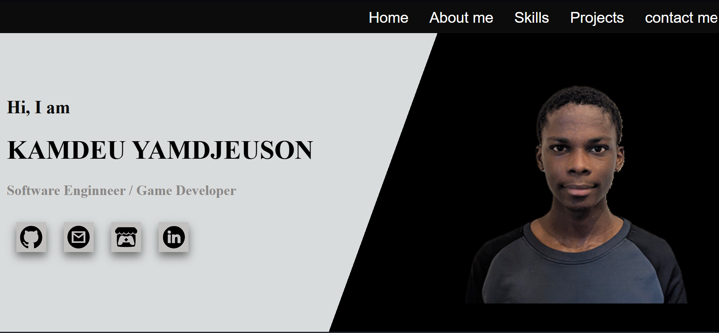Comments:

- First impressions and visual impact

- Layout and spacing

- Color scheme and typography

- Call-to-action elements

## 2. Header/Navigation



Comments:

- Navigation menu structure

- Logo/branding placement

- Mobile responsiveness

- User experience

## 3. About Section

Comments:

- Personal introduction quality

- Profile image presentation

- Content readability

- Personality reflection

## 4. Projects/Portfolio Section

Comments:

- Project presentation style

- Image/gallery quality

- Project descriptions

- Technical skills demonstration

## 5. Skills/Technologies

Comments:

- Skills categorization

- Technology icons/logos

- Proficiency indicators

- Relevance to target roles

## 6. Contact Section

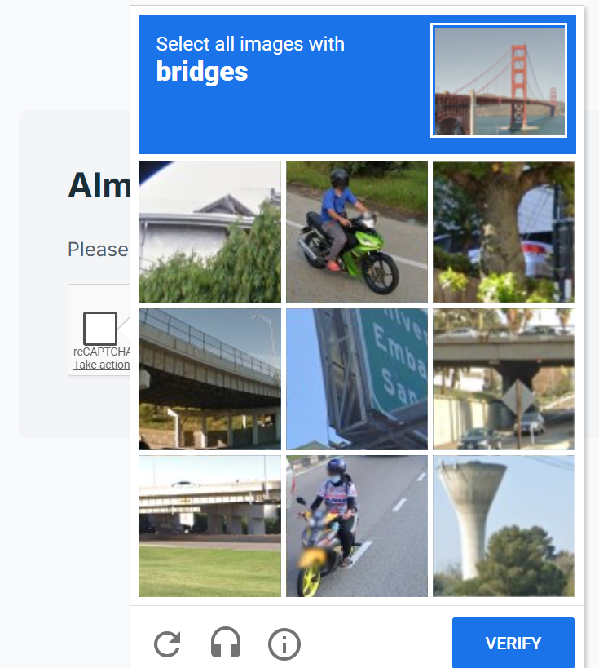

Comments:

- Contact methods available

- Form functionality

- Social media links

- Response expectations