CPSC 483 Study Guide

HW 1

Gradient Descent:
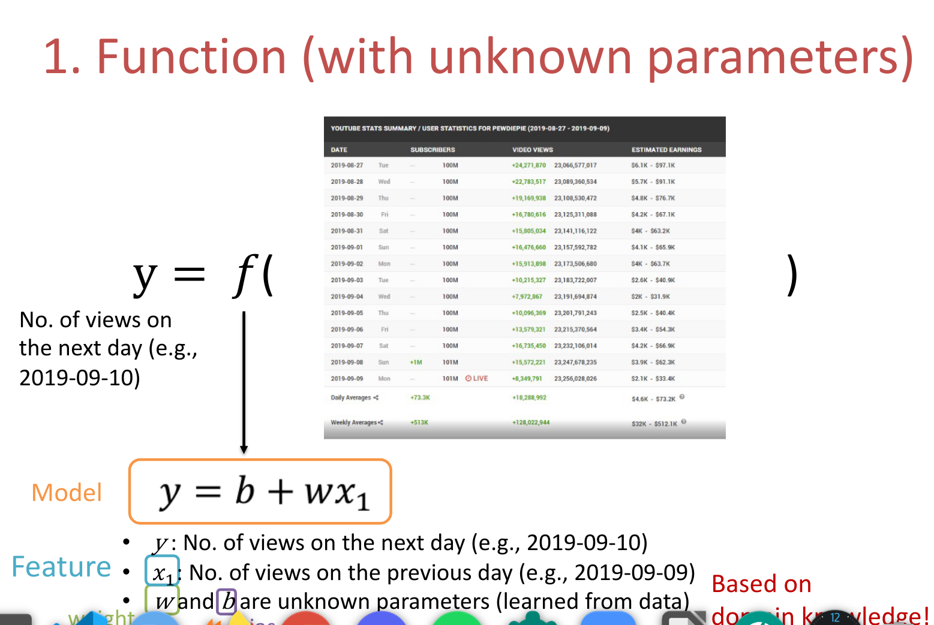

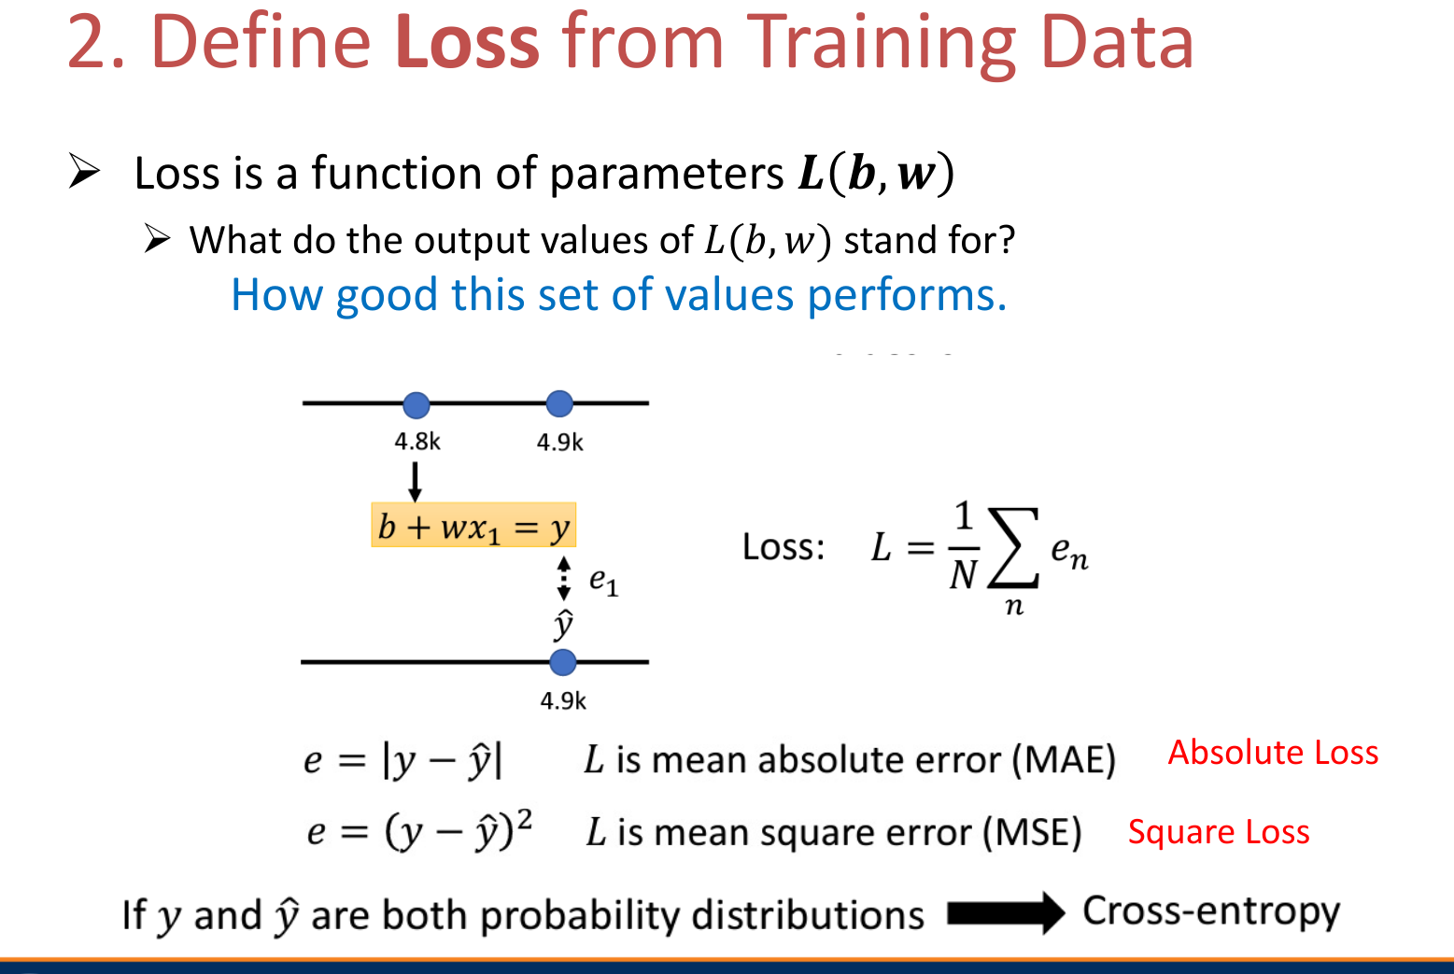
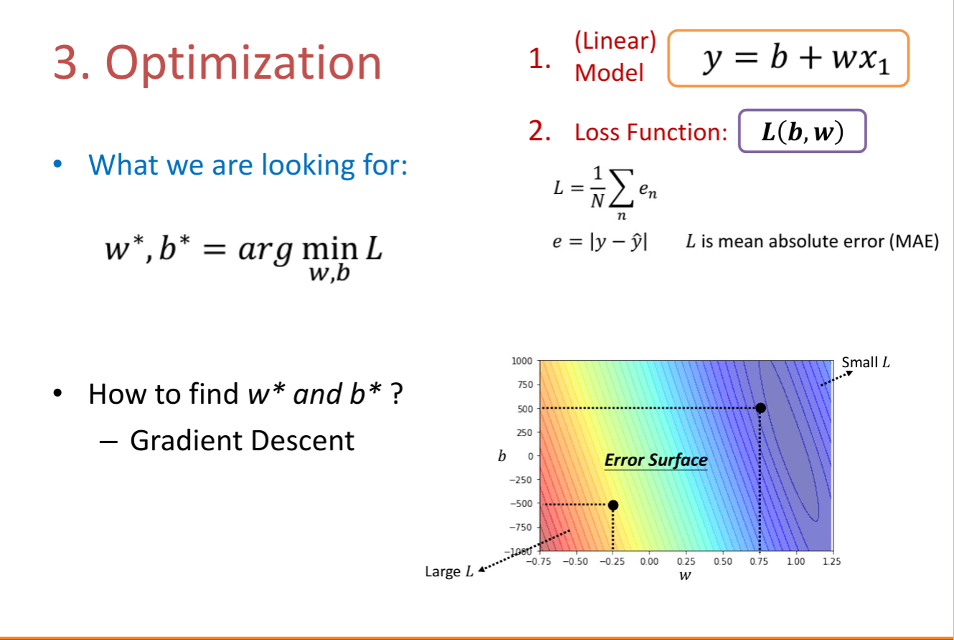

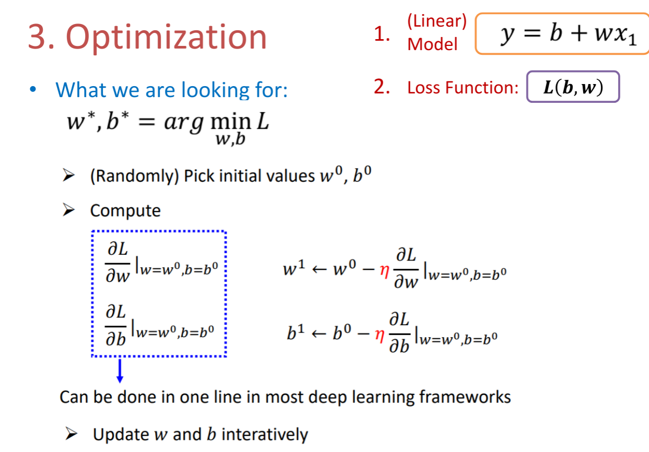

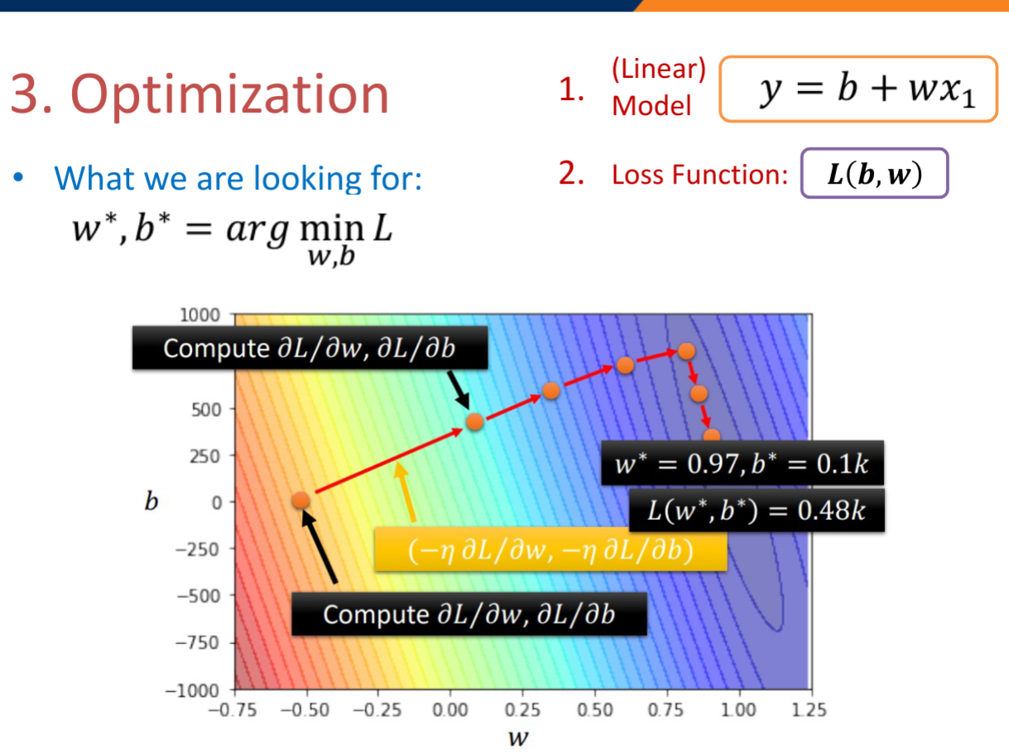
“Leave-One-Out” Cross Validation: generally involves taking one sample (the test set) at a time as the test sample an classifying them against the other samples (the training set) the data set.

Naive Bayes
P(a₁=”feature #1”, a₂ = “feature #2”, a3=…,| h=”class (column of target variable)
Ex.
 | Age (a₁) | Wealth Status (a₂) | Intelligence (a₃) | Employment Status (h)
 | young | Poor | Smart | yes
 | old | poor | Dumb | no
 | middle-aged | poor | Dumb | yes
 | old | rich | Dumb | no
 | middle-aged | rich | Smart | yes
 | old | poor | Smart | no
 | old | poor | Smart | yes

Find whether the probability a person is employed or not using Naive Bayes Classfier
With the attributes that they are old, they are not wealthy, they are smart.
 | P(a₁|h) | P(a₂|h) | P(a₃|h) | P(h)
Employeed (h) = ”yes” | 1/4 | 2/4 | 3/4 | 4/7
Employeed (h) = ”no” | 1 | 2/3 | 1/4 | 3/7

1/4 * 2/4 * ¾ * 4/7 = 0.571428571428
1 * 2/3 * ¼ * 3/7 = 0.428571428571

With Naive Bayes Classification and the given attributes someone who fits these attributes is more likely to be employed.

ID3
Steps to complete the ID3 Algorithm and Build the Tree:

Formula for Entropy:
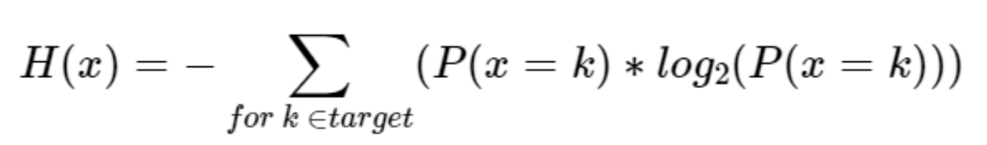
Step1: Calculate the Information Gain (Entropy) of the whole dataset:

Ex.
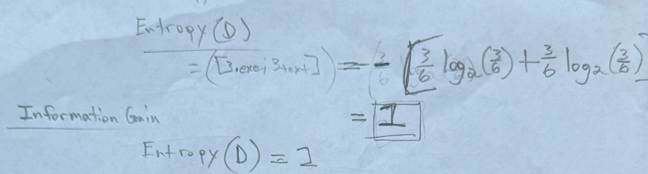
* This is calculated by using the classification (target variable) as the variable to calculate the entropy for the whole dataset.
Step 2a: For each attribute calculate the entropy of each attribute in regards to the class.
Ex.
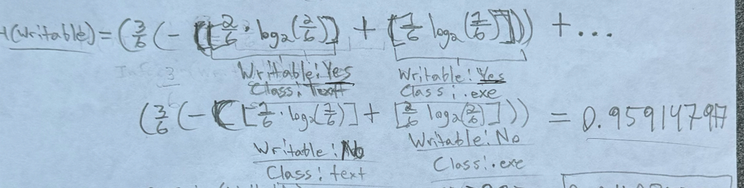
Step 2b. After calculating each one calculate the Information Gain of the attribute by taking the entropy calculated and subtracting it from the InformationGain/Entropy of the whole dataset.
Step 3: Create the tree using the calculations for the information gain. The one with the highest information gain goes first, followed by the next, etc… until working down to the one with the least amount of information gain.

HW 2

K-Fold Cross-Validation: Similar to regular cross-validation; however the amount set out for the training set is dependent on the number of samples m, and the number of folds k the amount of samples set out for the test set is m/k.

Equations for calculating K-Fold:
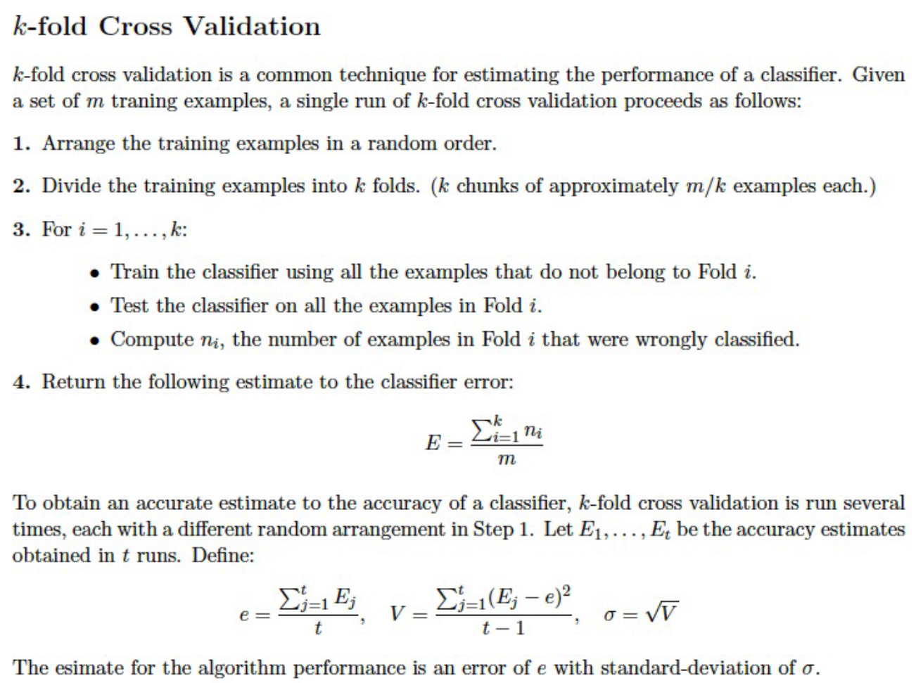
* Note: For whatever algorithm she chooses interpret the instructions as-is. Follow exactly how it is stated even if ‘tie-breakers’ are ambiguous.

Overfitting
Ways to resolve over-fitting:
- Data Augmentation
- Add More Training Data
- Constrained Model

4. Early Stopping

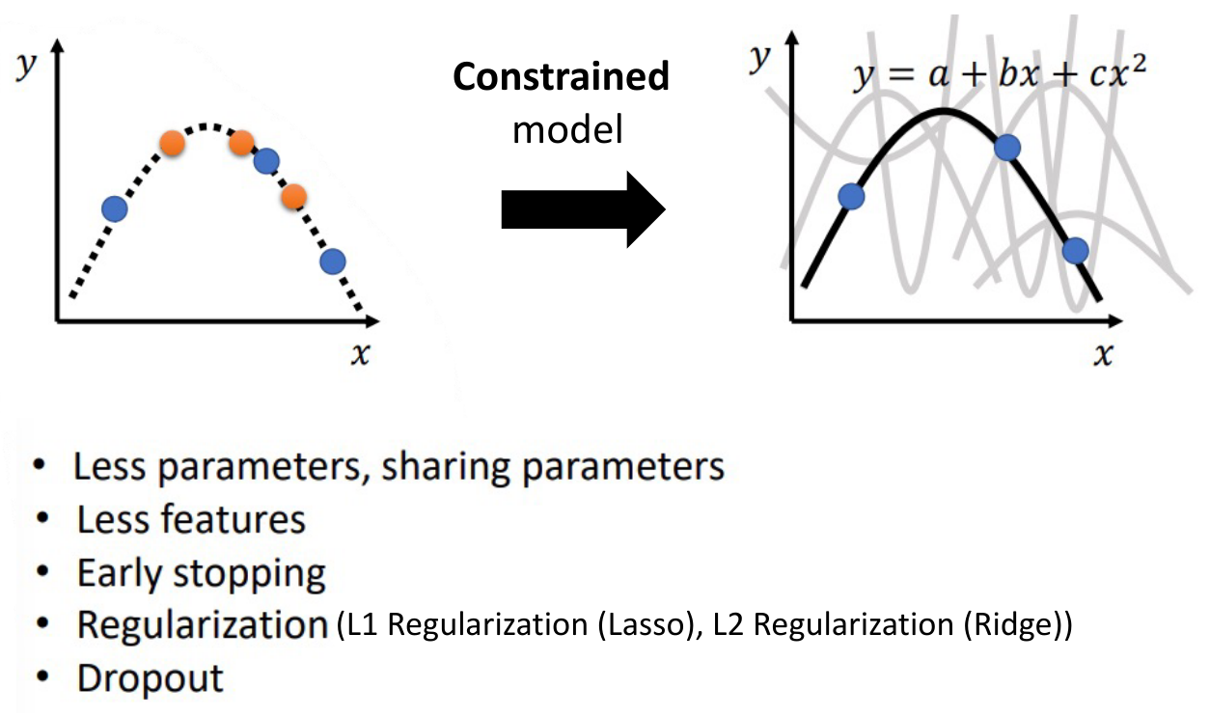
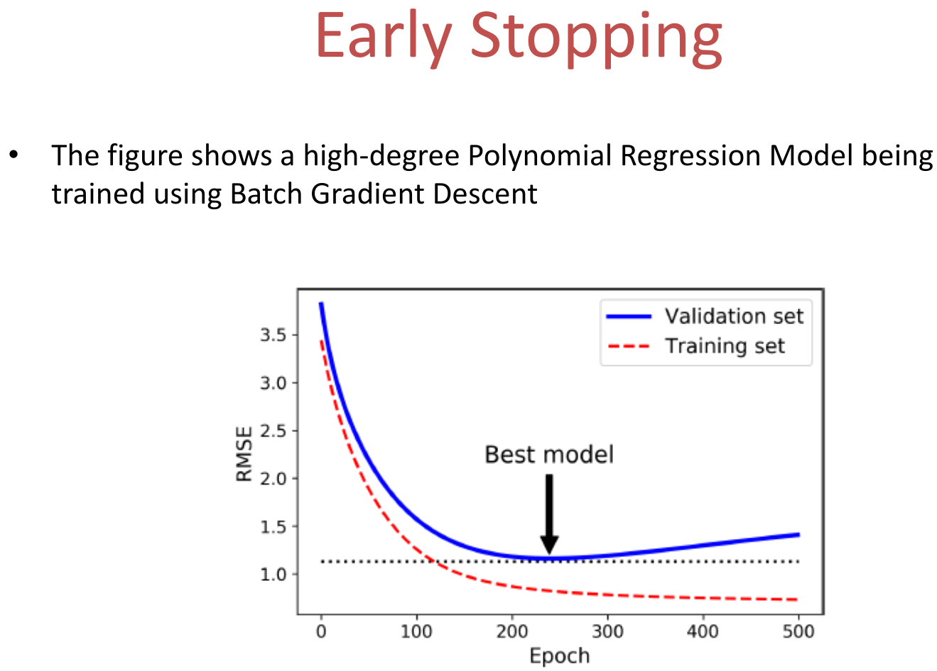
Model Bias vs Optimization Issues
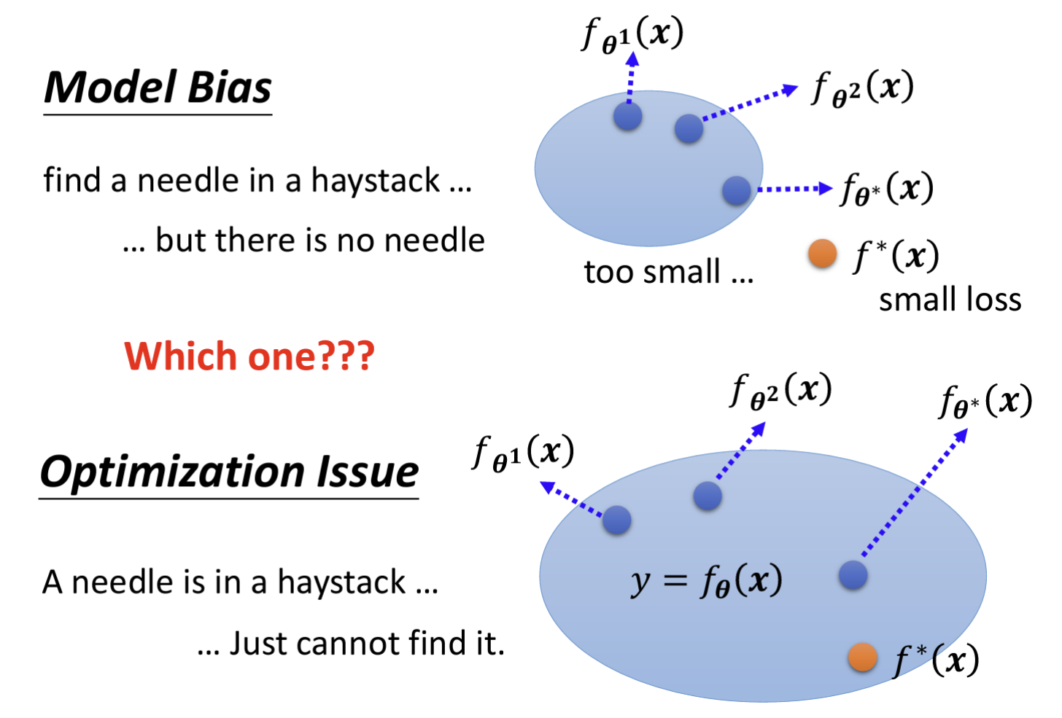

Neural Networks
See HW3

