CON DAO ISLAND, VIET NAM

3D2N

OVERVIEW

## location

Côn Đảo is a group of islands off the southeast coast of Vietnam. They’re known for their sandy beaches, coral reefs and marine life. The shores of Bảy Cạnh Island are a breeding ground for turtles, and there are many dive sites in the surrounding clear waters. On the island’s eastern tip, a trail through the forest climbs to the colonial-era Bảy Cạnh Lighthouse. The site offers panoramic views.

Area: 76 km²

Province: Ba Ria–Vung Tau Province

Capital: Côn Sơn Island

Region: Southeast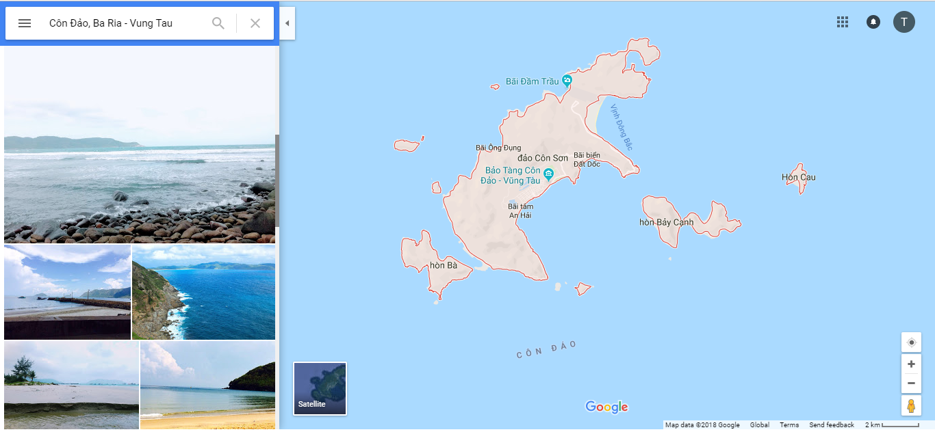

## Characteristics

The Con Dao island is the largest island in the chain of 15 islands as well as islets. It is ringed with lovely beaches, scenic bays, coral reefs, and partially covered in thick forests. There are a variety of activities for tourists to take part in Con Dao, be it diving, hiking, and exploring some empty coastal roads as well as deserted beaches, and much more.

The Con Dao island has pristine tropical coastal regions with long white sandy beaches together with a high-end diverse ecosystem of marine. Used to be known by the Western sailors in the past, up to now, this mysterious island turns into a famous travel destination. From the so-called “living hell on earth” that was controlled by the French colonialism and American imperialism, Con Dao rapidly became a charming destination for tourists worldwide to explore.

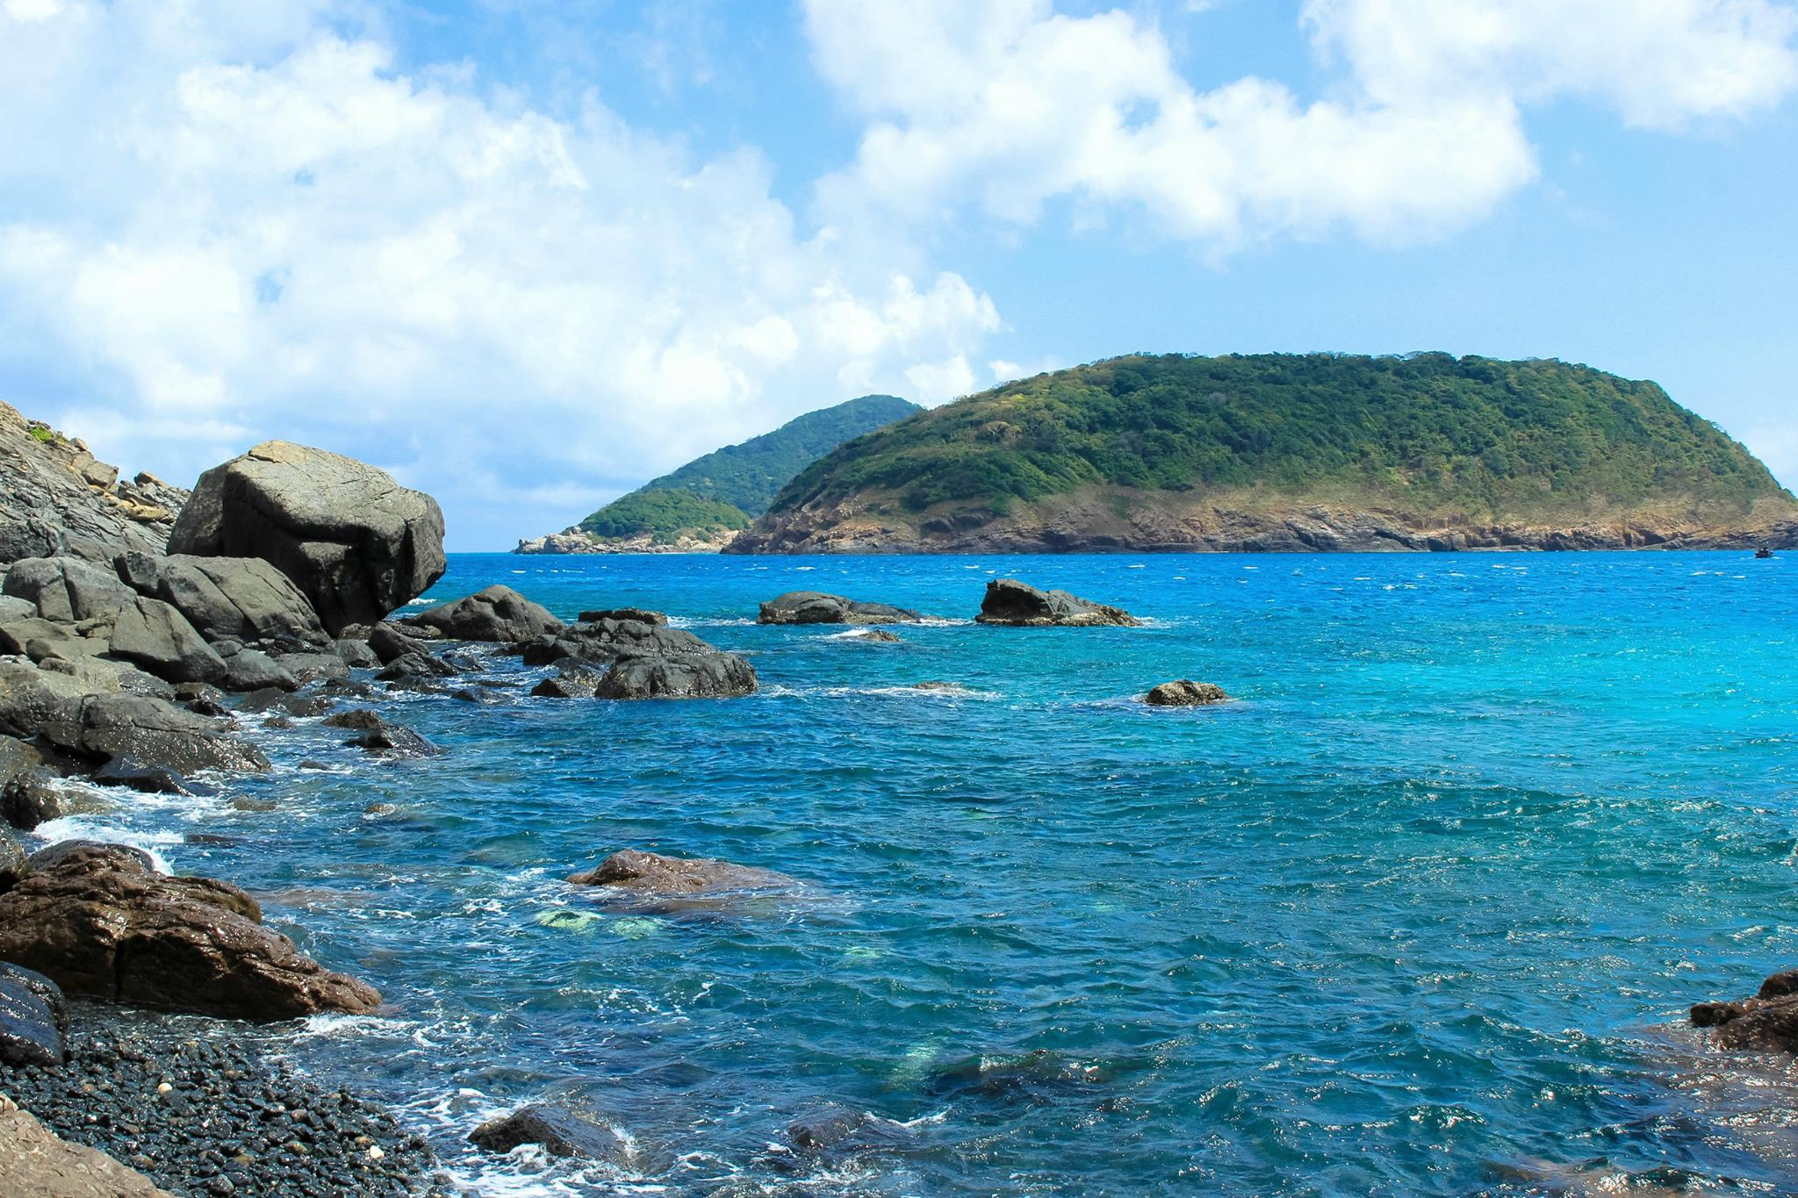

|  |  |
| --- | --- |
|  | Saigon – Tour to Con Dao Island (Lunch, Dinner) |

* The Con Dao Discover 03 days tour will be started by meeting our guide/ staff at Tan Son Nhat Airport and then enjoy the flight to Con Dao. Pick up on arrival and then drive to Con Son town. On the way, we will have chance to drive throughout the famous villages such Co Ong, Suoi Ot, Dat Doc, Lo Voi… Check in on arrival and then free at leisure before lunch is severed at the restaurant.
* In the afternoon, we will spend time to discover the Mount A Temple – Con Dao TT views from a height of 50m. Next, we will visit Ban Dam, through the following localities: Nose, stone ground white shark, beach Cowardly , Peak love. Finally return hotel for a leisure or swimming time on beach. Dinner and overnight in Con Dao.

|  |  |
| --- | --- |
|  |  |
|  |  |

**12:00 PM:** Back to restaurant to have lunch and relax.

**Afternoon:** Check in hotel and relax.

**18:00 PM:** Back to restaurant to have dinner.

|  |  |
| --- | --- |
|  | Con Dao – Discover the history |

**7:30 – 8:30 AM:** Have breakfast at the hotel.

**9:00 AM:** Depart the hotel with our tour guide.

* Today, after the breakfast at the hotel, we will spend full day tour to visit Con Dao Museum, Pier 914, Phu Hai Historical Pier, Historic Stables French Tiger, Tiger Cages US. Next, we will visit Vo Thi Sau temple, Ma Thien Lanh Bridge, Ba Phi Yen Temple. Time for lunch.
* In the afternoon, we will be free for swimming or regist the open programs as below:
* Dam Trau beach is known for its long, sandy shoreline and beautiful, clear water. Although it is located just behind the Con Son airport, this won't keep you from enjoying the peace and tranquility offered by this unique spot. Since it is located on an island, it's best to spend some time staying there and taking a day trip (or longer) to one of the best beaches in Vietnam.

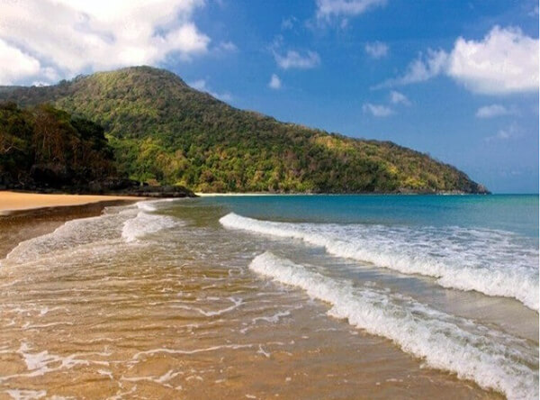

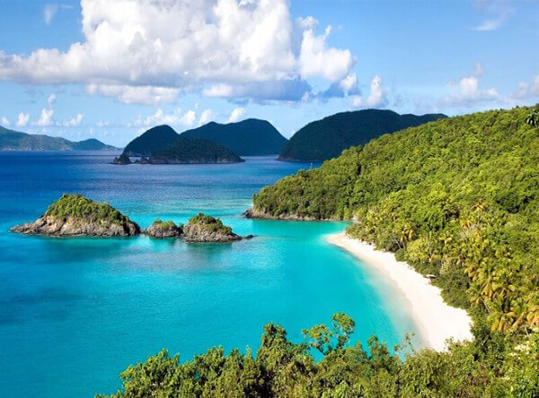

* Tour to glass bottom boat rental (coral) or canoe tour or Hon Cau Hon Bay Canh

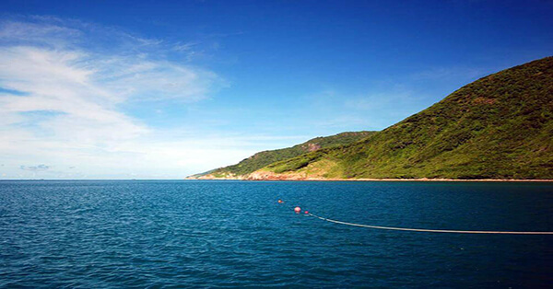

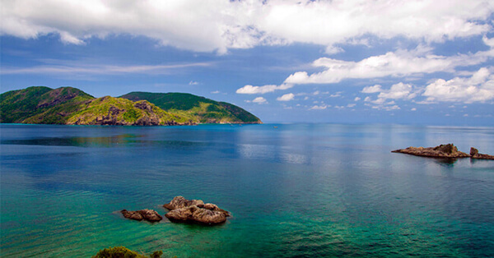

* Tre Lon Island and Tre Nho Islet Tre Lon Island, known as Big Bamboo Island, is the second popular place that sea turtles gather to lay eggs. Besides that, there is the other marine life, such as snails, giant clams, and reef fish. Alternatively, you can visit Tre Nho Islet or Small Bamboo Island to see many birds nesting ground.

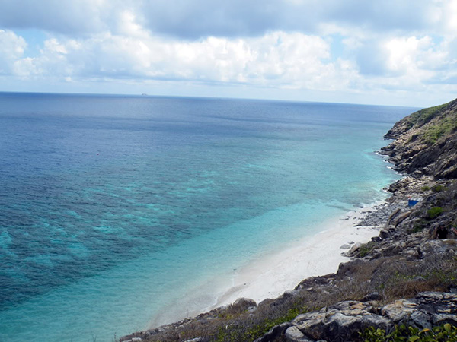

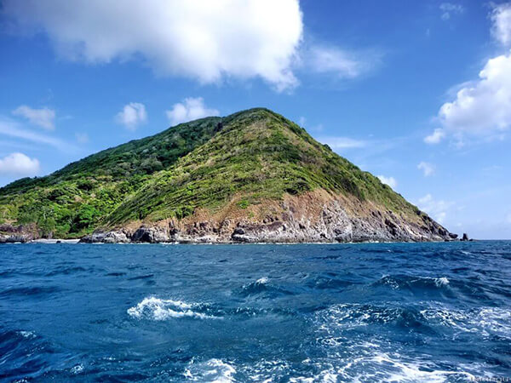

* Finally, return hotel and have dinner on your own. Free at leisure in the evening to discover Con Dao Island at night. Overnight in Con Dao.

**Back to hotel:** just in time to watch the sunset.

**18:00 PM:** back to restaurant to have dinner and relax.

|  |  |
| --- | --- |
|  |  |
|  | |
|  |  |

|  |  |
| --- | --- |
|  | Relax – Farewell & Goodbye |

**7:30 – 8:30 AM:** Have breakfast at the hotel.

* When ready and as your scheduled flight allows, check out of your hotel and we’ll take you to the airport in time for your flight.
* End of Tour.

