NINH BINH, VIET NAM

3D2N

OVERVIEW

## location

Ninh Binh town is the centre of Ninh Binh Province and is found in the south of the red River Delta region in northern Vietnam. A coastal Province on the Bay of Tonkin, it sits between the Red River and the Ma River. It has a population of 900,000 and a land mass of over 500 square miles. The population is made up of mainly Viet or Kinh people, with 2% being from 23 different ethnic minorities..

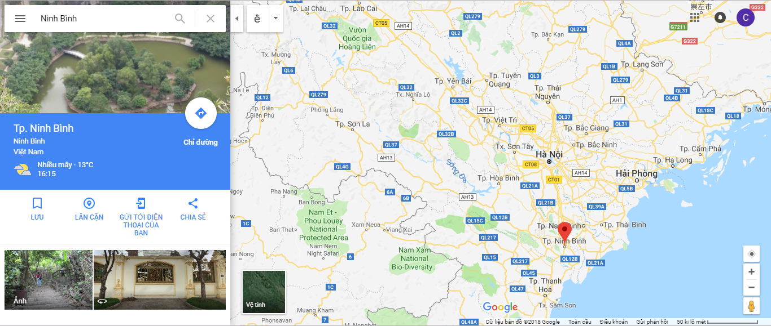

## Characteristics

With over 1.377,57km² of natural area, Ninh Binh has forests, sea and a diverse system of fauna and flora. Ninh Binh topography encompasses plains and the mountains of the Vietnam northwest mountain range. Ninh Binh also keeps a strategic position for military security and social development. Here, troops were usually rallied on their way to the north or south of Vietnam, creating famous victories in Vietnamese national history.

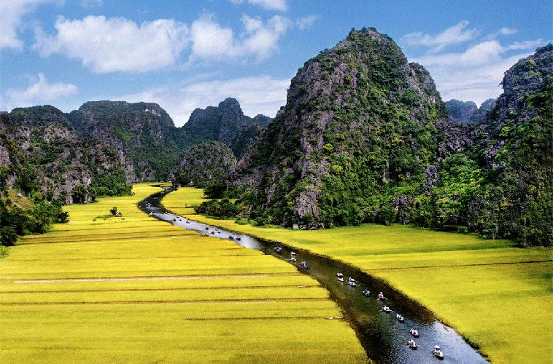

|  |  |
| --- | --- |
|  | SAI GON TO NINH BINH |

## how to get to HUE

* By plane:

From Tan Son Nhat International Aiport in Saigon to Hue is with Noi Bai International Airport

* By bus:

From Hanoi, we will take 2-hours the bus and transit to Ninh Binhn Province.

|  |  |
| --- | --- |
|  |  |

* **Van Long Natural**

Van Long Natural reserve is located in Gia Vien district, Ninh Binh province. Van Long is not only a natural reserve of wetlands but also the cultural relics. Van Long is a legendary land, a beautiful area and the largest natural reserve of wetlands. Here, guests will be seated on the boat to visit Van Long. A large space with spectacular mountain ranges creates a natural wall surrounded a vast expanse of water. With an area of 3000 hectares, Van Long natural reserve has 32 beautiful grotto such as: Ca Grotto, Bong Grotto, Rua Grotto, Chanh Grotto, each grotto has an unique beauty. The most beautiful grotto is Ca grotto in the Hoang Quyen Mountain. It has 250 meters length, 8 meters height and 10 meters width, the ceiling is stalactites with strange shapes like animal, fish



* **Trang An Landscape Complex**

Trang An Landscape Complex covers an area of 6, The complex is surrounded by a buffer zone of 6,268ha, mostly comprising paddy rice fields and villages. As a mixed cultural and natural property, Trang An Landscape Complex contains three protected areas, including Hoa Lu Ancient Citadel Cultural – Historical Area; Trang An – Tam Coc – Bich Dong Scenic Area and Hoa Lu Special-Use Primary Forest. Located in the humid tropical region, Trang An Landscape Complex is a mountainous area that extends in a northwest-southeast direction. To the north and northwest of Trang An lie Bai Dinh karst hills; to the southwest and the south are Dong Tam – Son Ha and Tam Coc – Bich Dong karst ranges; to the southeast and northeast is Truong Yen karst range; to the northeast and the north is Trang An karst range. River network in Trang An is well developed with Hoang Long River to the north, Chanh River to the east, He River to the south, Ben Dang River to the west and river systems of Sao Khe, Ngo Dong and Den Voi in the heart of the heritage.

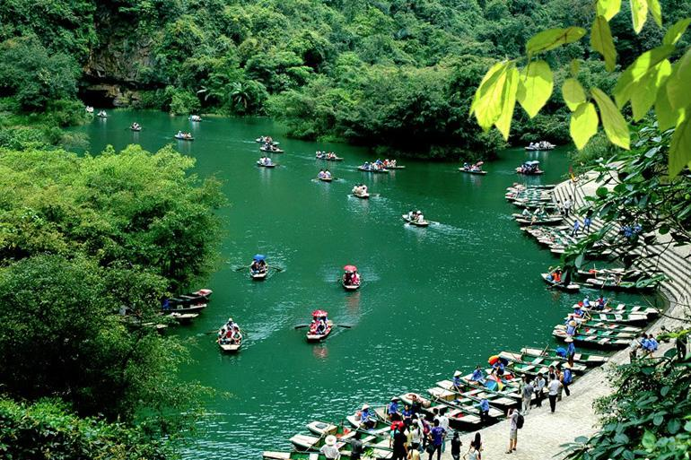

On 23 June 2014, in Doha (Qatar), World Heritage Committee of United Nations Educational, Scientific and Cultural Organization (UNESCO) recognized officially Trang An Landscape Complex as World Cultural and Natural Heritage Site based on three criteria: culture, aestheticism and geology – geomorphology

* **Bich Dong Pagoda**

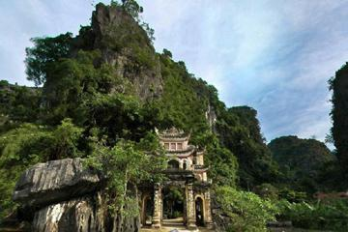

In 1773, Mr. Nguyen Nghiem (the father of the great writer Nguyen Du) visited this cave. After viewing the whole scenery of the mountains, waterways, fields, and sky covered in green mist, he gave the cave a very beautiful and romantic name, Bich Dong (which literally means “Green Pearl Grotto”). Bich Grotto has been said that the second most beautiful cave in Vietnam. Bich Dong pagoda is on the short drive to the South of Tam Coc, it was built on the Truong Yen limestone mountains range, Hoa Lu district, Ninh Binh province. Bich Dong pagoda includes three palaces on three levels: Lower, Middle and Upper pagoda. The Low pagoda has five compartments built on the ground at the foot of mountain. From the Low pagoda up to 120 steps is the impressive Middle pagoda with a half of it was carved into mountain including three compartments. Up to 40 steps is the High pagoda located on the highest point nearby the top of The Bich Dong mountain. From here you can have the wonderful perspective view of the Bich Dong pagoda.

|  |  |
| --- | --- |
|  | NINH BINH PROVINCE |

**7:30 – 8:30 AM:** Have breakfast at the hotel.

* **Tam Coc (The Three Grottoes)**

The Tam Coc area is a highlight of any visit to Vietnam. Called “The Halong Bay of the Rice Fields” after the UNESCO World Heritage Site north of Hanoi, the stunning limestone karst towers hearken to the famed landscape of the bay, as well as Guilin in southern China — a landscape that has inspired poets for centuries. The karst towers of Tam Coc are set in wide lowland fields of wet rice, and visitors can experience a 1-hour boat ride along a meandering river. Take in the stunning scenery as you listen to the hypnotic clacking of the oars against the side of the boat and enjoy the meditative progress of the boat along the winding river. Tam Coc means “Three Grottoes,” after the three caves you pass through on the backtracking route. The caves transport you through a seeming portal in time, ever farther from the familiar into the misty mountain valley along this meandering stream; there is Hang Ca, Cave One, which is over 100m (328 ft.) long; then Hang Hai, Cave Two, at 70m (230 ft.); and lastly the smaller Hang Ba, Cave Three.

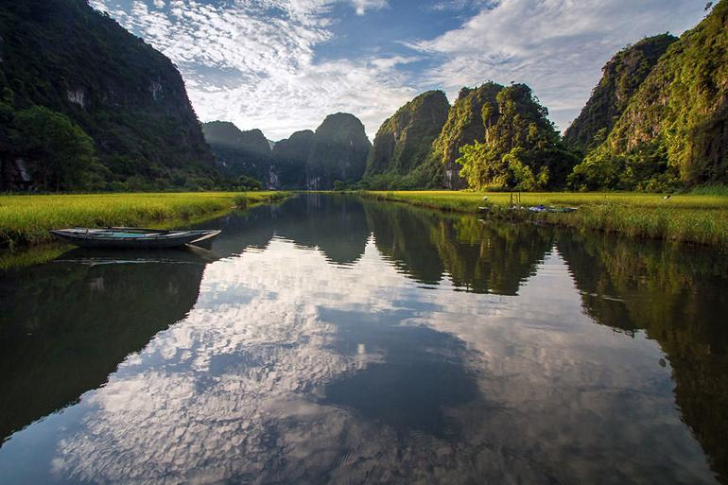

* **Mua cave (dancing cave)**

Mua cave (dancing cave) is near Tam Coc (about 3.5km from Tam Coc). About more than 500 steps to climbing up the mountain, Mua cave is one of the most beautiful place to view in Ninh Binh. Traveler can see the city far from the standing in front of, Tam Coc in back and the limestone mountain along to the south of Vietnam. The best time to visit there should be sunset or sunrise. When you climb up to mountain like you do your morning exercise or afternoon exercise. It’s very romantic with the lover, don’t forget bring some water or drinks. It’s really interesting when you take some wine or beer. By cycrling or motorbike with driver seem to be the best way to come there, going on countryside road and throughout some villages which are interesting too.

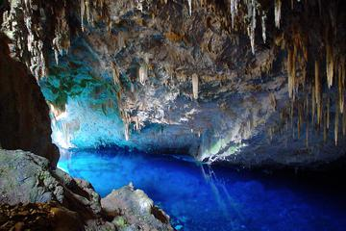

* **Hoa Lu: The Ancient Capital**

Hoa Lu ancient capital was the first capital of feudal state of Vietnam, Truong Yen Commune, Hoa Lu Distric, Ninh Binh Province. It is far 100 kilometer from Hanoi to the south. Since 968, Dinh Bo Linh throne in Hoa Lu, the Hoa Lu Capital has existed 41years (968-1009) in which 12 years is dynasty of Dinh and the next 29 years is dynasty of Le. Over thousands of years ago, Hoa Lu is magnificent capital. The mountains surrounded the capital as the painted veil, Hoang Long River is meander and Nho Quan, Gia Vien field has many deep trenches that are advantageous for military. Hoa Lu ancient capital is 300 hectares width, including outside area and inside area, surrounded by a series of rocky arc mountains, spectacular scenery. Outside area has 140 hectares width, belonging to Yen Thanh village, Truong Yen Commune.

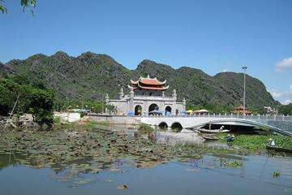

This is the main palace area with Dinh, Le Temple is the center and this is where Dinh Tien Hoang built the nation. Before the palace, there has Ma Yen Mountain. Inside area belongs to Chi Phong Village, Truong Yen Commune which reared children and maids in the palace. The South (to the south, opposite and connect with outside area) is surrounded by high mountains and is guarded the back, from here, it can quickly withdraw by the water. In 1010, Ly Thai To moved the capital from Hoa Lu to Thang Long. Hoa Lu capital becomes ancient capital.

* **Bai Dinh Pagoda**

Bai Dinh Pagoda is a religious complex covering a total area of 539 hectare, with both the ancient and the newly renovated Bai Dinh pagoda, parks, car parking and lake system. The pagoda belongs to Ninh Binh province, known as the ancient capital of Vietnam. The old Bai Dinh pagoda is located on the western slope of Dinh mountain and nestles in quiet forest. The pagoda houses an ancestor-worshipping house in the centre, Bright cave on the right hand side which worships the Buddha , the small temple worshipping Genie Cao Son. In addition, on the left hand side of the pagoda is another temple worshipping Saint Nguyen and next to it is Dark cave which worships the Fairy.

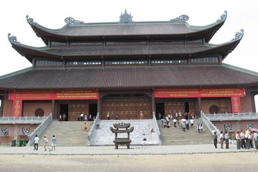

* **Phat Diem Cathedral**

Phat Diem Stone Cathedral is one of the most famous and beautiful churches in Vietnam with special architecture: an elegant combination between Western church architecture style and Vietnamese religious buildings. It took 24 years to build this church from 1875 to 1898. And as its name suggests, it was completely built of stone and wood that are readily available in the mountain area of Ninh Binh.

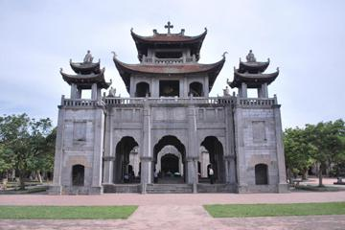

**18:00 PM:** back to hotel to have dinner and relax.

|  |  |
| --- | --- |
|  |  |
|  |  |

|  |  |
| --- | --- |
|  | Relax – Farewell & Goodbye |

**7:30 – 8:30 AM:** Have breakfast at the hotel.

* When ready and as your scheduled bus – train - flight allows, check out of your hotel and we’ll take you to the airport in time for your flight.
* End of Tour.

