SAPA, VIET NAM

4D3N

OVERVIEW

## location

Located at 1500 meters (4921 feet) above sea level in Vietnam's remote northwest mountains, Sapa is famous for both its fine, rugged scenery and also its rich cultural diversity. Sapa is an incredibly picturesque town that lies in the Hoang Lien Son mountain range near the Chinese border in northwestern Vietnam, known as "the Tonkinese Alps". Sapa and its surrounding region is host to many hill tribes, as well as rice terraces, lush vegetation, and Fansipan, the highest peak in Vietnam. Other great mountains like Aurora & J, where Sa Pa sees the first rays of sun, make up a very steep valley. However, as a result of a recent surge in popularity Sapa has rapidly become a tourist hotspot where money is the new drug of choice. Don't be put off by the rush, your explorations of the surrounding countryside will be worth the trouble. Be mindful of all the locals selling in the streets as they can be quite demanding. Groups of locals can be known to follow visitors around, aggressively selling handmade goods. The local government does not encourage tourists to buy from street sellers or give money to children, however it has become customary to hand out toothbrushes to the children.

Area: 24,02 km²

Province: Lao Cai Province

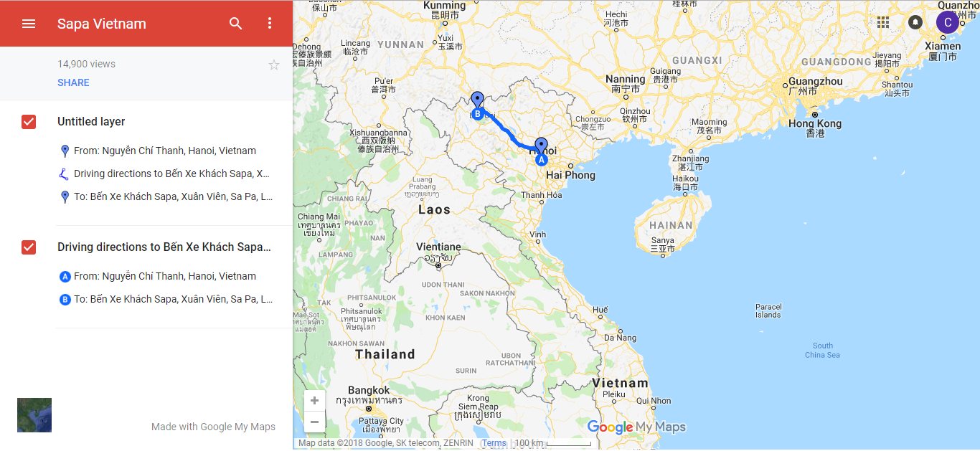

## Characteristics

* Sapa is an ideal highlands escape from the bustling city with breathtaking views of terraced rice fields, forests, and hidden wonders of nature that any adventurous travelers should never miss when coming to Vietnam. Immersing in a dynamic cultural exchange with ethnic minorities, you can also gain valuable exposure to the rich culture and traditions. Our comprehensive Sapa Travel Guide filled with things to do, markets, festivals, and foods to try will help you fully explore the beauty of this charming town.
* Weather in Sapa: Sapa is the place to visit if you prefer the chilly weather over the tropical climate. Sapa has a cool temperature all year round, about 15 degree Celsius (59 degrees Fahrenheit), but you can still expect a lot of rain during the summer from May to August. Within one day in Sapa, you can experience different weather from all four seasons: a cool spring morning, a summer afternoon with a little sunlight , a cloudy and foggy autumn evening with a cool breeze, and finally, a cold winter night.
* The best time to travel to Sapa is in October, November, March, and April. During these times, the rain gets lighter, and the weather is not as freezing. Especially in spring (around April) when all the flowers start to bloom, you can witness a magnificent picturesque scene in this mountain city.

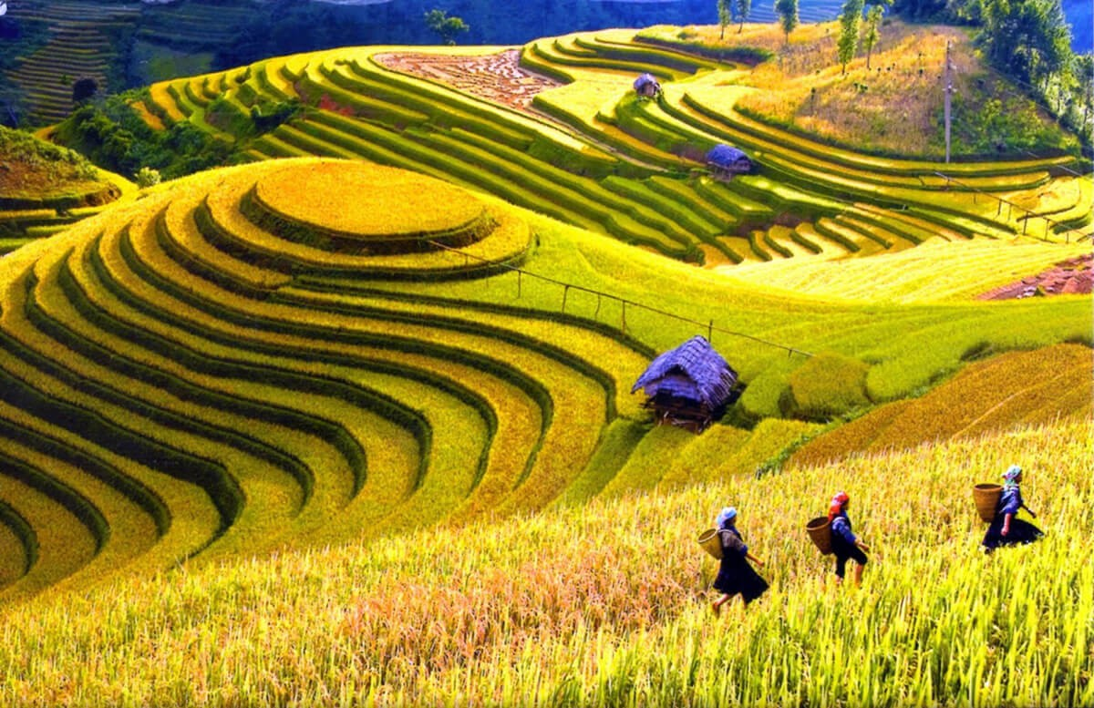

|  |  |
| --- | --- |
|  | Saigon – Ha Noi - Tour to SAPA (Lunch, Dinner) |

## how to get to sapa

* By plane:

From Tan Son Nhat International Aiport in Saigon for transits to SAPA is with Noi Bai International Airport in Hanoi

* By train:

From Hanoi, we will take the night train and arrive at Lao Cai early in the morning and take a 2-hour bus to Sapa.

|  |  |
| --- | --- |
|  |  |
|  | |

**4:AM:** Check in hotel and relax.

|  |  |
| --- | --- |
|  | SAPA – SAPA ATTRACTIONS |

**7:30 – 8:30 AM:** Have breakfast at the hotel.

**9:00 AM:** Depart the hotel with our tour guide.

* Hiking and Trekking

One of the most exciting things about traveling to Sapa is the beautiful landscape. Although in the city center, many services are available and opened for visitors, but if you get out a few kilometers outside of Sapa, you can indulge yourself in the arm of Mother Nature with many mountains and rivers. Sapa is home to the Indochina Summit and one of the most challenging tracks for trekking in Vietnam so trekking for a day or multi-day is an activity any adventurous soul when in Sapa.

**Notice:** Some of the trips might be challenging, and you would spend most of your time outdoors in these places so make sure to have all the pieces of equipment and gears you need.

* **Fansipan Mountain – Indochina’s Highest Peak**

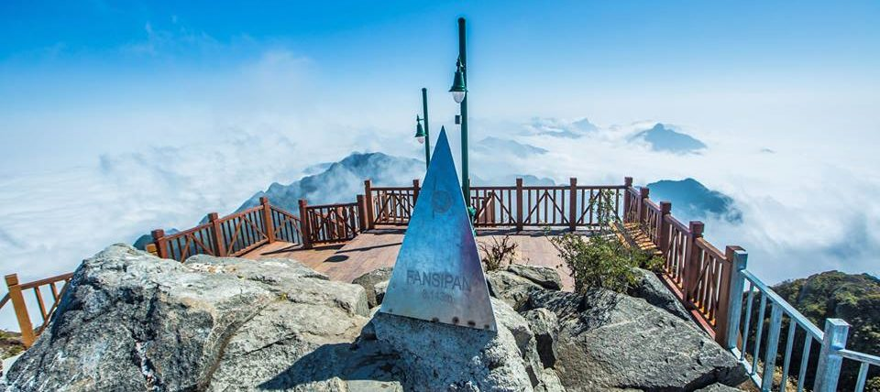

Fansipan is the highest peak of Indochina with the height of 3,143 meters in the center of Hoang Lien Son Range. On your way to the summit, you will be amazed by nature with many kinds of species like Hoang Lien - a special medicinal ingredient, exotic woods, perdix, and Indochinese serow.

You can sign up on a hiking trip with a tour agency or go with a local tour guide from the Mong or Dao ethnic groups. It would take about two or three days to go all the way to the top, so make sure to prepare yourself for this challenging climb.

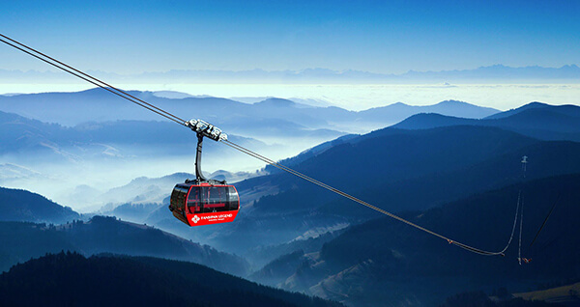

From 2016 onward, there’s a cable car system open to transport visitors directly to the top of Fansipan. It is listed in two **Guinness records** for the greatest elevation difference by a non-stop three-roped cable car of 1,410 meters and the longest non-stop three-roped cable car of 6,292.5 meters. With this cable car system, you can reach the top in 15 minutes, but the prices aren’t low.

* **Ham Rong Mountain**

If you prefer a day hike in Sapa, Ham Rong Mountain or Dragon Mountain is a great option for you. From Sapa City, you can walk there on foot then it takes you another three hours to hike up and down the mountain, but you'll get to reward yourself with the beautiful scenery. From the top of the mountain, you can look out to Sapa, Muong Hoa Valley, or Ta Phin Village hidden in the milky white fog. On your way to the top, you can also take a break and take pictures of the colorful flower garden.

|  |  |
| --- | --- |
|  |  |

* **Sapa Heaven’s Gate**

One of Hoang Lien Son range of mountain passes is Tram Ton. You should be able to find your way to Sapa Heaven’s Gate located at the top of Tram Ton pass. From the Heaven’s Gate looking down, beneath the thick cloud, you will see mountain roads packed with a line of cars submerged in various shades of green from the valley and the ethnic paddy, and at the far end lies the Silver Waterfall. You also get to see Fansipan Summit floating in the sky, standing on the edge of a seemingly bottomless cliff.

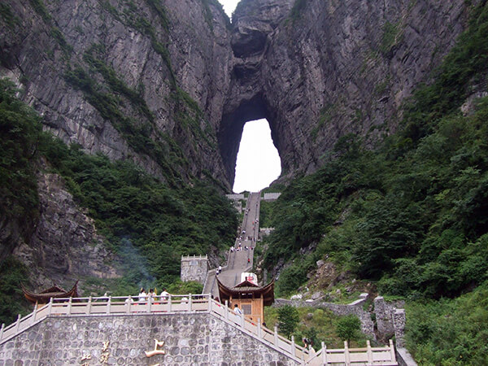

**Back to hotel:** just in time to watch the sunset.

**18:00 PM:** back to restaurant to have dinner and relax.

|  |  |
| --- | --- |
| **Horse Meat (Thang Co)** | This traditional dish of the H’mong minority requires skills, time, and with 27 different types seasonings such as cardamom, ginger, cinnamon, citronella, anise, etc. “Thang co” is a pot of soup made of organs of a horse, cow, vegetables, and hot pepper, which is often found in local markets. In restaurants, Thang Co is cooked with a more suitable taste for tourists, so it is something you can consider. |
| Dried Buffalo Meat (Thit Say Khang Gai) | Dried meat, especially buffalo, is an excellent cuisine every food lovers should note in their what to eat in Sapa list. The meat is cut off into 1 - 2 kg pieces, well dried and can be stored for months. To make the dish, locals usually fry them with tomatoes or bamboo shoots which is tasty and delicious. |

|  |  |
| --- | --- |
|  | SAPA – SAPA ATTRACTIONS |

**7:30 – 8:30 AM:** Have breakfast at the hotel.

* **Muong Hoa Valley - Sapa Ancient Rock Field**

The unique thing about this valley is the ancient rocks lying in nature and the ethnic rice terrace. Hundreds of rocks here have unusual signs sculpted on them; the origin and meaning of these signs remain a mystery until today. Sapa Ancient Rock Field has become a national heritage and a proof of Vietnam ancient civilization. In Muong Hoa Valley, there is also a long beautiful spring that runs through many villages such as Lao Chai, Ta Van, Hau Thao and Ban Ho.

|  |  |
| --- | --- |
|  |  |

* **Coc San Caves and Waterfalls Complex**

Coc San is an elaborate waterfall with many caves hidden behind the stream. On highway 4D, there is a small dirt path leading to Coc San. The way to Coc San is short, about one kilometer from the highway, but it could be tricky because it’s quite dark and sometimes blocked by rocks. Coc San’s beauty lies in its wilderness; you will be able to get close to nature while walking on the rock beds exploring the waterfalls and caves.

|  |  |
| --- | --- |
|  |  |

* **Silver Waterfall - Dinh Deo**

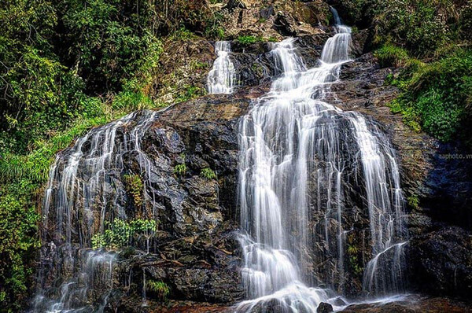

* **Ta Phin Village**

At Ta Phin, you can still see the customs of Dao Do (Red Dao) ethnicity like the craft of the brocade and rice terraces. Inside the cave near Ta Phin, the water erosion has formed and changed the rocks into many shapes like a fairy or animals and the sparkling forest is created by emerald green crystalized dripstone.

|  |  |
| --- | --- |
|  |  |

* **Sapa Holy Rosary Church**

Sapa Holy Rosary Church was built in 1895 by the French reflecting Roman Gothic architecture. It has been preserved and reinforced recently to become one of the most iconic attractions of Sapa city. The daily masses are at 7 PM, and Sunday mass is at 9 AM.

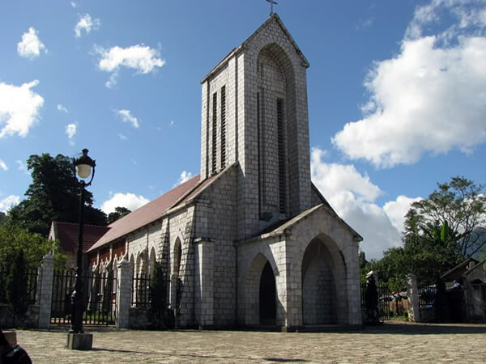

* **Hoang A Tuong Castle**

Hoang A Tuong Castle architecture is a combination of Asian and European style. It was built in 1914 as a place for the Mong Ethnic King and his son, Hoang A Tuong. Recently, the castle has been repainted with a vivid color to remove the gloomy feeling of the old gray walls.

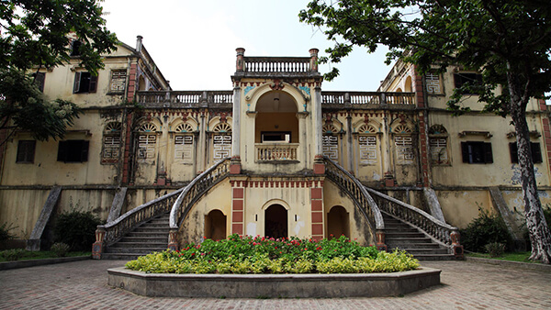

|  |  |
| --- | --- |
|  | Relax – Farewell & Goodbye |

**7:30 – 8:30 AM:** Have breakfast at the hotel.

* When ready and as your scheduled bus – train - flight allows, check out of your hotel and we’ll take you to the airport in time for your flight.
* End of Tour.

