**STUDY ON STRUCTURAL PERFORMANCE OF VARIOUS BRACINGS IN STEEL FRAME OF BUILDINGS**

***Lily Gurung 1*, Yeshi Dema, Ugyen Wangmo, Manoj Chhetri1, Yeshi Choden1***

*1 College of Science and Technology, Rinchending: Bhutan,*

*\*email:* [*lilygurung.cst@rub.edu.bt*](mailto:lilygurung.cst@rub.edu.bt)

**Abstract:** Steel framed buildings require support against lateral loads including the gravity loads. The components of the buildings are exposed to high stresses due to lateral loads making the whole structure sway and giving rise to lateral displacements. The research carried out highlights the modelling and analysis of one-storey industrial steel frame in ETABS employing various types of bracing systems namely diagonal, K and X-bracing and eventually determining the structural performance of the steel frames with different bracings. Initially, a bare frame was modelled with 6m, 7.5m and 10m bay lengths followed by the bracings being incorporated in an alternative system. For the seismic analysis, linear static analysis was performed and the performance matrices chosen were maximum storey displacement, time period and base shear. The results exhibited that the X-bracing was the most effective type of bracing system.

*Keywords: Bracing, Steel frames, displacement, time period, base shear*

**Introduction**

Steel framed industrial building refers to any factories or establishments in which goods or materials are manufactured, assembled, fabricated or stored. Industrial buildings are usually constructed by steel because steel enables large spaces to be constructed and can be easily modified, extended and recycled anytime without its loss in strength. Bhutan on the other hand lies in the most active seismic zone that is zone IV and V. Earthquakes are the most imminent hazard in Bhutan considering the location of the country and the past earthquake records, so it becomes crucial to build structures which can resist earthquakes of higher magnitudes. A braced frame in a building is commonly used to resist lateral forces like wind and earthquake. It is commonly used owing to its simplicity to analyze, it is economical and provides stability and makes the structure stiffer (Adin et al., 2016).

A braced frame is of two types namely, concentric bracings and eccentric bracings. Concentric bracings are those bracings which are connected to the joint of a frame and are usually adapted to increase the stiffness of the structure and reduce lateral displacements. Eccentric bracings are those bracing systems, where the ends of braces are connected at a certain distance from the joint of a frame.

**Research Gap**

Bhutan lies in a very seismically active zone and earthquakes have been one of the most disastrous hazards in Bhutan considering the location of the country and the records of past earthquakes. So, it becomes important to construct stiffer structures which can resist earthquakes of higher magnitude. Industrial buildings usually have large working space and it is also associated with high dead loads due to its heavy members used. So, it is important to look into the seismic response of the building (Adin et al., 2016).

The main aim of the research is to compare the performance of different bracings in industrial steel framed buildings and identify the most effective bracing system for a steel framed building. The study carried out is one of a kind with the objectives to model an industrial steel framed building, followed by identification and incorporation of different steel bracings. The research also studies the effect of different bay lengths on the structural performance of the buildings based on parameters like, maximum lateral displacement, time period, base shear and demand capacity ratio.

**Methodology**

After thorough the literature review and based on the aim and objectives of the research, the following methodology shown in Figure 1 was developed and adopted.

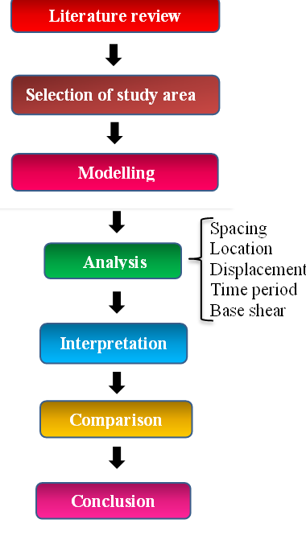

**Figure 1.** Research Methodology

*Study Area*

Pasakha was been chosen as the study area which is located 14 kilometers away from Phuentsholing town. The area comprises in total of 26 numbers of factories owing to different manufacturing products and functions. It was chosen based on the location, availability of raw materials, labors and the population density.

*Building plan*

The overall dimensions of the building are 60m length and 30m breadth. A 2-dimensional model along with the location of the columns in red was created in AutoCAD and the plan of the building is as shown below.

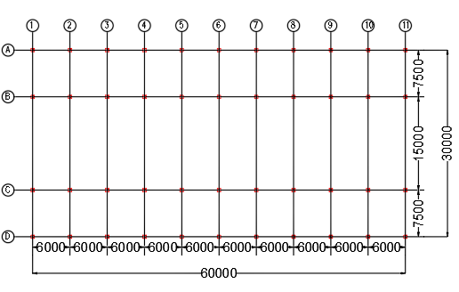

**Figure 2.** Building Plan (All dimensions in mm)

*Data Modelling and Analysis*

The truss configuration suitable for the building was Pratt truss. The roof trusses are divided based on the spacing kept between the columns.

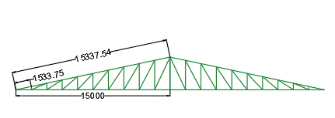

**Figure 3.** Pratt Truss (All dimensions in mm)

* Span of the truss= 30m
* Centre to centre distance= 6 m
* Height of the eave above the ground level= 6 m

The dead load, live load and wind load acting on the purlin and truss was calculated as per IS code 875 Part I, II and III.

The modelling details include a mathematical representation of the 3-D model and helps to visualize the virtual building. The planning of the steel structure was then followed by modelling. Modelling for the industrial structure incorporating different bracings were done based on altering the spaces and different types of bracings. The table below shows the modelling details.

**Table 1.** Modelling Details

|  |  |
| --- | --- |
| Parameters | Description |
| Building dimension | 60m×30m |
| Storey height | 3.2m |
| Bay length | 6m, 7m, 10m |
| Rafter and main tie | ISNB80M |
| Struts | ISNB65M |
| Purlins | ISNB65M |
| Grade of steel | Fe450 |
| Seismic zone | V |
| Type of soil | Type II medium |
| Seismic zone factor | 0.36 |
| Response reduction factor | 5 |

Mass source is a mass of the structure consisting of self-weight and additional gravity loads. Mass source should be defined to perform the seismic analysis so as to calculate the base shear of the structure. As per IS1893:2002 part I, the mass source for structure containing the imposed load less than 3 kN/m2 should be 25% of imposed load.

Other criteria for the seismic load analysis are model analysis. Model analysis gives us an idea on different shape a structure can take up during vibration and the shapes are known as mode shapes. In the analysis, the sum total of model masses should at least be 90 percent of the total seismic mass. The column sections were taken after repetitive iterations.

The column sections used for the 6m bay length: C1:ISMB200, C2: ISMB300, C3: ISMB200, C4: ISMB25. The column sections used for 7.5m bay length are C1:ISMB200, C2: ISMB300, C3: ISMB300, C4: ISMB300. The bracing angle sections for 6m and 7.5m bay length were of ISA80× 80×10. The column sections used for 10m bay length are C1:ISMB200, C2: ISMB300, C3: ISMB300, C4: ISMB300. The bracing angle sections for 10m bay length were of ISA110× 110×10 and ISA100× 100×10.

The following figures shows the bare frame (base design) and bare frame with diagonal, K and X-bracings.

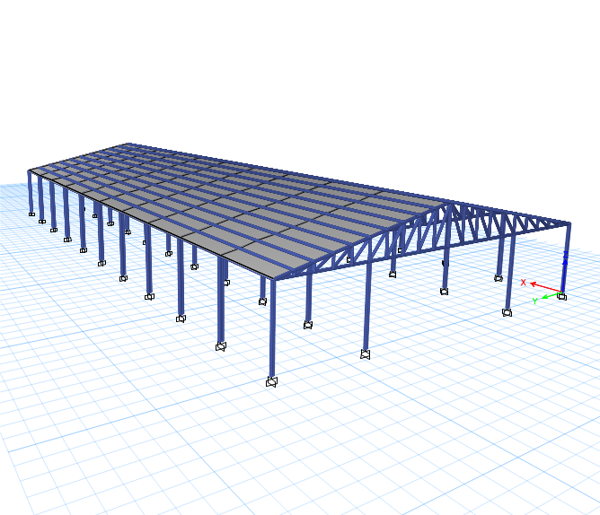 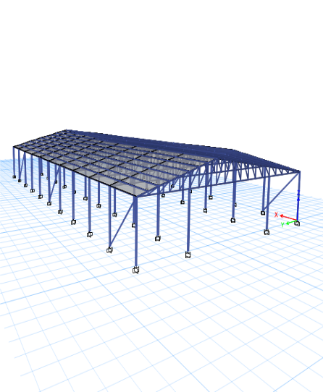

**Figure 4.** (a) Bare frame, (b) Diagonal braced frame

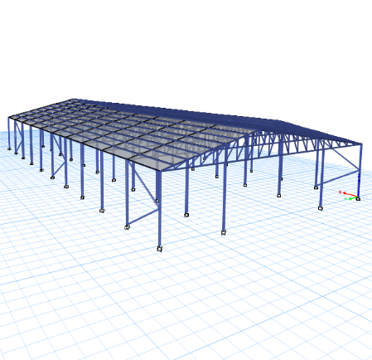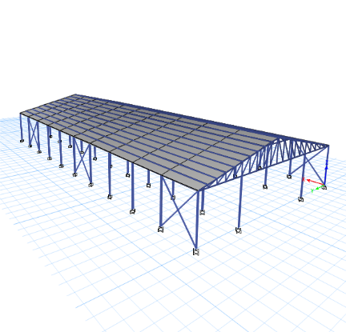

**Figure 5.** (a) K-braced frame, (b) X-braced frame

After result analysis, it was found that the alternate location was effective to place the bracings. The result analysis is given under the result and discussion section.

*Design check*

While carrying out design check, the main parameter considered was the demand capacity ratio. Demand capacity ratio is the measure of demand on the member against its capacity. And it should always be less than 0.95, so that the members would not be subjected to loads beyond the carrying capacity. After modelling the structures, analysis was done and the design check was carried out for all the models. Sections were reduced based on the demand capacity ratio limit. A sample of design check model is as given below.

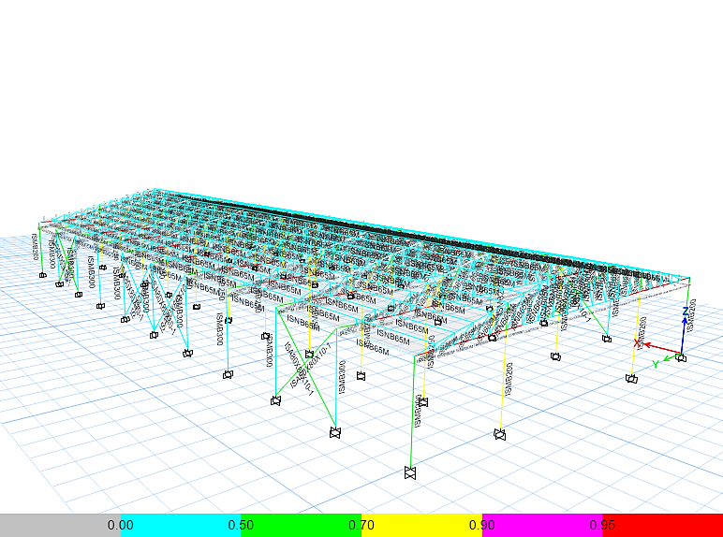

**Figure 6.** Designed Model

**Results and Discussion**

The results were obtained after the analysis and design check was carried out. The parameters used for the analysis are storey displacement, time period and base shear. Result analysis for 6m, 7.5m and 10m bay lengths are summarized in the following tables.

**Table 2.** Displacement results (all values in mm)

|  |
| --- |
| Types of bracing 6m 7.5m 10m  Bare frame 34.48 37.98 44.03  Diagonal 31.94 35.48 42.21  K-bracing 32.25 35.72 42.63  X-bracing 30.06 34.89 40.01 |

**Table 3.** Time period results (all values in secs)

|  |
| --- |
| Types of bracing 6m 7.5m 10m  Bare frame 2.06 2.18 2.47  Diagonal 1.797 1.99 2.35  K-bracing 1.798 1.98 2.41  X-bracing 1.796 1.97 2.05 |

**Table 4.** Base shear results (all values in kN)

|  |
| --- |
| Types of bracing 6m 7.5m 10m  Bare frame 15.6 14.18 11.89  Diagonal 17.75 15.98 12.72  K-bracing 17.83 15.64 12.01  X-bracing 18.10 16.18 12.89 |

For all the bay lengths, the displacement and time period were less for X-bracing. The base shear was greater as compared to the diagonal and K-bracing. For all the three bay lengths, X-bracing was the most effective bracing system.

The graphs shown below are the results for bracing in alternate location for base design.

**Figure 6.** (a) Displacement and (b) Time Period Results

**Figure 7.** Base Shear Results

For all three types of bracing, the displacement and time period are less and the base shear is more when placed in alternate bays. Alternative location was found to be the very effective location to place the bracings as per our findings. The indices also clearly indicated the improvement in the structural performance of the steel framed buildings.

**Conclusion**

The research compares the effectiveness of diagonal, K-bracing and X-bracing in one storey industrial steel framed building. The comparison was done for different bracing systems when placed in different bay lengths such as 6m, 7.5m and 10m at alternate locations. It was concluded that the X-bracing was most effective bracing system for all the bay lengths.

The results were plotted in the form of graph for their lateral displacement, time period and base shear. It was found that the effective way to place the bracings was in alternate bays.

**Conflict for interest:** The authors declare no conflict of interest.

**References**

Adin, C., Praveen, J. V., & Raveesh, R. M. (2016). Dynamic analysis of industrial steel structure by using bracing and dampers under wind load and earthquake load. International Journal of Engineering Research & Technology, 5(7).

Bidari, A., & Vishwanath, K. N. (2014). Analysis of Seismic and Wind Effect on Steel Silo Supporting Structures. International Journal of Research in Advent Technology, 2(9).

Consultancy, N. E. (2018). Detailed feasibility study on industrial linkages and cluster (mineral-based industry).

Dahal, S., & Suwal, R. (2019). Seismic Behaviour Analysis of Composite Buildings with Respect to RCC Buildings. Journal of the Institute of Engineering, 15(1), 54–61.

DiSarno, L., Elnashai, A. S., & Nethercot, D. A. (2008). Seismic Response of Stainless-Steel Braced Frames. 64(7-8),914-925.

Ganesh, M. (2017). Seismic Behaviour of Different Bracing. International Journal of Civil Engineering and Technol-ogy, 08(3), 973–981.

Khusru, S., & Tafheem, Z. (2014). Comparative assessment on structural performance of optimally designed steel braced buildings under lateral loading. Journal of Civil and Earthquake Engineering, 3(1), 52-63.

Mahmood, R. A., Barman, A. C., Hossain, M. H., & Khusru, S. (2020). Modal analysis of braced and unbraced steel frames. American Journal of Engineering Research, 9(8), 194-204.

Ragavan, A. C., nithin, J. B., Sunandha, M. P., & Srinivasan, K. (2018). Seismic Analysis of Steel Structure.

Razak, S. M., Kong, T. C., Zainol, N. Z., Adnan, A., & Azimi, M. (2018). A Review of Influence of Various Types of Structural Bracing to the Structural Performance of Buildings. E3S Web of Conferences, 34, 1–9.

Sheen, F. A., Hossain, M. M., Ferdous, A., & Rahman, A. (2019). Comparative Study for Different Bracing Systems of an Irregular Steel Structure. International conference on Structural Engineering Research.