

**Construction Journal of Bhutan**



Submitted By:

**NGN Technologies Private Limited**

Contents

1. CDB Home Page ………………………………………………………………………………. 2
2. Journal Home page …………………………………………………………………………. 3
3. Journal Menu ……………………………………………………………………………….... 4 – 6
4. Make Submission ……………………………………………………………………………. 7
5. Registration and Login ……………………………………………………………………. 8
6. Manuscript Submission Page ………………………………………………………….. 9

CDB Home Page

**For the submission of the Construction Journal**

* Firstly, you need to browse into “ **cdb.gov.bt** ” as shown below:

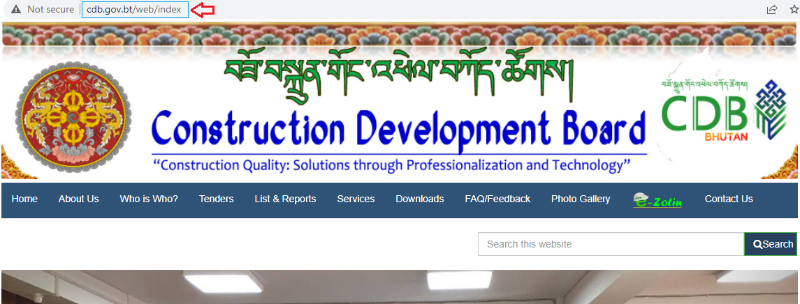

* After browsing into cdb.gov.bt, you will see the home page of **Construction Development Board**

with all the Menus as shown below:

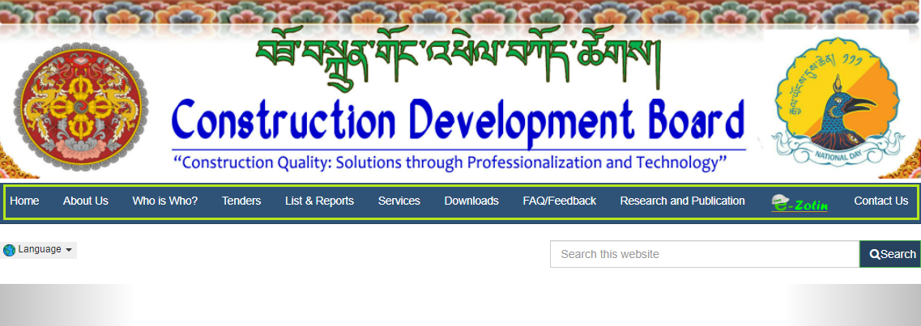

Journal Home Page

Besides all the menus given below, you have to hover in a particular menu called **Research and Publication.**

Under Research and publication, you will have two sub-menus as:

* **Construction Journal of Bhutan**
* **CDB Annual Reports**

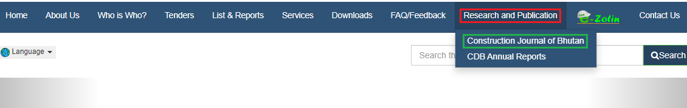

When you click on Construction Journal of Bhutan, you will be redirect to a new page of Journal.

There, you can see again five different menus and they are as follows;

a) Current,

b) Archive,

c) About,

d) Submit, and

e) Editorial.

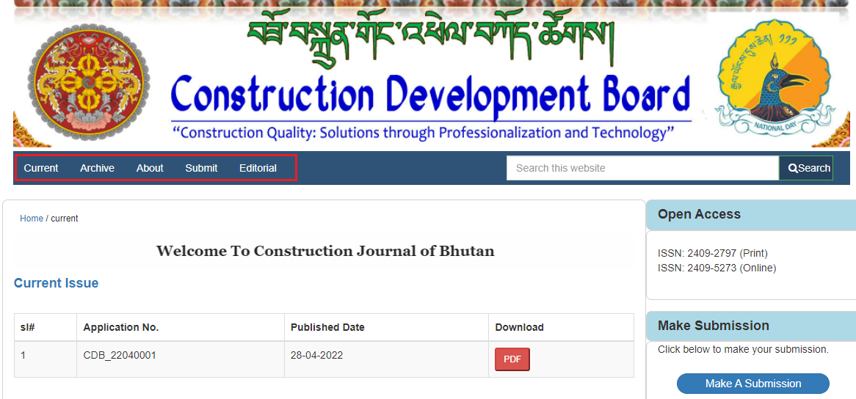

Journal Menu

1. Current

In Current menu, you will see only current issues of the author.

All the manuscript submitted by the authors within this year will be displayed in the current page.

If you want to go back to CDB home page, then you have to click at home as shown below:

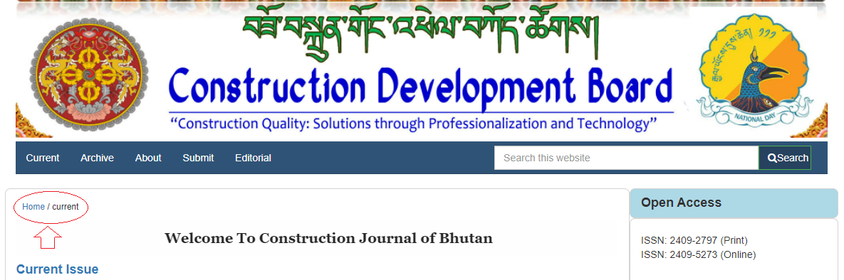

1. Archive

In Archive menu, there will be only past details of the author.

All the manuscript of authors published in past years will be displayed in the Archive page.

Manuscripts will be display in a table as shown below:

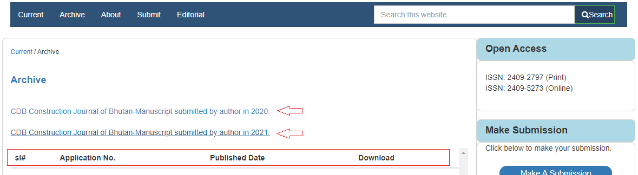

1. About

The About menu consists of five sub-menus:

1. *About the journal*
2. *Aims and Scope*
3. *Peer review process*
4. *Conflict of Interest*
5. *Contact*

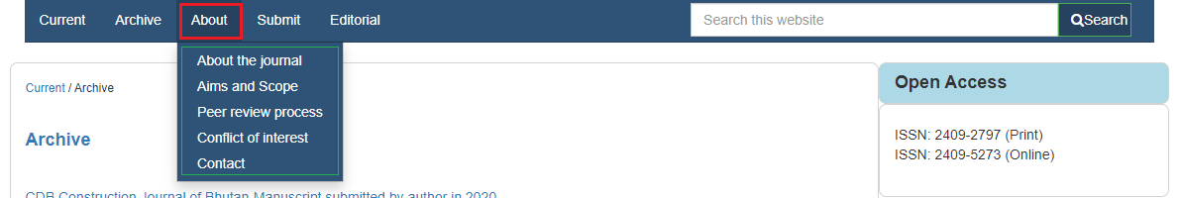

1. *About the journal*

In About the journal sub-menu, there will be a brief description for the journal.

1. *Aims and Scope*

In Aims and Scope sub-menu, there will be a brief description about the aims to fulfill and the reasons to make journal.

1. *Peer review process*

In Peer review process sub-menu, there will be a brief description about how the author will remark by the journal reviewer.

1. *Conflict of Interest*

In Conflict of interest sub-menu, there will be a brief description about the authors declaration of conflict.

1. *Contact*

In Contact sub-menu, there will be address of CDB with the Google map.

1. Submit

The Submit menu consists of two sub-menus:

1. *Manuscript preparation guidelines to the author*
2. *Submission preparation checklist*

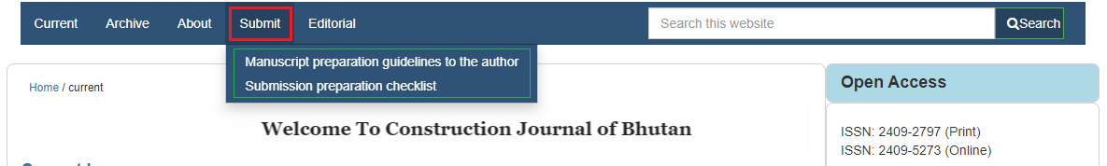

1. *Manuscript preparation guidelines to the author*

In Manuscript preparation guidelines to the author sub-menu, there will be a brief description about how the manuscript should be and how to submit manuscript by the author properly.

1. *Submission preparation checklist*

In Submission preparation checklistto the author sub-menu, there will be a brief description about how to submit manuscript by the author properly.

1. Editorial

The Editorial menu consists of two sub-menus:

1. *Editorial Policies*
2. *Editorial Team*

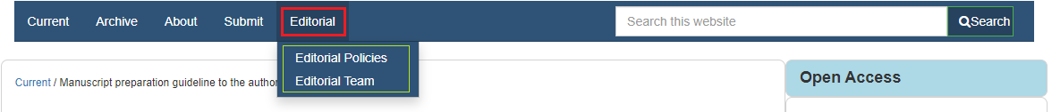

1. *Editorial Policies*

In Editorial Policies sub-menu, there will be a brief description about how the author will be examine and gives brief idea about policies of editor.

1. *Editorial Team*

In Editorial Team sub-menu, there will be list of Coordinator, Chief, Editorial team and Reviewers to examine the author’s manuscript.

Make Submission

For the submission of your manuscript, you need to click on “Make A Submission” button inside Journal home page as shown below:

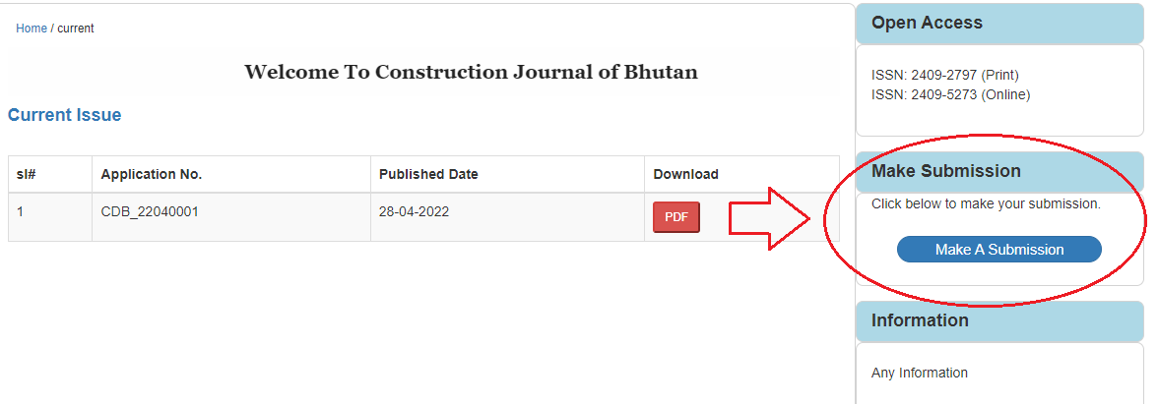

After you clicked on “Make A Submission” button, you will be redirect to a new page for login and registration for the submission of your manuscript.

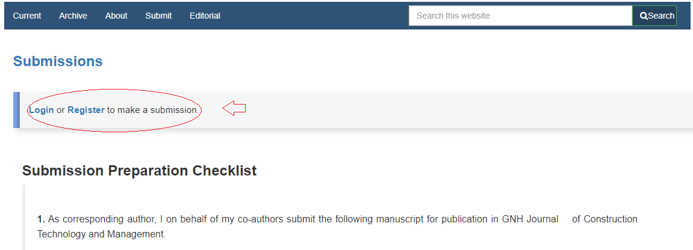

Inside this page you will also find a brief description of Submission Preparation Checklist and Manuscript Preparation Guideline to the Author.

1. Registration

If you click on register, then you will be redirect to Journal Registration page.

If you are a new user, then you have to register it first or if you have account already then you can go for login directly.

Inside registration, there will be five fields and it is necessary to fill all the fields by the author.

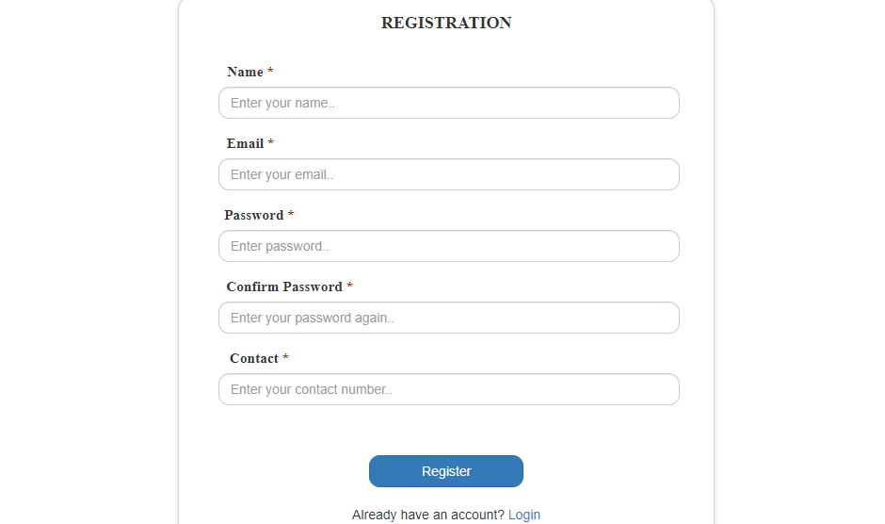

After the successful registration, you will receive an email from CDB as acknowledge for registering and a success message will be display in login page.

1. Login

After the registration is successful, you will be redirect to login page with success message.

You can only Login when your registration gets approved and get email again with APPROVED.

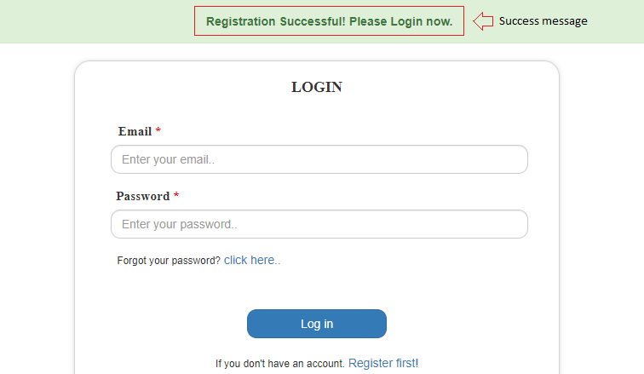

Manuscript Submission Page

After successful Login, you will redirect to manuscript submission page where you can see login author’s name and logout button in the menu bar and with the success message.

Author also has option to download the manuscript guideline to clarify their confusions.

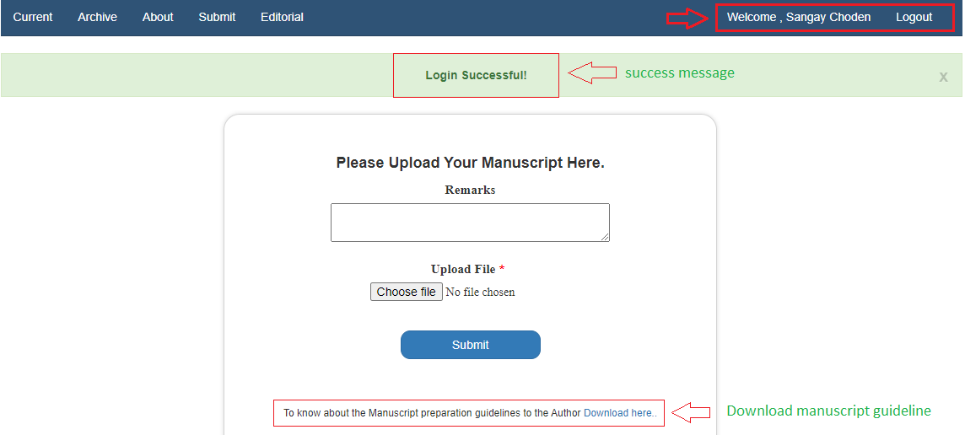

After submitting the manuscript, there will be a success message with the Application Number and author will also get an email from CDB.

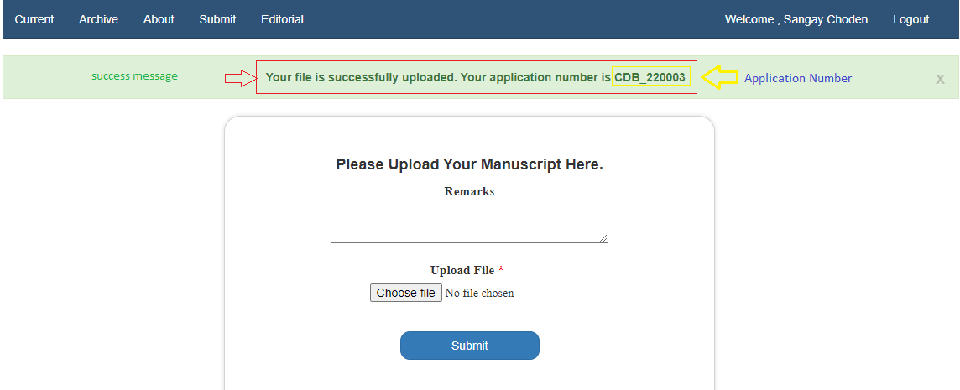

After getting a success message with application, submission of manuscript of Journal is complete.

Last but not the least, your manuscript will be verified and upload in current page and author will be informed either by email or call to your given number.