|  |
| --- |
| **STUDY ON LABOUR SHORTAGE IN BHUTANESE CONSTRUCTION INDUSTRY DURING COVID-19 PANDEMIC**  ***Yeshi Choden *1, Tshering Cheki1, Ashmita Rai1, Pem Tshering Tamang1, Tashi Tobgay1***    *Civil Engineering, College of Science and Technology, Royal University of Bhutan,*  [*Yeshichoden.cst@rub.edu.bt*](mailto:Yeshichoden.cst@rub.edu.bt)  [*Tsheringcheki.cst@rub.ebu.bt*](mailto:Tsheringcheki.cst@rub.ebu.bt)  **Abstract**    With the detection of the first positive case of SARS-CoV- 2, Bhutan, like every other nation faced pandemic challenges. The nation eventually imposed restrictions on recruitment of foreign labour. Bhutanese construction industry which was primarily dependent on the foreign labour (Indians) suddenly halted its daily activities. The mix method, qualitative and quantitative approaches was adopted for obtaining the various aspects of the study, consisting of data collected via questionnaire survey and from labour agency. Thematical and CAPI analysis was opted to study the labour shortage faced by Bhutanese construction industry during this pandemic. Results indicates the main factors that led to labour shortage within the country was due to the lack of necessary skills required, lack of foreign labour and lack of Bhutanese youth to work in construction industry which is ranked 1st, 2nd and 3rd with 48, 43 and 39 responses respectively. Unavailability of Bhutanese workers ranked 4th, with 30 respondents. The minimal population of the nation was the least concern for the labour shortage. This study provides specific precautionary methods to consider for sustainability during such emergency.  ***Key Words*:** *Labour Shortage, COVID-19, Bhutanese Construction Industry* |

**Introduction**

The World Health Organization (WHO) first declared COVID-19 a global health emergency in January 2020 on March 11 it announced the viral outbreak was formally a epidemic, the uppermost level of health emergency (Chappell, 2020).The term coronavirus which sounded so vague and distant, within no time reached Bhutan on 5th march in 2020. The first ever coronavirus positive case in Bhutan was detected in 5th march 2020 which followed by second positive case in 11th of August 2020 which led to nationwide lockdown (Ministry of Health, 2020). Thereafter, adhering to the national preparedness and response plan, Standard Operating Procedures (SOP) and follow-up actions were initiated immediately in all places. The nation introduced mandatory quarantine for minimum of 21 days for all the travelers entering Bhutan from 16th march 2020 and gradually had to close its international borders on 23rd march 2020.

Construction sector is one of the sectors of greatest importance in the overall economies of these countries and because it affects the rest of the economic sectors and the growth of the gross domestic product both positively and negatively (Alfadil et al., 2022). Bhutanese construction industry being dependent on foreign labour got affected instantly, which eventually led to shortage of human workforce, delay of projects and financial losses. Lack of a safe environment in the workplace, unskilled workers, heavy workloads, home situations, and concerns about job stability often contribute to anxiety, depression, and even suicide (Pamidimukkala & Kermanshachi, 2021).

Especially in construction industry Skilled labour plays a vital role in the success of every construction project and stands high in the advent of sophistication and technology in building construction project delivery. Skilled manpower as pointed out by (Gudiene et al., 2012) is considered to be one of the important factors of production in construction projects. Therefore, finding approaches to reduce the adverse effects of COVID-19 are crucial to avoid negative economic growth in the nation that can eventually result in an economic recession. This study explored the various reasons so as to why the Bhutanese construction industry is facing labour shortage when there is still 22.6 % of youth are unemployed.

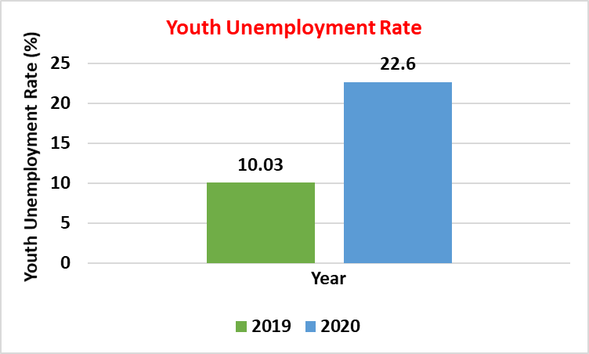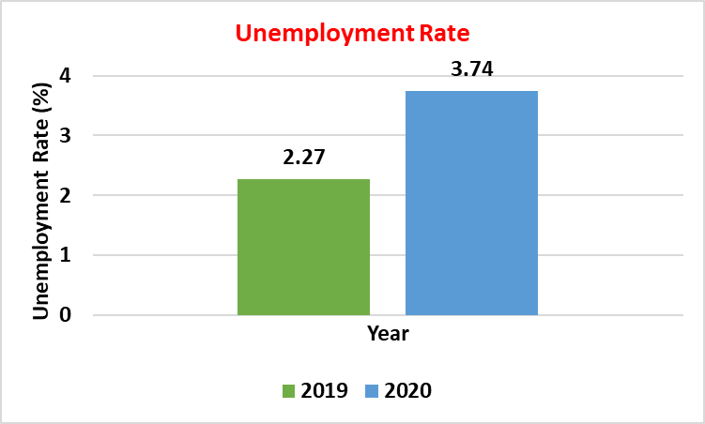

**Figure 1.** Youth unemployment rate **Figure 2.** Overall unemployment rate

The youth unemployment rate of Bhutan has increased from 10.03% in 2019 to 22.6% in 2020 (World Bank, 2021). On other hand Bhutanese construction industry had to halt indefinitely during the pandemic mainly due to the shortage of labour for the project execution.

(Zamani et al., 2021) have used survey method of data collection and found out that survey method is an economic and the fastest way of collecting data and helps in the collection of large volumes of data as compared to other methods. Likewise, (Akomah et al., 2020) has also incorporated the questionnaire survey method to reach out the respondents that consisted of project engineers, project managers, site foremen working with contactors. Questionnaires were designed based on the research objectives and used as the main instrument for data collection.

A survey conducted by (Biswas et al., 2021) found out that COVID-19 pandemic has affected the society as well as the economy of every country. The disease is spreading so fast that the government has been forced to lockdown. As a result of this lockdown, all transportation systems have been shut down, supply chains have been disrupted and workers are not able to come to the construction site even from home. That’s why work in the construction fields has stopped and the construction workers have also faced extreme uncertainty. So, construction companies are facing a financial recession. Construction is commonly regarded as a major investment component and is highly dependent on human labour, where the most numerous workers are low-skilled workers. Furthermore, the lack of qualified construction workers has become an alarming issue all over the globe, with the recent global growth in the construction sector (Juricic, et al., 2021). Building construction companies should invest in training of people to build their skills (Akomah et al., 2020).

In the midst of the COVID-19 pandemic, most of the construction projects were at halt due to restrictions on the foreign labor supply. During a quick assessment carried out by MoLHR, it was observed that the total demand for foreign workers was estimated at 35,567 as of June 2020 but the supply of foreign workers is short by 14,495 due to restrictions imposed (RGOB, 2020). This research aims to study on labour shortage in Bhutanese construction industry during COVID-19 pandemic and determine the strategies to overcome it, with a primary objective of the research to identify the required labour trades with in Bhutanese construction industry and motivate youths to involve in the industry in abundance so as to eliminate the future impacts due to labour shortage. Eventually achieving self-sufficiency on the basis of skilled work force availability and decrease the dependency on foreign (Indian) labours.

**Methodology**

The mix method, qualitative and quantitative approaches was adopted for obtaining the various aspects of the study. After exhaustive literature reviews and reports, following flow chart as shown in figure 3 has been develop to carry out the research.

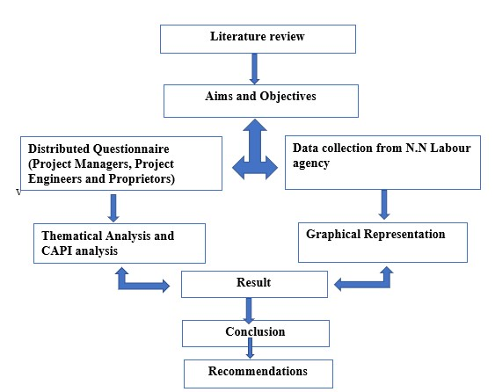

**Figure 3**. Schematic representation of Methodology adopted

*Data collection*

The data collection has been compiled from one of the labour agencies, Phuentsholing. All the recruited labour within 2019, 2020 and till Oct 2021 were collected. This approach has been used to quantify number of labours recruited before and during COVID-19 pandemic.

*Questionnaire survey*

The questionnaire survey was conducted to 42 project engineer, 12 contractor and 7 project managers. The minimum qualification of respondents who participated for this research was diploma in civil engineering for project engineer, bachelor’s degree for project managers and contractors were with experienced of minimum of 5 years in construction works. A total of 22 question was prepared using computer assisted personal interview (CAPI) with google forms. The questionnaire was distributed to respondents via social media platforms and emails.

*Sample size determination*

|  |
| --- |
| 𝑵  𝒏=  𝟏+𝑵𝒆² |

Till 2020, 2514 contractors; 1356 project engineers and 198 project managers have registered through Construction Development Board website (CDB Annual Report, 2020).

**……..Equation 1 Yamane’s equation**

N=2514 N: population size

n=61 n: Sample size

Error = 12.64%

e: Margin of Error

Confidence level = 87.36 %

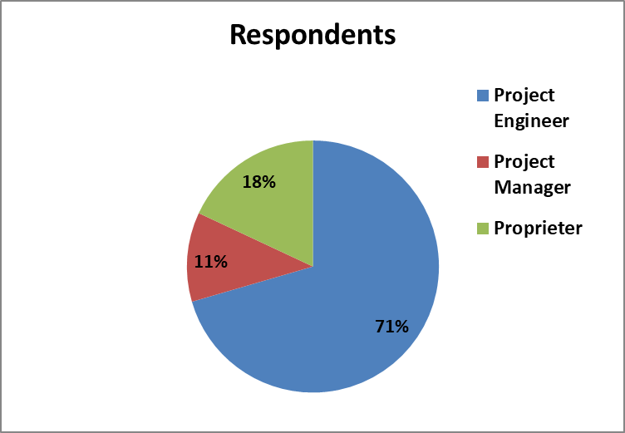

Figure 4. Respondents during questionnaire

A total of 61 responses was received during the questionnaire survey 43 project engineer, 7 project managers and 11 of them were construction firm proprietor (figure 4), achieving confidence level of 87.36% determined by using Yamane’s equation (Adam, 2020) (equation 1).

**Data Analysis and Results:**

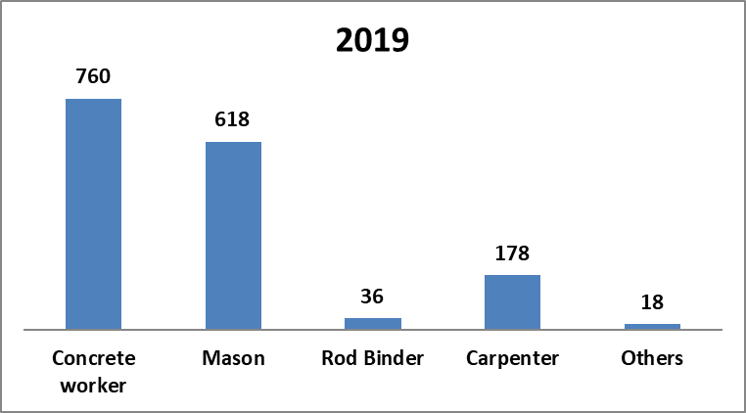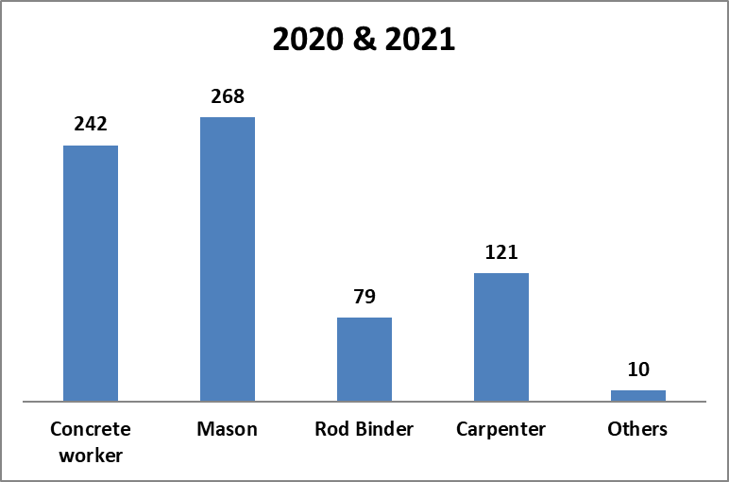**Data collected from labour Agency:**

**Figure 5.** A**.** Number of foreign labours recruited before pandemic i.e., in the year 2019. B. Number of foreign labours recruited during pandemic.

Figure 5 represents the number of labours recruited before and during pandemic respectively. Except for the rod binders, all the other labour trades recruited decreased drastically in 2020 and 2021 combined together than in 2019. Amongst all the labour trades, concrete worker and mason were found to be recruited in abundance signifying the necessity of those particular workers in the Bhutanese construction industry. The bar graph also mentions the core labour trades to be focused for the skill development trainings. It also shows the absence in involvement of Bhutanese labours in those fields which eventually leads to the recruitment of the foreign labours.

*Data Collected from Questionnaire survey:*

Did your project get delayed during this pandemic?

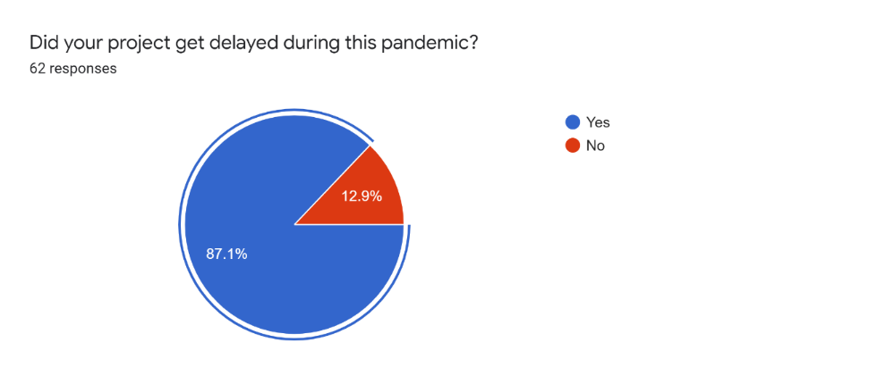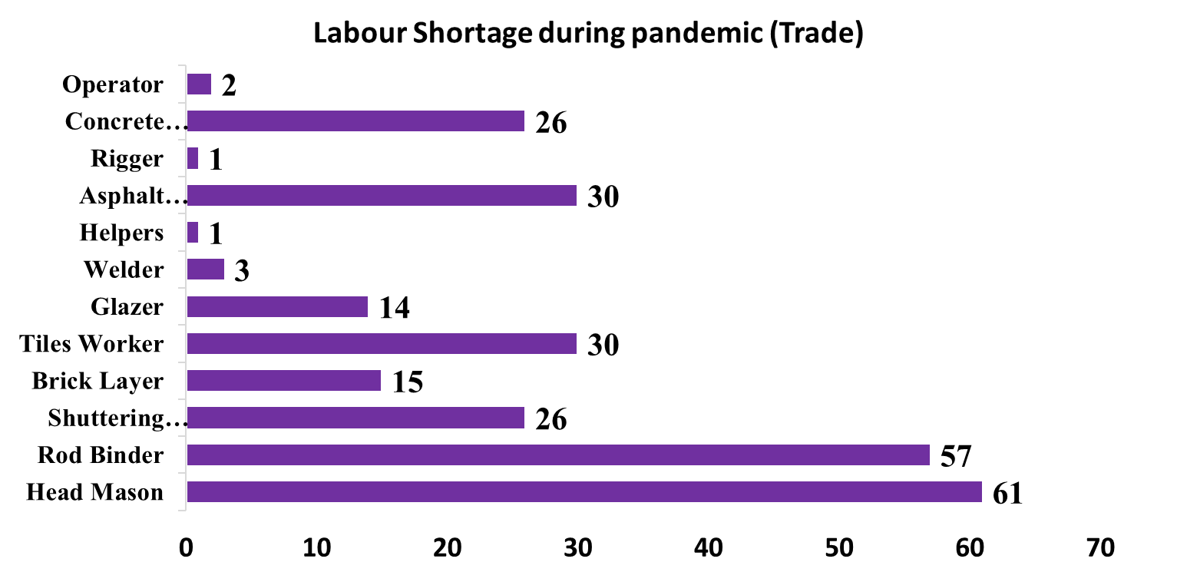

**Figure 6.**  Delay in project during pandemic. **Figure 7.** Skilled labour shortage according to trades.

**Table 1**. Ranking labour trades shortage

|  |  |  |  |
| --- | --- | --- | --- |
| Sl.no | Labour trades | No. of responses out | Rank |
| 1 | Head Mason | 61 | 1 |
| 2 | Rod binder | 57 | 2 |
| 3 | Tiles worker | 30 | 3 |
| 4 | Asphalt worker | 30 | 3 |
| 5 | Shuttering carpenter | 26 | 4 |
| 6 | Brick layer | 15 | 5 |
| 7 | Glazer | 14 | 6 |
| 8 | Welder | 3 | 7 |
| 9 | operator | 2 | 8 |
| 10 | Helpers | 1 | 9 |
| 11 | Rigger | 1 | 9 |

Table 1 shows that head mason, rod binders, tiles workers and asphalt worker were the professions that were in shortage within construction industry with 61, 57, 30 and 30 respondents confirming it respectively and were ranked 1st, 2nd and 3rd (figure 7). On other hand, welder, operator, rigger and helpers classified as the skilled labour force that occupied the 7th, 8th and 9th with only 3, 2, and 1 response (Figure 7). The data collected signifies that one of the most important skilled labours needed in any construction i.e., head mason and rod binders were in absence and directly impacted the project delay. Skilled manpower as pointed out by (Gudiene etal., 2012) is considered to be one of the critical factors of production in construction projects. As activities on site are largely reliant on skilled workforce (Iqbal et al, 2021) any shortage has a negative implication for the construction industry.

*Adversities during pandemic*

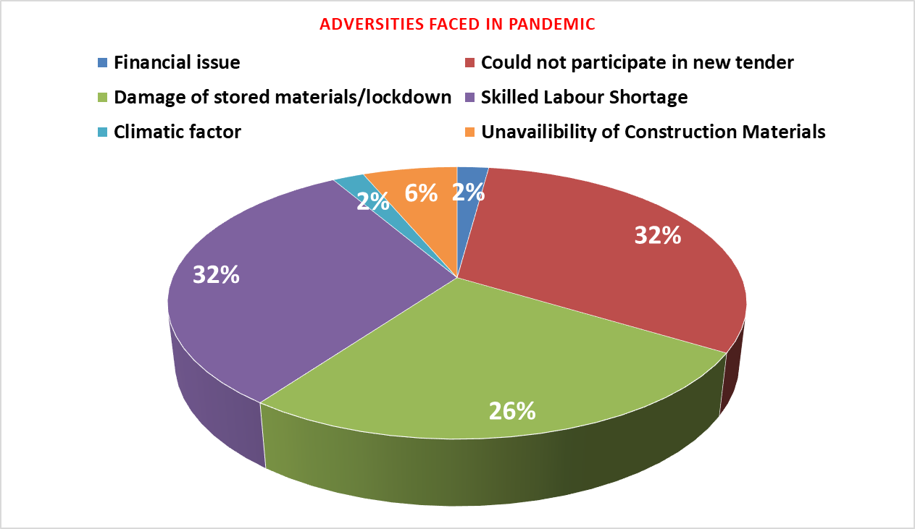

**Figure 8.** Adversities faced by construction firms during pandemic

As shown in Figure 8, skilled labour shortage and ineligibility to participate in new works tenders was the main challenges faced by the construction firms during the pandemic. Followed by losses the firms had to incur due to damage of the stored materials. Unavailability of construction materials, financial and climatic factors offered least obstruction in firm’s operations. As the drastic decrease in skilled labour led to delay in projects which made them ineligible indefinitely for the possible new projects announced during the period. With this delay and frequent lockdowns imposed the stored materials degraded adding to the losses. The construction materials were mostly available within the country which confirms the absence of skilled labour was the core for all adversities during the pandemic.

**Causes of Labour shortage**

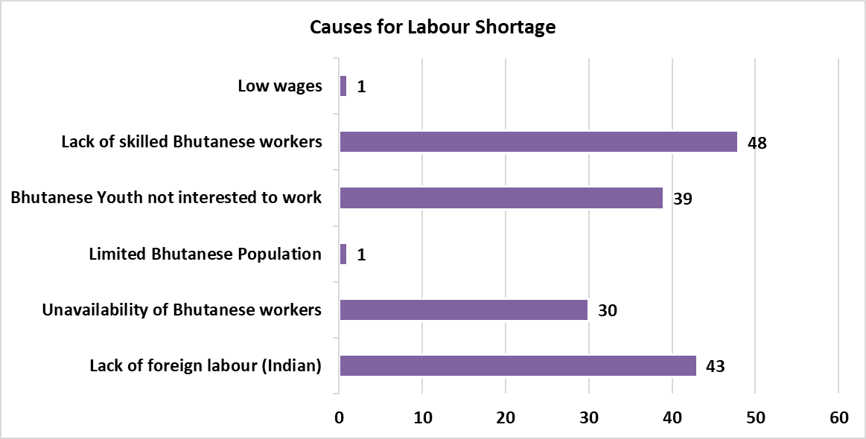

**Figure 9.** Factors leading to the shortage

The main factors that led to labour shortage within the country was due to the lack of necessary skills required, lack of foreign labour and lack of Bhutanese youth to work in construction industry which is ranked 1st, 2nd and 3rd with 48, 43 and 39 responses respectively. Unavailability of Bhutanese workers ranked 4th, with 30 respondents. The minimal population of the nation was the least concern for the labour shortage as presented in figure 9.

These data indicates that the scarce population did not affect the labour shortage but the lack of required skills for the projects and uninterested youths was the major concern to rectify upon.

Encouragement of the youths for the country’s constructions activities should be made a priority. With appropriate strategies above mentioned major factors are possible to resolved within the nation and with proper implementation the sustainability of the industry during similar exigencies could be achieved.

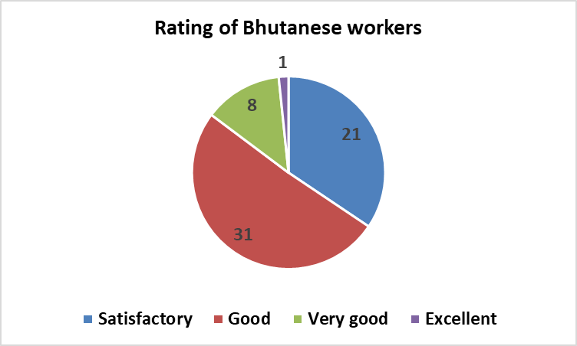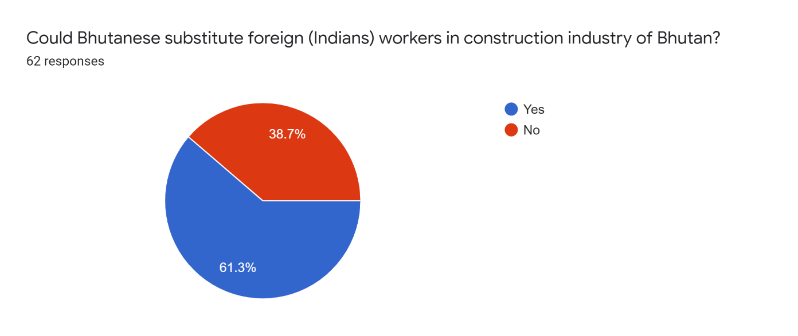

**Figure 10.** Bhutanese labour ratings form the employer **Figure 11.** % response voting Bhutanese are capable to substitute foreign skilled labours.

When asked to rate the skills of Bhutanese workers who are currently working in their projects, majority of the respondents have rated the workers as ‘good’ and ‘satisfactory’ as shown in the figure 10. Only 1 respondent out of 61 has rated the Bhutanese workers as ‘excellent’ which goes to show that Bhutanese lacks skills required in construction sector. On the other hand, majority of the respondents agree that Bhutanese could substitute foreign workers provided that they are given better platforms to develop the skills as shown in figure 11. To reduce the dependency on foreign labour and sustain Bhutanese construction industry, following recommendation could be incorporated and improvise the future situation:

1. Provide skill development training to Bhutanese youth since Bhutanese right now lack skill required in construction works and promote projects such as Build Bhutan Project (BBP) and Technical Training Institute (TTI).
2. Encourage Bhutanese youth to take construction work by providing better facilities, attractive wages, health and job security. Despite introducing Occupational Health and Safety (OHS) in Bhutan, it is not practiced all over the region strictly.
3. Provide awareness and advocacy to Construction Association Board of all class contractor and construction Development board to form construction labour center in the country where both the employers and the job seekers can interact. This way communication gap between the employees and the employers could be reduced significantly. The platform could also be used to provide internship opportunities to the youths currently in high schools, technical training institutes and colleges, preparing them for the practical approach with necessary skills.
4. Some future preventive measures during the epidemic to curb the spread of virus:
   1. Develop emergency plans (re-analyze, control and optimes cost).
   2. Online meetings, develop strict SOP and strengthen site supervision.
   3. Intelligent site access control and AI temperature checking.

**Conclusion**

The labour shortage within the Bhutanese construction industry during COVID-19 pandemic was primarily due to lack of skilled Bhutanese workers especially youth and absence of foreign labour (Indians). The industry mostly faced the scarcity of head mason and rod binder followed by tiles workers, asphalt worker and shuttering carpenter. The local construction firms succumbed to financial losses and ineligibility to participate in new works which accelerated the impact on the industry. The only strategy adopted by the firms to counteract the labour shortage was by offering attractive wages to the new willing workers eventually cutting down their profit margin to a minimal. Through this study, it can be understood that scarcity of human labour could not only affect the construction projects directly, but also affects the Gross Domestic Product of the country. Therefore, such issues need to be given immediate attention and come up with better solutions to tackle and reduce it.

To mitigate similar adversity, construction industry must work on its profile to be an appealing option for the youths, with introduction of certain necessary facilities (job security, health facilities, etc.) even in private sectors. Preparation of the youth for the industry by encouraging for construction skill workshops and institutes is also a major task to consider. Most notably education on dignity of works must be initiated to break the stereotypical view of construction industry as a dirty and high-risk industry. The industry should invest in training of the people to build the required manpower base within the country. Contractor association (such as CAB) should build a connection with the high schools, technical training institution and colleges to offer internships, training to the aspiring youths. A labour center system should be established whereby the construction firms and jobseekers could interact directly, accelerating the recruitment procedures. In the past Bhutanese construction industry solely depended on the foreign labour (Indians) but COVID-19 pandemic has exposed the venerability of this method. With the preference given to the foreign labour by the firms the Bhutanese workforce rarely had an opportunity to develop skills required for large projects. This pandemic has shed some light on an alarming problem to address and react to it as soon as possible is necessary.

**REFERENCES**

Adam, A. M. (2020). Sample Size Determination in Survey Research. *Journal of Scientific Research and Reports*, *26*(5), 90–97. https://doi.org/10.9734/jsrr/2020/v26i530263

Akomah, B. B., Ahinaquah, L. K., & Mustapha, Z. (2020). Skilled Labour Shortage in the Building Construction Industry Within the Central Region. *Baltic Journal of Real Estate Economics and Construction Management*, *8*(1), 83–92. https://doi.org/10.2478/bjreecm-2020-0006

Alfadil, M. O., Kassem, M. A., Ali, K. N., & Alaghbari, W. (2022). Construction Industry from Perspective of Force Majeure and Environmental Risk Compared to the COVID-19 Outbreak: A Systematic Literature Review. *Sustainability (Switzerland)*, *14*(3). https://doi.org/10.3390/su14031135

Biswas, A., Ghosh, A., Kar, A., Mondal, T., Ghosh, B., & Bardhan, P. K. (2021). The impact of COVID-19 in the construction sector and its remedial measures. *Journal of Physics: Conference Series*, *1797*(1). https://doi.org/10.1088/1742-6596/1797/1/012054

Chappell, B. (2020). *,* “COVID-19: COVID-19 Is Now Officially a Pandemic, WHO Says*,” National Public Radio, March 11, 2020.*

Iqbal, M., Ahmad, N., Waqas, M., & Abrar, M. (2021). COVID-19 pandemic and construction industry: Impacts, emerging construction safety practices, and proposed crisis management framework. *Brazilian Journal of Operations and Production Management*, *18*(2), 1–17. https://doi.org/10.14488/BJOPM.2021.034

Juricic, B. B., Galic, M., & Marenjak, S. (2021). Review of the construction labour demand and shortages in the EU. *Buildings*, *11*(1), 1–17. https://doi.org/10.3390/buildings11010017

Ministry of Health, R. (2020). First Confirmed COVID-19 Case In Bhutan. Retrieved from https://www.moh.gov.bt/first-confirmed-covid-19-case-in-bhutan/

Neringa Gudiene, A. B. and N. B. (2012). Evaluation of critical success factors for construction projects – an empirical study in Lithuania. *Journal of Strategic Property Management. Routledge, Tylar and Francis Group*, *17*(1), 21–31.

Pamidimukkala, A., & Kermanshachi, S. (2021). Impact of Covid-19 on field and office workforce in construction industry. *Project Leadership and Society*, *2*, 100018. https://doi.org/10.1016/j.plas.2021.100018

Royal Government of Bhutan. (2020). Economic Contingency Plan: Redesigning Development. Series I.

World Bank. (2021). *Supporting Youth-led Entrepreneurship in Rural Bhutan.* Retrieved from https://www.worldbank.org/en/news/feature/2021/08/30/supporting-youth-led-entrepreneurship-in-rural-bhutan

Zamani, S. H., Rahman, R. A., Fauzi, M. A., & Yusof, L. M. (2021). Effect of COVID-19 on building construction projects: Impact and response mechanisms. *IOP Conference Series: Earth and Environmental Science*, *682*(1). https://doi.org/10.1088/1755-1315/682/1/012049