# Project Documentation

## Introduction

Changi General Hospital (CGH) proposed to have on hand for doctors to access information regarding Antibiotics Dispensary. Currently, there is already a solution available for doctors and health providers to access such information on hand.

The mobile application solution is made available on Android platform, with great functionalities. It comes with a web application for admins to manipulate the data. Now, the users want to enhance the solution by allowing it to be able to be deploy on multiple platforms; not limited to Android platform, and to improve accessibility of data. Also, to incorporate more user functions that will improve User Experience (UX).

Thus, the current solution comes with downsides. Two predominant downside of this solution are:

1. Limited platform release (only current available in Google Play), and
2. Requires constant online connection to access these data. Users voice out the struggles they are facing currently while deploying this solution.

Therefore, this project come in place. This projects is aims to develop a cross platform solution with offline access to guide doctors and health providers in dispensing antibiotics information on the go.

Ionic will be used as the intended environment for developing this project, and Cloud Firestore will be used as the intended platform to store and dispensing information of this project.

By this means, we can now incorporate both mobile application and the web application into one solution through the medium of Ionic framework, which allows us to build a progressive web application.

## Project Objectives

Problem Statement

**“**According to CGH, the hospital seeks to provide doctors and health providers with a seamless and efficient was of access antibiotic information. Mobile application becomes one important aspect of this goal, since large percentage of the doctors and health providers own a smart phone and most of it are Apple devices (iOS).

Unfortunately, the current mobile application the doctors and health providers are using is only made available to Android devices. Many report that the mobile application is not accessible on iOS/App Store. Other report that they are unable to access the information in certain areas of the hospital due to weak/no internet connectivity.

In response to this problem, we proposes a project to redevelop a cross platform application. We will also take into consideration the internet connectivity issue raised by the doctors and health providers.**”**

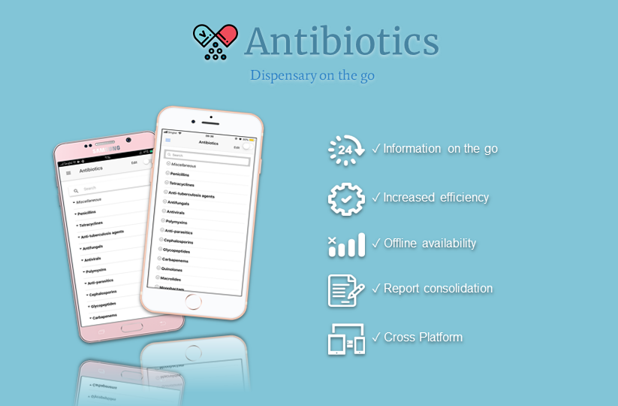

Figure : Project Solution Poster.

This project comes with the objective to provide a solution to solve troubles/inconvenience faced by the users, with features users requested for or/and they think would be useful to have. Also, to improve the User Interface Design (UID) to enhance UX.

With this, the following benefits will be realized through the availability of cross platform mobile application and the use of above proposed technologies:

1. Dispensing Antibiotic information on the go
2. Report consolidation with centralized location
3. Increased efficiency with shorter processing time required
4. Accessible on App Store, Google Play and Web Browser
5. Fetches updated release automatically when internet connection is available

## Project Specifications

The following use cases will represent the scope (functional and non-functional requirements) of this project.

Roles:

|  |  |
| --- | --- |
| **Superadmin** | Has all privileges and can add/remove/change hospitals and manage other admins |
| **Hospital-Admin** | Can change data for one specific hospital and manage other admins for that hospital |
| **User** | Has Login-Credentials and can save his settings and data in the cloud |

Priorities:

|  |  |
| --- | --- |
| **Essential** | Without this Feature the App won't be of any use.  *Milestone: v1.0* |
| **Advanced Feature** | Additional Features that are important but can be added later.  *Milestone: v1.1* |
| **Nice to Have** | If there is time for it, this will be included.  *Milestone: > v1.1* |

### Functional Requirements

### System Administration

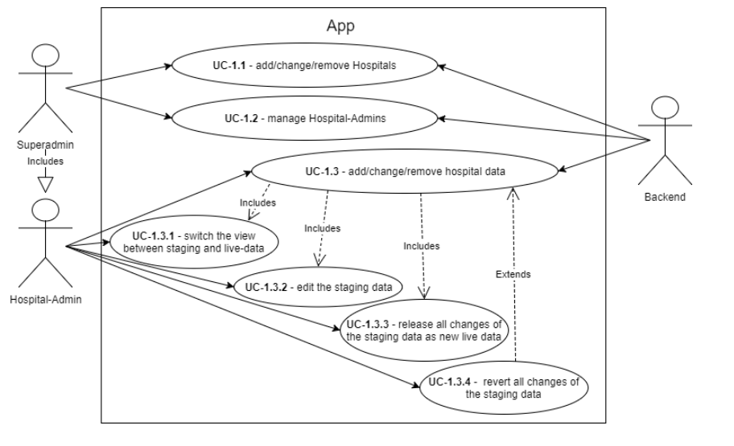

Figure 2: Use-Cases for administrative tasks.

|  |  |  |
| --- | --- | --- |
| Ref | User Story | Priority |
| UC-1.1 | *As a* ***Superadmin*** *I want to be able to* ***add/change/remove Hospitals.*** | Essential |
| UC-1.2 | *As a* ***Superadmin*** *I want to be able to* ***manage Hospital-Admins.*** | Essential |
| UC-1.3 | *As a* ***Hospital-Admin*** *I want to be able to* ***add/change/remove hospital data.*** | Essential |
| UC-1.3.1 | *As a* ***Hospital-Admin*** *I want to be able to* ***switch the view between staging and live-data.*** | Essential |
| UC-1.3.2 | *As a* ***Hospital-Admin*** *I want to be able to* ***edit the staging data.*** | Essential |
| UC-1.3.3 | *As a* ***Hospital-Admin*** *I want to be able to* ***release all changes of the staging data as new live data.*** | Essential |
| UC-1.3.4 | *As a* ***Hospital-Admin*** *I want to be able to* ***revert all changes of the staging data.*** | Advanced Feature |

* 1. User Functions

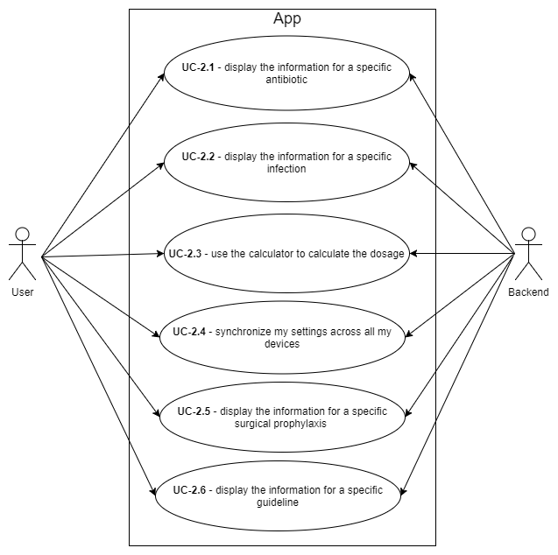

Figure : Use-Cases for administrative tasks.

|  |  |  |
| --- | --- | --- |
| Ref | User Story | Priority |
| UC-2.1 | *As a* ***User*** *I want to be able to* ***display the information for a specific antibiotic.*** | Essential |
| UC-2.2 | *As a* ***User*** *I want to be able to* ***display the information for a specific infection.*** | Essential |
| UC-2.3 | *As a* ***User*** *I want to be able to* ***use the calculator to calculate the dosage.*** | Essential |
| UC-2.4 | *As a* ***User*** *I want to be able to* ***synchronize my settings across all my devices.*** | Advanced Feature |
| UC-2.5 | *As a* ***User*** *I want to be able to* ***display the information for a specific surgical prophylaxis.*** | Nice to Have |
| UC-2.6 | *As a* ***User*** *I want to be able to* ***display the information for a specific guideline.*** | Essential |

Functions & Features:

|  |  |
| --- | --- |
| **Antibiotics** | * Search bar feature * View dosage information of specific antibiotic * Linked to Cockroft-Grault Equation * *Create/Edit/Update/Delete Antibiotic information\** |
| **Calculator** | * Formulated calculations based on inputs |
| **Guidelines** | * View guidelines information * *Create/Edit/Update/Delete Guidelines information\** |
| **Infections** |  |
| ***User Management****\** | * *Search bar feature* * *View user information of specific user* * *Update user roles* |
| ***Hospital Management****\** | * *Search bar feature* * *View hospital* information of specific hospital * *Edit hospital name* * *Set new release database to live* * *Add new hospitals, database releases* |
| **Settings** | * Select hospital database * Change user account password * Switch user account * *Select database type (staging/live)\** * *Master edit mode available*\* |

*\*Rights subjected to superadmin*

### Non-Functional Requirements

Besides functional requirements as described in the above sub-sections, there are also non-functional requirements that need to be achieved and fulfilled. These non-functional requirements includes:

1. Offline availability of all data
2. Hosting on PaaS-Platform (Cloud Firebase)
3. Distribution through App Store (iOS) and Play Store (Android)

### Hardware/Software Requirements

### Hardware Requirements

This project will be developed in house, at NYP’s SIT Centre of Information Technology Innovation (CITI) using its development personal computer.

Mobile web application is deploy using Ionic framework, which is free and open source, and Cloud Firestore, which is hosted on the cloud by Google. Hence, there are no additional hardware is needed.

For accessing the mobile web application, iOS and/or Android mobile device is required.

### Software Requirements

As mentioned, software requirements is needed. Ionic framework (<https://ionicframework.com/>) is required for development, while for deployment Cloud Firestore (<https://firebase.google.com/>) is required.

## Project Implementation

1. Technologies:

Ionic, and Cloud Firestore are used as part of the technologies.

Ionic, an open source framework for building mobile application in one codebase, but for multiple platforms. It is free and fully open source, which incur no initial expenses. It is useful for building beautiful cross-platform applications for mobile and web. It comes with various Application Programming Interface (API) and Ionic Native plugins which are all free.

Cloud Firestore is cloud-hosted, NoSQL document database for mobile and web application development. It is fully managed by Google, which is designed to easily store and synchronic application data at global scale. Google also provide free plan, so there is no add up to initial expenses. It is a flexible, scalable database for mobile, web, and server development from Firebase and Google Cloud Platform. This is a Real-time Document-Oriented Database that has also support for offline persistence of data, called Real-time Database as you can subscribe to value changes using Reactive Programming.

1. Libraries:
2. @angular/common

<https://www.npmjs.com/package/@angular/common>

1. @angular/compiler

<https://www.npmjs.com/package/@angular/compiler>

1. @angular/compiler-cli

<https://www.npmjs.com/package/@angular/compiler-cli>

1. @angular/core

<https://www.npmjs.com/package/@angular/core>

1. @angular/forms

<https://www.npmjs.com/package/@angular/forms>

1. @angular/http

<https://www.npmjs.com/package/@angular/http>

1. @angular/platform-browser

<https://www.npmjs.com/package/@angular/platform-browser>

1. @angular/platform-browser-dynamic <https://www.npmjs.com/package/@angular/platform-browser-dynamic>
2. @ionic-native/core

<https://www.npmjs.com/package/@ionic-native/core>

1. @ionic-native/dialogs

<https://www.npmjs.com/package/@ionic-native/dialogs>

1. @ionic-native/splash-screen

<https://www.npmjs.com/package/@ionic-native/splash-screen>

1. @ionic-native/status-bar

<https://www.npmjs.com/package/@ionic-native/status-bar>

1. @types/showdown

<https://www.npmjs.com/package/@types/showdown>

1. angularfire2

<https://www.npmjs.com/package/angularfire2>

1. cordova

<https://www.npmjs.com/package/cordova>

1. cordova-android

<https://www.npmjs.com/package/cordova-android>

1. cordova-ios

<https://www.npmjs.com/package/cordova-ios>

1. cordova-plugin-device

<https://github.com/apache/cordova-plugin-device>

1. cordova-plugin-dialogs

<https://github.com/apache/cordova-plugin-dialogs>

1. cordova-plugin-ionic-webview

<https://github.com/ionic-team/cordova-plugin-ionic-webview>

1. cordova-plugin-splashscreen

<https://github.com/apache/cordova-plugin-splashscreen>

1. cordova-plugin-whitelist

<https://www.npmjs.com/package/cordova-plugin-whitelist>

1. Firebase

<https://libraries.io/npm/firebase/4.8.0>

1. ionic-angular

<https://www.npmjs.com/package/ionic-angular>

1. ionic-plugin-keyboard

<https://www.npmjs.com/package/ionic-plugin-keyboard>

1. ionicons

<https://www.npmjs.com/package/ionicons>

1. ng-showdown

<https://www.npmjs.com/package/ng-showdown>

1. rxjs

<https://www.npmjs.com/package/rxjs>

1. showdown

<https://www.npmjs.com/package/showdown>

1. sw-toolbox

<https://www.npmjs.com/package/sw-toolbox>

1. zone.js

<https://libraries.io/npm/zone.js/0.8.18>

1. @ionic/app-scripts

<https://www.npmjs.com/package/@ionic/app-scripts>

1. @types/node

<https://www.npmjs.com/package/@types/node>

1. Typescript

<https://www.npmjs.com/package/typescript>

1. ionic-plugin-keyboard

<https://ionicframework.com/docs/native/keyboard/>

1. cordova-plugin-whitelist

<https://cordova.apache.org/docs/en/latest/reference/cordova-plugin-whitelist/>

1. Database Diagram:

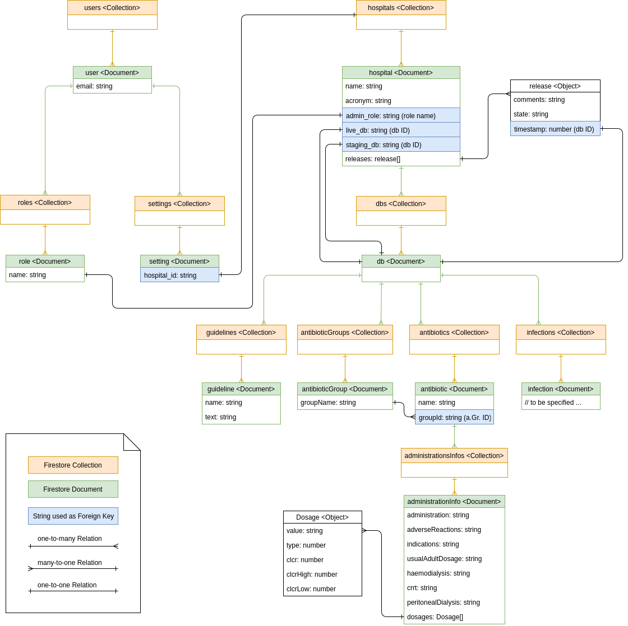

Figure : ERM-Model

1. Test Plan:

This project is tested for is expected behavior and deliverables.

Setup:

|  |  |  |  |
| --- | --- | --- | --- |
| **Test ID** | **Flow** | **User** | **Admin** |
| **01** | **Setup User Account**   1. Select Hospital 2. (a) Login   (b) Register   1. (a) Enter account credentials (E-Mail and Password)   (b) Enter account credentials (E-Mail, Password and Repeat Password)   1. (a) Press/Tap “Login” button   (b) Press/Tap “Register” button | √ | √ |
| **02** | **Change Hospital**   1. Press/Tap “Go Back” button 2. Select Hospital 3. Press/Tap “Continue” button 4. Proceed to **Setup User Account** | √ | √ |

Antibiotics:

|  |  |  |  |
| --- | --- | --- | --- |
| **Test ID** | **Flow** | **User** | **Admin** |
| **01** | **Search Antibiotic**   1. Enter search input in search bar 2. Antibiotic groups will be expanded with corresponding results | √ | √ |
| **02** | **View Antibiotic**   1. Select Antibiotic 2. Display Antibiotic dispensary information | √ | √ |
| **03** | **Search Antibiotic Dosage**   1. Enter dosage value 2. Dosage information will be highlighted | √ | √ |
| **04** | **Calculate Antibiotic Dosage**   1. Press/Tap calculator icon 2. Proceed to **Calculator** (Cockroft-Gualt Equation) | √ | √ |
| **05** | **Add New Antibiotic Group**   1. On “Edit” toggle button 2. Press/Tap plus icon 3. Enter Antibiotic Group Name 4. Press/Tap “Add” button |  | √ |
| **06** | **Edit Antibiotic Group**   1. On “Edit” toggle button 2. Press/Tap edit icon 3. Enter New Antibiotic Group Name 4. Press/Tap “Save” button |  | √ |
| **07** | **Delete Antibiotic Group**   1. On “Edit” toggle button 2. Press/Tap delete icon 3. Check “Delete related antibiotics” if necessary 4. Press/Tap “Delete” button |  | √ |
| **08** | **Add New Antibiotic**   1. On “Edit” toggle button 2. Press/Tap plus icon 3. Enter Antibiotic Name 4. Press/Tap “Add” button |  | √ |
| **09** | **Edit Antibiotic Details**   1. On “Edit” toggle button 2. Select Antibiotic 3. Amend changes to Antibiotic information |  | √ |

Calculator:

|  |  |  |  |
| --- | --- | --- | --- |
| **Test ID** | **Flow** | **User** | **Admin** |
| **01** | **Calculate Cockroft-Gault Equation**   1. Open Cockroft-Gault Equation 2. Select gender 3. Enter age, weight and serum creatinine | √ | √ |
| **02** | **Calculate Ideal Body Weight**   1. Open Ideal Body Weight 2. Select gender 3. Enter height | √ | √ |
| **03** | **Calculate Adjusted Body Weight**   1. Open Adjusted Body Weight 2. Enter height and weight | √ | √ |
| **04** | **Calculate Body Surface Area**   1. Open Body Surface Area 2. Enter height and weight | √ | √ |
| **05** | **Calculate CRUB-65**   1. Open CURB-65 2. Check applicable checkboxes | √ | √ |

Guidelines:

|  |  |  |  |
| --- | --- | --- | --- |
| **Test ID** | **Flow** | **User** | **Admin** |
| **01** | **View Guidelines**   1. Select Guideline 2. Display Guideline information | √ | √ |
| **02** | **Add New Guideline**   1. On “Edit” toggle button 2. Press/Tap plus icon 3. Enter Guideline Name 4. Press/Tap “Add” button |  | √ |
| **03** | **Edit Guideline Name**   1. On “Edit” toggle button 2. Press/Tap edit icon 3. Enter New Guideline Name 4. Press/Tap “Save” button |  | √ |
| **04** | **Delete Guideline**   1. On “Edit” toggle button 2. Press/Tap delete icon 3. Press/Tap “Delete” button |  | √ |
| **05** | **Edit Guideline Information**   1. On “Edit” toggle button 2. Select Guideline 3. Edit Guideline information accordingly 4. (a) Press/Tap “Save” button to save changes   (b) Press/Tap “Reset” button to discard changes   1. (a) Edit mode turned off to view changes   (b) Alert to confirm discard |  | √ |

User Management:

|  |  |  |  |
| --- | --- | --- | --- |
| **Test ID** | **Flow** | **User** | **Admin** |
| **01** | **Search Users**   1. Enter search input in search bar 2. Users will be filtered out with corresponding results |  | √ |
| **02** | **View User Details**   1. Select User 2. Display User information |  | √ |
| **03** | **Grant Superadmin Right**   1. On “Superadmin” toggle button |  | √ |
| **04** | **Remove Superadmin Right**   1. On “Superadmin” toggle button |  | √ |
| **05** | **Grant Hospital Admin Right**   1. On “Hospital Admin” toggle button |  | √ |
| **06** | **Remove Hospital Admin Right**   1. On “Hospital Admin” toggle button |  | √ |

Hospital Management:

|  |  |  |  |
| --- | --- | --- | --- |
| **Test ID** | **Flow** | **User** | **Admin** |
| **01** | **Search Hospital**   1. Enter search input in search bar 2. Hospital will be filtered out with corresponding results |  | √ |
| **02** | **View Hospital Details**   1. Select Hospital 2. Display Hospital information |  | √ |
| **03** | **Add Hospital**   1. On “Edit” toggle button 2. Press/Tap plus icon 3. Enter Hospital Name and Hospital ID 4. Indicate import preferences 5. Press/Tap “Add” button |  | √ |
| **04** | **Edit Hospital Details**   1. On “Edit” toggle button 2. Select Hospital 3. Amend changes to Hospital information 4. (a) Press/Tap “Save” button to save changes   (b) Press/Tap “Reset” button to discard changes   1. (a) Edit mode turned off to view changes |  | √ |
| **05** | **Add New Database Release**   1. On “Edit” toggle button 2. Select Hospital 3. Press/Tap plus icon 4. Add comments to new release |  | √ |
| **06** | **Set Release as Live Database**   1. On “Edit” toggle button 2. Select Hospital, and then release 3. Press/Tap “Set as live DB” button |  | √ |

Settings:

|  |  |  |  |
| --- | --- | --- | --- |
| **Test ID** | **Flow** | **User** | **Admin** |
| **01** | **Change Hospital**   1. Select Hospital | √ | √ |
| **02** | **Change Database**   1. Select Database type (staging/live) | √ | √ |
| **03** | **Change Password**   1. Press/Tap “CHANGE PASSWORD” button 2. Enter current password 3. Enter new password and repeat 4. (a) Press/Tap “CONFIRM” button to save changes   (b) Press/Tap “CANCEL” button to discard changes | √ | √ |
| **04** | **Switch User**   1. Press/Tap “SWITCH USER” button | √ | √ |
| **05** | **On Master Edit Mode**   1. On “Edit mode” toggle button |  | √ |

## Source and References

## Tacit Knowledge

## How It Works

User menu

## Reflection

JIAQI LOH DFI 151378C

Write here…

ONG SHI JIA DBA 154469M

Write here…

# Project Management

## Project Schedule

## Calendar

## Tasks

## Issue Tracker